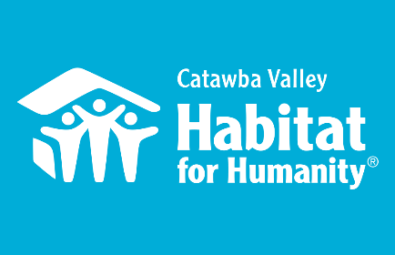
Table Captain Welcome

Greetings Habitat Table Captain,

We’re very excited to have you as a Table Captain for our fifth annual Home Is The Key Breakfast. Your support is more vital than ever to the breakfast’s success, and we applaud and thank you for your commitment! We could not do this without you.

Inside this packet you will find a few helpful worksheets and other items that will help you get organized and maximize the potential of your table! Electronic versions of these documents are also located at: https://habitatcatawbavalley.org/table-captains-info/

- Treasure Map--- What groups of people or organizations might you have a connection to that you could explore to identify guests for your table? Use this form to map out your networks/groups and start your list.

- Potential Guests Worksheet--- After completing your treasure map you may be surprised to see how many networks you are a part of. Use this worksheet to help capture names of potential guests for your table as you consider each group.

- Engage in Habitat’s Welcome Events--- Now that you have a list of potential guests, we strongly encourage you to invite your guests to learn more about Habitat’s mission by attending one or more of Habitat’s Welcome Events prior to November 10:
- September 28, 12:00-1:00pm – Behind the Scenes Tour
- October 15 – Ridgeview Neighborhood Celebration
- October 13, 2:00-3:00pm – Behind the Scenes Tour
- October 25, 4:30-5:30pm - Behind the Scenes Tour
    - A part of the success of your table will rest upon how connected your guests feel to Habitat. These series of events will allow for a flexible and fun way for your guests to have an introduction and share in the buy-in before they come to the breakfast!

- Guest Information Form--- You have confirmed 10 guests for your table, great! Now you can use our Confirmed Guest Information Form to let us know who is attending. The form can be found at: https://habitatcatawbavalley.org/table-captains-info/guest-info-form/ Using this form will ensure Habitat staff sends out breakfast invitations to your guests. Please submit your form no later than October 17, 2022. Any changes thereafter should also be sent to Lynn Nelson (lynn@habitatcatawbavalley.org or 828-328-9263).
- Save-the Date Postcard--- Now that your table is set with 10 confirmed guests, send out the pre-stamped Save-the-Date postcards.

Also included is the 2021 Annual Report, a sample past pledge sheet, and a model of the program. We hope you will find this packet useful in your preparation for this year’s breakfast. We are confident in all your efforts and look forward to continuing an amazing tradition that will have a lasting impact on our community.

Many thanks!
Lynn
Lynn Nelson
Development Assistant
lynn@habitatcatawbavalley.org
work 828-328-4663x309
cell 828-638-2911

