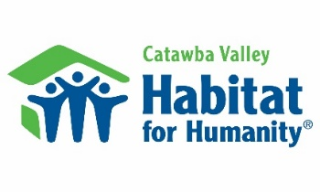
Three Legal Duties:
Duty of Care: Directors and officers must perform their responsibilities in good faith and with the same care an ordinary person would use in managing his/her own affairs. Directors hold no individual authority and only act together as a Board.
Duty of Loyalty: Directors and officers must act in good faith and in a manner which does not harm the organization to the benefit of the director or officer. Avoid any conflicts of interest or appearances of impropriety. Sign Conflict of Interest form annually.
Duty of Obedience: Directors and officers must comply with the provisions of the articles of incorporation, bylaws, and state laws, and should safeguard Habitat Catawba Valley's vision, mission and values.
Areas of Impact:
Serving the Community:
: Directors and officers are active participants in the work of Habitat. This includes being a leading presence on worksites and at Habitat events so that Directors can experience our work, build relationships with our partner families, and meet our community of supporters.
Championing the Message:
Directors and officers bring the message of Habitat into the community. Directors consider their own personal network of influence, and make invitations to those individuals and organizations who could be inspired by the work of Habitat.
Funding the Mission:
: Directors and officers grow Habitat’s capacity to serve more families by assisting with fundraising. This may include leading by example with a tithe, assisting with donation asks, or connecting Habitat to individuals and organizations interested in investing in the impact of Habitat.
General Expectations:
- Demonstrate an interest in Habitat for Humanity's mission, programs, and needs.
- Prepare for and participate in ten Board meetings annually and serve on at least one committee.
- Support the Habitat President in his or her relationships with groups or individuals.
- Assist with fund raising to ensure that resources are available to support the affiliate’s programs.
- Contribute experience and/or knowledge in board member’s specific area of expertise.
- Advocate for Habitat Catawba Valley in the community.
- Give an annual gift from personal income that is meaningful relative to your personal financial circumstances.

Printed Name: ______________________________________________
Signature: _______________________________________________ Date: ____________

