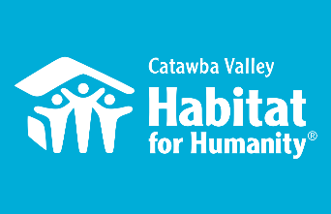

Home is the Key
Breakfast
November 4, 2021

Mark Your Calendar

Aug 31st & Sept 9th
Table Captain Packet Pick Up/Orientation

October 1st

Confirmed Guest Info Sheet DUE to Lynn Nelson

November 3rd

Give a reminder call or email to your guests.

November 4th

At 7:30 am, send a text or email to your guests inviting them to grab coffee and join you for the Breakfast. Tune in for the program at 8:00 am. Later that afternoon, call guests to thank them and remind anyone who hasn’t watched yet that the program is still available for viewing.

QUESTIONS?

Contact Lynn Nelson:
lynn@habitatcatawbavalley.org
Or 828-638-2911

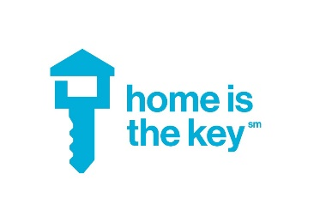
Your Role as a Table Captain

Being a table captain is easy.
Your job is to fill and host a virtual table of ten at our online Home is the Key Breakfast.

Here’s how you do it:

Invite Guests

- Identify people in your social and professional networks who might be interested in learning about Habitat. We can help you identify people to fill your 10-person virtual table using an easy tool called treasure mapping.

- Make personal invitations to your friends and colleagues. Utilize the paper or electronic Save-the-Date to help your confirmed guests keep the event on their mind. Receive a commitment to attend the breakfast from 9 guests.

- Include on the Potential Breakfast Guests Form a list of people you would like to consider inviting to the breakfast. You may also use this form to list people who cannot attend the event but said they would like to know more about Habitat.

- Gather your guests’ contact information and submit your final list to us by October 1st. Use the Breakfast Guest Information form included in your Table Captain packet or download it from https://habitatcatawbavalley.org/table-captains-info/

Before the Breakfast

- Send guests a Save-the-Date postcard or email after they have committed to attend the event.

- Engage with Habitat’s Insider Blueprint webpage: We are utilizing technology to inform you and our guests about Habitat Catawba and what they will be experiencing during the event. It is vital that our guests, especially those new to Habitat, have at least a little ownership before the event.

- Call and email your guests on Wednesday, November 3rd to remind them to attend the virtual Home is the Key Breakfast.

The Big Day

- At 7:30 am, send out an email or text to your crew inviting them to grab their coffee and join you online for an insider’s look into the work of Habitat.
- Tune in at 8:00 am for the virtual event.
- Sometime that afternoon, call your guests to thank them for attending, and ask them their impressions. If they haven’t had a chance to watch yet, please inform them that the event is still accessible after the fact, and encourage them to watch.

