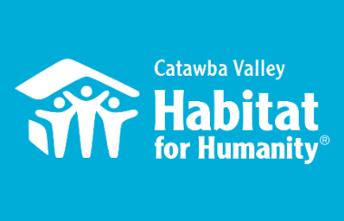
2019-2020 Board of Directors Engagement Form

Board Member: _____________________________________________________

FY19-20 will be a year of growth for our organization, and require more capacity building, revenue growth & volunteer engagement:

Volunteer engagement:
- ___ Participate in the “Board Build” Spring 2020
- ___ Host a POE event and invite friends to attend
- ___ Host a “Birthday build” or coordinate a group of friends to volunteer
- ___ Receive advocacy emails
- ___ Contact my network (corporate, church or community contacts about Apostle Build or group volunteering activities). Possible leads: ______________________________________________________________________________

Financial engagement:
- ___ Contribute an annual gift to Habitat Catawba Valley reflective of my personal giving ability, my knowledge of the growth needs and goals, and which places Habitat Catawba Valley as a personal philanthropic priority
- ___ Help to identify prospective donors- Goal for the year:________
- ___ Actively introduce staff to others in the community (individuals, companies, community leaders, faith-based institutions)- Goal for the year:_________
- ___ Accompany the staff on corporate, foundation, faith-based and/or individual donor visits as needed, and aid in solicitation efforts
- ___ Consider making a planned gift to Habitat Catawba Valley by adding a codicil in my will or by designating HFHCV as a beneficiary of an IRA or life insurance plan, for example
- ___ Be a Table Host for the Home is the Key Breakfast event
- ___ Solicit table sponsorships from my networks for Home is the Key - Goal for the year:________

Other ways to be involved:
- ___ Participate in the donor thank-a-thon in November 2019
- ___ Write thank you notes to 10 donors
- ___ Serve on a Habitat Committee : Resource Development, Land Acquisition, Hospitality
- ___ Lead an opening devotion and/or prayer at a Board meeting

Signature: Date:

_____________________________________________ _________________

