Habitat for Humanity of Catawba Valley
Board of Directors’ Meeting
January 30, 2023

Devotion – Tina Morgan

Adoption of Agenda – Rodney Garren
Consent Agenda:
Items are considered routine by the Board of Directors and will be enacted by one motion. There will be no separate discussion of these items unless requested by a member. The item will be removed from the Consent Agenda, then added to Action or Informational Items.

- Minutes from December Board Meeting
- Staff Reports
- Strategic Plan Quarterly Update

Action Items:
- Anti-money Laundering Policy – Andrew Isola
- Annual “in good standing” Documents – Andrew Isola

Informational Items:

- Executive Director Update

Upcoming Events:
Coming soon!

Next Board Meetings/Events:
- February 27, March 27, April 24, May 22, June 26

- Minutes from December Board Meeting

Habitat for Humanity of Catawba Valley
Board of Directors’ Meeting
December 5, 2022

Members Present: Jim Benton, Tara Bland, Scott Echelberger, Rodney Garren, Tiffany Gray-Napier, Lori Greveling, Gerry Knox, Jim Meade, William Pleasant, Margaret Pope, Charlotte Williams
Members Not Present: Bill Burnham, Rob Howard
Staff Present: Mitzi Gellman, Andrew Isola, Tina Morgan, Melissa Neal, Lynn Nelson, Derek Ross, Jenna Ross, Phillip Steppe, Meg Spivey, Hannah Yost
Guest: John Braswell - Homebuyer

Welcome
There being a quorum, the December meeting of the Habitat for Humanity of Catawba Valley Board of Directors was called to order by Board President, Rodney Garren, at 12:10pm. Due to COVID19, a hybrid of in-person and zoom Board meeting was held.
Devotion
Tina Morgan, Director of Homeowner Services, introduced John Braswell, homebuyer in process, to share the devotion. John shared on his family upbringing and the faithfulness and goodness of God. He led the devotion sharing Matthew 6:1-4, followed by The Lord’s Prayer.
Adoption of Agenda
Rodney Garren, President, made an addition to the Agenda under Informational Items:
- Executive Report – Mitzi Gellman
Upon a motion by Charlotte Williams and a second by Margaret Pope, the Board unanimously adopted the updated December Agenda.
Consent Agenda
The Board adopted the Consent Agenda of the October Board Meeting Minutes, Staff Reports, and October Financial Statements by a motion from Tara Bland and a second by Charlotte Williams without dissent.
Action Items
William Pleasant, Treasurer, presented the October and November Financial Statements
- William discussed an uptick in donations for November due to Home Is The Key.
- Strategies for Finances – talks continue with Habitat Mortgage Solutions.
- Upcoming House Closings – Habitat is expected multiple house closings in first quarter 2023.
- People’s Bank Account – $500,000 has been moved from checking account into an interest-bearing account. Monies have also been moved into a sweep account. In January 2023, Habitat will be looking at RFQ’s.
- Anti-Money Laundering Policy – Due to time constraints of the Board Meeting, Andrew Isola requested the training on Anti-Money Laundering Policy be moved to the January Board of Directors meeting. A motion to reschedule the training until January 2023 was made by Jim Benton and a second by Charlotte Williams. With all in favor, Anti-Money Laundering training was rescheduled.
Informational Items
- Meg Spivey, Development Director, presented an update on HITK (Home Is The Key) stating there were 24 new LBS (Legacy Builder’s Society) pledges, 128 gifts, 160 in attendance and 20 TC (Table Captains). As of December 1, 2022, HITK has raised $271,158.00. Meg also shared the results of Giving Tuesday, which was held on Tuesday, November 29. Habitat raised over $40,000.00! Congratulations to all for their hard work and a job well done.
- Jenna Ross, Assistant Director, presented current standings with Habitat’s Strategic Plan. Jenna shared a chart showing current 2nd quarter information along with in-process items for 3rd and 4th quarter 2022 and 1st quarter 2023. Currently we have completed the interdepartmental communication norms. Items in process for 2nd quarter are:
  - Short term rental pilot program
  - Viability of Habitat mortgage model assessment
  - Staff structural analysis (organizational charts, job descriptions)
  - Board committees
- Mitzi Gellman presented the Executive Report:
  - Update on partnership with JRN Construction – Habitat has selected JRN Construction to build 3 homes located on 8th Ave Ct SW. JRN has quoted a turnkey price of $170,000 per home. Regarding energy efficiency of the homes JRN has submitted “Project Input Form” with Southern Energy Management in a first step toward determining the energy efficiency of their homes. Additionally, JRN has submitted a multi-family site plan for lots located on the corner of 1st St SE and 3rd Ave SE (The Cottages). Their plan is to build a 5-unit townhome complex to include 2 single-story/handicap accessible end units and 3 two-story, 3 bedrooms, 2 bath units.
  - Hybrid Construction Model – Two homes located on F Avenue will be constructed by subcontractors with oversite by Derek Ross. This model will decrease the overall construction time, allowing Habitat to move families into homes faster and improve the affiliate’s cash flow. Last week contractors completed the framing of 2 homes.
  - Administrative Office Move – Atriax is scheduled to move from 102 3rd Ave NE office building on December 15, 2022. Following their move, staff will assess the building to determine needs of furniture, painting, and cleaning.
  - Finance Manager – The job description for the Finance Manager is nearly complete with an expected 1st quarter hiring of new Finance Manager.
Upcoming Board Meetings
Upcoming Board meetings for 2023 include:
- January 30th (proposed alternative date). The Board approved moving the January 23 Board Meeting to January 30.
- February 27, March 27, April 24, May 22, and June 26
Adjourn
There being no further business, a motion to adjourn was made by Margaret Pope with a second by Charlotte Williams. With all in favor, the meeting was adjourned at 1:03 pm.

__________________________________________________________________

October/November Staff Reports

Habitat “New Construction” Report
Derek Ross October/November 2022

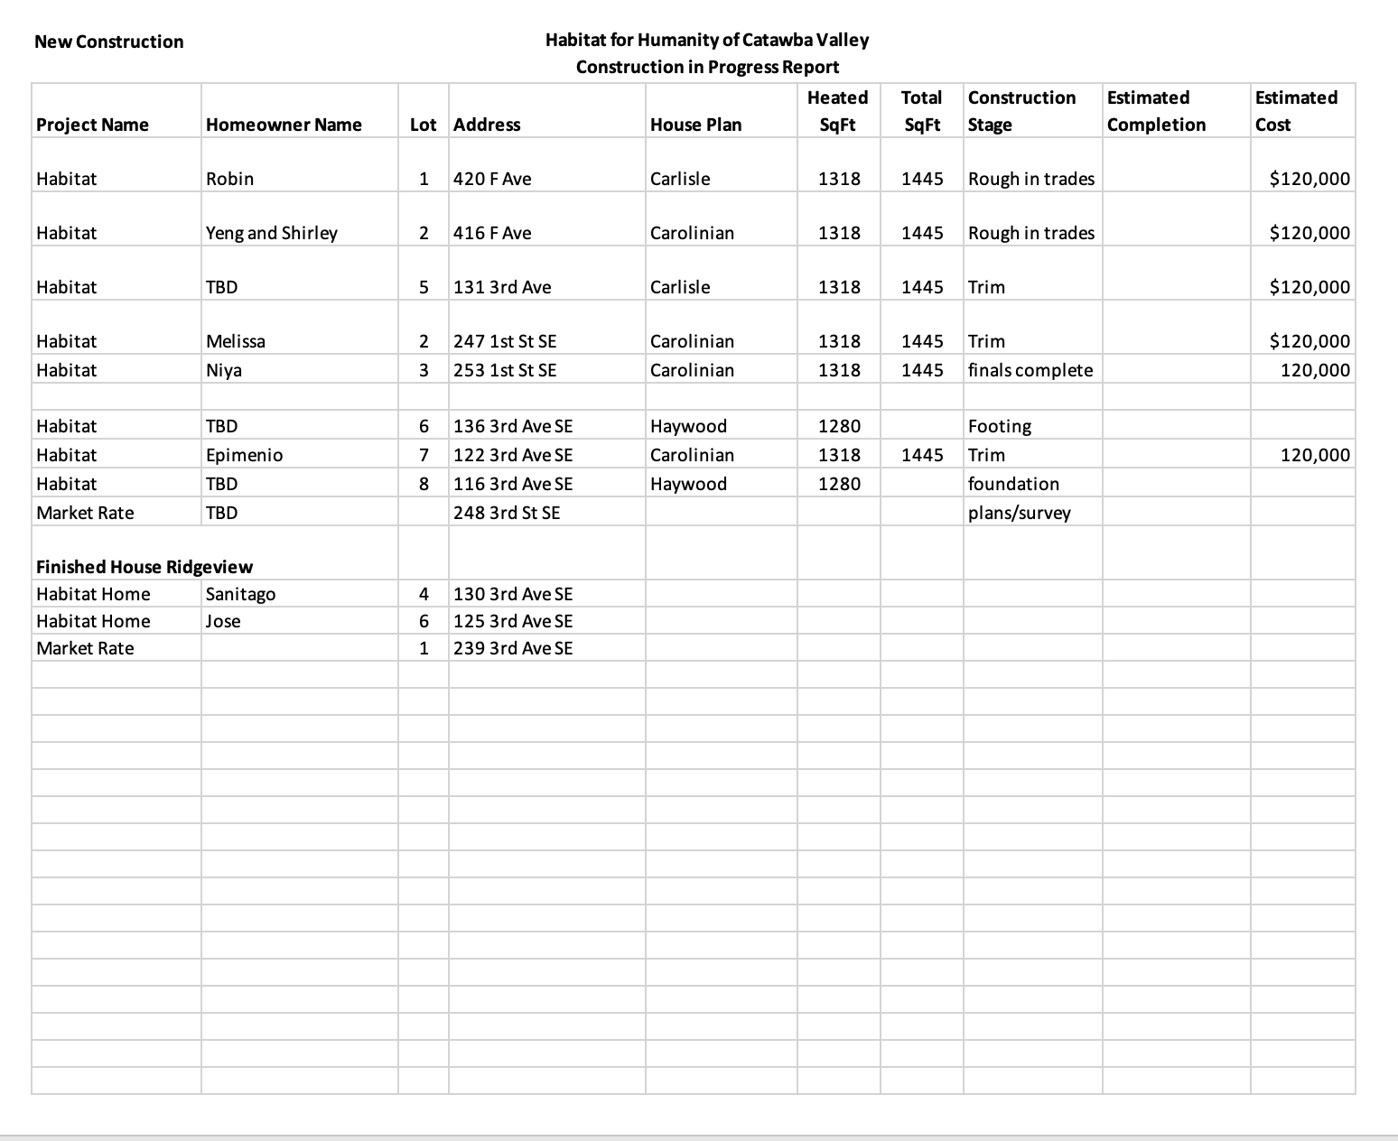

Development Report
Meg Spivey January 2023

Overall
Development Metrics for the period July 1, 2022 through December 31, 2022
Contributions: Budget* | $1,405,000
Contributions: Actual Received as of 12/31/22 | ($665,523)
Difference to Goal | $739,477
% Goal to Actual as of 12-31-22 | 47%
* Includes gifts received by Individuals, Estates,
Churches, Corporations, Foundations
Foundation Relations activity
Grants awarded for the period November 1, 2022 through December 31, 2022
Catawba Valley Community Foundation $4,000; Habitat Repairs!
Saint Gobain Foundation $5,000; Habitat Repairs!
George Foundation $45,000; Habitat Repairs!
Kenneth K. and Suzanne G. Milholland Fund $3,500; Habitat Repairs!
Publix Supermarket Charities $6,500; New Construction

Direct Mail Appeals
Christmas mailer: 1,492 households $33,826
Fall mailer: 1,444 households $8,051

Donor Events
Legacy Builders Society Stewardship Event – March TBD

Requests for Board Assistance
Advancement/Development Advisory Committee
- Provide suggestions/nominations to Meg Spivey; meg@habitatcatawbavalley.org

_________________________________________________________________________

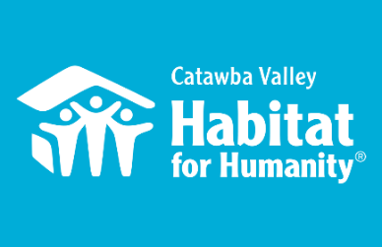
Mission and Outreach
Jenna Ross – December Board Report

Capacity Building
- Strategic Planning in collaboration with team members:
  - Implemented Q2 ‘22 accomplishment: interdepartmental communication norms established
  - Established Strategic Plan reporting process
  - Ongoing: oversee overarching staff Strategic Plan implementation processes

Mission, Messaging & Media
- $10,000 HFHI Family Story Grant Award Winner: family story featuring Kisha Brewer to be utilized in national HFHI campaign

Outreach
- NAACP Equity & Inclusion Task Force – Housing Committee Liaison
  - 12/5 – Co-facilitated Housing Committee meeting
- LiveWell Catawba
  - 12/13 – sworn in as Board Chair, representing Habitat
- Housing Visions Continuum of Care
  - 12/8 – monthly meeting
- 12/8 – WPCOG homelessness prevention consultation meeting

Volunteers
- Volunteer Hours 9/1 – 9/30
  - 62 volunteers
  - 607 hours served
  - Groups: 9/10,24 - YMCA, 9/15,30 - CommScope, 9/17 - First Baptist
    - 12/8 – Saint-Gobain
    - 12/10 – CREC
    - 12/17 – Brewer Build

____________________________________________________________________

The ReStore Report Nov/Dec 2022
Donations and Sales – November Sales $85,250.12 (Total sales plus scrap runs) Round Up Change $307.84 Transactions 2727 Avg. Sale $30.93. Approximately 16.93% increase compared to last year same month.
December Sales $90,084.57 (Total sales plus scrap runs) Round Up Change $161.59 Transactions 2851 Avg. Sale $31.55 Approximately 10.66% increase compared to last year same month.
Mid-Year Sales Report – Increased sales due to increased donations and social media awareness.
2021 | 2022 | % difference
$444,686.49 | $506,055.12 | 13.80%

Please help us grow the ReStore by sharing contacts and making introductions. Thanks.
Purchased Product Summary – Purchased Product updates for November / December
Cost of new inventory added | Total retail sales | Total cost of goods sold | Net Profit | Gross Profit Margin
$3580.00 | $8199.50 | $5070.00 | $3129.50 | 38.16%
Purchased Product Mid-Year Summary – Updates Mid-June/December
Cost of new inventory added | Total retail sales | Total cost of goods sold | Net Profit | Gross Profit Margin
$15,410.00 | $28,849.75 | $12,925.00 | $15,924.75 | 55.20%
Donations, Donations, Donations – From out of county travel accommodation to a major refit at Lowe’s Hardware Hwy 127, donations in November and December were a steady stream keeping the store stocked and customers shopping. End of year donations have exploded!!! Bunny Williams Home (165 pieces), Good’s Home Furnishings (50+ pieces), Hooker Heritage Outlet (70+ pieces), McCreary Modern (77 pieces), Precedent Furniture (13 pieces) a wonderful combination of new items, returns, as is gently used, lamps and lighting, and home accessories. Even better news it’s continued into January with Sutter Street and Vanguard!
All this in addition to our regular county wide scheduled pickups. On average the truck hits 5-6 donation stops per day.
Staff/Volunteer Needs – Kristi Biggar led a conversation at First United Methodist in Newton/Conover. It was well attended, including Faye Swofford, with lots of good questions and potential volunteers.
Volunteers are still crucial. As donations and sales increase so does the workload. Are you part of a social organization that needs to hear the ReStore message? Contact Kristi and we will set something up. https://habitatcatawbavalley.org/restore/volunteer/
- Cashier: Tuesday AM/PM, Thursday PM, Saturday AM/PM
- Sales Floor: General awareness of the merchandise combined with the ability to talk with customers.
- Fabric: Open time slots all week.
- Greeter: Anytime throughout the week.
- Receiving/Pricing: Tuesday AM
- Custodian (General Cleaning/Store maintenance): Friday AM/PM
- Warehouse Receiving/Cleaning: Opportunities open throughout the week, ask for details.
- Online Store (Posting/Inventory) Weekly opportunities open
- Merchandising: All areas Hardware, construction, housewares, and furniture constantly need straightening and display attention, ask for details.
________________________________________________________________

Homeowner Services Report
Tina Morgan January 2023

Homeowner Services: Selection and Homeowners-in-Progress
The Homeownership Program’s open application period was very successful. The program distributed 123 applications during this period. This is very similar to the number given out in the last round. This application round was the first time the Homeownership Program has had a truly online application available to potential applicants through the NewOrg platform. The NewOrg online application collects the information needed and enters it into the NewOrg database. 12 individuals completed the NewOrg online application in this round. In total, the Homeownership Program received 73 applications during this round, also a similar number to the last open application period.

Utilization of the NewOrg platform is now in full swing. As this is the first application round under the NewOrg platform, staff is experiencing the online application for the first time. Staff is also learning the details of utilizing this database to its fullest capacity. There have been some growing pains as staff has had to convert over 60 of the applications received from a paper format to the digital format required for the NewOrg database. This has required a significant amount of data entry. All Homeowner Services staff has contributed to this effort and the Homeownership Program is grateful for their efforts.

This application round has continued to show an interesting trend regarding housing patterns among our applicants. The cost of housing has radically increased over the past 12-18 months across the country and in our county. Staff believes that it should be seeing a significant increase in overall rents among our applicants. There has been some increase but not to the degree expected. What has been more prominent has been a decrease in the quality of housing reported by our applicants. In other words, our applicants are self-reporting paying roughly the same amount in rents while living in worse conditions.

Homeowner Services: Habitat Repairs!
Habitat Repairs! currently has twenty-two open projects, including one homeowner that is in the process of signing the contract. The construction team is working hard to move along some projects that have been in the pipeline for a while, and soon the only remaining open projects will be those accepted in the last application round. All of these projects should be finished within the next few months.

Because the construction team is getting caught up with the projects, another application round is being scheduled. The application round will be held after moving into the new building to make sure the location to pick up and drop off the applications is the same and not confusing for applicants. Tentatively, applications will be available the weeks of February 20th and 27th with the applications being due March 10th.

This will be the first time for Habitat Repairs to do a true application round. We will be using the online application with the NewOrg database. Staff are excited to test out the database with this round and be able to track progress more easily. The goal is to have between 10 and 15 projects in process and to have this group close to finished before another application round is scheduled.

Homeowner Services: Homeowner Support January 2023

Delinquency Report
Reporting Period as of 1/1/2023 Total Mortgages: 88
Delinquent | # Mortgages Delinquent | Arrearage | % Delinquent
1-2 months | 6 | $ 1,603 | 6.8%
2-3 months | 0 | $ 586 | 0.0%
Over 3 months | 4 | $ 2,071 | 4.5%
Total this month | 10 | $ 4,260 | 11.3%
Total 11/1/22, 87 mtgs | 11 | $ 6,565 | 12.6%
Total same mo. prior yr: 1/1/22, 89 mtgs | 11 | $ 9,267 | 12.3 %
Total 1/1/20, 98 mtgs pre-pandemic | 22 | $ 21,492 | 22.4%
Jun. 2013, last mo. prior to AMS, 119 mtgs | 12 |  | 10.1%

Homeowner Services News

Delinquencies have gone down by one percent over the past month, with an increase in the one to two months delinquencies and decreases in the two to three months and over three months delinquencies. What’s remarkable is that there has been a decline in delinquencies over the holidays, hooray for our homeowners’ financial discipline!

We have 12 homeowners who we know have applied to NCHAF for COVID related mortgage assistance funded by the American Rescue Plan. Of those 12, nine have received funds, two have funds in processing, and one is waiting to hear if they will be accepted.

Niya Mayfield has closed and moved into her new home in the Cottages.

Miesha Johnson’s closing preparations are well underway. Her loan reservation with NCHFA has been accepted, and her loan application for down payment assistance has been submitted. Miesha is in the Section 8 Homeownership Program, so they will be another agency to coordinate with for this closing and then available to support her successful homeownership.

Homeowner Services is very happy to welcome Stacy Gibson to our team! Her presence will enable us to manage our recently doubled applications as well as to grow into our strategic plan to “Build More, Do More, Serve More”. Stacy comes to us from the housing program at GHCCM, and she brings not only skills but an extensive network of resources and contacts with local housing professionals and providers. The networking opportunities that come with Stacy will be instrumental as we work toward our strategic plan goal to create new programs to serve the diverse housing needs of the broader community.

Many thanks for your prayers for our homeowners, home buyers, and their families.

_________________________________________________________________________

Action Items:

- Anti-money Laundering Policy – Andrew Isola
- Annual “in good standing” documentation – Andrew Isola

______________________________________________________________________

Informational Items:

- Executive Director Update – Mitzi Gellman

___________________________________________________________________

