Habitat for Humanity of Catawba Valley
Board of Directors’ Meeting
September 26, 2022

Introduction of New Board Members – Rodney

Devotion – Tina Morgan

Adoption of Agenda – Rodney Garren
Consent Agenda:
Items are considered routine by the Board of Directors and will be enacted by one motion. There will be no separate discussion of these items unless requested by a member. The item will be removed from the Consent Agenda, then added to Action or Informational Items.

- Minutes from August Board Meeting
- Staff Reports
- Affiliate Covenant Agreement

Action Items:
- Board of Directors Officers’ Slate – Rodney
- Treasurer’s Report – William
  - August Financials
  - Investment Policy

Informational Items:
- Home is the Key: in-person! – Meg/Lynn
- Review of Strategic Plan Draft – Jenna/Meg

Upcoming Events:
- September 27: 5:30 – 7pm; Home is the Key Table Captain Social; Boca
- September 27, October 7, October 13: Tour with the Executive Director
- October 15: 11:30-1; Ridgeview Celebration/Dedication of Niya Mayfield’s House with Morning Star Baptist Church
- November 10: 8am; Home is the Key in-person event

Next Board Meetings/Events:
- October 24, no meeting in November, December 5

Habitat for Humanity of Catawba Valley
Board of Directors’ Meeting
July 25, 2022

Members Present: Jim Benton, Bill Burnham, Doug Dickson, Scott Echelberger, Rodney Garren, Lori Greveling, Frances Hilton, Ander Horne, Pat Jones, Gerry Knox, William Pleasant
Members Not Present: Tara Bland, Graham Hunsucker, Margaret Pope, Charlotte Williams
Staff Present: Mitzi Gellman, Andrew Isola, Jeff Mingus, Tina Morgan, Melissa Neal, Lynn Nelson, Jenna Ross, Meg Spivey, Hannah Yost
Welcome
There being a quorum, the August meeting of the Habitat for Humanity of Catawba Valley Board of Directors was called to order by Board President, Rodney Garren, at 12:00 noon. Due to COVID19, a hybrid of in-person and zoom Board meeting was held.
Devotion
Bill Burnham, Board Member, led the devotion sharing Acts 17:28, followed by prayer.
Adoption of Agenda
Rodney Garren, Board President, made an addition to the Agenda adding Action Item – Truist Loan. Upon a motion by Bill Burnham and a second by Jim Benton, the Board unanimously adopted the revised August Agenda.
Consent Agenda
The Board adopted the Consent Agenda of the July Board Meeting Minutes, Staff Reports, and July Financial Reports by a motion from Pat Jones and a second by Lori Greveling without dissent.
Action Items
- Mitzi Gellman, Executive Director, presented the 2022-23 Slate of Officers – Jim Meade, Rob Howard, and Tiffany Gray-Napier. Mitzi also presented a recommendation for William Pleasant to serve as the Treasurer for the FY2022-23. Bill Burnham made a motion to accept the Slate of Officers and William Pleasant as Treasurer with a second by Gerry Knox. With all in favor, the motion was approved.
- Mitzi Gellman, Executive Director, discussed Habitat’s current loan with Truist Bank (formerly BB&T) stating the original loan amount was approximately $269,000. We currently have a balance of $69,000 with monthly payments of $2,000. Mitzi offered two options to either request a short-term renewal or pay off the loan. A motion to pay off the loan and reimburse the funds to the account once the sale of the Habitat building is finalized was made by Bill Burnham, with a second by Pat Jones. With all in favor the motion was approved.
- Andrew Isola, Homeowner Services Coordinator, presented a Recommendation from the Homeowner Selection Committee to approve the Homeowner Selection Policy updates. With all in favor, the updates were approved.
Informational Items
Strategic Planning Stakeholder Overview: Meg Spivey/Jenna Ross
- Meg Spivey, Development Director, reviewed the Strategic Planning notebook which included: Strategic Plan, Affiliate Catawba Valley, Habitat International, Stakeholder Feedback, and Notes. She also discussed Sharing our stories focus groups.
- Jenna Ross, Assistant Director, discussed the following guideposts for preparation of the upcoming Retreat. The following was discussed:
  - The Two Feet of Love in Action – Charity & Justice and Direct Services & Indirect Services.
  - Our Scaling Strategy – Community Impact, Sector Impact, Societal Impact.
  - Habitat Principles – Demonstrate the love of Jesus Christ, Focus on shelter, Advocate for affordable housing, Promote dignity and hope, and Support sustainable and transformative development.
  - Principles Aligning with Major Donors – Advancing equity for underserved communities, Reducing food insecurity, Addressing high local poverty rates, and Alleviating suffering for those hit hardest by the COVID-19 pandemic.
  - Neighborhood Revitalization – Community development practices and Habitat housing products.
  - Key Take Aways – Where we stand, What’s changing, and Building forward.
Upcoming Events
Rodney Garren, Board President, shared upcoming events:
- September 8: 5:30-7pm; Home is the Key Table Captain Social at Boca Restaurant
- September 17: 10am; Ridgeview Celebration/Kick-off of First Baptist House
- September 27, October 7, October 13: Tour with the Executive Director
- November 10: 8am; Home is the Key, virtual event
Adjourn
Rodney Garren, Board President, made the following announcements:
- Strategic Planning Retreat - August 29 & 30, Habitat Administrative Offices, 8:30am
- The next Board meetings will be held on September 26, October 24, and December 5.
There being no further business, Rodney Garren adjourned the meeting at 1:12pm.

- Staff Reports:

Executive Director Report
August 2022
Informational Items:
- Update on Bailey House: Atriax’s last day on the current lease is 12/15/22. After they move, we will assess the condition of the building and plan repairs and upfitting.
- Still waiting for a final date for the sale of current administrative building on 4th ST SW. Selling price is $375,000. The Cranfords have agreed to lease the administrative space, in addition to the warehouse area, through January for an additional fee of $1,000/month.
- On Wednesday, 9/21, JNR development celebrated the completion of 6 affordable homes in the Ridgeview Community. Take a look at the Hickory Daily Record article on the event:
- https://hickoryrecord.com/news/local/young-familes-find-stability-chance-to-put-down-roots-in-new-affordable-homes/article_c314e482-39d9-11ed-a92e-739db978fb94.html
The homes are sold to buyers at or below 80% of the area median income, and prices are set with an upper limit of $180,000.
Since our last meeting I’ve received quotes on construction of the homes by JNR for Habitat. For the 3-bed, 2-bath single story 1210sq/ft price to Habitat $175,000, with projected competition time of 150 days. This price is well in line with our current construction costs. Derek is evaluating the construction quality and energy efficiency and will have recommendations to improve efficiency and sustainability.

The ReStore Report August 2022
Jeff Mingus

Bottom Line: Approximately 25% increase compared to last year same month.
Donations and Sales – August Sales $85,562.44 (Total sales plus scrap metal recycling)
Round Up Change: $225.16
Number of Transactions (Sales): 2656
Avg. Sale: $31.45.

Sales By Department
August 2022 Comparison
Category | Sales this period | Sales last period | % increase/  decrease | Average value this period | Average value last period | % increase/  decrease
APPLIANCES | $1,590.90 | $2,177.10 | 26.93% | $38.80 | $55.82 | 30.49%
BOOKS/RECORDS | $2,763.33 | $2,583.04 | 6.98% | $1.78 | $1.86 | 4.38%
COLLECTIBLES | $3,271.38 | $2,793.79 | 17.09% | $17.40 | $20.39 | 14.67%
CONSTRUCTION | $10,404.28 | $7,004.90 | 48.53% | $29.56 | $19.35 | 52.75%
FABRIC | $1,433.15 | $828.55 | 72.97% | $7.46 | $3.53 | 111.71%
FURNITURE | $32,683.57 | $25,421.90 | 28.56% | $52.46 | $40.87 | 28.36%
HARDWARE | $6,164.53 | $7,108.25 | 13.28% | $4.61 | $3.69 | 25.09%
HOUSEWARES | $9,363.62 | $8,722.96 | 7.34% | $3.30 | $2.00 | 64.63%
JEWELRY | $227.50 | $261.25 | 12.92% | $2.77 | $1.78 | 56.11%
LIGHTING/LED Bulbs | $6,937.70 | $5,670.10 | 22.36% | $5.86 | $2.76 | 112.47%
PINK TAG Clearance | $4,744.35 | $0.00 | 100% | $107.83 | $0.00 | 100%

This month’s big donation and inventory news:
Duke Energy LED light bulb programs MaxLite and GreenLite continue to be a huge draw for the store.
Hickory Park and Good’s Home Furnishings came through with sizeable furniture donations. Another great pick up in Forsyth County of odd cabinet pieces. Plus, Precision Cabinet delivered a good load also. CVMC came through with pieces including file cabinets, desks, and even Carl Moser framed photography. Late August found us back at Stone & Leigh for more purchased product. Individual donors have also stepped up in quality and quality.
It is market season again so still waiting for responses and opportunity with, Hooker Heritage Outlet, Hickory-White, Vanguard, and McCreary Modern.

Purchased Product Update –
Stone and Leigh sofas, and beds are making a difference. Our initial purchase of the Laramie microfiber sets got off to a slow start. In fact, we still have product available. Beds and cribs have been a success, with cost low at $25.00 each, allowing increased profit margins. Neutral fabric sofa/loveseat sets purchased and have completely sold out. Already checking for more items like these. I recommend that we continue with this program as a great way to grow ReStore sales.
Cost of new inventory added | Total retail sales | Total cost of goods sold | Net Profit | Gross Profit Margin
$11,830.00 | $12,943.50 | $5,390.00 | $7,553.50 | 58.36%

Staff/Volunteer Needs – Are you part of a social organization that needs to hear the ReStore message? Contact Kristi and we will set something up. https://habitatcatawbavalley.org/restore/volunteer/
- Cashier: Tuesday AM/PM, Thursday PM, Saturday AM/PM
- Sales Floor: General awareness of the merchandise combined with the ability to talk with customers.
- Fabric: Open time slots all week.
- Greeter: Anytime throughout the week.
- Receiving/Pricing: Tuesday AM
- Custodian (General Cleaning/Store maintenance): Friday AM/PM
- Warehouse Receiving/Cleaning: Opportunities open throughout the week, ask for details.
- Online Store (Posting/Inventory) Weekly opportunities open
- Merchandising: All areas Hardware, construction, housewares, and furniture constantly need straightening and display attention, ask for details.

______________________________________

Habitat “New Construction” Report
Derek Ross August 2022

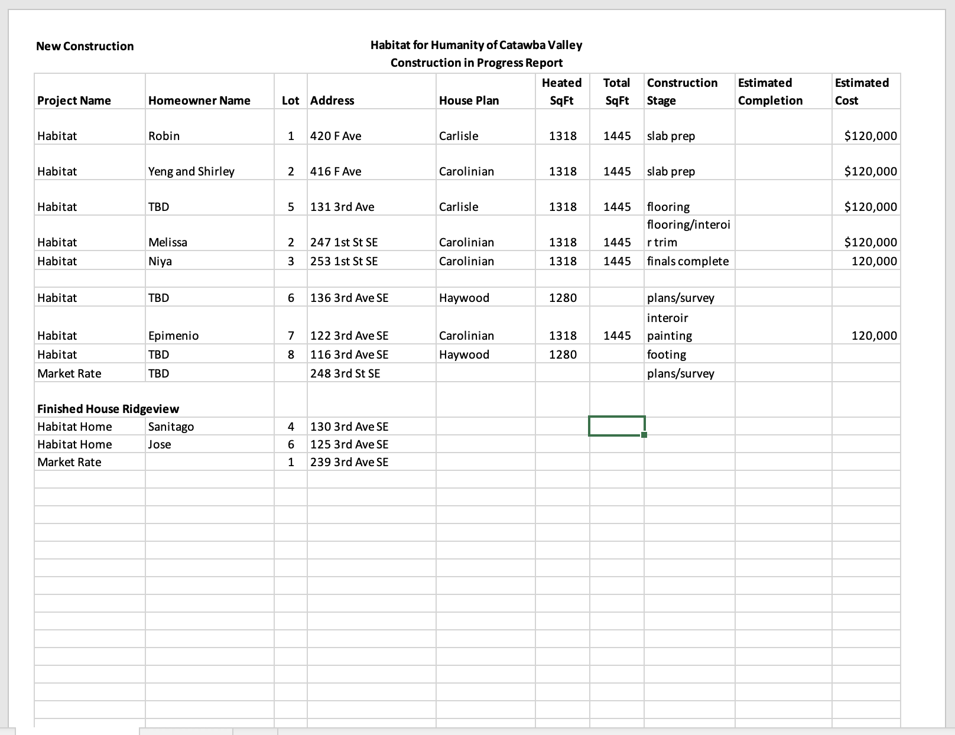

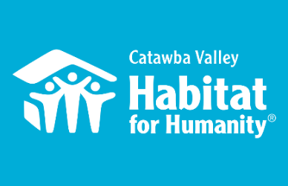
Community Outreach
Jenna Ross – August Board Report

Capacity Building
- Strategic Planning in collaboration with team members:
  - Regular planning and execution of Strategic Planning preparation meetings and reading staff and board for Planning Retreat
  - 8/11 – Homeowner Focus Group
  - 8/22 – prepared and lead presentation on key Habitat indicators for the future
  - 8/29-8/30 – supported 2-day Strategic Planning Retreat
- Digital Marketing Manager
  - Organized and conducted 6 first round Phone Interviews
  - Organized and facilitated staff evaluation process of candidates
- Assistance with new board recruitment and onboarding

Messaging & Media
- Summer Educational Mailer
  - Oversaw design process and execution on Summer Mailer
  - Mailer design and content completed, sent to printer
- Homeowner Development
  - Conducted 4 separate Ambassador Orientations with each newly accepted partner family
  - 8/20 – Partner Family Build Day: workday for all newly accepted Homebuyers to serve as orientation and ice breaker

Outreach
- NAACP Equity & Inclusion Task Force – Housing Committee Liaison
  - 8/2 – attended annual planning meeting with City Planner as part of Task Force Steering Committee
  - 8/8 – Facilitated Housing Committee meeting
  - 8/22 – Facilitated Housing Committee meeting
- LiveWell Catawba
  - 7/27 – full day Strategic Planning Board Retreat
- 8/4 – represented Habitat staff at Northstone Block Party
- 8/8 – consultation meeting with Zack King
- 8/26 – Partnership meeting: Catawba Schools

Development
- HITK
  - 8/6 am, 8/6 pm - Filming with Families
  - 8/5 – Visionary Speaker onboarding meeting
  - 8/20 – homebuyer photography, headshots, and b-roll
  - 8/25 – Filmed HITK welcome and closing remarks
- 8/11 – Stewardship recognition and Cottages tour with Woodmark
- Charted 12-month communication strategy with Development Director

Volunteers
- Volunteer Hours 8/1 – 8/31
  - 51 volunteers
  - 582.5 hours served

____________________________________________________________

Development Report
Lynn Nelson August 2022

Grant Updates
- Grants Submitted:
  - Corning Foundation
  - The Leon Levine Foundation
  - Publix Super Market Charities
  - Cleveland Cliffs
  - Catawba Valley Community Foundation
      - Grants Awarded (August-Sept. 12)
        - American Woodmark Foundation - $3,125 New Construction
        - First Horizon - $5,000 New Construction
        - TSH Charitable Foundation - $25,000 Habitat Repairs!
      - Grants In Process/Prep:
        - Sisters of Mercy
        - Millholland Endowment Fund
        - George Foundation
        - Carpenter Foundation
- Monthly planning meeting with Amy Clinton, grant writer
Communication/Donors
- HITK Pledge payment reminders
- Lapsed donor phone calls
- Thank you, calls/cards, on incoming donations as needed
HITK Event
- Update – Decision to go to LIVE in-person event.
- Table Captain Social scheduled for BOCA Sept. 17 at 5:30pm (rescheduled for 9/27)
- Continue confirming Table Captains and Sponsors
- Prep TC orientation materials
- Video in process
General
- One-on-One Development Meeting with Meg Spivey
- Monthly tracking of development planner and mail appeals
- Monthly Financial Reports
- Staff Meeting on Tuesday and Development Meeting on Wednesday

__________________________________________________________________

Homeowner Services: Selection and Homeowners-in-Progress

Report for Board of Directors August 2022
The homeownership program completed its orientation process with Habitat’s new homebuyers. This orientation reviewed many of the details of the homeownership program. New homebuyers learned how to schedule sweat equity shifts, the details of budget reporting, and specifics about their house construction. They also learned what to expect with their mortgage structure and future housing costs. One of the features of the orientation process is that new homebuyers get a chance to meet and begin their relationships with Habitat staff members. A big thanks to staff in construction, repairs, and the ReStore for taking time to meet with new homebuyers. The orientation process culminated in a ‘homebuyer only’ workday in Ridgeview. Our new homebuyers loved the opportunity to meet their future neighbors and get their feet wet on the construction site.

The homeownership program has been working with local businesses to inform their employees about Habitat and its programs. The program is participating in a wellness fair at Design Foundry this month. This fair has been set up by the HR department at Design Foundry and is intended to give Design Foundry employees the opportunity to interact with community partners. Habitat will have a booth at this fair and get the opportunity to talk with employees about the ways Habitat might possibly help them or their loved ones. The homeownership program is hoping that this targeted interaction with Design Foundry employees might lead to more quality candidates for the program.

The homeownership program has been working closely with the development department to facilitate interviews, photography, and videography with Habitat homebuyers. Habitat is working with Revival Creatives to build development materials that can be used to tell the story of our homebuyers. Our homebuyers’ interesting and important stories are being recorded. Partnerships with other organizations connected to our homebuyers are being formed. Good work is being done.

Homeowner Services: Habitat Repairs!

Report for Board of Directors August 2022
Over the past month, Habitat Repairs! has closed two projects. Currently, there are thirty-three open projects, and the construction team is expecting to finish at least two more projects during September. Staff are working to move along some projects that have been in the pipeline for a while with the hope of an application cycle in the near future.

Vetting of the Newton-Conover High School shop class is almost complete; they will become a new Habitat Partner to be able to complete ramp repairs or build ramps using funding Habitat has for the Partners Program. The benefit of the Partners Program is that Habitat is able to provide the funding for projects without having to provide the labor or use staff time; this allows Habitat and the Partners to reach more homeowners in need.

Hannah, Jenna, and Derek are scheduled in September to meet with the director and program leads for the construction programs at the Catawba County Schools to discuss the possibility of partnering. We are excited at this partnership possibility and to see the Partners Program continue to grow.

Homeowner Services: Homeowner Support

Report for Board of Directors August 2022

Delinquency Report
Reporting Period as of 9/1/2022 Total Mortgages: 88
Delinquent | # Mortgages Delinquent | Arrearage | % Delinquent
1-2 months | 8 | $ 2,428 | 9.1%
2-3 months | 0 | $ 1,038 | 0,0%
Over 3 months | 5 | $ 6,934 | 5.7%
Total this month | 13 | $ 10,400 | 14.8%
Total 8/1/22, 88 mtgs | 10 | $ 9,553 | 11.3%
Total same mo. prior yr: 9/1/21, 94 mtgs | 13 | $ 8,615 | 13.8%
Total 1/1/20, 98 mtgs pre-pandemic | 22 | $ 21,492 | 22.4%
Jun. 2013, last mo. prior to AMS, 119 mtgs | 12 |  | 10.1%

Homeowner Services News
We’ve picked up 3 new delinquencies this month in the 1-2 month category.

We have 11 homeowners who we know have applied to NCHAF for COVID related mortgage assistance funded by the American Rescue Plan. Of those 11, four have received funds, three have been accepted and should be receiving funds in the near future, and four are waiting to hear if they will be accepted.

William Pleasant has volunteered to review our newly drafted Anti-Money Laundering Policy, AML Risk Assessment, and related policies. As it turns out, William created the CommScope AML policy and procedures. We are very happy to have found a willing expert right under our noses! Thank you, William. We will be making a few changes based on William’s advice, and then sending these policies back by the Homeowner Resource Committee before bringing them to the board, hopefully in October.

We’ve received the appraisal on what will be Niya Mayfield’s new home in the Cottages at Ridgeview. It came in at $200,000. We’re in the process of submitting underwriting packages to our lending partners with a hope to close with Niya by the end of October. The process this time is complicated by Niya’s participation in the Section 8 Homeownership Program which will provide a welcome safety net for her successful homeownership.

Christina Tolley, a homeowner in our Green Park neighborhood, has found it more difficult to find a new home than expected and is newly grateful for the homeownership opportunity that Habitat has provided. She has decided that she would like to stay in her Habitat home, and HCV is withdrawing our offer to purchase her house.

Freda Wingate, who has been recovering in rehab “up north” and close to her children, has now returned to her Habitat home. Kimberly Moore, who had a stroke, has invited an aide, vetted by the Section 8 program, to share her home. Many thanks for your prayers for these folks and for all of our homeowners, home buyers, and their families.

__________________________________________________________________

Action Items:

- Board of Directors Officers’ Slate - Rodney
  - President – Rodney Garren,
VP – Tara Bland
Treasurer – William Pleasant
Secretary – Bill Burnham

- Treasurer’s Report – William
  - August Financials
  - Investment Policy

________________________________________________________________

Informational Items:
- Home is the Key: in-person! – Meg/Lynn
- Review of Strategic Plan Draft – Jenna/Meg

