Habitat for Humanity of Catawba Valley
Board of Directors’ Meeting
April 25, 2022

Devotion – Tara Bland

Adoption of Agenda — Rodney Garren

Consent Agenda:
Items are considered routine by the Board of Directors and will be enacted by one motion. There will be no separate discussion of these items unless requested by a member. The item will be removed from the Consent Agenda, then added to Action or Informational Items.

1) Minutes from March Board Meeting
2) March Financial Reports

Informational Items:
1) Staff Reports

Action Items:
1) Homeowner Selection Report – Margaret Pope
2) Habitat Repairs! Policy Modification Request – Richard Greathouse

Old Business
1) Finance Committee Members – Doug Dickson

New Business

Upcoming Events:
May 1: Whit Malone Retirement Celebration (FPC members only)
Next Board Meetings: May 23, June 27, July 25, August 22

Habitat for Humanity of Catawba Valley
Board of Directors’ Meeting

Members Present: Tara Bland, Jim Benton, Bill Burnham, Doug Dickson, Scott Echelberger, Rodney Garren, Lori Greveling, Frances Hilton, Ander Horne, Graham Hunsucker, Pat Jones, Gerry Knox, William Pleasant, Charlotte Williams
Members Not Present: Margaret Pope
Staff Present: Mitzi Gellman, Richard Greathouse, Andrew Isola, Jeff Mingus, Tina Morgan, Melissa Neal, Lynn Nelson, Hannah Yost
Welcome
There being a quorum, the March meeting of the Habitat for Humanity of Catawba Valley Board of Directors was called to order by Board President, Rodney Garren, at 12:02 pm. Due to COVID-19, a hybrid of in-person and zoom Board meeting was held.
Devotion
Tina Morgan, Director of Homeowner Services, led the devotion by sharing from Mark 2:1-13 and followed with prayer.
Adoption of Agenda
Upon a motion and second, the Board unanimously adopted the March Agenda.
Consent Agenda
The Board adopted the Consent Agenda of the February Board Meeting Minutes, the February Financial Reports, and Staff Reports by a motion and second without dissent.
Informational Items
Mitzi Gellman, Executive Director, gave a presentation on the Apex Housing Study. She discussed the following recommendations and opened the floor for discussion:
- Board to endorse a Hickory Housing Study.
- Seek partners for a housing study (local government, private and non-profit organizations, etc.).
- Contact Apex and Wake Habitat to give a presentation for our next best steps.
After discussion, it was agreed for Mitzi to schedule a meeting with Apex and Wake Habitat for a more in-depth presentation.
Next, Mitzi Gellman discussed, “now that we have money, what’s next?” Mitzi offered an outline of possibilities:
- $464,000 – Pay off Paul Thompson loan
- $500,000 – Set up Endowment/Reserve Fund
- $600,000 – Retain 5-month Operating Reserve
- $300,000 – Set up 3-5 year Brokerage CD
- $300,000 – Set up 6-10 year Brokerage CD
Mitzi Gellman also discussed the need to review/establish an investment policy and as stated in the by-laws to set up a Finance Committee. Board President, Rodney Garren, appointed Doug Dickson to serve as Chair of the Finance Committee. With his acceptance, the appointment was voted on by the Board and unanimously approved. His responsibilities would include:
- Set up a Finance Committee
- Develop an investment policy
Hannah Yost, Homeowner Services Coordinator, gave a presentation on the NewOrg Family Services Software. She stated Habitat Repairs information is currently being loaded into the software program.
Action Items
No Action Items
New Business
No New Business
Old Business
Purchase to offer Rhyne House, Habitat has a received a verbal acceptance of offer to purchase and is awaiting a written acceptance.
Adjourn
Upon motion, second, and unanimous approval, President Rodney Garren adjourned the meeting at 1:07 pm. The next Board meeting will be held on Monday, April 25th, 2022.

______________________________________________________________________________

2) March Financial Reports (Separate Attachment) – Doug Dickson

Informational Items:

1) Staff Reports

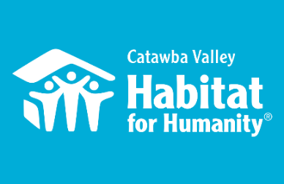
Community Outreach
Jenna Ross – April Board Report

Capacity Building
- Hiring:
  - Development Director: hiring timeline, job description, online application, position advertising, prep interview questions, serve as lead contact for Funding for Good’s support in this process
  - 3/21 - initial interview with candidate
- Recruiting and onboarding new vendors to fill FMC support with marketing needs:
  - Blu Design Shop: webhosting, web design, graphic design, email marketing
  - Salem One: print, direct mail design and layout, mail house
  - Video: in process
- HFHI Trainings at Camp Habitat:
  - 3/1 – full day diversity, equity, and inclusion training
  - 3/10 – half day Land Trust training
  - 3/10 – half day meeting with Mitch Rhodes, incoming director of Habitat NC
- Strategic Planning: selecting consultants, preparing timeline and planning process
- Major Gift Support: behind the scenes support preparing for announcement of MacKenzie Scott major gift

Messaging & Media
- Scott Gift Announcement:
  - 3/16 – training meeting with HFHI on coordinated announcement
  - Created website announcement landing page: https://habitatcatawbavalley.org/news/habitat-catawba-valley-receives-transformational-2-5m-gift-from-mackenzie-scott/
  - Created email announcement for Affiliate & ReStore Lists
  - Created social media posts and stories for facebook and Instagram
  - Collaborated on joint press release with Habitat Charlotte & Habitat York
  - 3/22 - Helped plan and execute announcement event

- Fundraiser for Ukrainian Refugees – 3/15 – 3/22
  - Designed graphics
  - Created fundraiser social media posts and stories on facebook and Instagram
  - Created fundraiser email for ReStore and Affiliate lists
  - Redesigned total raised graphics
  - Created total raised social media posts and stories on facebook and Instagram
  - Created total raised email for ReStore and Affiliate Lists
- HITK
  - 3/16 – meeting with Development and Homeowner Services to vet 2022 Spotlight Family

Outreach
- NAACP Equity & Inclusion Task Force – Housing Committee Liaison
  - 3/7 – led Housing Committee Meeting
  - 3/21 – led Housing Committee Meeting
  - 3/31 – Task Force Executive Committee Meeting
Catawba Valley Housing Fair – Lead Planner
      - 3/4 – tour of Ridgeview Rec Center + follow up planning meeting
      - 3/11 – led Housing Fair planning meeting
      - 3/31 – Housing Fair check-in
      - Coordinated behind the scenes infrastructure for Fiduciary Agent, online registration, and paypal integration
      - Collaborated to provide content and design for Exhibitor Recruitment Landing Pages: https://hickorynaacp.org/fair-exhibitor-landing
      - Created Exhibitor Recruitment Flyer
      - Created Exhibitor Recruitment Postcard
      - Exhibitor Recruitment scheduled to launch 4/5
- Catawba County Juneteenth Celebration – Planning Committee
  - 3/9 – attended planning meeting; Habitat collaborating on 6/11 Housing Fair
- LiveWell Catawba
  - 3/9 - Executive Committee Meeting
  - 3/11 – Public Health Discussion
  - 3/15 – Board Meeting

Development
- Spring Appeal – Created content for the Spring appeal “Something to Build on”
  - Wrote 8 custom versions of the appeal letter
  - Created 3 versions of the reply card
  - Scheduled photographer and attended photo shoot in support of partner family
- Funding for Good: continuous coordination of hiring process, strategic planning, and vendor replacement support
- 3/16 – client onboarding meeting with Jon Bowman of Salem One Printing
- 3/17 - attended presentation by NC Community Foundation along with key HFHCV stakeholders

Volunteers
- Villanova Collegiate Challenge: Feb 26 – March 5th
  - Collaborated with FUMCH as the host Church
  - 8 volunteers: 7 students + 1 adult advisor
  - Service: 8:00 – 4:00, M-F in New Construction + Repairs
  - Tour of Habitat Neighborhoods: 2/28
  - Habitat Cookout: 3/1, hosted by the Greathouse’s
  - ReStore Tour: 3/2
  - Community Luncheon: 3/3 at the Sails with board, homeowners, and staff
  - Community Dinner: 3/3 hosted by Troy Howard of FUMCH
  - Cultural Immersion: 3/4 Wiseman’s View excursion
- Volunteer Hours 3/1 – 3/31:
  - 68 volunteers
  - 774 hours served
    - Villanova Collegiate Challenge: 8 members

___________________________________________________________________

Development Report
April 2022
Lynn Nelson

Grant Updates
- Grants Submitted:
        - Walmart
        - Corning
        - TSH Foundation
        - Unifour Foundation
- Grants In Process/Prep:
  - United Way
        - Michael Peeler/Virginia Casey Funds
        - Underdown Family Foundation
        - Kulynych Family Foundation I
        - The Bolick Foundation
        - Philip Van Every Foundation
        - Wells Fargo Foundation
- Monthly planning meeting with Amy Clinton, grant writer
Communication/Donors
- Easter postcards and greeting cards finalized and mailed
- HITK Sponsorship Request Letters finalized and mailed, follow-up calls in process
- Spring Appeal Letter finalized sent to Salem One for design
- Spring Appeal mail lists finalized
- HITK Pledge payment reminders
- Lapsed donor phone calls
- Thank you calls/cards on incoming donations as needed
General
- Monthly tracking of development planner and mail appeals
- Staff Meeting on Tuesday and Development Meeting on Wednesday

_____________________________________________________________

Habitat “New Construction” Report
Derek Ross April 2022

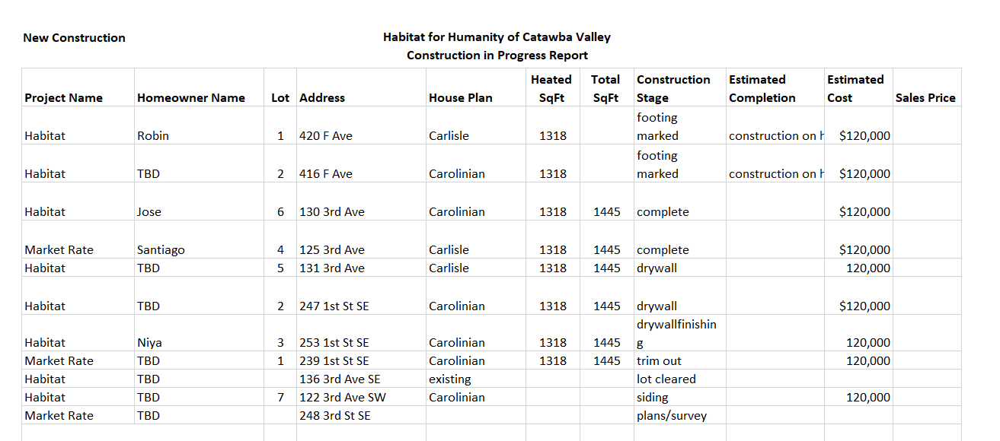
___________________________________________________________________

HABITAT REPAIRS! Construction
Board Report April 2022
Richard Greathouse

The February repair of the month features David Clark who lives in a 56 year old house at 11 North Ervin Ave. in Newton. David is on disability. We are doing the following repairs
- Tear off and replace roof shingles.
- Repair gutters and install leaf guards.
- Repair and paint exterior trim.
- Weatherization.
- Install new HVAC. (Currently not working.)
- Repair rear exit stairs.

Half of the HVAC and weatherization cost funded from the grant from Piedmont Natural Gas.

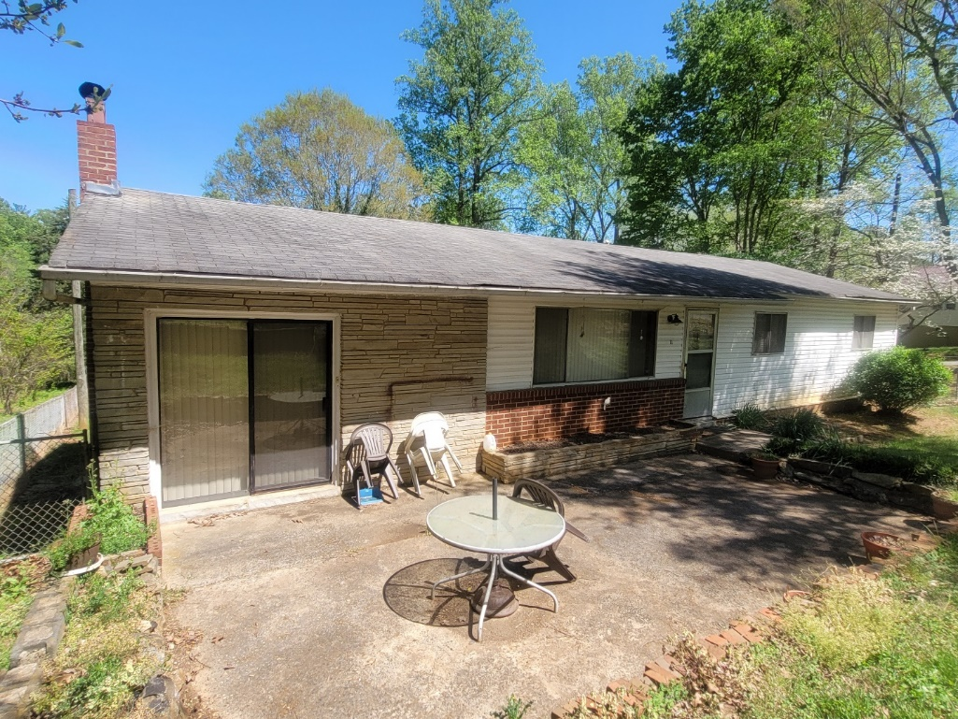
Front of house
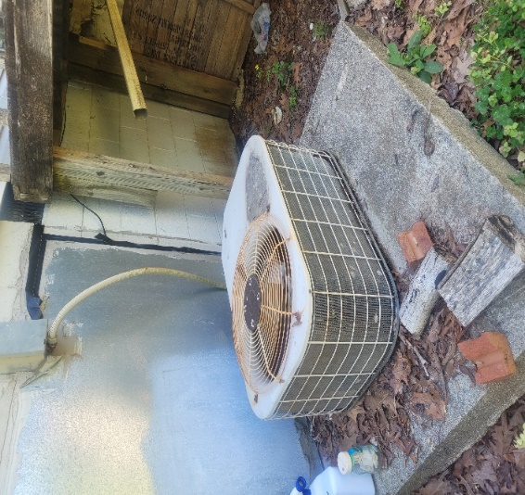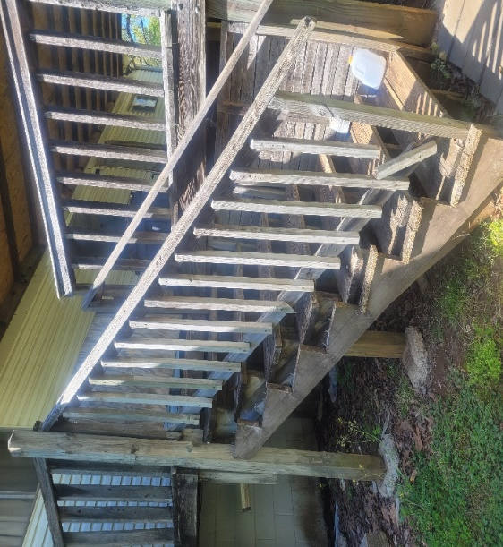
Thirty-something compressor Unsafe rear Exit

Current Home Repair Status:

- Jobs completed March 2
- Jobs in progress 26
- Jobs pending approval 8
- Habitat Partners Completions 1

___________________________________________________________________

Homeowner Services: Selection and Homeowners-in-Progress
Report for Board of Directors April 2022

Having completed ability to pay screenings for the current applications, the Homeownership Program has moved to the next phase of the process. There are 9 applicants who are still being considered by the committee out of the 77 who applied in this selection round. The Homeowner Selection Committee is asking these applicants to submit additional financial information and documentation supporting their current expenses. The committee will also be obtaining landlord references, employer references, verifications of employment, and background checks on these applicants. The selection committee will compile all of this information for further consideration of the 9 applicants.

The Homeownership Program finished its Financial Management education course with its homebuyers in progress. The course finished with an overview of the banking and credit systems in the U.S. Our homebuyers have all expressed their appreciation for the information taught in these courses. One homebuyer told the class about their recent car repair emergency. Using some of the things learned in this course, the homebuyer already had emergency fund money saved and was able to pay for the repair without issue. The homebuyer said, “Paying for the repair was the first time in my life I was able tell the mechanic, go ahead and fix my car, I’ve got the money to pay for it. I didn’t have to borrow money from anyone. I could just pay to fix my car. It was a wonderful feeling.”

The Homeownership Program is beginning work with NewOrg (our database system) on the homeownership side of the database. We are excited for the possibilities this database will offer us. The work required to implement this section of the database has been aided by an intern from Lenoir-Rhyne who has been working with Homeowner Services for the Spring 2022 semester. The implementation process with NewOrg will continue for another few weeks but the process of bringing the database up to full functionality will take at least an additional 6 months.

Homeowner Services: Habitat Repairs!
Report for Board of Directors April 2022

The most recent round of applications for Habitat Repairs! has finished with two more applications denied due to failure to complete the applications, and two more homeowners accepted to the program. This brings the total numbers for this selection round to five applications denied, four awaiting site visits, and eight applications accepted thus far.

Richard is doing the remaining site visits and getting Scopes of Work done on the eight newly accepted homeowners. Tina is supporting the process by communicating with homeowners, getting out denial and acceptance letters, creating contracts, and reviewing those contracts with homeowners.

Homeowner Services: Homeowner Support
Report for Board of Directors April 2022
Delinquency Report
Reporting Period as of 4/1/2022 Total Mortgages: 89
Delinquent | # Mortgages Delinquent | Arrearage | % Delinquent
1-2 months | 4 | $ 2,148 | 4.5%
2-3 months | 4 | $ 1,473 | 4.5%
Over 3 months | 4 | $ 5,542 | 4.5%
Total this month | 12 | $ 9,073 | 13.5%
Total 3/1/22, 89 mtgs | 13 | $ 10,189 | 14.5%
Total same mo. prior yr: 4/1/21, 96 mtgs | 12 | $ 12,225 | 12.6%
Total 1/1/20, 98 mtgs pre-pandemic | 22 | $ 21,492 | 22.4%
Jun. 2013, last mo. prior to AMS, 119 mtgs | 12 |  | 10.1%

Homeowner Services News
Delinquencies are down by one loan in this month. They continue to be much lower than pre-pandemic, but we have not seen as much improvement with tax return season as usual. We have had one homeowner who has received COVID mortgage assistance funding from NC HAF; we expect several more to hear from their applications to this program soon.

Epimenio Mendoza, a homebuyer who was accepted in September of last year, has completed his first set of partnership requirements and picked the lot that he would like to have for his family and himself in Ridgeview. His home will be beside Jose and Lidia, at 122 3rd Avenue SE, in Hickory.

Having finished the first set of Homeowner-in-Progress classes that focus on financial management, we will begin the week following Easter with our second set of classes focusing on topics that support successful homeownership. These classes include maintenance and landscaping, savings and equity, covenants and neighbor relations, wills, life insurance, homeowners’ insurance, homeownership documents, closings, and avoidance of delinquencies.

Christina Tolley, one of our Green Park homeowners, has taken a job that is a long commute from Hickory and is considering selling her home.

The Homeowner Resource Committee will be meeting this month to monitor delinquencies, consider homeowner requests, and review the latest draft of our evolving policies and documents addressing Bank Secrecy Act requirements for anti-money laundering activities.

Mee Thao and her family are continuing to work with their homeowners’ insurance company with regard to the fire at their house on January 30th. The demo work has been done, and an engineer was due out this week to rule on whether or not the foundation of the home is still sound. Many thanks to Jim Benton and his son, Joshua, for their help and support with this continuing process.

Anissa Comb’s Estate completed the sale of her home in Blue Sky Acres; Habitat Catawba Valley has received the payoff of her loans.

As always, your prayers for our homeowners and their families is greatly appreciated.

________________________________________________________________

The ReStore Report
April 2022
Jeff Mingus, General Manager

Donations and Sales – Sales $117,565.44 Round Up Change $380.41 Transactions 2886 Avg. Sale $40.31
- Bunny Williams Home was the highlight of March sales. We received excellent feedback from the donor and look forward to receiving more donations in the future.
- Repeat scheduled donor pickups Vanguard Furniture (4), Glaze Construction (3), Good’s Home Furnishings (2), Home Depot (2), Stage Organizing (2), Designers Judi Armstrong and Rhonda Hull (2)
- MaxLite and GreenLite, Duke Energy Programs – Feb Sales $2470.00 / 1602 pieces
The ReStore model is simple. More donations equal more sales, do you have corporate / business / retail connections? Please help us grow the ReStore by sharing contacts and even making introductions. Word of mouth and personal touches are always best. Thanks.
Volunteer Needs – We are rebuilding our volunteer base! With a full staff, Kristi can now concentrate more time on recruitment, training, and retention. If you are part of a social, civic, or business group with members longing to stretch themselves a bit after the last two years contact the ReStore and we will reach out.
- Cashier: Tuesday AM/PM, Thursday PM, Saturday AM/PM
- Fabric: Our lead, Teresa, is leaving soon. Open time slots all week.
- Greeter: Saturday AM/PM
- Receiving/Pricing: Tuesday AM
- Custodian (General Cleaning/Store maintenance): Friday AM/PM
- Warehouse Receiving/Cleaning: Opportunities open throughout the week, ask for details.
- Online Store (Posting/Inventory) Weekly opportunities open
- Merchandising: All areas Hardware, construction, housewares, and furniture constantly need straightening and display attention, ask for details.
https://habitatcatawbavalley.org/restore/volunteer/ We have volunteer opportunities open throughout the week. Any “regular” volunteers, individuals who comply with our covid safe protocols and can commit to a regular schedule of a few hours each week, are welcome.
Shop Online – The ReStore online is growing. It is still a small part of overall sales but people are checking it out regularly. www.shopcatawbarestore.org An easy, safe and comfortable shop from home experience. Browse and add items to your cart then pay online. You will get an email notification when the transaction is complete and ready for pickup. Simply pull around to the warehouse loading area. Show your purchase notification and we will help you from there. Make sure you bring help for loading and the appropriate size vehicle… armoires do not fit inside small cars and loveseats should not ride on rooftops.

Open to the Public Tuesday through Saturday 10am to 5pm. Mondays are workdays for volunteers and staff. Donation Drop offs Monday through Saturday 10am to 4pm Free Donation Pick Ups Tuesday through Saturday Call 828-327-7467 or go online https://habitatcatawbavalley.org/restore/donate/ to schedule.

__________________________________________________________________

Action Items:

1) Homeowner Selection Report – Margaret Pope

Action Item 1: The following individuals were presented to the Homeowner Selection Committee as applicants for the homebuyer program. These individuals were recommended for denial based on their failure to complete the application or to meet the ability to pay guidelines presented in the Homeowner Selection Policy. The HSC has voted to deny these individuals for ability to pay and recommends this decision to the Board. Per HFHI recommendation, names are not included in the information to the board to lessen the appearance of biased decision making.

Feb 2022 Ability to Pay Screening
Applicant Name | Household Size with Number of Adults/Children | Income as a % of AMI | Reason for Denial
Applicant #1 | 2 (1/1) | 21% | AMI lower than selection guidelines
Applicant #2 | 2 (2 adults) | 23% | AMI lower than selection guidelines
Applicant #3 | 5 (1/4) | - | Needs 12 months of steady employment
Applicant #4 | 1 | 12% | AMI lower than selection guidelines
Applicant #5 | 1 | 24% | AMI lower than selection guidelines
Applicant #6 | 1 | - | Application submitted after deadline
Applicant #7 | 1 | 24% | AMI lower than selection guidelines
Applicant #8 | 1 | 93% | AMI higher than selection guidelines
Applicant #9 | 1 | 98% | AMI higher than selection guidelines
Applicant #10 | 3 (1/2) | 66% | Applicant lives and works outside service area
Applicant #11 | 7 (1/6) | 15% | AMI lower than selection guidelines
Applicant #12 | 2 (2 adults) | - | Applicant lives and works outside service area
Applicant #13 | 3 (3 adults) | 0% | AMI lower than selection guidelines
Applicant #14 | 1 | 37% | AMI lower than selection guidelines
Applicant #15 | 1 | 34% | AMI lower than selection guidelines
Applicant #16 | 4 (2/2) | 70% | Needs 12 months of steady employment
Applicant #17 | 4 (1/3) | 98% | AMI higher than selection guidelines
Applicant #18 | 4 (1/3) | 16% | AMI lower than selection guidelines
Applicant #19 | 3 (1/2) | 80% | AMI higher than selection guidelines
Applicant #20 | 3 (1/2) | - | Has not worked current job long enough to earn 3 paystubs, unable to calculate current AMI
Applicant #21 | 2 (1/1) | 91% | AMI higher than selection guidelines
Applicant #22 | 2 (1/1) | 107% | AMI higher than selection guidelines
Applicant #23 | 2 (1/1) | 86% | AMI higher than selection guidelines
Applicant #24 | 3 (1/2) | - | Needs 12 months of steady employment
Applicant #25 | 4 (1/4) | 87% | AMI higher than selection guidelines
Applicant #26 | 3 (1/2) | 27% | AMI lower than selection guidelines
Applicant #27 | 3 (1/2) | 84% | AMI higher than selection guidelines
Applicant #28 | 8 (1/7) | 14% | AMI lower than selection guidelines
Applicant #29 | 3 (1/2) | - | Applicant lives and works outside service area
Applicant #30 | 4 (2/2) | 86% | AMI higher than selection guidelines
Applicant #31 | 5 (3/2) | 155% | Household AMI higher than selection guidelines
Applicant #32 | 2 (2 adults) | - | Incomplete application
Applicant #33 | 1 | - | Incomplete application
Applicant #34 | 4 (1/3) | - | Needs 12 months of steady employment
Applicant #35 | 1 | 31% | AMI lower than selection guidelines
Applicant #36 | 4 (2/2) | 22% | AMI lower than selection guidelines
Applicant #37 | 3 (1/2) | 80% | AMI higher than selection guidelines
Applicant #38 | 2 (2 adults) | 61% | Debt to Income ratio of 81%
Applicant #39 | 1 | 77% | AMI higher than selection guidelines
Applicant #40 | 3 (1/2) | 54% | Debt to Income ratio of 53%
Applicant #41 | 3 (1/2) | 60% | Debt to Income ratio of 41%
Applicant #42 | 3 (1/2) | 50% | Collections / Charge-offs = $1,975
Applicant #43 | 5 (2/3) | 39% | Debt to Income ratio of 45%
Applicant #44 | 6 (1/5) | 41% | Debt to Income ratio of 46%
Applicant #45 | 2 (1/1) | 27% | AMI lower than selection guidelines, Collections / Charge-offs = $4,479
Applicant #46 | 1 | 51% | Applicant currently owns a home
Applicant #47 | 1 | 70% | Debt to Income ratio of 43%
Applicant #48 | 1 | 52% | Debt to Income ratio of 50%
Applicant #49 | 4 (1/3) | 41% | Debt to Income ratio of 74%
Applicant #50 | 4 (2/2) | 77% | Collections / Charge-offs = $4,372
Applicant #51 | 3 (1/2) | 37% | Collections / Charge-offs = $715
Applicant #52 | 3 (1/2) | 57% | Debt to Income ratio of 42%
Applicant #53 | 7 (1/6) | 40% | Debt to Income ratio of 63%
Applicant #54 | 3 (1/2) | - | Incomplete application
Applicant #55 | 3 (1/2) | 38% | Debt to Income ratio of 52%
Applicant #56 | 3 (1/2) | 73% | Collections / Charge-offs = $515
Applicant #57 | 7 (2/5) | 72% | Debt to Income ratio of 48%
Applicant #58 | 1 | 24% | AMI lower than selection guidelines
Applicant #59 | 4 (1/3) | 14% | AMI lower than selection guidelines
Applicant #60 | 7 (1/6) | - | Incomplete application
Applicant #61 | 2 (1/1) | - | Incomplete application
Applicant #62 | 3 (3 adults) | 35% | AMI lower than selection guidelines
Applicant #63 | 2 (2 adults) | 39% | Student Loans in collections (DLA 7/15) = $2,062
Applicant #64 | 2 (2 adults) | 49% | Collections / Charge-offs =$3,964
Applicant #65 | 4 (1/3) | 8% | AMI lower than selection guidelines
Applicant #66 | 3 (1/2) | 35% | AMI lower than selection guidelines
Applicant #67 | 7 (5/2) | 17% | AMI lower than selection guidelines
Applicant #68 | 5 (1/4) | 23% | AMI lower than selection guidelines

Please be aware that the above information is of a confidential nature and handle it accordingly.

2) Habitat Repairs! Policy Modification – Richard Greathouse/Tina Morgan

Habitat for Humanity
of
Catawba Valley
--------
Habitat Repairs! Policy

PRIORITIES AND POLICY STATEMENTS

Priorities and Commitments

Habitat for Humanity of Catawba Valley (HFHCV) Habitat Repairs! will serve homeowners whose income falls at or below 75% of the AMI, who are willing to partner with HFHCV, and who have a need for help accessing repairs. Priority is given to the critical nature of required repairs, to severity of applicant’s financial need, to the elderly, the disabled, single parent families, and households with at least one minor child. The program is particularly designed to serve those homeowners who are most in need and who are unable to access services elsewhere.

HFHCV’s Habitat Repairs! has a responsibility to the community to preserve housing and neighborhoods. It also has a responsibility to the donors and other funding sources to find the best use of available funds.

Referrals, Project Cost, and Board Authority

When a completed application is received, all information will be processed and verified by the homeowner services staff. Staff will review the property record to confirm ownership, location, building value, and status of any loans on the property. Referrals to other repair programs will be made as they are appropriate.

After the homeowner services staff confirms that the property and homeowner criteria are met, the construction staff will do an inspection of the house to determine the scope and cost of the repair project. The usual maximum project cost will be $9,000 Habitat out-of-pocket costs and/or $20,000 total costs. With special approval, project costs may go above that amount only when it is required to keep the occupants of the home dry, safe, and warm. If the project meets program funding requirements, then staff will prepare a home repair contract that details the scope of work, the homeowner price and payment arrangements, and the sweat equity requirements. After the contract is signed, the repair work will be done. The project will be considered complete upon signed Certificate of Completion. A limited, one year warranty will be provided.

The number of houses to be repaired each fiscal year will be based on the affiliate budget and types of available restricted funding. The Board authorizes the homeowner services staff to process and conduct due diligence for all applications, to decline all applicants who do not meet the policy criteria, and to accept applicants who do meet the policy criteria.

__________________________________________________________________

Old Business:

1) Finance Committee – Doug Dickson

New Business:

Upcoming Events:

May 1: Whit Malone Retirement Celebration (FPC members only)
Next Board Meetings: May 23, June 27, July 25, August 22

