Habitat for Humanity of Catawba Valley
Board of Directors’ Meeting
March 28, 2022

Devotion

Adoption of Agenda — Rodney Garren

Consent Agenda:
Items are considered routine by the Board of Directors and will be enacted by one motion. There will be no separate discussion of these items unless requested by a member. The item will be removed from the Consent Agenda, then added to Action or Informational Items.

1) Minutes from February Board Meeting
2) February Financial Reports
3) Staff Reports

Informational Items:
1) Review of Apex Housing Study – Mitzi
2) Now that we have money, what’s next? - Mitzi
3) NewOrg Family Services Software – Tina & Andrew

Action Items:
No action items for this month

New Business

Old Business

Upcoming Events:

Next Board Meetings: April 25, May 23, June 27

Habitat for Humanity of Catawba Valley
Board of Directors’ Meeting
February 28th, 2022

Members Present: Tara Bland, Jim Benton, Bill Burnham, Doug Dickson, Scott Echelberger, Rodney Garren, Lori Greveling, Frances Hilton, Ander Horne, Pat Jones, Gerry Knox, William Pleasant, Charlotte Williams
Members Not Present: Graham Hunsucker, Margaret Pope
Staff Present: Mitzi Gellman, Richard Greathouse, Andrew Isola, Jeff Mingus, Tina Morgan, Melissa Neal, Lynn Nelson, Derek Ross, Jenna Ross, Hannah Yost
Welcome
There being a quorum, the February meeting of the Habitat for Humanity of Catawba Valley Board of Directors was called to order by Board President, Rodney Garren, at 12:00 pm. Due to COVID-19, a hybrid of in-person and zoom Board meeting was held.
Devotion
Bill Burnham, Board Member, led the devotion by sharing from Proverbs 17:22 and followed with a prayer.
Adoption of Agenda
Upon a motion and second, the Board unanimously adopted the February Agenda.
Consent Agenda
The Board adopted the Consent Agenda of the January Board Meeting Minutes, the January Financial Reports, and Staff Reports by a motion and second without dissent.
Informational Items
Mitzi Gellman, Executive Director, discussed the current NC Legislation and mobile homes located adjacent to Habitat properties. (G.S. 160D910 confirms the caselaw rule that local governments may not exclude manufactured homes based solely on the age of the home (Five C’s, Inc. v. Pasquotank County, 1 95 N.C. App. 401, 672 S.E.2d 737 (2009)). She met with Senator Dean Proctor and gave him a tour of our current properties and the mobile homes. Mitzi stated the mobile homes are 30+ years old, in disrepair, and have a negative impact on Habitat’s property value. Ideally, Habitat would like to connect with the City of Hickory to change this ordinance. Charlotte Williams, Board Member, will discuss with Hickory City Council and city staff.
Mitzi Gellman reported that the contracted advertising company, Full Metal Chicken, ended their contract with Habitat effective February 10, 2022. After discussions, FMC has agreed to complete a selected jobs through early March. Habitat is currently in process of identify a temporary graphic company and looking for a replacement agency.
Action Items
Lynn Nelson, Development Assistant, presented to the Board a request to apply to the Michael Peeler/Virginia Casey Funds for Habitat Repairs! in the amount of $6,500.00. Upon a motion and second, the request to apply was unanimously approved.
Mitzi Gellman, Executive Director, presented the following capacity bui-lding for staff additions:
- Development Director – Job description was provided along with Board discussion.
- Digital Marketing Manager – Job description was provided along with Board discussion.
- Assistant Director/Strategic Development – Mitzi is currently working on this job description.
Upon a motion and second, the Board unanimously gave approval to seek qualified candidates for both the Development Director and Digital Marketing Manager positions.
The staff was dismissed and the Board went into closed session.
Adjourn
Upon motion, second, and unanimous approval, President Rodney Garren adjourned the meeting at 1:05 pm. The next Board meeting will be held on Monday, March 28th, 2022.

______________________________________________________________________________

2) February Financial Reports (Separate Attachment) – Doug Dickson

______________________________________________________________________________

3) Staff Reports
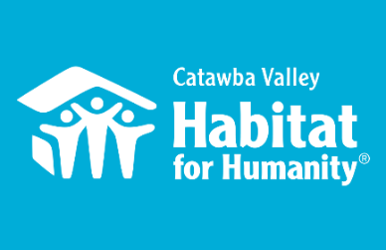
Community Outreach
Jenna Ross - March Board Report

Capacity Building
- Hiring:
  - Development Director: hiring timeline, job description, online application, position advertising, prep interview questions, serve as lead contact for Funding for Good’s support in this process
  - Digital Marketing Manager: researching marketing and communications
- Recruiting and onboarding new vendors to fill FMC support with marketing needs:
  - Blu Design Shop: webhosting, web design, graphic design, email marketing
  - Salem One: print, direct mail design and layout, mail house
  - Video: in process
- HFHI Trainings at Camp Habitat:
  - 2/22 – full day advocacy intensive
- Strategic Planning: assessing consultant and facilitation options, developing process, exploring timeline
- Major Gift Support: behind the scenes support preparing for major anonymous gift

Messaging & Media
- 2/1 – “My Habitat Story” interview with Sean and Michelle as part of new partner family story library, and in preparation for the Spring Appeal
- 2/23 – meeting with videographer to discuss how best to transition HITK process

Outreach
- NAACP Equity & Inclusion Task Force – Housing Committee Liaison
  - 2/7 – led Housing Committee Meeting
  - 2/21 – led Housing Committee Meeting
  - 2/24 – Task Force Executive Committee Meeting
Catawba Valley Housing Fair – Lead Planner
      - 2/1 – led planning meeting
      - 2/15 – led planning meeting
      - 2/25 – led planning meeting
- Catawba County Juneteenth Celebration – Planning Committee
  - 2/1 – attended planning meeting; Habitat collaborating on 6/11 Housing Fair
  - 2/23 – attended planning meeting; “ “
- LiveWell Catawba
  - 2/9 - Executive Committee Meeting
  - 2/15 – Board Meeting
  - 1/24 – branding subcommittee meeting
- Leadership Catawba
  - 1/12 – served as Project Advisor for a Leadership Catawba Project team, coaching them on the creation of a community-wide online volunteer portal
- 2/15 - Joined Ascension’s Outreach Committee meeting to discuss NAACP Housing Committee and Habitat’s willingness to partner on creative housing solutions for our community
- 2/20 – represented Habitat staff at annual MLK Legacy Celebration and Service where Habitat received Spirit of King Award; board member Margaret Pope received the award on behalf of Habitat

Development
- Funding for Good: continuous coordination of hiring process, strategic planning, and vendor replacement support
- Easter Postcard: created content and directed design of Easter Postcard
- attended team meeting to represent future growth of development needs in relation to the repairs program

Volunteers
- Villanova Collegiate Challenge Preparations
  - Worked with Villanova staff Campus Minister to plan administrative, logistical, and liability aspects of the trip
  - Ongoing coordination with FUMCH in its role as host site for the group
  - Ongoing planning with student leaders and adult advisors to provide orientation, training, waivers, goals, educational, and schedule support prior to group’s arrival
  - Coordination with construction, repair, and ReStore staff in preparation of weeklong worksites for the group
  - Feb 26th – March 5th: 7 students + 1 adult advisor arrive in Hickory for Justice Experience
- Volunteer Hours 2/1 – 2/28:
  - 52 volunteers
  - 745 hours served
    - Villanova Collegiate Challenge: 8 members

___________________________________________________________________

Development Report
March 2022
Lynn Nelson

Grant Updates
- Grants In Process/Prep:
        - Walmart
        - United Way
        - Corning
        - Michael Peeler/Virginia Casey Funds
        - TSH Foundation
        - Cannon Foundation
        - O. Leonard Moretz Foundation
- Grants Awarded:
  - Publix Super Market Charities - $6,500 New Construction
  - Saint Gobain Corporation Foundation - $5,000 Habitat Repairs!
- Monthly planning meeting with Amy Clinton, grant writer
Communication/Donors
- Create and prep Easter postcards and greeting cards
- Finalized 2022 Basic Thank You Letter
- Prep HITK Sponsorship List
- Draft Spring Appeal Letter
- HITK Pledge payment reminders
- Lapsed donor phone calls
- Thank you calls/cards on incoming donations as needed
General
- Met with Jim Benton to discuss 2022 HITK Sponsors
- Phone meeting with Jon/Salem One Printing
- Phone meeting with David Kennedy/e-Tapestry (Renewal/discussion on options)
- Monthly tracking of development planner and mail appeals
- Staff Meeting on Tuesday and Development Meeting on Wednesday
Training/Webinar
- Camp Habitat Online – Advocacy Intensive, February 22
- US Chamber of Commerce Foundation – The Role of Employers, Endemic COVID, February 23

_____________________________________________________________

Habitat “New Construction” Report
Derek Ross March 2022

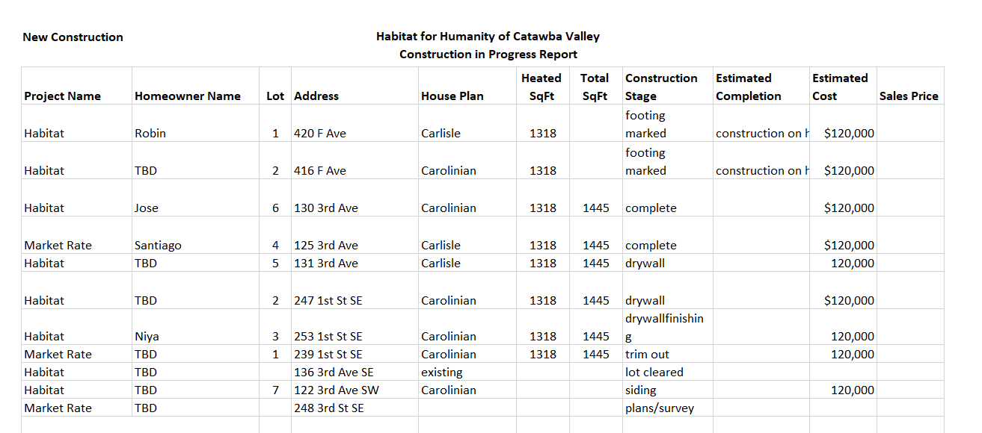
___________________________________________________________________

HABITAT REPAIRS! Construction
Board Report February 2022
Richard Greathouse

The February repair of the month features Michael and Wendy Gaffney whose home is located at 6717 Little Mountain Road in Sherrills Ford. Michael and Wendy who live in a double wide house are both on disability which is their sole source of income. We are doing the following repairs
- Service heat pump and repair and clean existing ductwork that has fallen.
- Repair floor insulation.
- Repair electrical panel.
- Tear out existing deck, replace with a smaller deck, and install safe rear exit.
- De-clutter yard.

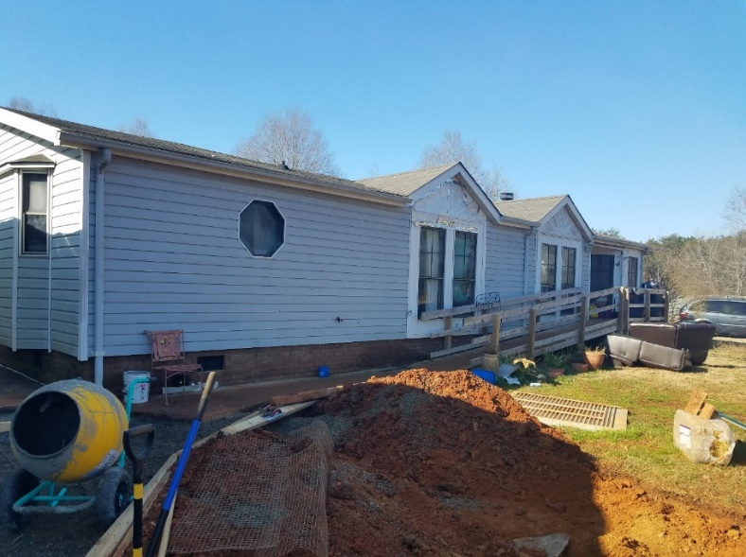

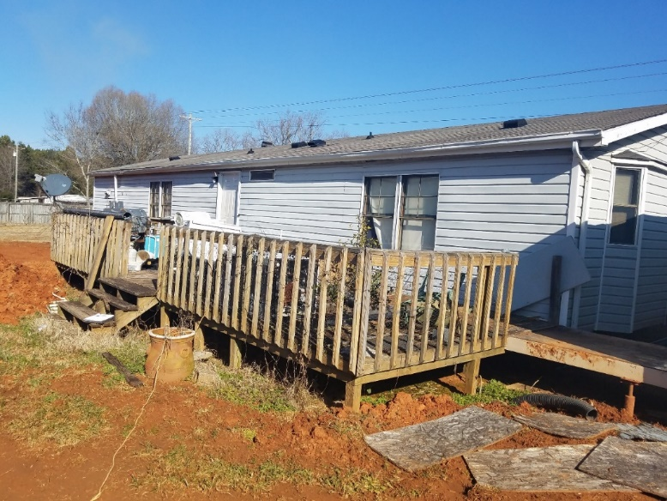

Current Repair Status
- Jobs completed January 2
- Jobs in progress 24
- Jobs pending approval 7
- Habitat Partners Completions 2
Homeowner Services: Selection and Homeowners-in-Progress
Report for Board of Directors March 2022

The Homeownership Program held an open application period from February 7th to February 18th with applications being due by February 25th. The open application period was very active. 112 applications were distributed in person, by mail, and by email; roughly twice the number that is normally distributed! The application page on the Habitat website had 170 unique visits during this period. 77 applications were submitted to the program for consideration; roughly twice the number that is usually received! The selection committee will now begin the process of reviewing these applications. The committee is excited for the possibilities that this new application period brings!

After confirming that income requirements are met, further consideration of applications includes a review of applicants’ creditworthiness. As part of the application process, applicants give Habitat permission to pull a tri-merge credit report. The selection committee then reviews an applicant’s credit history to determine if the applicant shows the current and future ability to pay on a Habitat mortgage. Calculations are done to determine an applicant’s debt to income ratio and the impact any derogatory debt might have on the applicant. This process is very similar to the process any conventional lender would undertake when evaluating an applicant’s mortgage readiness.

The Homeownership Program began homebuyer education classes this past month with the homeowners-in-progress. The education classes start with a general financial management curriculum. This curriculum teaches things like budgeting, saving, and paying off debt. After the financial management curriculum is completed, homebuyers take a homeowner education curriculum. This curriculum teaches things like purchasing homeowners’ insurance, home maintenance, the importance of having a will, neighbor relations, and what to expect at closing.

Homeowner Services: Habitat Repairs!
Report for Board of Directors February 2022

Habitat Repairs! recently closed an application round. Anyone who inquired during the year 2021 was invited to apply. 17 applications were received. Of those 17 applications, three have been denied - two were denied due to income that is above program requirements and the other was denied because the property is outside of Catawba County. Four of the applications are still being assessed, and the remaining 10 have been passed on to construction staff for site visits.

Once site visits have been completed, applications are either accepted into the program or denied based on the repairs needed. After acceptance, a Scope of Work is created, and a contract is completed. The goal is to have as many of these projects as possible under contract before Hannah goes on maternity leave so that the construction staff will have plenty of projects in the pipeline until Hannah returns.

Homeowner Services: Homeowner Support
Report for Board of Directors February 2022

Delinquency Report

Reporting Period as of 3/1/2022 Total Mortgages: 89

Delinquent | # Mortgages Delinquent | Arrearage | % Delinquent
1-2 months | 6 | $ 2,266 | 6.7%
2-3 months | 2 | $ 1,170 | 2.2%
Over 3 months | 5 | $ 6,753 | 5.6%
Total this month | 13 | $ 10,189 | 14.5%
Total 2/1/22, 89 mtgs | 12 | $ 9,697 | 13.4%
Total same mo. prior yr: 3/1/21, 96 mtgs | 13 | $ 12,322 | 13.5%
Total 1/1/20, 98 mtgs pre-pandemic | 22 | $ 21,492 | 22.4%
Jun. 2013, last mo. prior to AMS, 119 mtgs | 12 |  | 10.1%

Homeowner Services News
Delinquencies are up (again) by one loan in the one-to-two-month (owes for both March and February) range. They continue to be much lower than pre-pandemic and are expected to improve more with tax return season. In addition, we have several homeowners who have applied for COVID mortgage assistance funding from NC HAF. They should begin receiving answers in the next couple of weeks.

Mee Thao and her family are still waiting for final results of the investigation into the fire that burned their house down almost two months ago on January 30th. They are also still awaiting a response from their homeowners’ insurance company.

Ka Thao, our first Women Build homeowner and a homeowner in our older Highland neighborhood, died on March 2, 2022, of liver disease. Her son, Seng Thao, will inherit her Habitat house and is already in residence there.

Santiago Agreda Parker closed on his new home in the Cottages at Ridgeview on March 2, 2022. His family moved in that same day, and they are now comfortably settled across the street from Jose Vargas and his family.

A March 21, 2022, closing has been set for Anissa Comb’s Estate to sell her Habitat home that is located in Blue Sky Acres. Habitat should receive a payoff of about $60,000, but we’ll owe some of that back to NCHFA. The new home buyer is a nurse named LeeAnn who has a 17-year-old daughter in the Challenger program at CVCC. Lee Ann likes baking and gardening and has been out making friends in the neighborhood.

Trinia Coulter’s eldest son, Dejuan, and his family now officially own her property, having closed on Monday, March 7. The NCHFA rehab loan was satisfied before the closing, and the taxes were paid through the closing, so the property is unencumbered. Dejuan is relieved and very grateful for the support of their Habitat partners. Special thanks go to Mitzi, the Catawba County property tax office, Rodney, NCHFA, and Dawn at Amos and Kapral.

We have heard lately from several homeowners whose children have had COVID, but there’s been no serious illness in these recent reports. We appreciate your prayers for Ka’s family and for all of our homeowners, including the ones whose needs we may not know.

________________________________________________________________

The ReStore Report
March 2022
Jeff Mingus, General Manager

Donations Opportunities – A sneak peek into March, New donor highlights Bunny Williams Home and Sherrill Furniture
Charlotte Region ReStores (Carlisle Food Services two pallets coming soon)
Regular Major GIK donors – Welcome back Vanguard Furniture. (Thanks in part to Jim Benton for helping make the request) Hickory Park, Good’s, Home Depot Hickory White/Sherrill Furniture
Forsyth ReStores (We continue to trade product) Dogwood, now Ferguson Lighting products
MaxLite and GreenLite, Duke Energy Programs – Feb Sales $2961.00 / 1766 pieces
Do you have corporate / business / retail connections? Please help us grow the ReStore by sharing contacts and even making introductions. Word of mouth and personal touches are always best. Thanks.
Volunteer Needs – We’re rebuilding our volunteer base! With a full staff, Kristi can now concentrate more time on recruitment, training, and retention. If you’re part of a social, civic, or business group with members longing to stretch themselves a bit after the last two years contact us and we’ll reach out.
https://habitatcatawbavalley.org/restore/volunteer/ We have volunteer opportunities open throughout the week. Any “regular” volunteers, individuals who comply with our covid safe protocols and can commit to a regular schedule of a few hours each week, are welcome.
Shop Online – Special thanks to volunteers Faye and Ann for keeping the online store filled with product.
Have you seen our online shop? www.shopcatawbarestore.org It’s easy. Relax safe and comfortable at home. Add to cart and pay online. You’ll get an email notification when the transaction is complete and ready for pickup. Simply pull around to the warehouse loading area. Show your purchase notification and we’ll help you from there. Make sure you bring help for loading and the appropriate size vehicle… armoires do not fit inside small cars and loveseats should not ride on rooftops.

Open to the Public Tuesday through Saturday 10am to 5pm. Mondays are workdays for volunteers and staff. Donation Drop offs Monday through Saturday 10am to 4pm Free Donation Pick Ups Tuesday through Saturday Call 828-327-7467 or go online https://habitatcatawbavalley.org/restore/donate/ to schedule.
_______________________________________________________

Donations and Sales – Sales $82,473.90 Round Up Change $242.32 Transactions 2657 Avg. Sale $31.01
Category name | Sales total | Quantity Sold | Average Unit Price | Percent of all sales
– APPLIANCES | $1,409.10 | 26 | $54.20 | 1.83%
– – DRYER | $316.00 | 1 | $316.00 | 0.41%
– – FREEZER | $0.00 | 0 | $0 | 0.00%
– – MICROWAVE | $35.10 | 1 | $35.10 | 0.05%
– – MISC APPLIANCES | $279.10 | 17 | $16.42 | 0.36%
– – REFRIGERATOR | $160.50 | 4 | $40.13 | 0.21%
– – STOVE/OVEN | $0.00 | 0 | $0 | 0.00%
– – WASHER | $618.40 | 3 | $206.13 | 0.80%
– BOOKS/RECORDS | $2,590.19 | 1331 | $1.95 | 3.36%
– COLLECTIBLES | $2,878.79 | 145 | $19.85 | 3.74%
– CONSTRUCTION | $7,591.80 | 289 | $26.27 | 9.86%
– – CABINETS | $581.00 | 19 | $30.58 | 0.75%
– – CARPET | $1,404.90 | 16 | $87.81 | 1.82%
– – DOORS | $1,177.80 | 39 | $30.20 | 1.53%
– – FLOORING | $1,172.00 | 83 | $14.12 | 1.52%
– – MISC CONSTRUCTION | $1,690.00 | 95 | $17.79 | 2.19%
– – SINKS | $916.00 | 14 | $65.43 | 1.19%
– – WINDOWS | $650.10 | 23 | $28.27 | 0.84%
– DONATIONS | $242.32 | 583 | $0.42 | 0.31%
– FABRIC | $1,041.25 | 195 | $5.34 | 1.35%
– FURNITURE | $32,836.67 | 519 | $63.27 | 42.63%
– – ARTWORK/PRINTS FURNITURE | $2,127.35 | 98 | $21.71 | 2.76%
– – BETTER/NEW FURNITURE | $16,583.28 | 106 | $156.45 | 21.53%
– – GENTLY USED FURNITURE | $12,200.54 | 279 | $43.73 | 15.84%
– – OFFICE FURNITURE | $1,925.50 | 36 | $53.49 | 2.50%
– HARDWARE | $8,917.83 | 1879 | $4.75 | 11.58%
– HOUSEWARES | $9,247.66 | 3169 | $2.92 | 12.01%
– JEWELRY | $422.80 | 172 | $2.46 | 0.55%
– LIGHTING/ELECTRONICS | $9,848.37 | 2463 | $4.00 | 12.79%
– – ELECTRONICS | $338.36 | 50 | $6.77 | 0.44%
– – LAMPS/FIXTURES | $6,549.01 | 647 | $10.12 | 8.50%
– – LED BULBS | $2,961.00 | 1766 | $1.68 | 3.84%

__________________________________________________________________

Informational Items:

1) Apex Housing Study – Mitzi
(Study included in separate attachment)

2) Now that we have money, what’s next?

3) NewOrg Family Services Software – Tina & Andrew

__________________________________________________________________

Action Items:

No actions items for this month
__________________________________________________________________

