Habitat for Humanity of Catawba Valley
Board of Directors’ Meeting
December 5, 2022

Devotion – Tina Morgan

Adoption of Agenda – Rodney Garren
Consent Agenda:
Items are considered routine by the Board of Directors and will be enacted by one motion. There will be no separate discussion of these items unless requested by a member. The item will be removed from the Consent Agenda, then added to Action or Informational Items.

- Minutes from October Board Meeting
- Staff Reports

Action Items:
- Treasurer’s Report – William Pleasant
a. October & November Financial Statements
- Anti-money Laundering Policy – Andrew Isola

Informational Items:
- Home is the Key Update – Lynn Nelson/Meg Spivey
- Strategic Plan – Jenna Ross

Upcoming Events:
Coming soon!

Next Board Meetings/Events:
- January 30th (proposed date as alternative for 1/23), February 27, March 27,
April 24, May 22, June 26

- Minutes from October Board Meeting

Habitat for Humanity of Catawba Valley
Board of Directors’ Meeting
October 24, 2022

Members Present: Tara Bland, Jim Benton, Bill Burnham, Scott Echelberger, Rodney Garren, Tiffany Gray-Napier, Lori Greveling, Pat Jones, Gerry Knox, Jim Meade, William Pleasant, Margaret Pope,

Members Not Present: Rob Howard, Charlotte Williams

Staff Present: Mitzi Gellman, Andrew Isola, Jeff Mingus, Tina Morgan, Melissa Neal, Lynn Nelson, Derek Ross, Jenna Ross, Phillip Steppe, Meg Spivey, Hannah Yost
Welcome
There being a quorum, the October meeting of the Habitat for Humanity of Catawba Valley Board of Directors was called to order by Board Vice President, Tara Bland, at 12:03pm. Due to COVID19, a hybrid of in-person and zoom Board meeting was held.
Note: Ander Horne has completed his board service as of October 7, 2022.
Devotion
Tina Morgan, Director of Homeowner Services, led the devotion sharing Matthew 14:25-31, followed by prayer.
Adoption of Agenda
Upon a motion by Margaret Pope and a second by Bill Burnham, the Board unanimously adopted the October Agenda.
Consent Agenda
The Board adopted the Consent Agenda of the September Board Meeting Minutes, Staff Reports, and September Financial Statements by a motion from Margaret Pope and a second by Bill Burnham without dissent.
Action Items
- William Pleasant, Treasurer, presented the Treasurer’s Report, Investment Policy, and Loan options.
  - Investment Policy – William stated edits have been completed. A motion to adopt the Investment Policy was made by Pat Jones with a second from Bill Burnham; with all in favor, the policy was adopted. Willian also stated that the funds currently housed in Peoples Bank checking account will be transferred to a sweep account at Peoples Bank.
  - Loan Options – William stated Habitat CV has currently been pursuing loan options (to assist with operating cash) through Habitat International and Peoples Bank; however, due to interest rates continuing to increase from 6% or higher, the Finance Committee recommends Habitat CV loan money to ourselves (via the Scott gift) and then make payments back based on house closings. The prior plan was to supplement operating cash via $500,000 per year. The Finance Committee has made an adjustment to this amount due to the current financial market and recommends loaning up to $1,000,000 for this year with a payback over the next 24 months. With all in favor, Habitat CV has loan approval of up to $1,000,000 with a 24-month payback period.
- Jenna Ross, Assistant Director, presented the Strategic Plan for approval. Margaret Pope made a motion to approve Habitat CV’s Strategic Plan with a second from Gerry Knox. With all in favor, the motion was approved.
Informational Items
- Meg Spivey, Development Director, and Lynn Nelson, Development Assistant, gave an upon on current standings for the Home Is The Key breakfast. The in-person event is well on its way thanks to board ambassadors. The event will be held Thursday, November 10, with buffet at 7:30am and program 8:00-9:00 am at 74 South at Moretz Mill. Board was reminded and encouraged to sign up for a tour of The Cottages with their guests prior to the breakfast.
- The Homeowner Services Update was presented by Director of Homeowners Services, Tina Morgan, and Homeowner Services Coordinators – Andrew Isola and Hannah Yost:
  - Short-Term Rental Pilot Program – Tina Morgan stated the pilot program description has been drafted and funding is in process. Currently, 1 homebuyer family is in dire need of the rental program.
  - New Homeowners Selection round – Andrew Isola announced the next round will be open from November 7-18, 2022. Informational meetings will be held on November 8 & 9 at 10am and 6pm at the Ridgeview Library.
  - Habitat Repairs! – Hannah Yost stated the Repairs program currently has 24 open projects. An application period may open by the end of the year.
Upcoming Events/Next Board Meeting
Tara Bland, Board Vice President, shared upcoming events and next Board meeting:
- Tuesday, October 25 - Tour with the Executive Director at The Cottages at Ridgeview
- November 10: 7:15 am; Home Is The Key Table Captains arrive, buffet at 7:30am, and program from 8:00-9:00am at 74 South at Moretz Mills.
- Monday, December 5 at 12 noon – Board of Directors meeting (no meeting in November)
Adjourn
There being no further business, Tara Bland adjourned the meeting at 12:54pm.

__________________________________________________________________

October/November Staff Reports

Habitat “New Construction” Report
Derek Ross October/November 2022

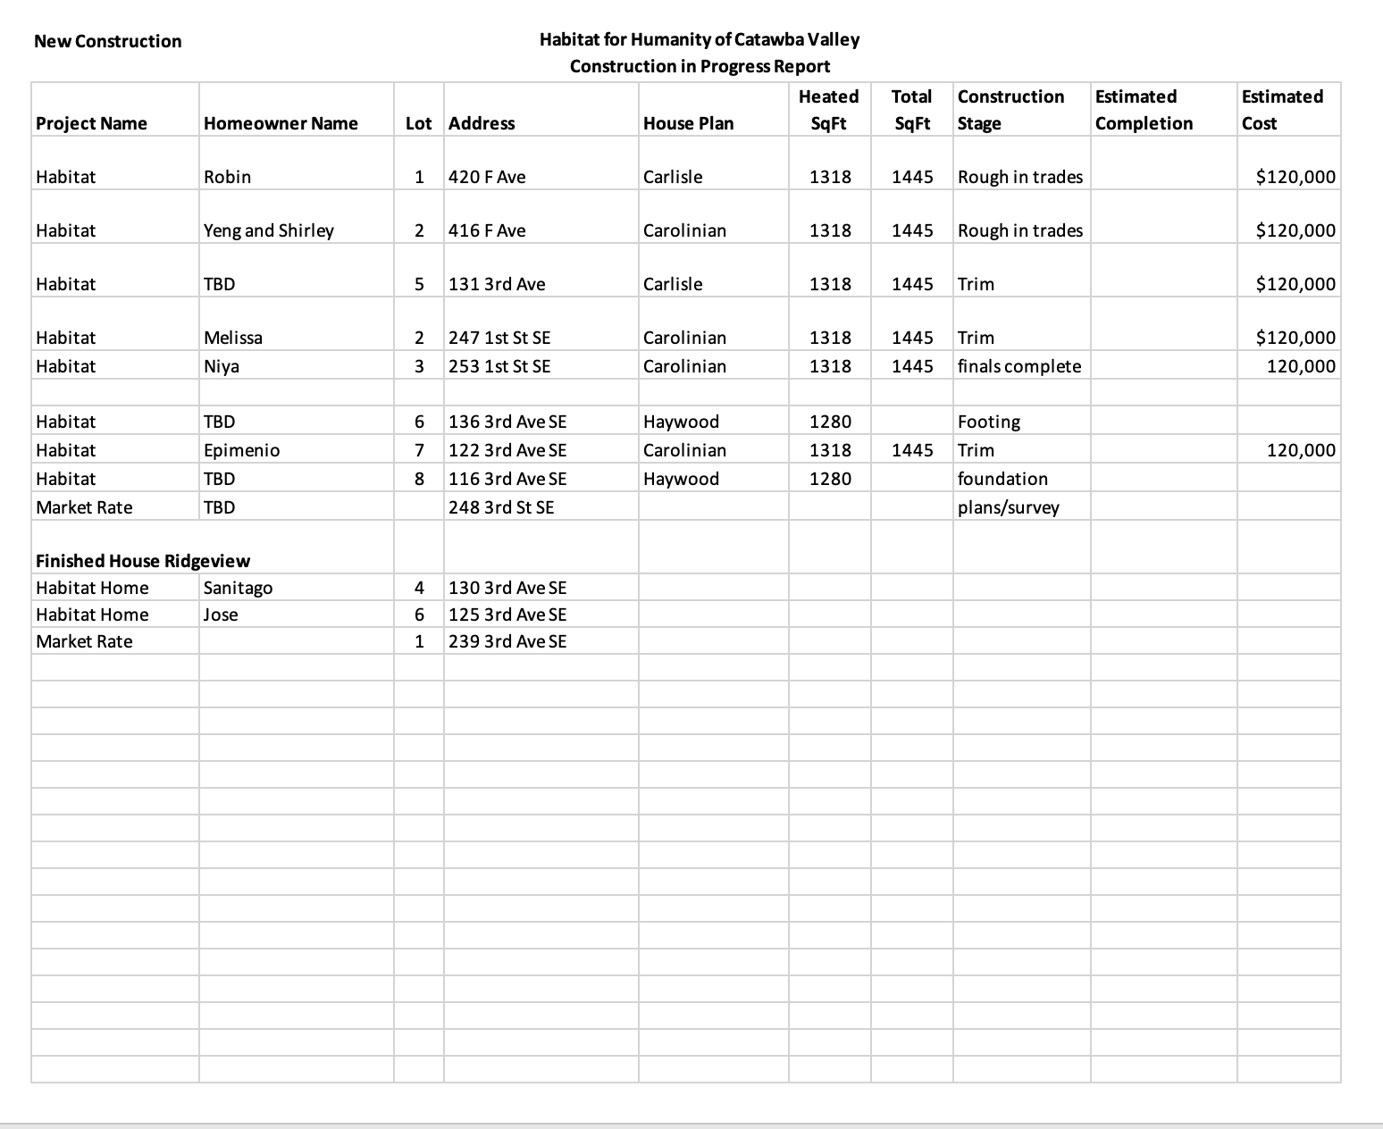

_________________________________________________________________________

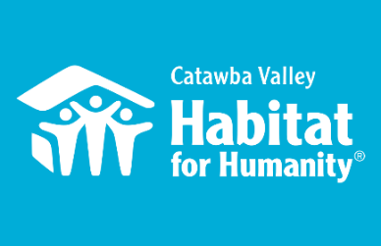
Mission and Outreach
Jenna Ross – October/November Board Report

Capacity Building
- Strategic Planning in collaboration with team members:
  - Finalized and approved Strategic Plan and Implementation Plan
  - Work on quarterly goes ongoing
- Digital Marketing Manager
  - Hired candidate
  - Completed onboarding and orientation

Mission, Messaging & Media
- Fall Mailer
  - Created content, supervised design and production of:
  - Fall Appeal letter, reply card, reply envelope, and #10 envelope
  - Fall Appeal landing page
  - Fall Appeal eblast
  - Fall Appeal social media post
- Christmas Mailer
  - Created content, supervised design and production of:
  - Christmas Appeal letter, reply card, reply envelope, and #10 envelope
  - Christmas Appeal landing page
  - Christmas Appeal eblast
  - Christmas Appeal social media post
- Christmas Cards
  - Supervised design selection
  - Coordinated Homebuyers to write personalized messages on major donor cards
- Family Story Grant Submission to HFHI – featuring Kisha Brewer
- 11/11 - New employee orientation

Development
- Home Is The Key
  - Created content and supervised design for print materials:
    - Invitation
    - Annual Report
    - Program
    - Pledge Form
  - Prepared speakers with:
    - Written instructions
    - Affiliate language and content
    - One on one meetings
    - Script revisions
    - Dress rehearsal
  - Video
    - Arranged final speaker interviews and b-roll shots
    - Organized story board
    - Heavily supervised content and revision rounds
  - Created 2 eblast emails to confirmed guests
- Giving Tuesday – 11/29, $24,545.07 as of 11/30
  - Created verbiage for 8 weekly social media lead-up posts starting 10/18
  - Created 3 eblast emails
  - Created content for website Landing Page
  - Created verbiage for 11 day-of posts throughout the day on Giving Tuesday
  - Assembled, trained, and communicated with Advanced Team of 10 volunteers

Outreach
- 10/15 Dedication at the Cottages – lead organizer
  - 4 partner families, 4 sponsor families, ~ 75 attendees
  - Planned event agenda & prepped presenters
  - Created materials including:
    - Print invitation
    - Email invitation
    - Program
- NAACP Equity & Inclusion Task Force – Housing Committee Liaison
  - 10/3 – Co-facilitated Housing Committee meeting
  - 10/17 – Co-facilitated Housing Committee meeting
  - 11/7 – co-facilitated Housing Committee Meeting
  - 11/10 – represented Housing Committee at Task Force
  - 11/21 – Facilitated Housing Committee meeting
- LiveWell Catawba
  - 10/18 – Board meeting
  - 11/15 – Coalition Meeting
- Housing Visions Continuum of Care
  - 10/13 – monthly meeting
- 10/20 – Meeting with Jenny Cody, Hickory Museum of Art
- 11/3 – Panel speaker for Leadership Catawba class: “Serving Our Community”
- Designed and ordered Christmas stewardship gifts

Volunteers
- Volunteer Hours 9/1 – 9/30
  - 115 volunteers
  - 1,216.5 hours served
  - Groups: 9/10,24 - YMCA, 9/15,30 - CommScope, 9/17 - First Baptist
    - 10/8 – CREC
    - 10/14 – Corning
    - 10/15 – First Baptist
    - 10/22 – CommScope
    - 11/11 – CommScope
    - 11/12 – CommScope
    - 11/19 – LR Bears Build

_______________________________________________________________________

Development Report
October/November 2022

Grant Updates
      - Grants Submitted
        - Sisters of Mercy (Summary)
        - Millholland Endowment Fund
        - George Foundation
        - Saint Gobain Foundation
      - Grant Awarded
        - Bank of America - $10,000 New Construction
        - Saint Gobain Corporation Foundation - $5,000 Habitat Repairs!
        - Catawba Valley Community Foundation - $4,000 Habitat Repairs!
      - Grants In Process/Prep:
        - Sisters of Mercy (Final)
        - Carpenter Foundation
- Monthly planning meeting with Amy Clinton, grant writer
Communication/Donors
- HITK Pledge payment reminders
- Lapsed donor phone calls
- Thank you, calls/cards, on incoming donations as needed
HITK Event
- Behind the Scenes Tours – Offered Oct 13 & Oct 25
- Finalize details with Caterer & Venue
- Finalize Guest List, Seating Chart
- Prep TC packets
- Print and Prep program materials (invitation, pledge form, annual report, program)
- Finalize Video
- HITK – Thursday, November 10, 2022
  - Raised To Date – $222,658 + $50,000 (match) = $272,658
  - 23 New LBS Pledges
  - Attendance 160
  - 80 LBS Members

General
- One-on-One Development Meeting with Meg Spivey
- Monthly tracking of development planner and mail appeals
- Monthly Financial Reports
- Staff Meeting on Tuesday and Development Meeting on Wednesday

____________________________________________________________________

The ReStore Report October 2022
Donations and Sales – October Sales $80,929.96 (Total sales plus scrap runs) Round Up Change $135.19 Transactions 2478 Avg. Sale $32.62. Approximately 9.26% increase compared to last year same month.
Category | Sales this period | Sales previous period |  | Average item value this period | Average item value previous period
APPLIANCES | $2,226.20 | $488.00 | 356.19% | $71.81 | $27.11 | 164.88%
BOOKS/RECORDS | $2,602.22 | $2,460.05 | 5.78% | $1.71 | $1.88 | 8.83%
COLLECTIBLES | $2,423.45 | $2,423.30 | 0.01% | $18.22 | $19.08 | 4.51%
CONSTRUCTION | $4,816.72 | $8,647.90 | 44.30% | $33.22 | $28.26 | 17.54%
FABRIC | $732.60 | $1,090.35 | 32.81% | $6.72 | $4.87 | 38.08%
FURNITURE | $34,262.24 | $25,765.75 | 32.98% | $64.52 | $37.72 | 71.04%
HARDWARE | $7,106.78 | $12,382.15 | 42.60% | $7.42 | $5.55 | 33.72%
HOUSEWARES | $8,949.29 | $8,301.62 | 7.80% | $2.87 | $2.56 | 12.13%
JEWELRY | $199.00 | $294.75 | 32.49% | $2.55 | $1.91 | 33.30%
LIGHTING/LED BULBS | $9,418.30 | $6,696.75 | 40.64% | $13.97 | $2.80 | 399.75%

Please help us grow the ReStore by sharing contacts and making introductions. Thanks.
Purchased Product Summary – Purchased Product updates for October
Cost of new inventory added | Total retail sales | Total cost of goods sold | Net Profit | Gross Profit Margin
$0.00 | $4739.50 | $1520.00 | $3219.50 | 67.9%

Trades and Incoming Product – We continue to build relationships with local ReStore trading partners. Fortunately, we received a mega-donation from Robert Abbey Lighting which allowed us to participate. Charlotte Regions ReStore gave us another 50+ rugs from Rugs.Com warehouses in their area. Cleveland County (Shelby) also came through with 900 Scarecrows and assorted other Walmart product. Overall, very nice trades in our favor. Still working with Wilkes County on putting together a fabric trade.
Staff/Volunteer Needs – NEW Staff joining the ReStore crew. We are pleased to welcome JJ Keller to the crew. He’s already doing good work and growing skills. Also, welcome Sally Grecco. She’s a former volunteer that we’ve brought on to help with cashiering, pricing, and merchandising. We’re building a crew to lead the ReStore into the future.
Volunteers are still crucial. As donations and sales increase so does the workload. Are you part of a social organization that needs to hear the ReStore message? Contact Kristi and we will set something up. https://habitatcatawbavalley.org/restore/volunteer/
- Cashier: Tuesday AM/PM, Thursday PM, Saturday AM/PM
- Sales Floor: General awareness of the merchandise combined with the ability to talk with customers.
- Fabric: Open time slots all week.
- Greeter: Anytime throughout the week.
- Receiving/Pricing: Tuesday AM
- Custodian (General Cleaning/Store maintenance): Friday AM/PM
- Warehouse Receiving/Cleaning: Opportunities open throughout the week, ask for details.
- Online Store (Posting/Inventory) Weekly opportunities open
- Merchandising: All areas Hardware, construction, housewares, and furniture constantly need straightening and display attention, ask for details.
__________________________________________________________________

Homeowner Services Report
Tina Morgan October/November 2022

Homeowner Services: Selection and Homeowners-in-Progress
The Homeownership Program held an open application period from Nov 7th to Nov 18th. Applications are only available during these open application periods and a big push is made during this time period to get as many applications to interested people as possible. Applications are always made available at the Habitat offices and can be sent to interested people by mail or email. This application round is the first time we have an online application available to those wanting to apply for the Homeownership Program online. This online application is possible because of our partnership with NewOrg and our use of the NewOrg database. To date, 113 applications have been distributed to the community.

Applicant Information Meetings (AIMs) were held during the open application period. The AIMs were held on Nov 8th at 10am and 6pm and on Nov 9th at 10am and 6pm. These meetings were held at the Ridgeview Branch Library and were open to the public. 48 people attended the AIM meetings. AIM meetings are a chance for people to learn about Habitat and the work it does. Attendees learn about the application process, Habitat’s selection guidelines, the requirements of participating in the Homebuyer program, and what they can expect from a Habitat home. Applicants also get the opportunity to ask Habitat staff any questions they have about Habitat. These meetings are often a chance for Habitat staff to dispel myths the community has about Habitat.

There are a few reoccurring myths about the Habitat Homeownership Program that circulate among potential applicants. One myth is that Habitat only accepts families with small children into its program. The truth is that Habitat has no rules around a household size or an applicant’s age. An applicant must be at least 18 years old to be able to legally sign a contract in the state of North Carolina. Other than that, anyone could be accepted into Habitat. Another myth is that Habitat takes a homeowner’s house back when they die. The truth is that Habitat homes are subject to all the same estate and property laws as any other home purchased in the state of North Carolina. Habitat always recommends to its homebuyers that they have a will and a life insurance policy in place before they die. These two items will ensure that a Habitat home can be passed from the homebuyer to their heirs free and clear. A third common myth is that Habitat gives homes away, but of course, the truth there is that Habitat homeowners buy their homes and pay an affordable mortgage. If anyone has an opportunity to help us dispel these myths, we’ll appreciate your help!

Homeowner Services: Habitat Repairs!
Report for Board of Directors November 2022
Over the past month, Habitat Repairs! has closed seven projects. Currently, there are seventeen open projects, including one that is in the process of signing the contract. Open projects should be caught up to those accepted in the last application round within the next few months.

Staff met with the Executive Director of the Women’s Resource Center. We also attended a resource fair at the Hickory Soup Kitchen as part of the Hunger and Homelessness Awareness week. Staff were able to make some good connections with individuals interested in the Homeownership and Repairs Programs as well as with other providers and community resources.

The Repairs! team met to discuss how the current projects are going, the types of projects we would like to complete in the future, the timing of application cycles, and whether to target repairs in Ridgeview. A consensus was reached on all these items, and an application cycle will be held in early 2023 while inviting current inquiries to apply before the cycle to maintain a good workflow. We are excited to see the program growing and increasing its impact in the community.

Homeowner Services: Homeowner Support
Report for Board of Directors November 2022
Delinquency Report
Reporting Period as of 11/1/2022 Total Mortgages: 87
Delinquent | # Mortgages Delinquent | Arrearage | % Delinquent
1-2 months | 4 | $ 1,759 | 4.6%
2-3 months | 1 | $ 1,157 | 1.1%
Over 3 months | 6 | $ 3,649 | 6.9%
Total this month | 11 | $ 6,565 | 12.6%
Total 10/1/22, 88 mtgs | 11 | $ 6,259 | 12.5%
Total same mo. prior yr: 11/1/21, 91 mtgs | 11 | $ 8,627 | 12.1 %
Total 1/1/20, 98 mtgs pre-pandemic | 22 | $ 21,492 | 22.4%
Jun. 2013, last mo. prior to AMS, 119 mtgs | 12 |  | 10.1%

Homeowner Services News:

Delinquencies are very stable. It’s counter-intuitive to note that delinquencies are remaining at about half what they were before the pandemic started. One of the silver linings of the pandemic has been the temporary, part-time, low wage work filling online orders, etc., that has become available for those who want it. There are also public assistance programs and support for those affected by COVID. The fact that delinquencies have been halved over the course of the pandemic seems to be evidence of something that we know but is hard to show empirically, which is that our homeowners, when they have the resources available to make their payments, generally prioritize their house payments and do.

We have 11 homeowners who we know have applied to NCHAF for COVID related mortgage assistance funded by the American Rescue Plan. Of those 11, six have received funds, three have funds in processing, and two are waiting to hear if they will be accepted.

Niya Mayfield’s closing is scheduled for Tuesday, November 29th, at the offices of Amos and Kapral.

Miesha Johnson will be purchasing the home in the Glen at Green Park that recently belonged to Christina Tolley. Miesha is extremely happy about the opportunity, and about the house and neighborhood that she will be moving into. Miesha has met all her Habitat requirements to this point including sweat equity, Habitat homebuyer classes, budget work and down payment saved. She and Melissa Cruse will soon be submitting applications for their down payment assistance loans, which is the first step of preparing for closing.

Crystal Alcantara has recently had COVID for the third time, likely due to her work in a doctor’s office. Deidre Mayfield, Dinie Knox, and others continue to deal with a variety of ongoing health issues. Many thanks for your prayers for our homeowners, home buyers, and their families.

__________________________________________________________________

Action Items:

- Treasurer’s Report – William Pleasant
  - October and November Financial Statements

- Anti-money Laundering Policy – Andrew Isola

__________________________________________________________________

Informational Items:

- Home is the Key Update – Lynn Nelson/Meg Spivey

- Strategic Plan Check-in – Jenna Ross

___________________________________________________________________

