Habitat for Humanity of Catawba Valley
Board of Directors’ Meeting
January 24, 2022

Devotion

Adoption of Agenda — Rodney Garren

Consent Agenda:
Items are considered routine by the Board of Directors and will be enacted by one motion. There will be no separate discussion of these items unless requested by a member. The item will be removed from the Consent Agenda, then added to Action or Informational Items.

1) Minutes from December Board Meeting
2) November Financial Reports
3) Staff Reports

Informational Items:
1) Who are our current homebuyer applicants?
How Habitat is changing lives. Andrew Isola

2) Mid-year affiliate review: how are we doing? Mitzi Gellman

Action Items:
No Action Items this meeting

Upcoming Events:

Next Board Meetings: February 28, March 28, April 25,
May 23, June 27

Habitat for Humanity of Catawba Valley
Board of Directors’ Meeting
December 6, 2021

Members Present: Tara Bland, Doug Dickson, Scott Echelberger, Rodney Garren, Lori Greveling, Frances Hilton, Ander Horne, Graham Hunsucker, Pat Jones, William Pleasant, Margaret Pope, Charlotte Williams
Members Not Present: Jim Benton, Bill Burnham, Gerry Knox
Staff Present: Mitzi Gellman, Richard Greathouse, Andrew Isola, Jeff Mingus, Tina Morgan, Melissa Neal, Lynn Nelson, Derek Ross, Jenna Ross, Hannah Yost
Welcome
There being a quorum, the December meeting of the Habitat for Humanity of Catawba Valley Board of Directors was called to order by Board President, Rodney Garren, at 12:00 pm. Due to COVID-19, the Board meeting was held via Zoom Meeting.
Devotion
Tina Morgan led the devotion by sharing scriptures from Philippians 4:8 and ll Esdras 2:37, a message on the importance of gratitude through the eyes of Peggy, a Habitat Homeowner, and then led a prayer.
Adoption of Agenda
Upon a motion and second, the Board unanimously adopted the December Agenda with the following addition to Action Items:
- COVID-19 Board of Directors Meeting Policy
Consent Agenda
The Board adopted the Consent Agenda of the October Board Meeting Minutes, October Financial Reports, and Staff Reports by a motion and second without dissent.
Informational Items
Home is the Key Wrap Up
- Development Assistant, Lynn Nelson, presented the Numbers:
  - Current Raised Total - $147,521; 2 new LBS members; 7 pledge upgrades; 27 Table Captains, 17 sponsors at $24,820.
- Executive Director, Mitzi Gellman, presented the Growth displaying a chart listing the quarterly impact from 2013-2021. She highlighted number of donors, number of gifts, number of online gifts, total pledged, and total raised.
- Community Outreach Coordinator, Jenna Ross, presented the Contribution discussing homeownership wealth creation and repairs health

Habitat for Humanity of Catawba Valley
Board of Directors’ Meeting
December 6, 2021

  - Homeownership with lower income earnings equals 81% wealth. This wealth is also transferred to child(ren).
  - Repairs creates increased health through stabilization of costs, limited exposure to toxins, and physical comfort.
In FY 20-21, Habitat’s Homeownership Program assisted 8 families with 230 inquiries and Habitat Repairs Program served 61 individuals/39 families/158 repairs.

Action Items
Homeowner Services Report – Margaret Pope presented the following items to the Board of Directors as a recommendation from the Homeowner Services Committee. The Board of Directors approved each recommendation unanimously:
- Recommendation for denial of 23 applicants to the Homeownership Program based on failure to complete the application and/or failure to meet the ability to pay guidelines.
- Recommendation for denial of 2 applicants to the Homeownership Program based on ability to pay guidelines.
- Recommendation for approval of 1 applicant (Household of 4 – 2 adults/2 children) to be conditionally approved for the Homeownership Program and pre-approved for a Habitat loan.
- Recommendation to approve a revision to an existing policy used with the homebuyers-in-progress regarding their partnership commitments.
  - A homebuyer who anticipates an inability to make timely payments of either sweat equity or savings may present a request for additional time to a Homeowner Services Coordinator before a monthly deadline is missed. If a homebuyer is unable to reach a Homeowner Services Coordinator, a detailed message should be sent to the Homeowner Services Coordinator before a monthly deadline is missed. The homebuyer should offer: 1) an acceptable reason for the difficulty, and 2) a plan for how and when the missed savings or hours will be made up.
COVID-19 Board of Directors Meeting Policy – Mitzi Gellman, Executive Director discussed the need for a meeting policy. The Board discussed the criteria for an in-person/hybrid meeting policy. A motion and 2nd were made and all were in favor to include the following information into a COVID-19 Board of Directors Meeting Policy:
- The board will meet in-person/hybrid when the following conditions are met:
  - The community transmission needs to be “moderate” or lower which means:
    - Case rate per 100k is less than 50; AND
    - % Positivity is below 8% for 7 or more days
An in-person/hybrid meeting will also have occupancy limits (based on room size), NOT provide lunch, and require face masks.
At 1:00 pm, the Board went into a Closed Session.

Closed Session

Adjourn
President Rodney Garren adjourned the meeting at 1:30 pm. The next Board meeting will be held on Monday, January 24, 2022.

______________________________________________________________________________

2) November Financial Reports (Separate Attachment) – Doug Dickson

3) Staff Reports
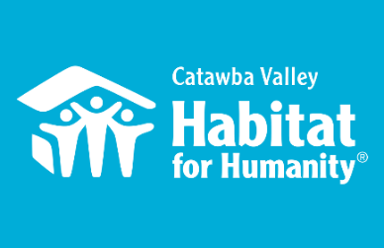
Community Outreach
January Board Report

Messaging & Media
- Christmas Direct Mail Appeal
  - Finalized Christmas Appeal segmentation strategy
  - Created content for Christmas Appeal landing page
  - Christmas appeal dropped
  - Created Christmas Appeal Eblast
- Giving Tuesday
  - Created thank you e-mail and results email
  - Created thank you and results social media posts
- HITK
  - Shared results
  - Helped educate board and donors on real-world impact of HITK in the community

Events
- Deck the Halls Holiday Block Party – 12/16
  - Created flyer
  - Ran organizational point
  - Staffed event

Outreach
- NAACP Equity & Inclusion Task Force – Housing Committee Liaison
  - 12/2 – Task Force Executive Committee Meeting, conducted minutes
  - 12/13 – facilitated Housing Committee Meeting
- LiveWell Catawba
  - 12/8 – Executive Committee Meeting
  - 12/14 – Board Meeting
- Leadership Catawba
  - 12/13 – project advisor virtual meeting, representing Habitat as a non-profit advisor to a group of LC members working to streamline online volunteer presence for the county
- Attended team meeting with CCM exploring how to collaboratively meet community’s urgent housing needs

Development
- Stewardship
  - Christmas Cards:
    - Coordinated Homeowners to sign Christmas cards
    - provided theme, instructions, and support around crafting their message
  - Major Donor Christmas Gifts:
    - Finalized payment and receipt of gifts
    - Created recipient drop-off routes
    - Recruited volunteer drivers
    - Drove delivery routes

Volunteers
- Volunteer Hours 12/1 – 12/31:
  - 50 volunteers
576 hours served

___________________________________________________________________

Development Report
October/November 2021
Lynn Nelson
Grant Updates
- Grants Submitted:
        - E. Rhodes & Leona B. Carpenter Foundation
- Grants In Process:
        - E. Rhodes & Leona B. Carpenter Foundation
- Grants Awarded/Received:
  - George Foundation - $40,000 Habitat Repairs!
  - Sisters of Mercy - $35,000 Habitat Repairs!
- Monthly planning meeting with Amy Clinton, grant writer
Events
- The Cottages Holiday Block Party – Thursday, December 16 / 4:00-6:00pm
Communication/Donors
- Finalized and mailed Christmas Greeting Cards and Postcards
- Finalized and mailed Christmas (EOY) Appeal letters
- Delivered Christmas gifts to major donors
- Processed and mailed holiday tribute cards
- Quarterly update of general email list with FMC (Full Metal Chicken)
- HITK Pledge payment reminders
- Lapsed donor phone calls
- Thank you calls on incoming donations as needed

General
- Monthly tracking of development planner and mail appeals
- Staff Meeting on Tuesday and Development Meeting on Wednesday

_____________________________________________________________

Habitat “New Construction” Report
Derek Ross December 2021

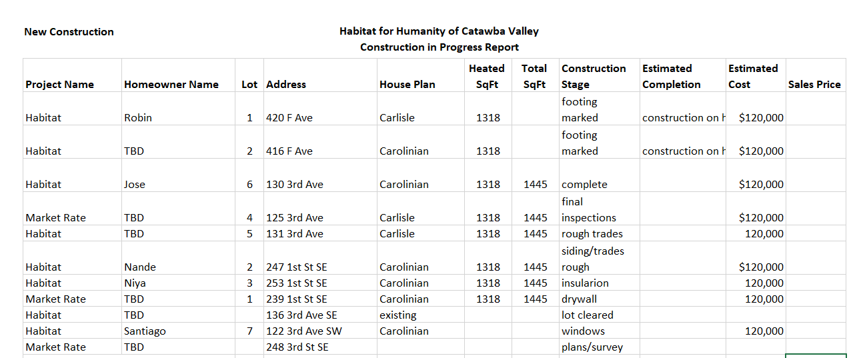

___________________________________________________________________

Homeowner Services: Selection and Homeowners-in-Progress
Report for Board of Directors January 2022

At the December 2021 board meeting, the Habitat board approved the application for Sean Betts and Michele Mungro. We welcome Sean and Michele as new Homebuyers in Progress. They are originally from Philadelphia and moved to North Carolina over 10 years ago. They have two sons, Stephan and Anthony. Michele works as an Assembler/Packer for Engineered Controls Int’l in Conover. Sean is a stay-at-home dad. They are very excited to be a part of the program. They are especially excited to begin working on their home. Sean and Michele have had their orientation to the program and have already begun to meet their partnership requirements.

The homeownership program will begin a new open application period on Monday, February 7th. Applications will be available until Friday, February 18th and will be due by Friday, February 25th. Applications will be available at the Habitat offices, on the Habitat website, by mail, or by email. Habitat is looking for applicants interested in living in the Cottages at Ridgeview. The open application period will be advertised in local newspapers, on social media, and on the Habitat website.

The Homeowner Services department has spent much time reviewing a number of policies that guide the department’s work. The new and revised Homeowner Selection and Mortgage Origination policy is under final review and will be sent to the Selection Committee soon. This policy will guide the Selection Committee as they review Habitat homeownership applications. The FACT Act Identity Theft policy is under review by the Homeowner Resource Committee. This policy guides how homeowner services handles our clients’ personal identifying information. The Anti-Money Laundering Policy and Program Procedures are also under review by the Homeowner Resource Committee. This document will be the governing document for Habitat for Humanity of Catawba Valley’s Anti-Money Laundering program.

Homeowner Services: Habitat Repairs!
Report for Board of Directors January 2022

Habitat Repairs! has been inviting Ridgeview homeowners to apply for the program. There are currently 13 homeowners in and around the Ridgeview neighborhood who will be invited to apply for the program. In planning for Hannah’s maternity leave beginning in April, staff are working to ensure that construction staff have projects to sustain their work. Staff are in the process of opening an application round for all who inquired during 2021 (plus the 13 Ridgeview homeowners). A selection round will be completed to find the homeowners who are most in need with projects Habitat can accommodate. Staff are determining the timeline and best way to move forward with a selection round.
Currently, there are 30 open projects, 0 waiting for contracts, 0 waiting for site visits, and 0 applications being assessed.

Homeowner Services: Homeowner Support
Report for Board of Directors January 2022

Delinquency Report
Reporting Period 1/1/2022 Total Mortgages: 89
Delinquent | # Mortgages Delinquent | Arrearage | % Delinquent
31-60 days | 4 | $ 1,938 | 4.5%
61-90 days | 2 | $ 1,216 | 2.2%
90 plus days | 5 | $ 6,113 | 5.6%
Total this month | 11 | $ 9,267 | 12.3%
Total 11/1/21, 91 mtgs | 11 | $ 8,627 | 12.1%
Total same mo. prior yr: 1/1/21, 95 mtgs | 18 | $ 15,466 | 19.0%
Total same mo. 2 yrs ago, 1/1/20, 98 mtgs | 22 | $ 21,492 | 22.4%
Jun. 2013, last mo. prior to MF (119 mtgs.) | 12 |  | 10.1%

Homeowner Services News
Normally, delinquencies increase in the last half of the year as our homeowners deal with children out of school for the summer, followed by the expenses of a new school year and Christmas. It’s remarkable that this year, our delinquencies are about what they were last summer. They also continue to be significantly improved over recent years.

Trinia Coulter’s heirs (her three children) are continuing to try to maintain ownership of their mom’s home with support from Habitat and from Amos and Kapral. It is unclear how this will turn out.

Xia Yang’s property taxes went up about $700 this year. Part of this was expected because her first year’s taxes were based on a partial value, but part of it was because of increasing property values. She has savings that will cover her negative escrow amount and is planning for the expected increase of about $60 per month to her house payment. She says, “We love our house, and we’ll work hard to keep it.” Xia’s is one of the largest escrow increases but higher construction costs and property values mean significant changes to property taxes and homeowners’ insurance for many of our homeowners. For those whose house payments are already at the limit of affordability, this is a real challenge.

The hearing for Anissa Comb’s estate to gain the court’s permission to sell Anissa’s house took place on January 12, 2022. The executor has chosen not to get an appraisal and plans to put the house on the market for about $140,000.

As Omicron makes its presence felt, we continue to hear about homeowners, home buyers, and their children who are sick with COVID and/or who have employment challenges due to the pandemic. Many of them work in jobs that are impacted or that make it difficult to stay safe. A recent sampling of those: Rosa Bessette is a homeowner who has been seriously ill due to the combination of her COPD and COVID; she is now improving. Mahongany Smith left a furniture job because they didn’t have the materials to give her enough hours to pay her bills; she is relieved to have a new job with Corning. Thelma Powell lost a job due to COVID, found another in August that was part-time and expected to go soon to full-time, but is still part-time and struggling. Hershon Blackburn was laid off due to supply chain issues. Your prayers for our folks are appreciated.

________________________________________________________________

HABITAT REPAIRS! Construction
Board Report January 2022
Richard Greathouse

Repair of the Month

The repair highlighted this month is the home of Samone Parson who lives at 1016 South Caldwell Avenue in Newton. Ms. Ward lives alone and is need of a considerable number of exterior repairs:
- Repair and paint exterior trim.
- Paint exterior of house.
- Replace foundation vents.
- Replace window screens.
- Repair and paint shutters.
- Repair gutters and install leaf guards.
- Repair exterior trim.

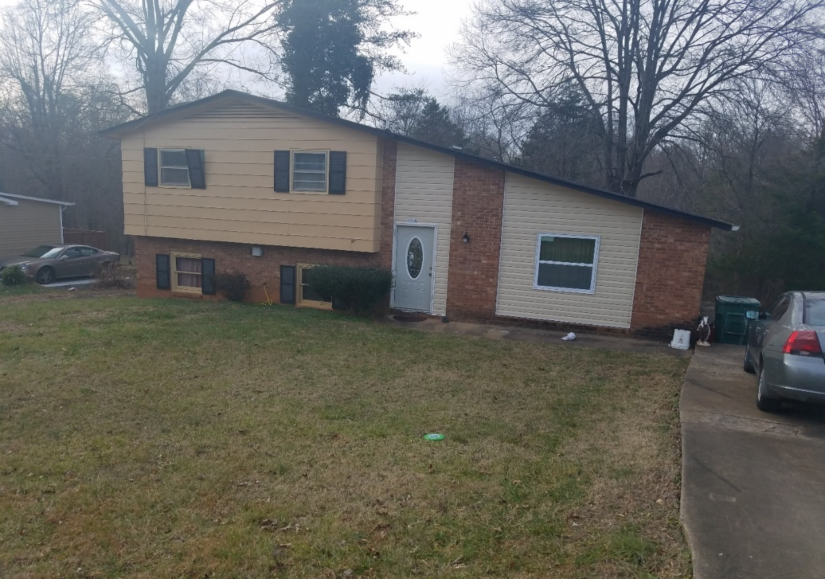
Ms Parsons’s home

Current Repair Status
- Jobs completed December 1
- Jobs in progress 30
- Habitat partners Completed 1

________________________________________________________________

The ReStore Report
January 2022
Jeff Mingus, General Manager

No Report this month.
__________________________________________________________________

Informational Items:
1) Who are our current homebuyer applicants?
How Habitat is changing lives. Andrew Isola

2) Mid-year affiliate review: how are we doing? Mitzi Gellman

__________________________________________________________________

Action Items:
No Action Items this month

