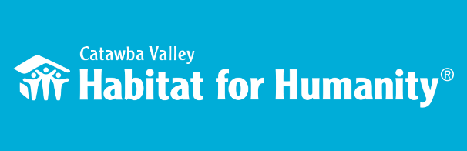
Greetings Habitat Table Captain!

We’re very excited to have you as a table captain for our fourth annual Home is the Key Breakfast. With this virtual format, your support is more vital than ever to the breakfast’s success, and we applaud and thank you for your commitment! We could not do this without you.

Inside this packet you will find a few helpful worksheets, and other items that will help you get organized, and maximize the potential of your virtual table!

- Treasure Map--- What groups of people or organizations might you have a connection to that you could explore to identify guests for your virtual table? Use this form to map out your networks/groups and start your list.

- Potential Guest Worksheet--- After completing your treasure map you may be surprised to see how many networks you are a part of. Use this worksheet to help capture names of potential guests for your virtual table as they come to you while thinking within each network.

- Unlocking Habitat’s Insider Blueprint -- Now that you have a list of potential guests, we strongly encourage you to invite your guests to learn more about Habitat’s mission. A part of the success of your virtual table will rest upon how connected your guests feel to Habitat. Our Insider Blueprint webpage hosts a series of videos, interviews, and impact data that allow for a flexible and fun way for your guests to have an introduction and share in the buy-in before they come to the online breakfast! You and your guests can access the Insider Blueprint at: https://habitatcatawbavalley.org/home-is-the-key/

- Guest Information--- You have confirmed 10 guests for your virtual table, great! Now you can use the included form to capture guest information. You can also download a copy at: https://habitatcatawbavalley.org/table-captains-info/ Using this form will ensure Habitat staff promptly send out breakfast invitations to your guests. After your form is complete, please email it to Lynn Nelson at lynn@habitatcatawbavalley.org or fax it to 828-328-9263 no later than October 1st. Any changes thereafter should also be sent to Lynn.

Also included in your packet is a 2020 Annual Report, an example of a past pledge sheet, and Save the Dates to share with your guests. We hope you will find this packet useful in your preparation for this year’s online breakfast. We are confident in all your efforts and look forward to an amazing tradition of breakfasts that will have a lasting impact on our community.

Huge thanks! We can’t do it without you!
Lynn
Lynn Nelson
lynn@habitatcatawbavalley.org
828-328-4663x309
828-638-2911

Through shelter, we empower.

772 4th St SW, Hickory NC 28602 | 828-328-4663 | habitatcatawbavalley.org

