Habitat for Humanity of Catawba Valley
Board of Directors’ Meeting
September 27, 2021

Devotion – Tina Morgan

Adoption of Agenda — Rodney Garren

Consent Agenda:
Items are considered routine by the Board of Directors and will be enacted by one motion. There will be no separate discussion of these items unless requested by a member. The item will be removed from the Consent Agenda, then added to Action or Informational Items.

1) Minutes from August Board Meeting
2) August Financial Reports (Separate Attachment)
3) Staff Reports

Action Items:

1) Homeowner Services Report – Margaret Pope
2) Beloved Community – Mitzi Gellman/Jenna Ross
3) Covenant and Quality Assurance Checklist – Mitzi Gellman

Informational Items:
Affiliate’s Mission Moment:
Impact Report:
Where we’ve been. Where we’re going. Jenna Ross

Upcoming Events:
The Cottages Block Party – this Saturday at 10am;
Home is the Key Virtual Event - November 4
Next Board Meetings: October 25th, November 22 or 29?

Habitat for Humanity of Catawba Valley
Board of Directors’ Meeting
July 26, 2010
Members Present: Jim Benton, Tara Bland, Bill Burnham, Doug Dickson, Rodney Garren, Lori Greveling, Frances Hilton, Ander Horne, Pat Jones, Gerry Knox, Whit Malone, William Pleasant, Margaret Pope, Charlotte Williams
Members Not Present: Scott Echelberger, Troy Howard, Graham Hunsucker
Staff Present: Mitzi Gellman, Richard Greathouse, Andrew Isola, Jeff Mingus, Melissa Neal, Lynn Nelson, Derek Ross, Jenna Ross, Hannah Yost

Welcome and President’s Remarks
There being a quorum, the August meeting of the Habitat for Humanity of Catawba Valley Board of Directors was called to order by Board President, Charlotte Williams at 12:00 pm. Due to COVID-19, the Board meeting was held via Zoom Meeting. President Charlotte Williams welcomed new board members – Jim Benton, Tara Bland, and Gerry Knox.
Devotion
Jenna Ross led the devotion sharing a quote from Dr. Martin Luther King, Jr., Facing the Challenge of a New Age, 1956 followed by prayer.
Adoption of Agenda
Upon a motion and second, the Board unanimously adopted the August Agenda.
Consent Agenda
The Board adopted the Consent Agenda of the July Board Meeting Minutes, July Financial Reports, and Staff Reports by a motion and second without dissent.
Action
- Margaret Pope, Homeowner Selection Committee member presented a recommendation from the Homeowner Selection Committee to deny 20 applicants due to ability to pay guidelines. The Board moved to accept the recommendation with all in favor.
Informational Items
- Board Welcome and (Re)orientation
  - What We’re About – Jenna Ross, Community Outreach Coordinator, welcomed the board and encouraged the Board that we are doing so much more than building 7 homes in Ridgeview, we are securing foundations, developing better futures, and offering strength, stability, and self-reliance. She also introduced the Beloved Community pledge and requested the Board to adopt the pledge. Board Member, Bill Burnham, suggested the board review the pledge and discuss it at the September Board meeting; all were in favor.
  - What’s Your Role – Mitzi Gellman, Executive Director ,shared the duties of a board member, serving the community by being a champion of the message, and funding the mission. One means of funding is through the Home is the Key fundraising/friend raising event.
  - Let’s Get Started – Lynn Nelson, Development Assistant, thanked the board for the past success of the HITK events and shared the next steps for the upcoming HITK event in November 2021.
- Mitzi Gellman, Executive Director, introduced the new board members and opened the floor for them to share about themselves.
- Jeff Mingus, ReStore, and Derek Ross, Construction, gave updates on their department.
Adjourn
President, Charlotte Williams reminded the board of the next meeting and recognized and gave thanks for outgoing board members Whit Malone and Cliff Moone. The meeting was adjourned at 1:21 pm. Following the meeting, the Board was invited to take a tour of The Cottages at Ridgeview. The next Board Meeting will be held on Monday, September 27th at 12:00pm.

______________________________________________________________________________

2) August Financial Reports (Separate Attachment) – Doug Dickson

3) Staff Reports

Homeowner Services: Selection and Homeowners-in-Progress
Report for Board of Directors September 2021
The Homeowner Selection Committee conducted a home visit evaluation with one applicant in the latest application round. The committee conducted this home visit in a safe and socially distanced manner. The purpose of a home visit is to assess the level of need an applicant has for safe, affordable housing. The HSC met in September to review the findings of the home visit. The committee presents one applicant to the board today and recommends that the application be approved. An action item has been presented to the board with details.

The Homeownership Program’s recent open application period ended on Sept 3rd. Applications were due to Habitat by Sept 10th. During this application period, the Homeownership Program gave out 67 applications (a very high number!). Habitat received 23 applications back by the due date. The Selection Committee will now begin the work of reviewing these applications. The committee is hopeful that a good class of applicants will be found.

The Homeownership Program held an open house at the Cottages at Ridgeview for individuals interested in applying for the program. The open house was held at the home intended to be sold to Jose Vargas. As the floor plans in the Cottages at Ridgeview are similar, ‘Jose’s house’ served as a great model to attendees of what they could purchase if they are accepted into the Homeownership Program. The open house was well attended. Individuals who toured the house were very impressed with the house’s layout, the quality of craftsmanship, and the changes being made to the neighborhood. Overall, it was a great success.

Homeowner Services: Habitat Repairs!
Report for Board of Directors September 2021
Habitat Repairs! has begun inviting Ridgeview homeowners to apply for the program. 11 Ridgeview homeowners on our inquiry list were sent an application that was due at the end of August. Only 1 application was turned back in. 5 more Ridgeview homeowners on the inquiry list have been invited to apply, and those applications are due September 24th. After the September 24th application deadline, advertising will be done on the current worksite and at the Ridgeview library if needed. The goal is to have 5 or 6 projects in Ridgeview with the hope to increase that number as more of the projects in progress are completed.
Repair staff have shifted some administrative responsibilities to make the process run more smoothly. Staff are excited to continue to implement new procedures and update responsibilities so that each project is accomplished more efficiently and in a shorter timeframe.

Homeowner Services: Homeowner Support
Report for Board of Directors September 2021
Delinquency Report
Reporting Period 8/31/2021 Total Mortgages: 94
Delinquent | # Mortgages Delinquent | Arrearage | % Delinquent
31-60 days | 6 | $ 2,277 | 6.4%
61-90 days | 2 | $ 1,190 | 2.1%
90 plus days | 5 | $ 5,148 | 5.3%
Total this month | 13 | $ 8,615 | 13.8%
Total 7/30/21 (94 mtgs) | 12 | $ 8,200 | 12.8%
Total 12/31/20 (95 mtgs) | 18 | $ 15,466 | 19.0%
Total same mo. prior yr: 8/31/20, 97 mtgs | 17 | $ 14,388 | 17.6%
Jun. 2013, last mo. prior to MF (119 mtgs.) | 12 |  | 10.1%

Homeowner Services News
Delinquencies are up two loans in the 30 day past due group and down one in the 60 day past due group, so very stable in spite of extra summer expenses for families with children. In August 2019, our delinquencies were 22.2%. Delinquencies have come down 5% in each of the last two years.

The closing for Jose Vargas and Lidia Garcia Ramirez is scheduled for Thursday, October 7th. We have loan approval from NCHFA, and First Bank has given us a loan number, signaling that they are moving forward.

We are adding our principal residency requirement and our right of first refusal to the covenants for the Cottages at Ridgeview so that all homes that we sell in the neighborhood, including the market rate homes, will be covered. These changes will ensure that the properties will continue to be used for homeownership and will preserve Habitat Catawba Valley’s right to recover those properties for affordable homeownership whenever titles transfer.

Three homeowners have paid off their mortgages since the last board meeting. They are DeHaven Phillips, LaShanda Sharpe, and Geraldine Rippy.

The Anissa Combs Estate is making plans to sell Anissa’s home in Blue Sky Acres. There is approximately $43,000 owed on that home to Habitat Catawba Valley.

Yong Vang Chang, a homeowner in Blue Sky Acres, died in mid-September. His wife, Mee Thao, will continue to own the home and to live there along with one or two of their young adult daughters.

Northminster Presbyterian Church has very generously provided Habitat with the child friendly furniture, rugs, books, toys, etc. that will help make the children of our homeowners happier and their parents hopefully more able to relax and focus on meetings when they are with us. We are grateful.

Construction Report – Derek Ross
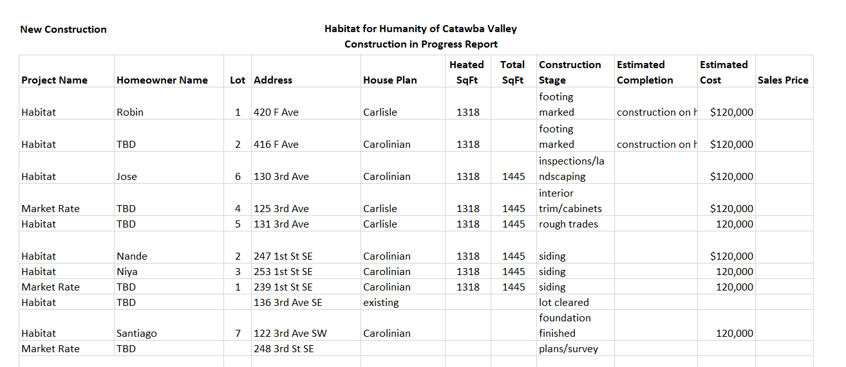

________________________________________________________________
HABITAT REPAIRS!
September 2021
Repair of the Month

The featured repair for this month is for Peggy McIlwain. Peggy is a Habitat homeowner who is living in her house that was constructed in 2002. Her house is located at 633 2nd Street Drive SW in Conover. Peggy has kept her home clean and in good shape but needed help on the following items.

- HVAC service.
- Plumbing repairs including repairing kitchen and bathroom sinks and installing ADA compliant toilets and changing out a tub shower to a walk in shower.
- Repairing and painting the front and rear porches and steps.
- Installing new automatic foundation vents.
- Painting the foundation stucco.
- Gutter repair and leaf guard installation.
- Repair and paint the storage shed.
- Entry door repairs and weatherstripping.
- Vinyl siding repair.
- Repairing bathroom and dryer vents.
- Pressure cleaning the house and driveway.

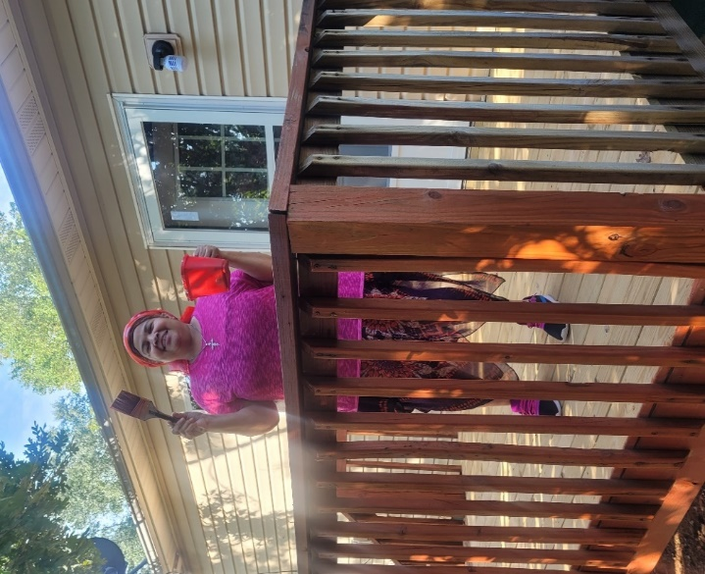
Peggy helping with the painting.

Current Repair Status

- Jobs completed August 4
- Jobs in progress. 24
- Jobs approved waiting start 11
- Habitat partners projects completed 1

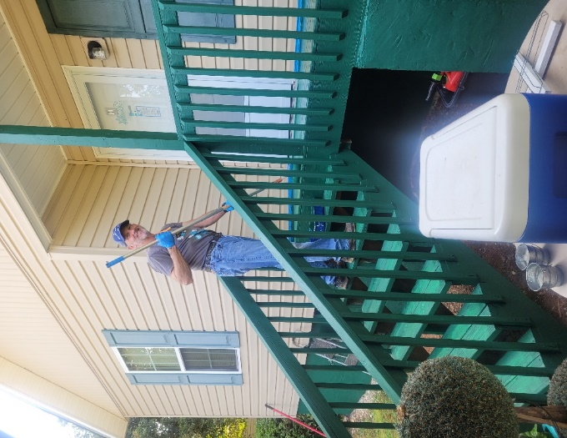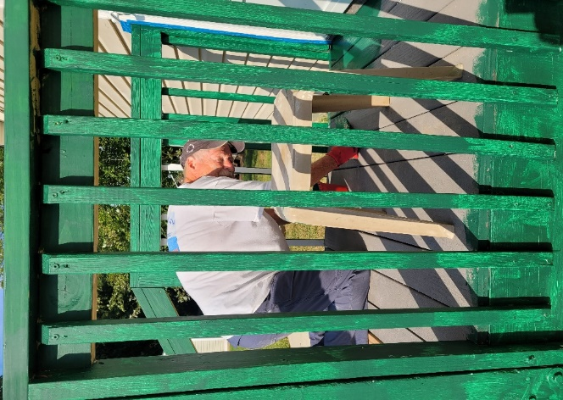
Volunteer Doug Wells Volunteer Jim Voebel

___________________________________________________________________
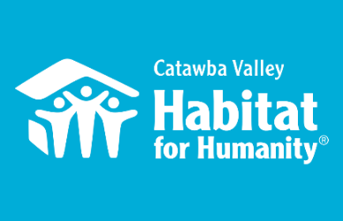
Community Outreach

August 2021 Report

Messaging & Media
- Fall Direct Mail Appeal
  - Crafted Eblast asset
  - Designed website landing page
- Christmas Direct Mail Appeal
  - Preparing a longer format letter based on current ROI data

Outreach
- NAACP Equity & Inclusion Task Force
  - Joined as Secretary for Steering Committee
  - Serving as Liaison for the Housing Committee under this Task Force
  - 8/4 – Task Force Meeting
  - 8/12 – Led Tour of Cottages at Ridgeview
  - 8/25 – Task Force Meeting
- LiveWell Catawba
  - 7/11 - Executive Committee Meeting
  - 8/17 - Board Meeting
- HFHI Training
  - 8/19 – Webinar on the effects of housing disparities in the built environment
  - 8/26 -Webinar on building equity into Neighborhood Revitalization Programming

Development
- 2021 Church Outreach
  - Finalized Apostle Build on-site schedule/registration links
  - Designed and mailed Block Party Invites
  - Created content for Block Party evite
- HITK
  - 8/12 - Breakfast meeting to prepare Niya Mayfield and Tim Shuford for filming
  - 8/18 - Filmed interview with Niya Mayfield and Tim Shuford for spotlight video
  - 8/18 - Toured Cottages with Mandy Pearce and prepared her to deliver video Ask
  - Table Captain Training 8/31 – 6 people
  - Designed Save the Date
  - Reached out to Table Captain invitees to follow-up and answer any questions
- Funding for Good
  - 8/31 – Coaching Call, Optimizing ROI for Christmas Direct Mail Appeal
- Stewardship
  - Created content for Thanksgiving Postcard
  - Created content for Christmas Postcard
  - Created content Holiday In Honor cards

Volunteers
- Volunteer Hours 8/1-7/31:
  - 56 volunteers
  - 774 hours served

___________________________________________________________________

Development Report
August 2021
Lynn Nelson
Grant Updates
- Grants Submitted:
        - The Leon Levine Foundation
        - Publix Supermarket Charities
        - Catawba Valley Community Foundation
- Grants In Process:
        - Ameriprise
        - First Horizon
        - Beaver Family Foundation
- Grants Received:
  - The Underdown Family Foundation
  - Wells Fargo Foundation
- Monthly planning meeting with Amy Clinton, grant writer
Home is the Key
- HITK Virtual Event - Thursday, November 4, 2021
- Board/Staff to make Table Captain follow up calls
- Notify current TC’s of Table Captain Packet Pick Up/Orientation/Tour dates
  - Tuesday, August 31 11:00 – 1:00
    - Training Session and tour was well attended
  - Thursday, September 9 4:00 – 6:00
- Prepare TC packets
- Select HITK Speakers
- Continue filming video, developing guest and TC lists, seeking sponsors
  - To date, 15 confirmed sponsors: Aiken Black Tire Service, Cargo Transporter, Catawba Valley Building Supply, Commscope, Link Management/McDonald’s, Oakley Building Co, Pepsi Bottling Co, Statesville Brick Co, Tightlines Designs, Canella Heating & Air Conditioning Inc, Shabeldeen Engineering, PA, Allegra Print Marketing & Mail, Broome Associated Insurance, Stephen Austin, and Bass-Smith Funeral Home.
Communication/Donors
- Prep and finalize Fall Mail Appeal documents: letters, reply cards, envelopes and mailing lists for 9 segmented groups. All materials to printer with drop date of mailer set for September 22.
- HITK Pledge payment reminders
- Lapsed donor phone calls
- Thank you calls and handwritten thank you cards on incoming donations as needed

General
- Updated and sent Board packets
- Webinars:
  - US Chamber of Commerce Foundation
  - CFRE
  - HFHI Government Grant Funding
  - Investing APRA Funds for Nonprofits
  - CVCC Small Business Center – QuickBooks Intro
  - CVCC Small Business Center – QuickBooks Intermediate
- Monthly tracking of development planner and mail appeals
- Phone meeting with Mandy Pearce/Development
- Staff Meeting on Tuesday and Development Meeting on Wednesday

___________________________________________________________________

The ReStore Report August 2021
Jeff Mingus
Donations and Sales – August Sales $68,286.23 Round up change donations $354.06 Transactions Count 2614
Thanks to Forsyth County aka Winston Salem we’ve been able to trade off excess donations in short end fabric for pallets of Kids Activity gyms, and an assortment of different product. Lowe’s Planogram is just around the corner …stayed tuned for a great donation. New deals with Charlotte Region too.
Meet Cody and Parker, Our ReStore Donation Ambassadors…available Tuesday through Friday 8:30am to 3pm. Simply call 828-327-7467 or online at https://habitatcatawbavalley.org/restore/donate/
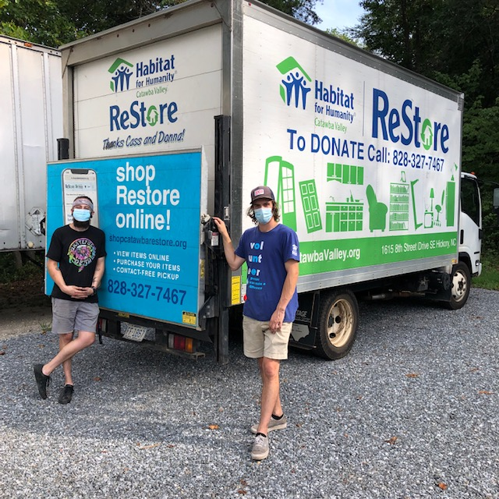
ReStore Fun Facts for Fiscal year 2020-21:
- We average around 1200 scheduled pickups per year. Drop off donations are closer to 1400. Making our average donation value over $330.00.
- Sales per square foot $46.32
- Sales transactions 25,185 Items per sale 4.25 Average sales total $32.93
- Individual Volunteers (Fiscal 20-21) 59 for a total of 4794.25 hours
Celebrating 10 years at the new location… Watch for our “Thank you” eblast.
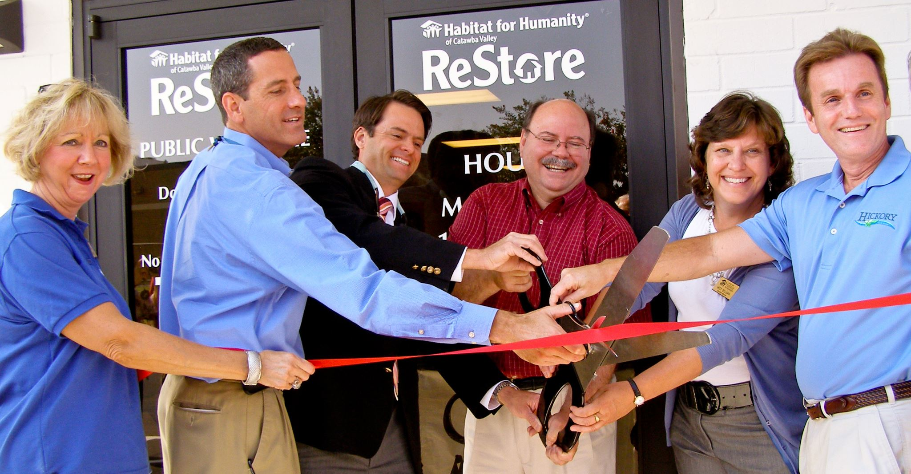
Volunteer Needs - https://habitatcatawbavalley.org/restore/volunteer/ We have volunteer opportunities open throughout the week. Any “regular” volunteers, individuals who comply with our covid safe protocols and can commit to a regular schedule of a few hours each week, are welcome.

Cashiers
All you need are some basic math skills, cash register skills, and a smile. Okay so it’s a little more detailed than that, but not by much. Customer service, phone answering, and greeting are important along with “understanding” how the store works. It’s not just about handling money. This is the last interaction with the customer, and we want them to leave smiling and happy with their purchase. No worries, this position comes with constant training. There are two shifts daily: 9:45am to 1:30pm, and 1:15 to 5:00pm.

Merchandising and Customer Service
It’s a retail space so always in flux. A constant organizing vigil must be maintained. Our mantras…If I can’t get to it, I can’t sell it! Believe in our donations… keep them clean, organized, and attractive! All areas of the store from hardware to construction, appliances to housewares, home furnishings to office need daily attention. Again, it’s simple and we’ll help (some pieces are difficult to move around, and you’re not Superman). Here’s a benefit. You get to interact with customers too! If you’re working/moving/organizing they will have questions. Open shifts of a few hours or more daily.

Pricing and Stocking
If you’ve ever wondered how we come up with our pricing? Here’s your chance to learn our secrets. Not everyone gets to carry…a black sharpie. Of course, to price donations, you sometimes must help receive donations too. No worries…we’ll teach and guide you along this greatest of ReStore mysteries. Whew! Now that it’s priced it needs to hit the sales floor. Knowing the areas of the store and organizational skills really help. Everything has a place, like things with like things, I think you get the idea.
Open shifts of a few hours or more daily.

Warehouse Receiving and Loading
Truly the backbone of the store… get it? Lots of lifting, pushing, pulling, carrying, unloading, loading, cleaning, and sorting, I’m tired already. But that’s what keeps the store moving.
Open shifts of a few hours or more daily!
Social Media Guru
Enjoy browsing and posting FB and Instagram? Like shopping the ReStore? Love supporting Habitat? Here’s something right up your alley. Help us tell our story.

ReStore Schedule Open to the Public Tuesday through Saturday 10am to 5pm. Mondays are workdays for volunteers and staff. Donation Drop offs Monday through Saturday 10am to 4pm Free Donation Pick Ups Tuesday through Saturday Call 828-327-7467 or go online https://habitatcatawbavalley.org/restore/donate/ to schedule.

___________________________________________________________________

Action Items:

1)Homeowner Selection Committee – Margaret Pope

Please be aware that this information is of a confidential nature and should be handled accordingly.

The following individual was presented to the Homeowner Selection Committee as an applicant for the homebuyer program. The applicant listed below meets Habitat for Humanity of Catawba Valley’s (HFHCV) selection criteria for ability to pay, need, and willingness to partner. The Homeowner Selection Committee recommends that this applicant be conditionally approved for HFHCV’s Homeownership Program and pre-approved for a Habitat loan. Per HFHI recommendation, names are not included in the information to the board to lessen any appearance of biased decision making.

Household of 2 (1 adult/ 1 child)
Employer: Bassett Furniture
Annual Income: $33,377.58
Applicant’s Income as a percentage of the Area Median Income: 69%
Credit: meets requirements
Consumer Debt to Income Ratio: 29% (back end)
Current Rent: $500/month (18% of monthly gross income)
Need: Overcrowding, unsanitary conditions, structural problems
Willingness to partner: meets requirements

2) Beloved Community: Mitzi Gellman/Jenna Ross
In the August meeting, Jenna presented the Habitat International Beloved Community initiative to the Habitat Board. Following discussion, the Board asked to delay a vote on this initiative until the September meeting. A vote to incorporate the Beloved Community’s pledge into our affiliate’s core operating principles is requested.
Within the “Beloved Community,” justice, equal opportunity and love for others are foundational principles of a society tasked with eliminating poverty, prejudice, and violence. The additional belief is that we achieve our goals through strong partnerships and alliances with our neighbors, and within these partnerships we will create strength, stability, and self-reliance for all.
Why now?: while this initiative was rolled out 2 years ago by Habitat International, the issue of housing inequity has become front and center following a report released by the City of Hickory earlier this year. The attached Power Point presentation is a summary of the report.
(Here is a link to the full report: https://www.hickorync.gov/sites/default/files/hickoryncgov/Council/Presentations/Hickory%20Ethnicity%20Data%20Report%20January%208%202021.pdf
Here is a link to the highlights from the city: https://www.hickorync.gov/sites/default/files/hickoryncgov/Council/Presentations/Hickory%20Ethnicity_Race%20Report%20Highlights%20Updated%20Jan%2019%202021.pdf

3) Habitat International Affiliate Covenant & Quality Assurance Checklist–Mitzi Gellman
The Board will be asked to vote to approve the Covenant between Habitat Catawba Valley and Habitat International. This is agreement is renewed annually along with the Quality Assurance Checklist. The purpose of the Covenant and QAC is confirm that the Affiliate is maintaining best practices and adhering to Habitat International guidelines and policies.
A link to the document can be accessed here:
file:///C:/Users/MGellman/AppData/Local/Microsoft/Windows/INetCache/Content.Outlook/9A83DCW3/FY22%20Covenant%20and%20Quality%20Assurance%20Checklist.pdf
____________________________________________________________________________

Informational Items:

Affiliate’s Mission Moment: Jenna Ross

Impact Report:
Where we’ve been. Where we’re going.
(Presentation of preliminary year-end numbers and data)

