Habitat for Humanity of Catawba Valley
Board of Directors’ Meeting
March 22, 2021

Devotion – Tina Morgan

Adoption of Agenda — Charlotte Williams

Consent Agenda:
Items are considered routine by the Board of Directors and will be enacted by one motion. There will be no separate discussion of these items unless requested by a member. The item will be removed from the Consent Agenda, then added to Action or Informational Items.

1) Minutes from February Board Meeting
2) January+February Financial Reports (Separate Attachment)
3) Staff Reports

Action Items:
None this meeting

Informational Items:

Upcoming Events:
Next Board Meetings: April 26th, May 24th, June 28th

Consent Agenda
- February Minutes

Members Present: Bill Burnham, Doug Dickson, Scott Echelberger, Rodney Garren, Lori Greveling, Frances Hilton, Troy Howard, Pat Jones, Whit Malone, Cliff Moone, William Pleasant, Margaret Pope, Charlotte Williams
Members Not Present: Ander Horne, Graham Hunsucker
Staff Present: Mitzi Gellman, Richard Greathouse, Andrew Isola, Jeff Mingus, Tina Morgan, Melissa Neal, Lynn Nelson, Jenna Ross
Welcome and President’s Remarks
There being a quorum, the February meeting of the Habitat for Humanity of Catawba Valley Board of Directors was called to order by Board President Charlotte Williams at 12:00 pm. Due to COVID-19, the Board meeting was held via Zoom Meeting.
Devotion
Tina Morgan led the devotion by sharing scripture from 1 John 1:5-7 followed by prayer.
Adoption of Agenda
Upon a motion and second, the Board unanimously adopted the February Agenda.
Consent Agenda
The Consent Agenda was amended to remove the January Financial Reports (partial January financials to be included in the Information Items). The Board adopted the amended Consent Agenda of the January Board Meeting Minutes, the December Financial Reports, and Staff Reports by motion and second without dissent.
No Action Items

Informational Items
- Andrew Isola, Homeowner Services Coordinator, gave an update from Habitat on the Hill virtual event. The three day virtual event reviewed HFHI goals for the year and aides for local congressional members were present.
- Jenna Ross, Community Outreach Coordinator, presented the updates to COVID Protocols for Habitat volunteers.
- Andrew Isola, Homeowner Services Coordinator, updated the Board on the recent AIMs meetings held January 29 and 30.
- Mitzi Gellman, Executive Director, gave updates on the January financials stating current approximate cash out: Paul Thompson - $150,000.00, purchase of home in Ridgeview - $13,000.00, and purchase of a lot in Kenworth neighborhood - $10,000.00. Cash in consists of the following: City of Hickory to allocate $50,000.00 to Ridgeview new construction in replace of Habitat Repairs!, the City of Hickory donated three lots in the area of 8th Ave Ct SW, the PPP loan (1st round) to be forgiven, the PPP loan (2nd round) for approximately $86,000.00 to be submitted. Habitat is also looking at additional land parcels in the vicinity of Publix.

Adjourn
President, Charlotte Williams adjourned the meeting at 12:55 pm. The next Board Meeting will be held on Monday, March 22nd at 12:00pm via Zoom.

2) January + February Financials (available as separate attachment)

__________________________________________________________________

3) Staff Reports

Development Report
February 2021
Grant Updates
- Grants Submitted:
- CDBG (Community Development Block Grant/City of Hickory) - $50,000 New Construction
- American Woodmark Foundation – LOI submitted
- Grants in Process:
        - Beaver Family Foundation - $16,900 Habitat Repairs!
- Grants Received:
  - Publix Super Market Charities - $6,000 New Construction
  - City of Hickory Community Relations Council - $1,000 Housing Inequality Forum
- Held meeting with Amy Clinton to review and update full grant cycle calendar. Assigned list of grants for communication with grant administrators. Reviewed and assigned grant research for new grant prospects.
Communication/Donors
- Continuing with personal thank you calls and handwritten thank you cards on incoming donations.
- Draft of Easter postcard and specialty greeting cards.
- Create mailing list for postcards and greeting cards (LBS members, major donors, and board members)
- Sent finalized cards to printer with scheduled mail drop date of March 19
- Coordinate Habitat homeowners in process to write notes on greeting cards
- Update mail tracker (appeal letter history) for audit
- Pledge payment reminders
- Lapsed donor phone calls
General
- Progressive Women’s Leadership virtual event
- Continuing to update 2021 Development Timeline Calendar
- Create monthly e-Tapestry reports for appeal and development tracking and accounting
- Monthly zoom and phone meetings and with Mandy Pearce/Development
- Staff connections via ZOOM – Meet Tuesdays and Thursdays for staff meetings, meet Wednesdays for Development Meetings

Homeowner Services: Selection and Homeowners-in-Progress
Report for Board of Directors March 2021

The homeowner selection process is underway for the latest round of applications received. We received 20 applications during the most recent open application period. Only one incomplete application was received! The selection committee is reviewing the current applications and is hopeful that a quality group of new homebuyers will be found.

The Homebuyer Program has begun another set of Financial Management classes. The classes meet weekly and include instruction from various personal finance professionals. These classes will give our homebuyers in progress the chance to discuss saving money, debt repayment, and budgeting. The classes will also touch on organization of important documents, personal financial behavior, and setting goals.

Our homebuyers-in-progress continue to meet their program obligations. Many of them have been exceeding their savings goals while in the program. Their sweat equity has been instrumental to work done on site and at the ReStore.

The Homebuyer Program is excited to welcome Gil Long as a resource to our homeowners and homebuyers in progress. Gil has a background in wholesale auto sales. He has agreed to help the homebuyer program as a one-on-one mentor to any homebuyers in need of car buying advice.

Homeowner Services: Habitat Repairs!
Report for Board of Directors March 2021

The Habitat Repairs! team is working with Jenna to create a system that feeds her the information that she needs in order to take advantage of the public relations and social media opportunities that each project presents. We’ll be sending her a quotation, a brief bio, and pictures so that she can create a “repairs client spotlight” for each new homeowner in the program.
Richard is continuing to work on scopes of work for each newly accepted homeowner. Contracts are being created, reviewed, and signed with homeowners as those scopes of work are completed. We are also working on getting certificates of completion and recapture agreements in place for finished projects, collecting final payments, and closing completed files.
We have enough repair projects in hand to keep Habitat Repairs! working for the next few months, and so are not now accepting new applications. We are collecting names and contact information from folks who inquire so that we can invite them to apply later.

Homeowner Services: Homeowner Support
Report for Board of Directors March 2021
Delinquency Report
Reporting Period 2/26/2021 Total Mortgages: 96
Delinquent | # Mortgages Delinquent | Arrearage | % Delinquent
31-60 days | 7 | $ 2,243 | 7.3%
61-90 days | 3 | $ 1,515 | 3.1%
90 plus days | 3 | $ 8,564 | 3.1%
Total this month | 13 | $ 12,322 | 13.5%
Total 01/29/21  (96 mtgs) | 16 | $ 14,175 | 16.7%
Total 12/31/20  (95 mtgs) | 18 | $ 15,466 | 19.0%
Total same mo. prior yr:  2/28/20 (96 mtgs) | 23 | $ 16,750 | 23.9%
Jun. 2013, last mo. prior to MF (119 mtgs.) | 12 |  | 10.1%
Homeowner Services News
We have one-third fewer loans that are 61 or more days past due now than we had a month ago, and one-half fewer than we had at the end of November 2020. Total delinquencies have dropped 10.4% from 23.9% on 2/28/20, which represents a 44% decrease in delinquencies over the past year.

Shaimaica Ferguson’s family has nearly doubled in size since she moved into her three bedroom home in Blue Sky Acres about 10 years ago. She is considering selling, but loves her home and neighborhood and hopes that an addition will work instead.

Crystal Alcantara was our only homeowner who chose to go onto an official COVID forbearance plan. Affiliate Mortgage Services has asked us to clear up any forbearance plans by April 1st through forgiveness, loan modification, or homeowner payments. It appears that Crystal will be able to pay the months of her forbearance on her own.

Homeowner Services is in the early stages of creating a new Homebuyer Success Program, the heart of which we hope to be a matched savings program.

Angela Farris had COVID and recovered quickly. Shelly Parridgen and Hershon Blackburn have lost work due to quarantine. Many of our homeowners are still struggling with health issues, COVID related losses of hours or jobs, and with a variety of COVID related financial challenges. Thelma Williams asked me to pass on her appreciation: “I thank you guys so much for working with me and not giving up on me even when things were going really bad.”

HABITAT REPAIRS!
March 2021
Repair of the Month

The repair featured this month is for Donielle Gore who lives with three children at 438 1st Street SE in Hickory.

We will be doing the following repairs utilizing Hickory CDBG and PNG funding.
- Replacing roof shingles.
- Replacing gutters and installing leaf guards.
- Pressure washing exterior awnings.
- Repair and paint exterior trim of the house.
- Interior electrical repairs
- Installing new HVAC system.
- Weatherization.

Ms. Gore

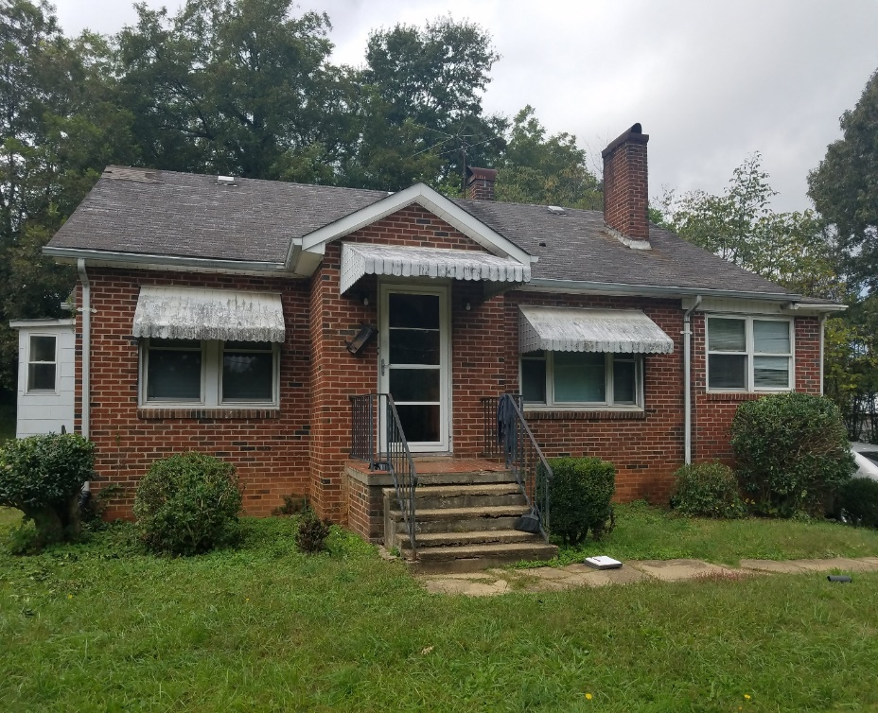

Note condition of roof shingles

Current Repair Status

- Jobs completed February 2
- Jobs in progress 20
- Jobs approved waiting start 18
- Jobs pending approval 10

The ReStore Report March 2021
Donations and Sales – Spring is in the air. It’s a season of hope. One year ago, saw the ReStore closed. Sales, donations, and volunteering came to a stop. Donations remain steady with occasional surprises from our major corporate donors. Furniture is still our main sales category by far. Construction materials and hardware have grown over the last year as home renovations and remodeling projects took off during the pandemic. All donations are good donations, but the best ones usually come from insider connections. Friends and neighbors can donate too just go online https://habitatcatawbavalley.org/restore/donate/ or call 828-327-7467 to schedule. Thanks
February Sales $62,984.51 Round up change donations $558.37
Open and Safe Update – New ReStore schedule Tuesday through Saturday 10am to 5pm. Mondays are workdays for volunteers and staff.
Social Media / Shop Online – We have a good following on FB and Instagram that eagerly wait for product postings. You can help, by taking pictures, creating memes, and posting to FB or even the online store. Mondays are wide open for “open and safe” volunteer work. www.shopcatawbarestore.org
Online stats: Over 1250 items uploaded, 98 still currently available.
Changes at the ReStore - The new warehouse bathroom and workstation are coming… construction should start sometime in March.
Safety is still Priority #1 for Staff and Volunteers “Wash your hands” – we’re still following the CDC, county and state health departments websites for advisories and warnings https://www.cdc.gov/coronavirus/2019-ncov/index.html, http://www.catawbacountync.gov/county-services/public-health/, https://www.ncdhhs.gov/divisions/public-health/coronavirus-disease-2019-covid-19-response-north-carolina focusing on Awareness, Communication, and Training.

__________________________________________________________

New Construction Report
March 2021

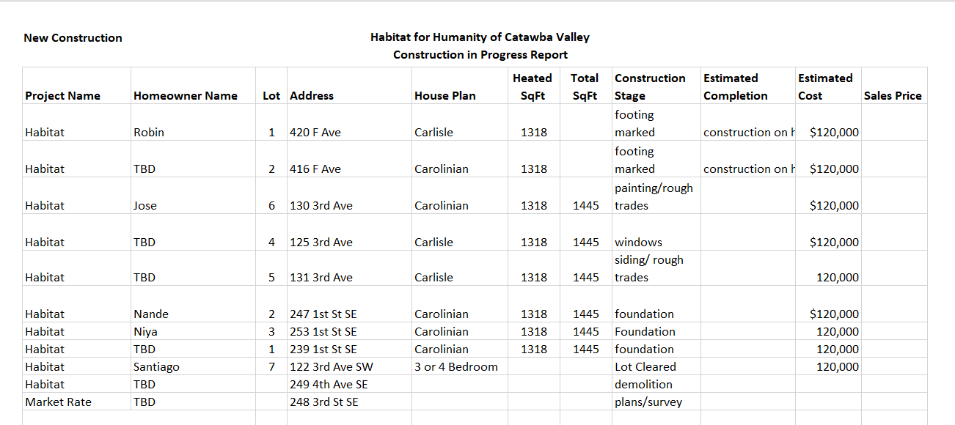

____________________________________________________________________________________

Messaging & Media
- Lenten reflection series
  - Launched 7 week Lenten reflection series on Istagram and Facebook
- Spring Direct Mail Appeal
  - Wrote and edited letter for Spring Appeal
  - Wrote reply card information for Spring Appeal
  - Wrote Thank-you letter for Spring Appeal
  - Submitted materials for design and layout to FMC
- Community and Housing Strategy Survey
  - Completed survey for HFHI to measure our impact in Neighborhood Revitalization and Aging in Place, and to better understand how our impact fits into the nationwide work of Habitat affiliates in these areas
- Easter Postcards
  - Created messaging and theme for Easter Postcards
  - Submitted to FMC for layout and design
  - Met with Homebuyers in project to instruct them on how to write personalized messages on the cards for major donors
- Cost of Home
  - Collaborated with Andrew to assess our affiliate’s participation in HFHI’s Cost of Home advocacy campaign
  - Concluded we will apply for participation at the Enthusiast Level

Outreach
- Lenoir Rhyne Equity, Diversity, and Inclusion Certification
  - EL01: The Courage Principle – 2/5
  - EL02: Foundations of Equity, Diversity, and Inclusion – 2/6
  - EL03: Equity over Everything – 2/20
  - EL04: Starting Equity, Diversity, and Inclusion Discussions – 2/17
  - EB01: Equitable Recruitment Strategies – 3/18
  - EB02: Building Inclusive Marketing Plans – 3/17
  - EB03: Measuring Organizational Inclusion
- Attended Building Futures Housing and Racial Equity summit hosted by Habitat Charlotte Region

Development
- Created a strategic plan for Church Outreach specific to 2021
  - Created content for Church Engagement Packet
    - Apostle Build 2021 Overview
    - Ways to Partner
    - 2020 Impact sheet
  - Submitted materials to FMC for design and layout
  - Will mail packets to churches by end of March
  - Will follow-up with phone calls to invite church leaders for private tours of Cottages at Ridgeview
- Team consultation session with Development Consultant, 2/25
- Began implementation of Asana project management platform
- Team consultation session with Development Consultant, 3/10

Volunteers
- Volunteer Hours 2/18 – 3/15:
  - 38 volunteers
  - 402 hours served
- Expanded updated COVID protocols to include adding a second waiver to volunteerhub which serves as a daily health assessment
  - Health assessment is now fully automated, and will be electronically completed and stored every time a volunteer signs in
  - Health assessment is included as a second event waiver that the volunteer signs in the volunteerhub system, instead of just written notice

