Habitat for Humanity of Catawba Valley
Board of Directors’ Meeting
February 22, 2021

Devotion – Tina Morgan

Adoption of Agenda — Charlotte Williams

Consent Agenda:
Items are considered routine by the Board of Directors and will be enacted by one motion. There will be no separate discussion of these items unless requested by a member. The item will be removed from the Consent Agenda, then added to Action or Informational Items.

1) Minutes from January Board Meeting
2) December+January Financial Reports (Separate Attachment)
3) Staff Reports

Action Items:
None this meeting

Informational Items:
- Habitat on the Hill Update – Andrew Isola
- Updated Covid Protocols for Habitat Volunteers – Jenna Ross
- Applicant Informational Meeting Update – Tina Morgan & Andrew Isola

Upcoming Events:
Next Board Meetings: March 22nd, April 26th, May 24th, June 28th

Consent Agenda
- January Minutes
Habitat Board of Directors’ Meeting
January 25, 2020
Members Present: Bill Burnham, Doug Dickson, Scott Echelberger, Rodney Garren, Lori Greveling, Frances Hilton, Ander Horne, Troy Howard, Graham Hunsucker, Pat Jones, Whit Malone, Cliff Moone, Charlotte Williams
Members Not Present: William Pleasant, Margaret Pope
Staff Present: Mitzi Gellman, Richard Greathouse, Andrew Isola, Jeff Mingus, Tina Morgan, Melissa Neal, Lynn Nelson, Derek Ross, Jenna Ross
Welcome and President’s Remarks
There being a quorum, the January meeting of the Habitat for Humanity of Catawba Valley Board of Directors was called to order by Board President Charlotte Williams at 12:01 pm. Due to COVID-19, the Board meeting was held via Zoom Meeting.
Devotion
Tina Morgan led the devotion by sharing scripture from Matthew 13:16-17 and Revelation 3:20 followed by prayer.
Adoption of Agenda
Upon a motion and second, the Board unanimously adopted the January Agenda.
Consent Agenda
The Board adopted the Consent Agenda of the November Board Meeting Minutes and the November Financial Reports by motion and second without dissent.
Action Items
- Troy Howard, Homeowner Selection Committee Chair presented a recommendation to the Board to deny 26 applicants due to failure to complete the application or meet the ability to pay guidelines. The Board moved to accept the recommendation with all in favor.
- Troy Howard also presented a recommendation to deny one applicant on the basis of willingness to partner. The Board made motion to accept recommendation with all in favor.
Informational Items
- The following Staff Reports were presented: Jenna Ross – Community Outreach, Lynn Nelson – Development, Jeff Mingus – ReStore, Richard Greathouse – Habitat Repairs!, Andrew Isola – Homeowner Services (Selection and Homeowners-in-Progress), Tina Morgan – Homeowner Services (Habitat Repairs! and Homeowner Support), Derek Ross – Construction.

Executive Director’s Update
- Mitzi Gellman, Executive Director gave recognition to her staff for their efforts in continuing the work of Habitat through the pandemic. She gave an update on two new sponsorships for The Cottages at Ridgeview – Flick Family $80,000 in honor of their children and Drendel Family Foundation $90,000 in memory of Matthew Drendel. Habitat has recently completed two land purchases: 1) Ridgeview, 122 3rd Avenue SE (the home will be demolished, and a new Habitat home constructed) and 2) one lot in Kenworth which will be divided into 3 building lots. The 2nd of 5 payments has been made to Paul Thompson. Habitat is looking into qualifying for the next round of the federal government’s PPP loan.
- Mitzi opened discussion with the Board on an additional property located in Ridgeview. Rodney Garren, Board Member, presented its location and history.

Adjourn
President, Charlotte Williams adjourned the meeting at 1:11 pm. The next Board Meeting will be held on Monday, February 22nd at 12:00pm via Zoom.

2) December + January Financials (available as separate attachment

__________________________________________________________________

3) Staff Reports

Development Report
January 2021

Grant Updates
- Plan, assign, review, and update 2021 Grant Calendar
- Grants Awarded:
  - Philip L. Van Every Foundation - $15,000 Habitat Repairs!
- Held two meetings with Amy Clinton to assign 1st quarter grants and review new research, communication with foundations, 2021 grant calendar.
Communication/Donors
- Continuing with personal thank you calls and handwritten thank you cards on incoming donations. We are striving to reach out and connect with our donors during the pandemic
- Donation Tax Statements – created, printed, and mailed
- Pledge payment reminders
- Lapsed donor phone calls
General
- 2021 Development Timeline Calendar – review and updated, added HITK to timeline. Continuing to finalize items.
- Create monthly e-Tapestry reports for appeal and development tracking and accounting
- Monthly zoom and phone meetings and with Mandy Pearce/Development
- Staff connections via ZOOM – Meet Tuesdays and Thursdays for staff meetings, meet Wednesdays for Development Meetings
- Attended e-Tapestry webinar on End of Year Statements

Homeowner Services: Selection and Homeowners-in-Progress
Report for Board of Directors February 2021

The Homeowner Program had a successful open application period from Jan 25th to Feb 5th. The program gave out 38 applications in person and had 94 visits to the application page on Habitat’s website. Applicant Information Meetings (AIMs) were held on Jan 29th and 30th in the parking lot of Morning Star First Baptist Church. The AIMs had more than 35 participants who were able to join us in a safe and socially distanced manner. We extend many thanks to Pastor David Roberts, Homeowner Selection Committee member Tim Shuford, and the congregation of Morning Star First Baptist Church for their help and the use of their facilities during the AIMs.

The Homeowner Program is very excited to welcome 3 new members to the Homeowner Selection Committee. Yesica Xiong works as a legal assistant in addition to working as a surgical CNA at CVMC. She also brings her experience as a current Habitat homeowner to the committee. Stephen Kue is a realtor at Century 21 American Homes in Newton. Luis Millan-Lara is the founder and owner of Valencia Photography, a small business in Hickory. Please join us in welcoming Yesica, Stephen, and Luis to Habitat.

The Homeowner Program participated in ‘Habitat on the Hill 2021’ from Feb 9th to Feb 11th. ‘Habitat on the Hill’ is Habitat for Humanity International’s annual legislative conference. It is a chance for Habitat staff, homeowners, and volunteers to unite as advocates for safe and affordable housing. Members of the Homeowner Program had the chance to meet with legislative aides for Rep. Patrick McHenry, Rep. Virginia Foxx, and Senator Thom Tillis to discuss steps Congress can take to support affordable housing. The focus of this year’s conference and lobbying was on COVID relief, passage of the Neighborhood Homes Investment Act, and continued budget appropriations for affordable housing.

Homeowner Services: Habitat Repairs!
Report for Board of Directors February 2021

We have worked our way through the last set of applications and have sent acceptance or denial letters as appropriate. Richard is now creating a scope of work for each newly accepted homeowner. Contracts will be created, reviewed, and signed with homeowners as those scopes of work are completed. We are also working on getting certificates of completion and recapture agreements in place for finished projects, collecting final payments, and closing completed files.
We have enough repair projects in hand to keep Habitat Repairs! working for the next few months, and so are not now accepting new applications. We are collecting names and contact information from folks who inquire so that we can invite them to apply later.

Homeowner Services: Homeowner Support
Report for Board of Directors February 2021
Delinquency Report
Reporting Period 1/29/2021 Total Mortgages: 96
Delinquent | # Mortgages Delinquent | Arrearage | % Delinquent
31-60 days | 7 | $ 3,325 | 7.3%
61-90 days | 4 | $ 1,962 | 4.2%
90 plus days | 5 | $ 8,888 | 5.2%
Total this month | 16 | $ 14,175 | 16.7%
Total 12/31/20  (95 mtgs) | 18 | $ 15,466 | 19.0%
Total same mo. prior yr:  1/31/20 (98 mtgs) | 18 | $ 21,237 | 18.4%
Jun. 2013, last mo. prior to MF (119 mtgs.) | 12 |  | 10.1%

Homeowner Services News
Delinquencies 31 or more days past due have fallen by 2.3% in the past month. Our most serious delinquencies that are 90 or more days past due have fallen by 5.3% in the past month. We expect this encouraging trend to continue as our homeowners receive tax returns in the next few months.

Santiago Agreda Parker and his family had chosen one of our lots on F Avenue but have now decided that they would prefer to be in Ridgeview. They have chosen the lot next to Jose Vargas where the old yellow house is being taken down. We hope to begin building the new home for Santiago and his family in the near future.

EeSaeng See, who was very sick with COVID, is recovering. Thelma Williams was recently released from the hospital where she was treated for COVID-19 and pneumonia. Andrea Davis is being treated for AML and is responding well. Many of our homeowners are still struggling with health issues, COVID related losses of hours or jobs, and with a variety of COVID related financial challenges.

Yee Vang, a homeowner who paid off his mortgage a few years ago, died in December 2020. His wife, one of his sons, and that son’s family plan to continue to live in their Habitat home.

Slow mail (sometimes taking 2 to 4 weeks for delivery) between Hickory and Affiliate Mortgage Services in Lansing, Michigan is a continuing problem for our homeowners as well as for our mortgage servicer. We are trying to support homeowners in dealing with this challenge. Some are setting up ACH withdrawals to make sure that their payments are received on time. Others are trying to mail their payments early or taking advantage of alternate payment methods like phone payments and payments through local CVS Pharmacies.
HABITAT REPAIRS!
Board report February 16, 2021
Repair of the Month

The February repair of the month features Dorothy Linebarger whose home is located at 494 Mable Street in the town of Catawba. Dorothy, who is 84, lives by herself in her home that was constructed in 1998. She has had a series of strokes in recent years, and her home needs the following repairs:
- New shingles (To be done by Blue Ridge Community action as a part of the six house they allocated to us from the BCBS grant.)
- Gutter repairs and leaf guard installation.
- Front and rear porch repairs
- Exterior foundation sealing.
- Bathroom vent replacements.
- Exterior trim repair and painting.

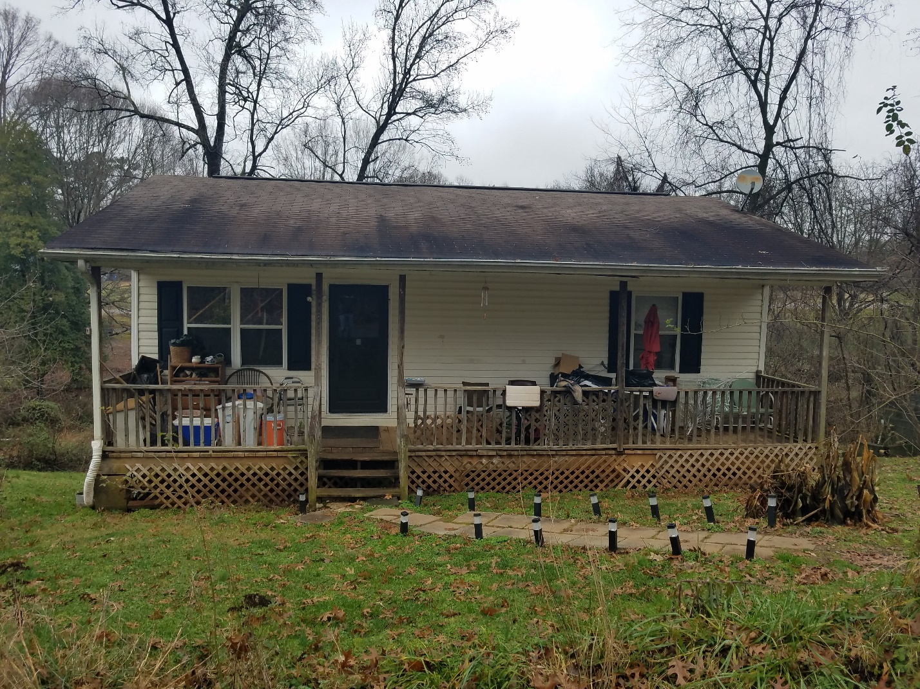
Ms. Linebarger’s Home

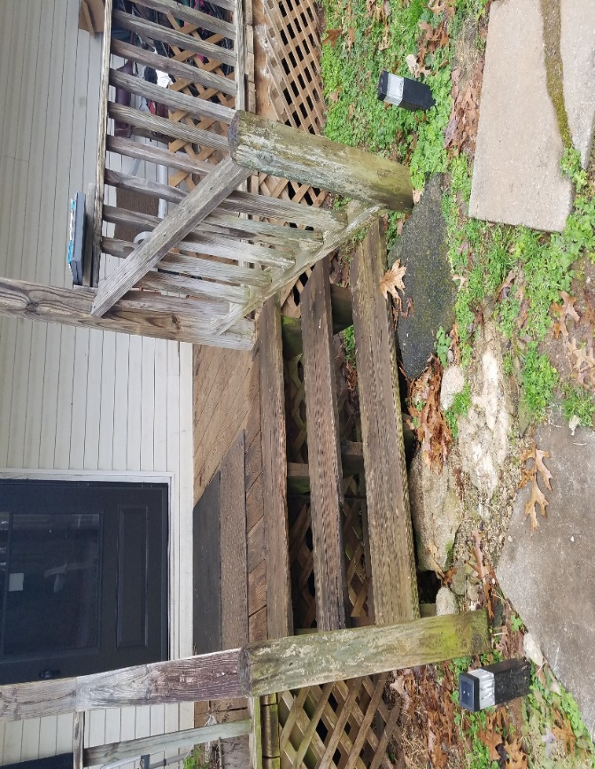
Front steps and porch in need of repair

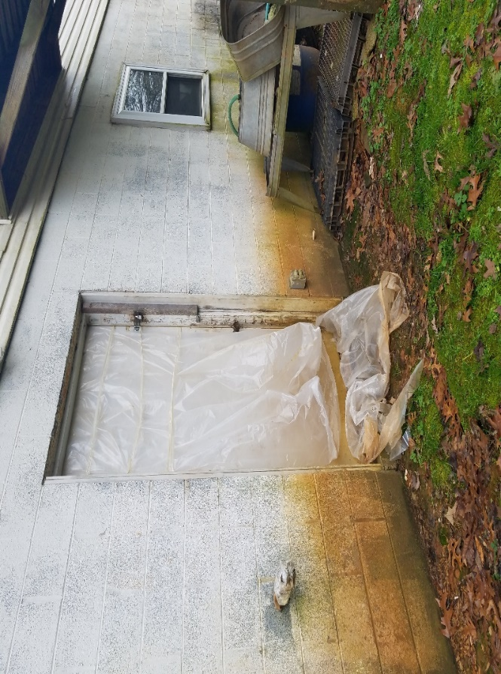
Foundation to be sealed and door repaired

Current Repair Status
- Jobs completed January 3
- Jobs in progress 20
- Jobs approved waiting start 18
- Jobs pending approval 10
- Habitat Partners Completions 2

The ReStore Report February 2021
Donations and Sales – Sales remain steady. Donations have tapered off from individuals and businesses.
Round up change donations December $638.29 January $803.84
ReStore CV Monthly Sales
 | FY 16-17 | FY 17-18 | FY 18-19 | FY 19-20 | FY 20-21
July | $67,253.41 | $71,625.33 | $80,146.76 | $82,539.22 | $61,298.52
August | $71,891.46 | $77,407.89 | $83,504.60 | $80,360.55 | $70,379.86
September | $71,337.90 | $56,283.67 | $77,744.76 | $65,581.02 | $70,701.05
October | $58,345.82 | $77,230.73 | $61,195.95 | $75,545.59 | $71,086.04
November | $63,641.08 | $66,987.67 | $68,489.54 | $69,951.60 | $56,816.62
December | $77,482.20 | $72,131.82 | $68,411.76 | $73,286.57 | $62,421.00
January | $63,111.57 | $57,343.17 | $58,732.51 | $85,636.65 | $69,478.37
February | $70,043.98 | $68,622.18 | $76,735.03 | $75,506.70
March | $76,671.33 | $77,237.35 | $85,598.29 | $23,889.75
April | $67,531.30 | $73,001.38 | $73,814.56 | $0.00
May | $80,323.70 | $78,168.17 | $73,717.21 | $14,149.52
June | $84,432.78 | $71,772.57 | $71,653.58 | $64,561.02
 | $852,066.53 | $847,811.93 | $879,744.55 | $711,008.19

Donation Procurement – Donations drive our success! New contacts in the ever-changing furniture industry open doors to more and better donations. All donations are good donations, but the best ones usually come from insider connections. Please reach out to Rick or me. If interested? Let’s chat and come up with an approach and make some donation contacts. Thanks!
https://habitatcatawbavalley.org/restore/donate/ or call 828-327-7467 to schedule. Thanks
Open and Safe Update – So far so good. Several volunteers have received covid vaccinations and are feeling more comfortable about helping. Welcome back Bonnie (Pricing/Merchandising one morning per week), Shari (Fabric one morning per week), Eleanor (Books), and Eric (Books). These are still limited returns and limited shifts but it’s a start.
Social Media / Shop Online Volunteer Engagement – We have a good following on FB and Instagram that eagerly wait for product postings. You can help, by taking pictures, creating memes, and posting to FB or even the online store. Mondays are wide open for “open and safe” volunteer work.
www.shopcatawbarestore.org We still need help growing and maintaining the online shop. New inventory added weekly for online offerings. Want to help keep our online store growing? We have “safer” volunteer days available every Monday and Tuesday. Our latest push…How to grow online sales?
Safety is still Priority #1 for Staff and Volunteers “Wash your hands” – we’re still following the CDC, county and state health departments websites for advisories and warnings https://www.cdc.gov/coronavirus/2019-ncov/index.html, http://www.catawbacountync.gov/county-services/public-health/, https://www.ncdhhs.gov/divisions/public-health/coronavirus-disease-2019-covid-19-response-north-carolina focusing on Awareness, Communication, and Training.

New Construction Report February 22, 2021

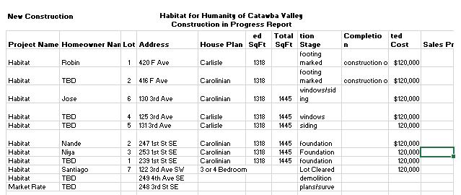

____________________________________________________________________________________

Informational Items:
- Habitat on the Hill - Andrew Isola
Links: Habitat on the Hill | Habitat for Humanity
Join us virtually for Habitat on the Hill - YouTube

- Updated Covid Protocols for Habitat Volunteers – Jenna Ross
Updated Covid Protocols for Habitat Volunteers
Below is a summary of the updated COVID protocols and volunteer expectations
SIGNAGE
- must be posted where the public can see. For construction, this is the inside of van doors.
- must be replaced if ripped, dirtied, or falls down.
- this is a NC legal protection required to protect the affiliate. We must have full compliance

COVID PROTOCOLS
- we must follow our protocols to the letter at all times.
- because we have physically and electronically posted our expectations, staff MUST make sure they are being carried out as written.
- there is no room for exceptions or flexibility. Even if volunteers push back or are regulars and feel they can bend the rules. This has to do with protecting the affiliate, so there is no wiggle room here. We must have consistency with our policies, and consistencies across every work site, every day.

REGISTRATION AND WAIVERING
- all volunteer work days must be reflected in an event posted in volunteerhub, no exceptions.
- all volunteers must sign the new 2021 COVID Waiver
- all volunteers must register in advance - advance registration contains a COVID health self-assessment, and must be completed EACH time an individual volunteers, which means volunteers must register for every event, no exceptions.
- all volunteers must be signed in every time they volunteer, in addition to maintaining accurate records, this also protects the affiliate, and lets us know who was on site any given day should we be notified about potential exposure.
- registration and sign-in should happen IN VOLUNTEERHUB
- HOWEVER, in the case of emergency for construction ... you are on site and volunteerhub isn't working, you are unable to figure out how to grant someone access to registration ... EMERGENCY ONLY, I have provided paper waivers that volunteers can sign.
- these ONLY apply to adults ... no minors can show up unregistered and be permitted to work that day
- have the individual fill out a paper waiver AND paper health assessment, and keep it on file in your volunteer folder
- Treat this paper waiver as applying to this single event ONLY, should this individual wish to volunteer again in the future, they need to register via volunteerhub and complete the electronic waiver there
- occasionally, there is some grey area as to whether someone is technically a volunteer or not, therefore new rule of thumb: if they plan to be on site for more than 20 mins, or the touch a tool, consider them a volunteer and waiver them

VOLUNTEER CULTURE
- we set the tone
- we worked hard to get to a point where the atmosphere led with mission
- we are here to form servant leaders, and help them develop their identity as a servant, community leader, and housing ambassador
- when coming back from a long break, trying to catch up on work, thinking about new protocols, and working with a small group of regulars, it’s easy to fall into a groove that is task oriented or that is defined by the attitudes of the volunteers. But whether they recognize it in the moment or not, ultimately volunteers come to us and stay with us because We are not just worksites, we are a community and a culture, grounded in our 4 cornerstone values, and that atmosphere starts top down. Invite you to really think about the culture you want to (continue) to shape on site. And to THANK YOU for all you continue to do in this arena, because more than anywhere else, the worksite is where the rubber meets the road for Habitat’s mission and message.

3.) Applicant Informational Meeting Update – Tina Morgan & Andrew Isola

Social media post on Applicant Informational Meeting

