Habitat for Humanity of Catawba Valley
Board of Directors’ Meeting
December 6, 2021

Devotion – Tina Morgan

Adoption of Agenda — Rodney Garren

Consent Agenda:
Items are considered routine by the Board of Directors and will be enacted by one motion. There will be no separate discussion of these items unless requested by a member. The item will be removed from the Consent Agenda, then added to Action or Informational Items.

1) Minutes from October Board Meeting
2) October Financial Reports (Separate Attachment)
3) Staff Reports

Informational Items:
Home is the Key Wrap Up
The Numbers: Lynn Nelson
The Growth: Mitzi Gellman
The Contribution: Jenna Ross

Action Items:
Homeowner Services Report – Margaret Pope
(4 separate items require a Board vote)

Upcoming Events:

Ridgeview Christmas Neighborhood Lighting: December 16 (Outside Event)
Next Board Meetings: January 24, February 28, March 28, April 25,
May 23, June 27

Habitat for Humanity of Catawba Valley
Board of Directors’ Meeting
October 25, 2021

Members Present: Jim Benton, Tara Bland, Bill Burnham, Doug Dickson, Scott Echelberger, Frances Hilton, Ander Horne, Graham Hunsucker, Pat Jones, William Pleasant, Margaret Pope, Charlotte Williams
Members Not Present: Rodney Garren, Lori Greveling, Gerry Knox
Staff Present: Mitzi Gellman, Richard Greathouse, Jeff Mingus, Tina Morgan, Melissa Neal, Lynn Nelson, Jenna Ross, Hannah Yost

Welcome
There being a quorum, the October meeting of the Habitat for Humanity of Catawba Valley Board of Directors was called to order by Board member, Charlotte Williams at 12:00 pm. Due to COVID-19, the Board meeting was held via Zoom Meeting.
Devotion
Jeff Mingus led the devotion sharing a Greek proverb and Habitat’s mission, vision, and principles followed by prayer.
Adoption of Agenda
Upon a motion and second, the Board unanimously adopted the October Agenda.
Consent Agenda
The Board made an addition to the Consent Agent of an oral Director’s Report. With this addition the Board adopted the Consent Agenda of the September Board Meeting Minutes, September Financial Reports, Staff Reports, and Director’s Report by a motion and second without dissent.
Director’s Report
Mitzi Gellman, Executive Director, updated the Board on the following:
- Finances and Properties: Habitat has received an anonymous donation of $104,000, the 2nd grant payment from TSH Charitable Foundation of $25,000 and an additional $25,000 from The Beaver Family Foundation. Jeff Jacomine has also donated a lot and house in Ridgeview approximate value of $60,000. John Clark will donate 5 lots within Ridgeview and a house sponsorship.

Habitat for Humanity of Catawba Valley
Board of Directors’ Meeting
October 25, 2021

No Action Items

Informational Items
Home is the Key Update
- Staff member, Lynn Nelson, gave a behind the scenes look of the steps/procedures to develop the annual Home is the Key Breakfast. She also updated the Board on the status of the 2021 HITK event:
  - 27 Table Captains, 16 sponsors at $24,300, a goal of $150,000, and approximately 480 guests have received an invitation and event packet.
- Staff member, Jenna Ross, presented the Board with a live HITK digital experience.
- Staff member, Tina Morgan, gave a power point presentation on Mortgages explaining the Habitat Loan Package and the facts and figures behind the 4 different mortgages.
Adjourn
Board member, Charlotte Williams, discussed the following upcoming events: Home is the Key - Thursday, November 4, Giving Tuesday - Tuesday, November 30th, and the next Board Meeting - Monday, December 6th. She then adjourned the October Board meeting upon a motion and 2nd with all in favor at 1:15 pm.

______________________________________________________________________________

2) October Financial Reports (Separate Attachment) – Doug Dickson

3) Staff Reports
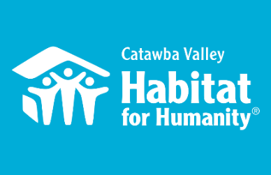
Community Outreach
October & November Board Report

Messaging & Media
- Christmas Direct Mail Appeal
  - Cowrote appeal in conjunction with consultants
  - Translated appeal into 12 different letter versions to correspond with different segments of our database
  - Created 3 different reply card versions
  - Coordinated layout and design of Christmas appeal with FMC
  - Designed website landing page for appeal
  - Wrote Thank You letter for appeal
  - Created eblast for appeal
- HITK
  - Filmed my portion of the Visionary Speaker role for HITK video
  - Scheduled reshoots with FMC
  - Heavily revised content of video, leading FMC through 6 different revisions of the final video
  - Collaborated with FMC to design the full series of webpages associated with HTK, including coordinating the different lead-up and live event views of each page
  - Created email campaign of 8 different eblasts including: announcement email, reminder email, day of email, thank you email, results email all tailored to different segments of our email list
  - Created social media campaign
- Giving Tuesday
  - Created eblast series, including: announcement email, reminder email, day of email, thank you email
  - Collaborated with FMC to design the full series of webpages associated with Giving Tuesday, including coordinating the different lead-up and live event views of each page
  - Created social media campaign consisting of 6 week series of lead-up posts, as well as hourly updates the day of.

Outreach
- NAACP Equity & Inclusion Task Force – Housing Committee Liaison
  - 10/28 – Task Force Executive Committee Meeting
  - 11/1 – hosted first ever Housing Committee Meeting
  - 11/15 – hosted Housing Committee Meeting
  - 11/29 – hosted Housing Committee Meeting
- LiveWell Catawba
  - 10/13 - Executive Committee Meeting
  - 10/19 – Board Meeting
  - 11/3 – Executive Committee Meeting
  - 11/9 – Board Meeting
  - 11/16 – Coalition Meeting
- Leadership Catawba
  - 10/13 – Subcommittee Planning Meeting
  - 11/11 – Facilitated non-profit panel at “Serving Our Community” Leadership Catawba session
  - 11/18 – Represented Habitat at “Serving Our Community: DEI” Leadership Catawba Session
- HFHI
  - 10/19 – webinar, Centering Resident Voices in Advocacy
  - 10/19 – webinar, Advancing Equity through Housing Affordability Indicators
  - 10/27 – webinar, How Policies, Practices, and Investments Shape our Neighborhoods (1/ of 6)
  - 11/10 – webinar, How Policies, Practices, and Investments Shape our Neighborhoods (2/ of 6)
  - 11/22 – webinar, How Policies, Practices, and Investments Shape our Neighborhoods (3/ of 6)

Development
- HITK
  - 11/4 – HITK event launch
- Giving Tuesday
  - 11/30 – Giving Tuesday
  - Oversaw the overall Giving Tuesday campaign
  - Recruited, coordinated, and thanked Advance Team donors
- Funding for Good
  - 9/10 – Met with Frances to prep testimonial for Christmas appeal
  - 9/13 – Coaching Call, Optimizing ROI for Christmas Direct Mail Appeal

- Stewardship
  - Coordinated Homeowners to sign Thanksgiving card, and provided theme, instructions, and support around crafting their message

Volunteers
- Volunteer Hours 10/1 – 11/30:
  - 95 volunteers
  - 1,300.5 hours served
    - 10/2 - The Guild at HTC
    - 10/9 – St. Luke’s Apostle Build
    - 10/14 – Holy Trinity Apostle Build
    - 10/30 – Holy Trinity Apostle Build
    - 11/6 – Corinth Apostle Build
    - 11/11 – Leadership Catawba @ ReStore
    - 11/13 – First Pres Hickory Apostle Build
    - 11/20 – Lenoir Rhyne Bears Build

___________________________________________________________________

Development Report
October/November 2021
Lynn Nelson
Grant Updates
- Grants Submitted:
        - Ameriprise
        - George Foundation
        - Millholland Endowment Fund
        - Pepsi
        - St. Gobain
- Grants In Process:
        - First Horizon LOI
        - ER Carpenter
- Grants Awarded:
  - Beaver Family Foundation - $25,000 The Cottages at Ridgeview
  - TSH Charitable Foundation -$25,000 (2nd payment from 2020 grant, The Cottages at Ridgeview)
  - Bank of America - $9,500 The Cottages at Ridgeview
  - Catawba Valley Community Foundation - $2,500 Habitat Repairs!
  - Sisters of Mercy - $35,000 Habitat Repairs!
- Monthly planning meeting with Amy Clinton, grant writer
- Phone meeting with Dianna Beaty, Leon Levine Foundation
- Met and toured The Cottages at Ridgeview with Joy Cline, Bolick Foundation

Home is the Key
October
- Received new HITK Sponsorships
  - Nordson Corporation $2,500
  - Northwest Drywall Company $500
- Finalize Guests List
- Prep and Mail Guest Packets
- Finalize Thank You Letters and On-Line Donation Form
- Finalize Video
- Prep Thank You emails
November
- Breakfast – November 4, 2021
- Made donor thank you calls
- Sent out guest thank you emails
- Sent out donor thank you email and letters
- Communicated with Table Captains on event and guest results
- 2021 HITK Stats
  - Current raised total $132,100 of our $150,000 goal!!
  - 2 - New Legacy Builder’s Society (LBS) members
  - 4 - Renewed LBS members (additional 5 years)
  - 3 – LBS members with 1 year upgrade
  - 1 pledge upgrade
Communication/Donors
- Finalize and mailed Thanksgiving Greeting Cards and Postcards
- Draft and Finalize Christmas (EOY) Appeal letter; coordinate segmentation and ask
- Finalize design and print Christmas Tribute greeting cards
- Finalize and print Christmas greeting card and postcard (to be sent out in December)
- HITK Pledge payment reminders
- Lapsed donor phone calls
- Thank you calls and handwritten thank you cards on incoming donations as needed
General
- Webinars:
  - HFHI: Donor Retention Oct. 5
  - BBCON – Blackbaud virtual conference Oct. 13-15
  - NewOrg Demo – Database HO Svcs Nov. 18
- Monthly tracking of development planner and mail appeals
- Phone meeting with Mandy Pearce/Donor Segmentation
- Staff Meeting on Tuesday and Development Meeting on Wednesday

_____________________________________________________________

Habitat “New Construction” Report
Derek Ross December 2021

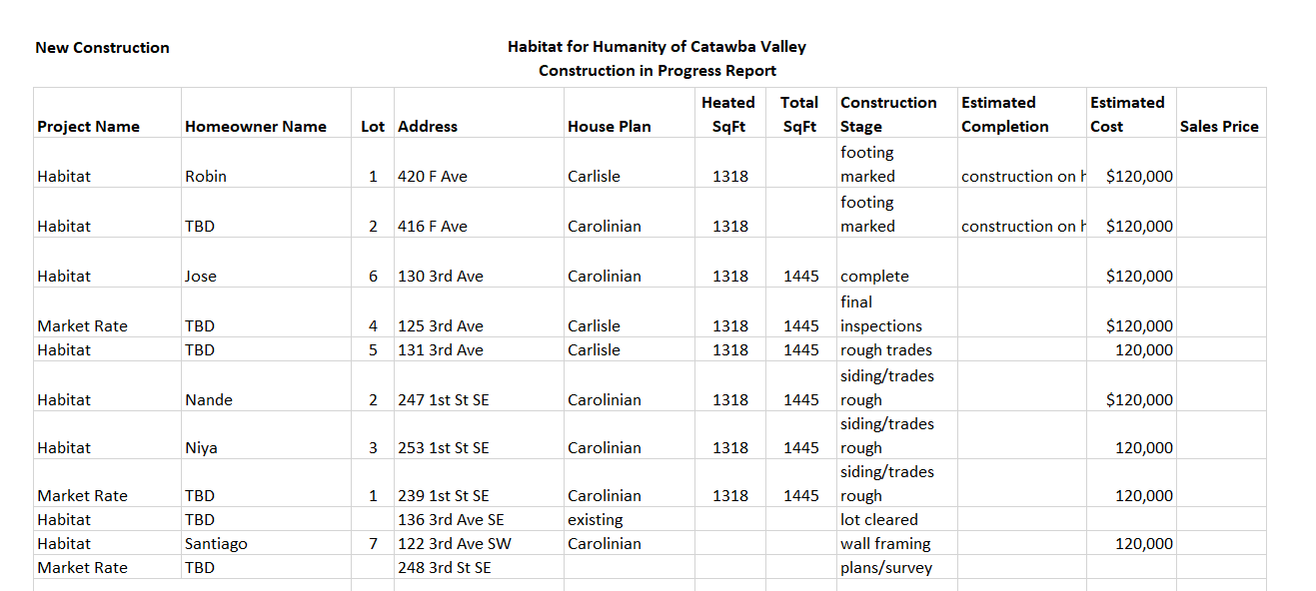

___________________________________________________________________

HABITAT REPAIRS!
Board Report December 2021
Repair of the Month

The repair highlighted this month is the home of Deborah Ward who lives at 703 20th Street NW in Hickory. Ms. Ward lives alone and has been a resident there for over 30 years.

We are in the process of completing the following repairs:
- Replacing roof shingles in partnership with Blue Ridge Community Action.
- Clean and repair gutters.
- Replace crawlspace vents.
- Repair and paint exterior of the house.
- Replace the HVAC and weatherization utilizing PNG grant funds
- Repairing and Painting exterior trim.
- Replacing rear deck and entrance.
- Demolishing old car port that is in dangerous condition. (On right in photo)

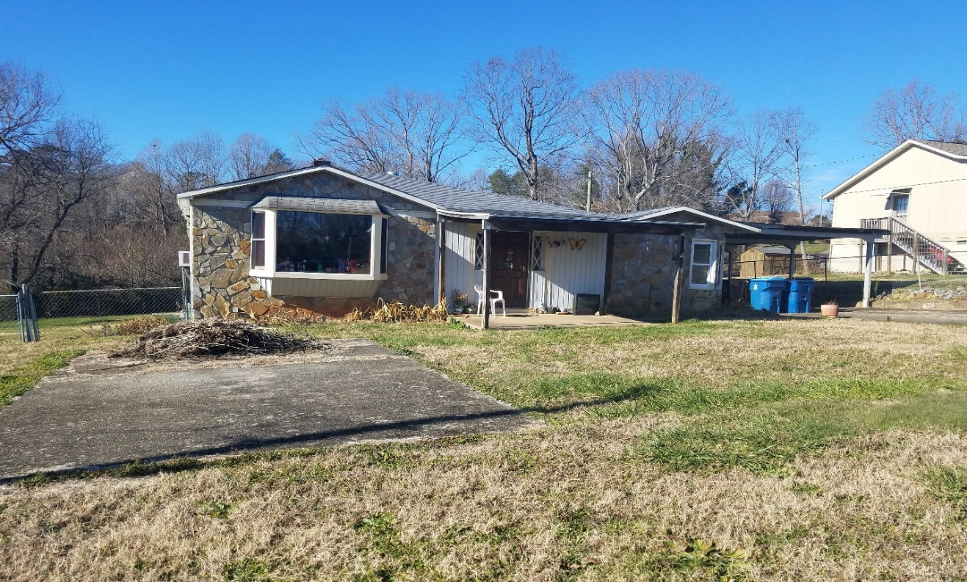
Ms. Ward’s home

Current Repair Status
- Jobs completed October 3
- Jobs in progress 29
- Jobs approved waiting start 4
- Habitat repairs Completed 2
_____________________________________________________________

The ReStore Report November 2021
Jeff Mingus, General Manager

Donations and Sales –
October Sales $74,069.11 Round Up Change $440.70 Transactions 2664
November Sales $72,804.50 Round Up Change $281.77 Transactions 2390
We had two good donation months from Corporate Gift In Kind donations. McCreary Modern, Good’s, and Home Depot in particular stand out. Christmas décor saved from last year and this year’s Lowe’s Hardware donations have been very popular. Here’s a look at our sales by category for the first 5 months.

 | SALES REPORT 7/1-11/30, 2021
 | Qty Sold Count | Average price | Total price
APPLIANCES | 170 | $72.63 | $12,347.05
BOOKS/RECORDS | 7277 | $1.78 | $12,984.21
COLLECTIBLES | 712 | $19.79 | $14,090.75
CONSTRUCTION
Cabinets | 97 | $55.42 | $5,375.48
Carpets | 54 | $40.13 | $2,167.05
Doors | 192 | $36.41 | $6,990.38
Flooring | 329 | $23.89 | $7,858.65
Misc | 690 | $8.02 | $5,535.60
Sinks | 62 | $30.79 | $1,909.15
Windows | 67 | $34.57 | $2,316.39
DONATIONS | 3659 | $0.51 | $1,874.83
FABRIC | 1031 | $4.28 | $4,417.63
FURNITURE
Artwork/Prints | 442 | $13.43 | $5,937.65
Better/New | 423 | $106.18 | $44,913.26
Gently Used | 2173 | $34.24 | $74,396.74
Office Furn | 354 | $32.25 | $11,417.94
HARDWARE | 11057 | $4.58 | $50,626.30
HOUSEWARES | 17770 | $2.52 | $44,846.55
JEWELRY | 870 | $1.88 | $1,636.42
LIGHTING/ELECTRONICS
Electronics | 66 | $7.13 | $470.70
Lamps/Fixtures | 1020 | $10.19 | $10,395.92
LED Bulbs | 8084 | $2.23 | $18,012.02

Let there be light – SUCCESS! The all areas of the store look great with the new LED lighting. Thank you!
Volunteer Needs - https://habitatcatawbavalley.org/restore/volunteer/ We have volunteer opportunities open throughout the week. Any “regular” volunteers, individuals who comply with our covid safe protocols and can commit to a regular schedule of a few hours each week, are welcome.
Shop Online – Have you seen our online shop? www.shopcatawbarestore.org It’s easy. Relax safe and comfortable at home. Browse the inventory, currently 160+ items. Add to cart and pay online. You’ll get an email notification when the transaction is complete and ready for pickup. Simply pull around to the warehouse loading area. Show your purchase notification and we’ll help you from there. Make sure you bring help for loading and the appropriate size vehicle… armoires do not fit inside small cars and loveseats should not ride on rooftops.

ReStore Holiday Schedule
Closed Dec. 24, 25, and 27 for Christmas and Jan 1 and 3 for New Year’s
Open to the Public Tuesday through Saturday 10am to 5pm. Mondays are workdays for volunteers and staff. Donation Drop offs Monday through Saturday 10am to 4pm Free Donation Pick Ups Tuesday through Saturday Call 828-327-7467 or go online https://habitatcatawbavalley.org/restore/donate/ to schedule.

_____________________________________________________________

Homeowner Services: Selection and Homeowners-in-Progress
Report for Board of Directors December 2021
The Homeowner Selection Committee met at the beginning of November to evaluate applications received in the latest application round. The Committee discussed the applications received that do not show the financial ability to purchase a home with Habitat. The Committee recommends to the board that these applications be denied for ability to pay reasons. An action item is presented to the board today with specifics. The Committee also discussed the applications received that do have the financial ability to purchase a home with Habitat. The Committee decided to conduct home visits with these applicants to assess their need for safe, affordable housing.

The Homeowner Selection Committee also discussed and approved a change in language to its “Homebuyer Delinquency Policy”. The policy details the consequences for delinquency on partnership requirements (sweat equity, down payment deposit, budget paperwork) during the time between acceptance and closing on a home. Changes to this policy are detailed in the action item that accompanies the new draft.

The Homeowner Selection Committee met again at the end of November to discuss the findings of its home visits. The Committee recommends to the board that the included applicants be accepted into the Homeownership Program. An action item is presented to the board today with specifics.

The homeownership program is continuing the orientation process for our most recently accepted homebuyers, Melissa, Miesha, and Epimenio. Orientation with Habitat takes time; it can be easy to overlook how steep the Habitat learning curve is. Anyone who has purchased a home knows how difficult a process it can be and how much there is to learn. With the addition of the Habitat partnership requirements of sweat equity, financial management classes, home buyer education, and budget work to that purchasing process, it becomes an immense amount of knowledge our homebuyers have to learn, retain, and act upon.

Homeowner Services: Habitat Repairs!
Report for Board of Directors December 2021
Habitat Repairs! has been inviting Ridgeview homeowners to apply for the program. Staff have been working to determine the best way to continue to spread the word about the HCV repair program to the Ridgeview community. Plans are being made to communicate with churches in the area to ask their help with our outreach through church announcements and bulletins.
Currently, there are 31 open projects, 0 waiting for contracts, 0 waiting for site visits, and 0 applications being assessed. 3 projects were completed, and the final paperwork has been sent to those homeowners for final sign offs.

Homeowner Services: Homeowner Support
Report for Board of Directors December 2021
Delinquency Report
Reporting Period 10/29/2021 Total Mortgages: 91
Delinquent | # Mortgages Delinquent | Arrearage | % Delinquent
31-60 days | 5 | $ 2,022 | 5.5%
61-90 days | 1 | $ 1,040 | 1.1%
90 plus days | 5 | $ 5,565 | 5.5%
Total this month | 11 | $ 8,627 | 12.1%
Total 9/30/21 (91 mtgs) | 8 | $ 7,548 | 8.8%
Total 12/31/20 (95 mtgs) | 18 | $ 15,466 | 19.0%
Total same mo. prior yr: 10/30/20, 96 mtgs | 18 | $ 14,535 | 18.8%
Jun. 2013, last mo. prior to MF (119 mtgs.) | 12 |  | 10.1%

Homeowner Services News
Delinquencies are up this month, but the additional delinquent loans are all in the 31-60 day category. Loans in this category come and go frequently for reasons as insignificant as late mail. The number in this group last month was unusually low; this month it’s more normal. Our delinquency numbers overall continue to be significantly improved over recent years.

We received word this month that one of our homeowners who paid off her house in 2014, Trinia Coulter, died in 2016. Her heirs plan to sell the home. Trinia’s deed for the property contains the Habitat restriction that the home be owner-occupied. We are trying to contact Trinia’s heirs in order to ensure that they receive the maximum benefit from the property while following Habitat’s mission by preserving the home for affordable homeownership.

We’ve participated in a Listening Session with NCHFA and with the Camp Habitat Intensive Homeowner Services training, picking up good ideas and fresh inspiration from both. We are also joining the effort with the NAACP Equity and Inclusion Task Force’s Housing Committee.

Tina has completed the annual continuing education requirement for training in the NC SAFE Act. This is required by HFHI for affiliate good standing and compliance with regard to having a Qualified Loan Originator.

___________________________________________________________________

Informational Items:

Home is the Key Wrap Up:
  - The Numbers: Lynn Nelson
  - The Growth: Mitzi Gellman
  - The Contribution: Jenna Ross
___________________________________________________________________

Action Items:

1)Homeowner Selection Committee – Margaret Pope

Please be aware that this information is of a confidential nature and should be handled accordingly.

Action Item 1:
The following individuals were presented to the Homeowner Selection Committee as applicants for the homebuyer program. These individuals were recommended for denial based on their failure to complete the application or to meet the ability to pay guidelines presented in the Homeowner Selection Policy. The HSC has voted to deny these individuals for ability to pay and recommends this decision to the Board. Per HFHI recommendation, names are not included in the information to the board to lessen the appearance of biased decision making.

Applications Denied Due to Ability to Pay
Applicant Name | Household Size with Number of Adults/Children | Income as a % of AMI | Reason for Denial
Applicant #1 | 1 | 26% | Income lower than selection guidelines
Applicant #2 | 4 (1/3) | 1% | Income lower than selection guidelines
Applicant #3 | 4 (1/3) | 61% | Collections / Charge-offs = $3,771
Applicant #4 | 2 adults | 27% | Income lower than selection guidelines
Applicant #5 | 1 | 50% | Debt to Income ratio of 45%
Applicant #6 | 2 (1/1) | 21% | Income lower than selection guidelines
Applicant #7 | 5 (2/3) | 91% | Income higher than selection guidelines
Applicant #8 | 1 | 44% | Collections / Charge-offs = $16,707
Applicant #9 | 3 (1/2) | 36% | Income lower than selection guidelines
Applicant #10 | 2 (1/1) | 20% | Income lower than selection guidelines
Applicant #11 | 1 | - | Incomplete Application
Applicant #12 | 2 (1/1) | 62% | Collections / Charge-offs = $14,148
Applicant #13 | 2 (1/1) | 70% | Collections / Charge-offs = $1,843
Applicant #14 | 6 (2/4) | 98% | Income higher than selection guidelines
Applicant #15 | 2 (1/1) | 46% | Debt to Income ratio of 53%
Applicant #16 | 3 (1/2) | - | Application submitted after deadline
Applicant #17 | 1 | 27% | Income lower than selection guidelines
Applicant #18 | 6 (3/3) | - | Collections / Charge-offs = $10,010
Applicant #19 | 3 (2/1) | - | Application submitted after deadline
Applicant #20 | 3 (2/1) | 40% | Ability to pay – Needs 12 months of steady employment income
Applicant #21 | 6 (1/5) | 52% | Ability to pay – Needs 12 months of steady employment income
Applicant #22 | 1 | 74% | Collections / Charge-offs = $580
Applicant #23 | 3 (1/2) | 59% | Incomplete Application

Action Item 2:
The following individuals were presented to the Homeowner Selection Committee as applicants for the homebuyer program. The Committee recommends denial of the following applications as they do not meet HFHCV Selection criteria.

Household of 2 (1 adult/ 1 child)
The Homeowner Selection Committee reviewed this application and found that the applicant met the income and credit guidelines set forth in the selection policy. However, the background report obtained on the applicant shows two charges for which the applicant has outstanding warrants. The Committee believes this situation presents an unknowable financial instability for the applicant as the applicant could have a disruption to their employment and/or court costs or judgments associated with these warrants. The Committee recommends this application be denied for ability to pay reasons.

Household of 4 (1 adult/ 3 children)

The Homeowner Selection Committee reviewed this application at its first meeting and found that the applicant met the income and credit guidelines set forth in the selection policy at that time. However, between the Committee’s first and second meetings the applicant accepted a new job at a new company. At the Committee’s second meeting the applicant could not present enough documentation from their new job to verify their ability to repay a mortgage loan. This lack of documentation was not due to a willingness to partner issue but rather due to the small amount of time the applicant had been employed at their current job. The Committee is unable to determine the applicant’s ability to pay at this time because of the lack of available documentation. The Committee recommends this application be denied for ability to pay reasons.

Action Item 3:
The following individual was presented to the Homeowner Selection Committee as an applicant for the homebuyer program. The applicant listed below meets Habitat for Humanity of Catawba Valley’s (HFHCV) selection criteria for ability to pay, need, and willingness to partner. The Homeowner Selection Committee recommends that this applicant be conditionally approved for HFHCV’s Homeownership Program and pre-approved for a Habitat loan. Per HFHI recommendation, names are not included in the information to the board to lessen the appearance of biased decision making.

Household of 4 (2 adults/ 2 children)
Employer: Engineered Controls Intl, Conover, NC; Disability Income
Annual Income: $43,022.61
Applicant’s Income as a percentage of Area Median Income: 71%
Credit: meets requirements
Consumer Debt to Income Ratio: 33% (back end)
Current Rent: $561.00/ month (16% of monthly gross income)
Need: Structural issues, poor air quality, problems with pests
Willingness to partner: meets requirements

Action Item 4:
The Homeowner Selection Committee has revised an existing policy used with our homebuyers-in-progress regarding their partnership commitments. This policy serves as the governing document to assess consequences in the event of a delinquency in partnership commitments prior to closing. The Homebuyer Delinquency Policy has been revised in two substantive ways:

- The revised policy gives greater prominence to the section of policy detailing how a homebuyer in progress can honor their Habitat partnership commitments even when dealing with hardship.
- The previous policy subtracted earned sweat equity hours from a homebuyer’s total in the event of a delinquency. The revised policy will instead add hours to a homebuyer’s required total in the event of a delinquency. The committee felt this change in language made this section of policy more positive while also maintaining consequences for a delinquency.

The Homeowner Selection Committee recommends to the board that the Homebuyer delinquency policy be approved as revised.

(Copy of the Policy)
Habitat for Humanity of Catawba Valley
Homebuyer Delinquency Policy

Habitat for Humanity of Catawba Valley hopes that homebuyers will be dedicated to honoring their partnership commitments in the same way that they will later dedicate themselves to making house payments and to being a supportive Habitat partner through many years of homeownership. Habitat considers a homebuyer’s monetary deposit ($700) and sweat equity hours (250/500) to be of equal value and recognizes them as one. Both the commitment of time and money must be verified each month, on time and as instructed. Neither stands alone. The failure to submit one is the same as failure to submit both, and the consequence for delinquency therefore always applies to either or both.

A homebuyer who anticipates an inability to make timely payments of either sweat equity or savings may present a request for additional time to a Homeowner Services Coordinator before a monthly deadline is missed. If a homebuyer is unable to reach a Homeowner Services Coordinator, a detailed message should be sent to the Homeowner Services Coordinator before a monthly deadline is missed. The homebuyer should offer:
- an acceptable reason for the difficulty, and
- a plan for how and when the missed savings or hours will be made up.

Due on the 1st of each month:
A bank transaction receipt to verify a deposit of $60 or more into your designated savings account, proof of increasing savings, and at least the minimum monthly number of sweat equity hours as required by the HFHCV Partnership Agreement are due.

For families not yet on the construction list, the consequence of delinquency is:
If there is no contact as described above between the homebuyer and the Homeowner Services Coordinator before the due date, all sweat equity earned to that point will be forfeited. The homebuyer will begin accumulating sweat equity again on the first of the next month.

For families who are on the construction list, the consequence of delinquency is:
If there is no contact as described above between the homebuyer and the Homeowner Services Coordinator before the due date, 50/100 hours will be added to the total minimum required number of hours due. If construction has not yet begun, the homebuyer will also be moved to the bottom of the construction list.

Due on the 7th of each month:
The spending plan record and all associated receipts and documents, copies of paystubs, and copies of bank statements as required by the HFHCV Partnership Agreement are due.

The consequence of delinquency is:
If there is no contact as described above between the homebuyer and the Homeowner Services Coordinator, one hour of sweat equity will be forfeited for each day (or portion of a day) this documentation is late.

Missed or Late to Homebuyer Education Classes:
If there is no contact as described above between the homebuyer and the Homeowner Services Coordinator, one hour of sweat equity will be forfeited for arriving late without notice and for every additional 15 minutes late to a class. Eight hours of sweat equity will be forfeited for each missed class.
Draft 11/2021

