Habitat for Humanity of Catawba Valley
Board of Directors’ Meeting
January 25, 2021

Devotion – Tina Morgan

Adoption of Agenda — Charlotte Williams

Consent Agenda:
Items are considered routine by the Board of Directors and will be enacted by one motion. There will be no separate discussion of these items unless requested by a member. The item will be removed from the Consent Agenda, then added to Action or Informational Items.

1) Minutes from November Board Meeting
2) November Financial Reports (Separate Attachment)

Action Items:

1) Family Selection

Informational Items:
1) Staff Reports

Upcoming Events:
Next Board Meetings: February 22nd, March 22nd, April 26th, May 24th

Consent Agenda
- November Minutes
Habitat Board of Directors’ Meeting
November 23, 2020

Members Present: Bill Burnham, Doug Dickson, Scott Echelberger, Lori Greveling, Frances Hilton, Troy Howard, Pat Jones, Whit Malone, Cliff Moone, William Pleasant, Margaret Pope, Charlotte Williams
Members Not Present: Rodney Garren, Ander Horne, Graham Hunsucker
Staff Present: Mitzi Gellman, Richard Greathouse, Andrew Isola, Jeff Mingus, Tina Morgan, Melissa Neal, Lynn Nelson, Derek Ross, Jenna Ross, Hannah Yost
Welcome and President’s Remarks
There being a quorum, the November meeting of the Habitat for Humanity of Catawba Valley Board of Directors was called to order by Board President Charlotte Williams at 12:02 pm. Due to COVID-19, the Board meeting was held via Zoom Meeting.
Devotion
Tina Morgan led the devotion by sharing scripture from Matthew 14:25-33 and Romans 10:14-15 followed by prayer.
Adoption of Agenda
Upon a motion and second, the Board unanimously adopted the November Agenda.
Consent Agenda
The Board adopted the Consent Agenda of the October Board Meeting Minutes, the October Financial Reports, and the Staff Reports by motion and second without dissent.
Action Items
No Action Items.
Informational Items
- Home is the Key - Updates were given by Lynn Nelson - Development Assistant, and Jenna Ross - Community Outreach Coordinator on the success of the virtual event held Thursday, November 12, 2020.
- Derek Ross - Director of Construction, Richard Greathouse – Habitat Repairs! Manager, and Jeff Mingus – ReStore General Manager gave updates on their current operations.
Executive Director’s Update
- Mitzi Gellman, Executive Director gave an update stating we have completed the Northstone neighborhood with the closing of the final home last week. Currently looking to purchase two additional properties in Ridgeview (Cottages at Ridgeview) and one property on F Avenue (potential to split the property into two building lots).
Adjourn
President, Charlotte Williams adjourned the meeting at 1:10 pm. The next Board Meeting will be held on Monday, January 25th at 12:00pm via Zoom.

2) November Financials (available as separate attachment)

Action Items:

Family Selection Recommendations:

Action Items from the Homeowner Selection Committee

Action Item 1: The following individuals were presented to the Homeowner Selection Committee as applicants for the homebuyer program. These individuals were recommended for denial based on their failure to complete the application or to meet the ability to pay guidelines presented in the Homeowner Selection Policy. The HSC has voted to deny these individuals for incomplete application or for ability to pay and recommends this decision to the Board. Per HFHI recommendation, names are not included in the information to the board to lessen the appearance of biased decision making.

Applications Denied Due to Incompleteness or Ability to Pay
Applicant Name | Household Size with Number of Adults/Children | AMI | Reason for Denial
Applicant #1 | 5 (1/4) | - | Application withdrawn
Applicant #2 | 3 (1/2) | - | Application submitted after due date
Applicant #3 | 1 | 23% | AMI lower than selection guidelines
Applicant #4 | 3 (2/1) | 22% | AMI lower than selection guidelines
Applicant #5 | 1 | 28% | AMI lower than selection guidelines
Applicant #6 | 2 | 26% | AMI lower than selection guidelines
Applicant #7 | 1 | 36% | AMI lower than selection guidelines
Applicant #8 | 2 | 81% | AMI higher than selection guidelines
Applicant #9 | 1 | 33% | AMI lower than selection guidelines
Applicant #10 | 4 (1/3) | 20% | AMI lower than selection guidelines
Applicant #11 | 4 (1/3) | - | Incomplete Application
Applicant #12 | 2 | - | Incomplete Application
Applicant #13 | 3 (1/2) | 80% | AMI higher than selection guidelines
Applicant #14 | 2 (1/1) | 41% | Debt to income ratio of 63%
Applicant #15 | 3 (1/2) | - | Incomplete Application
Applicant #16 | 2 | 71% | Collections/Charge-offs = $7,343
Applicant #17 | 3 (1/2) | 39% | Collections/Charge-offs = $13,235
Applicant #18 | 3 (1/2) | 47% | Debt to income ratio of 47%
Applicant #19 | 2 (1/1) | 44% | Collections/Charge-offs = $5,563
Applicant #20 | 4 (1/3) | 61% | Collections/Charge-offs = $22,637
Applicant #21 | 1 | 71% | Debt to income ratio of 48%
Applicant #22 | 6 (1/5) | 34% | Collections/Charge-offs = $229
Applicant #23 | 1 | 41% | Collections/Charge-offs = $407
Applicant #24 | 5 (1/4) | 54% | Collections/Charge-offs = $3,180
Applicant #25 | 2 (1/1) | 62% | Collections/Charge-offs = $49,160
Applicant #26 | 2 (1/1) | 22% | AMI lower than selection guidelines

Action Item 2: Applicant #27 met ability to pay guidelines as set forth in the Homeowner Selection Policy. However, the Homeowner Selection Committee flagged a number of willingness to partner issues with this applicant. These issues included an unwillingness to live in the Ridgeview neighborhood of Hickory and difficulty contacting the applicant by phone, text, and email. The Homeowner Selection Committee recommends Applicant #27 for denial based on willingness to partner issues.

Please be aware that the above information is of a confidential nature and handle it accordingly.

Informational Items:
- Staff Reports:

Messaging & Media
- Giving Tuesday – December 1st
  - Designed and carried out Giving Tuesday Campaign;
  - Created digital assets:
    - 7 lead up social media posts, posted weekly in the run up to Giving Tuesday
    - 4 Eblasts:
      - Matching Challenge announcement
      - day before reminder
      - day of
      - results total
    - 17 day-of social media posts
    - Website Landing Page (now disabled)
  - Recruited and coordinated advanced team of pre-determined donors
  - $26,700 raised in total
- Christmas Direct Mail Appeal
  - Created content for Christmas mail appeal
  - Facilitated design and layout with FMC
  - Created digital assets:
    - Social media
    - Eblast
    - Landing page: https://habitatcatawbavalley.org/at-the-heart-of-home-for-the-holidays/
- Stewardship
  - Thanksgiving postcards
  - Thanksgiving Eblast
  - Christmas Postcards
  - Christmas Eblast
  - Ordered pictures and wrote notes for Christmas card inserts
  - Christmas gifts for major donors:
    - Facilitated homeowner written Christmas cards
    - Wrapped gifts
    - Facilitated team for gift deliveries
    - Delivered gifts as well
    - 123 major donor Christmas gifts distributed
  - Volunteer Appreciation Gifts
    - Provided t-shirts and thank you notes for all Habitat’s 2020 regular volunteers

Outreach
- LiveWell Catawba Board Meeting, 11/18
- LiveWell Catawba Strategic Plan, 12/7
- Future of Catawba County Summit, 12/8
- LiveWell Catawba Board Meeting, 12/15

Development
- One on One consultation session with Development Consultant, 11/20
- VIP session with Development Consultant, 11/22

Events
- Giving Tuesday, Dec 1
- Volunteer Appreciation Christmas Gifts, Dec 12/23 – 1/8

Volunteers
- Volunteer Hours 8/18-9/15:
  - 41 volunteers
  - 829 hours served
- Reactivated regular volunteers in New Construction: opportunities opened to a closed group of regular volunteers on a limited basis
- Updated volunteer landing page: https://habitatcatawbavalley.org/get-involved/volunteer-with-habitat/

__________________________________________________________________

Development Report
November-December 2020

Grant Updates
- Grants Submitted:
  - E.R. Carpenter Foundation - $50,000
  - Informational Summary to PNC Bank
- Grants Awarded:
  - Philip L. Van Every Foundation - $15,000 Habitat Repairs!
- George Foundation - $40,000 Habitat Repairs!
- Zoom meetings and phone communication with grant writer, Amy Clinton.
Communication/Donors
- Continuing with personal thank you calls and handwritten thank you cards on incoming donations. We are striving to reach out and connect with our donors through this time of sheltering in place
- Thanksgiving & Christmas Postcards
- Christmas Appeal Letter
- Christmas and Thanksgiving Specialty Cards
- Major Donors Christmas gift w/handwritten note from homeowners in process
- Pledge payment notifications and lapsed donor phone calls
- Monthly zoom and phone meetings and with Mandy Pearce/Development
- Staff connections via ZOOM – Meet Tuesdays and Thursdays for staff meetings, meet Wednesdays for Development Meetings
Events
- Home is the Key – November 12, 2020 as of 12/31/20 we raised $186,925.00

__________________________________________________________________

The ReStore Report November/December 2020
Donations and Sales – Hours of operation Monday -Saturday 10am to 4pm for drop off donations and purchase pickups, Tuesday – Friday for scheduled truck pickups, and Wednesday – Saturday 10am to 4pm Open to the public. Sales for November 2020 $56,816.62, December 2020 $62,154.00 (approx.). This is a combination of in-store and online (Nov $178.37 / Dec $2303.36) sales. “Round-up your purchase donations” continue strong in Nov $474.98 / Dec 638.29.
Thank you to Mortenson Construction for the massive donation of materials and equipment from the solar farm project in Maiden. 80 crews were employed to install. Each crew had a full compliment of coolers, carts, umbrellas, safety equipment, tool belts, and so much more. These items have been a great boost to the “construction and hardware” departments. These items were saved from the dump by a supervisor that knew Habitat’s mission and the Restore’s purpose. Please continue to share donation information with our community. You never know when a donation connection can be made.
(Jan. Donation Surprise – Lowe’s Plannogram was picked up 1/6/21.)
https://habitatcatawbavalley.org/restore/donate/ or call 828-327-7467 to schedule. Thanks
Open and Safe Update – New IWave technology added to our air systems to help eliminate virus particulates. The (3) container system continues to work well. Followed by a disinfecting sanitizer spray before being brought into the store for clean-up, pricing, and merchandising.
www.shopcatawbarestore.org We still need help growing and maintaining the online shop. New inventory added weekly for online offerings. Want to help keep our online store growing? We have “safer” volunteer days available every Monday and Tuesday. Our latest push…How to grow online sales?
ReStore Volunteer Opportunities cont. – We have a core group of dedicated volunteers who weekly work regular shifts of a couple hours. It is a big challenge to keep the ReStore running safe and open. There are several ways you or someone you know can still help. We need cashiers, book advocates, fabric rollers, and social media gurus.
Safety is still Priority #1 for Staff and Volunteers “Wash your hands” – we’re still following the CDC, county and state health departments websites for advisories and warnings https://www.cdc.gov/coronavirus/2019-ncov/index.html, http://www.catawbacountync.gov/county-services/public-health/, https://www.ncdhhs.gov/divisions/public-health/coronavirus-disease-2019-covid-19-response-north-carolina focusing on Awareness, Communication, and Training.

Jeff Mingus, ReStore General Manager
HABITAT REPAIRS!
Board Report January 2021
Repair of the Month

Habitat Repairs is happy to announce that we have partnered with Blue Ridge Community Action in Morganton to do 6 roof replacements using a Blue Cross Blue Shield grant they received for roof repairs. This will save Habitat over $10,000.00

The repair featured this month is for Edith Clemmons who lives by herself at 1253 Venus Street in Conover.
We will be doing the following repairs:
- Replacing roof shingles in partnership with Blue Ridge Community Action.
- Clean and repair gutters.
- Replace crawlspace vents.
- Repair and paint exterior of the house.
- Service and repair heat pump.
- Repair and paint front and rear doors
- Repairing and Painting exterior trim.

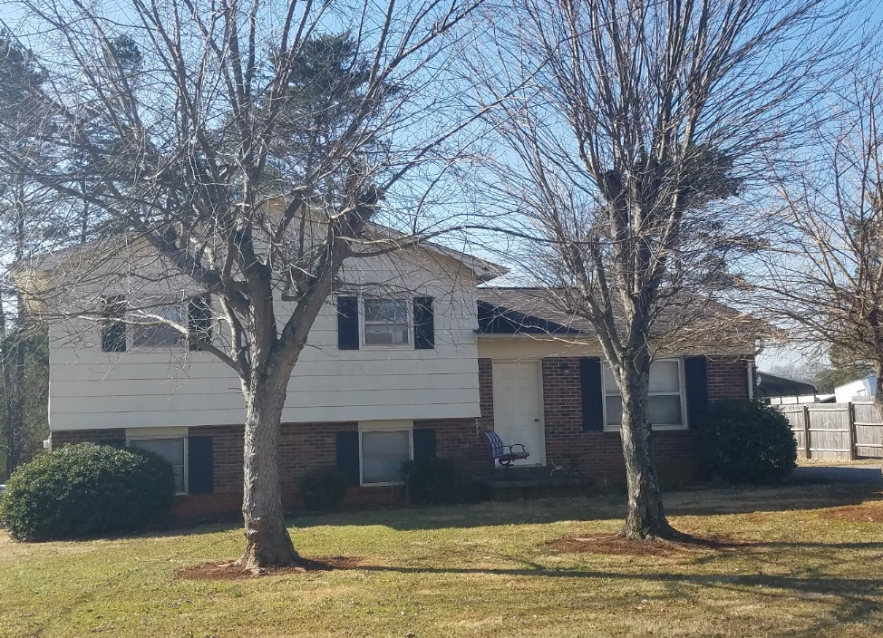
Ms. Clemons House

Current Repair Status
- Jobs completed Nov.-Dec 5
- Jobs in progress 17
- Jobs approved waiting start 16
- Jobs pending approval 12

____________________________________________________________________________________

Homeowner Services: Selection and Homeowners-in-Progress
Report for Board of Directors January 2021
The Homeowner Selection Committee met in December to review applications received for the Homeownership Program. At the December meeting, the Committee voted to recommend to the board the denial of some applications for incompleteness or for ability to pay reasons. Action Item 1 from the Committee represents this recommendation. The Committee met in January to review the remaining application. At the January meeting, the Committee voted to recommend to the board the denial of the remaining application for willingness to partner reasons. Action Item 2 from the Committee represents this recommendation.

The Homeowner Program has a new open application cycle beginning in January. Applications will be available at the Applicant Information Meetings (AIMs), the Habitat office, and on the Habitat website from January 25th to February 5th. These applications will be due on February 12th. AIMs will be held on January 29th and 30th at 10am in the parking lot of Morning Star First Baptist Church. The Homeowner Services staff and Homeowner Selection Committee wish to thank Rev. David Roberts and his congregation for the use of its facilities for the AIMs.

Homebuyers continue to faithfully fulfill their partnership responsibilities. With the help of diligent COVID safety measures our homebuyers have continued to complete sweat equity hours in the ReStore, on the construction site, and at home. Each of our homebuyers wrote Christmas thank you cards to earn sweat equity hours. These cards were distributed to Habitat donors prior to Christmas to thank them for their involvement with Habitat. The Christmas cards were very well received by our donors.

Homeowner Services: Habitat Repairs!
Report for Board of Directors January 2021
Hannah worked diligently before her maternity leave, working to have enough applications to keep Habitat Repairs! busy through April. She expects to be back at work around the end of March, and then will have the month of April to get new applications in and ready before new projects are needed by construction.
Thanks to a sudden rush of applications in the last two weeks before Christmas, we have more repair projects in hand than expected. We are busy pushing through the applications in progress, getting letters out and contracts in place, and being available to repair homeowners.
We are not now accepting new applications for repairs. We are collecting names and contact information from folks who inquire so that we can invite them to apply later.
We currently have six joint projects in progress with Blue Ridge Community Action and have referred another to the City of Hickory. For all these projects, we will be doing some repairs that fall within our scope, while the homeowners will have other needs met by partner programs.

Homeowner Services: Homeowner Support
Report for Board of Directors January 2021
Delinquency Report
Reporting Period 12/31/2020 Total Mortgages: 95
Delinquent | # Mortgages Delinquent | Arrearage | % Delinquent
31-60 days | 7 | $ 3,586 | 7.4%
61-90 days | 1 | $ 2,294 | 1.1%
90 plus days | 10 | $ 9,586 | 10.5%
Total this month | 18 | $ 15,466 | 19.0%
Total 10/30/20  (97 mtgs) | 18 | $ 14,535 | 18.8%
Total same mo. prior yr:  12/31/19 (98 mtgs) | 22 | $ 21,492 | 22.4%
Jun. 2013, last mo. prior to MF (119 mtgs.) | 12 |  | 10.1%

Homeowner Services News
Our delinquencies are pretty stable, and almost exactly the same as they were at the end of September. The small gains that we made in October were lost to an end-of-year slide. Still, we are in remarkably good shape given the challenges that 2020 has presented to successful homeownership.

We continue to have a few homeowners at any given time who have lost hours due to COVID changes at work or who have missed work due to being sick or having to quarantine. Also, many homeowners’ work hours and finances are affected by having children at home attending virtual school.

Som Lor and Kandi Xiong closed on their home on November 19, 2020, and now there’s more great news for them - Som has a new kidney!

Pennie McCorkle Audrey and Lula Camp have paid off their mortgages. Pennie and Lula, homeowners in our first Highland neighborhood, both paid off their houses a few months early. Congratulations to them!

We expect the next two foundations in our Ridgeview neighborhood to be for Nande Rhinehardt and Niya Mayfield.

EeSaeng See is currently very sick with COVID. Deidre Mayfield is dealing with a long, slow COVID recovery. Kimberly Moore had a mild stroke at the end of September and is recovering at home now, continuing to have trouble with the motor areas of speech but understandable if she speaks carefully. Our homeowners would appreciate your prayers.

Tina has completed the NC SAFE Act training required to maintain status with HFHI as a Qualified Loan Originator.

____________________________________________________________________________________




