Habitat for Humanity of Catawba Valley
Board of Directors’ Meeting
September 28, 2020

Devotion – Tina Morgan

Adoption of Agenda — Charlotte Williams

Consent Agenda:
Items are considered routine by the Board of Directors and will be enacted by one motion. There will be no separate discussion of these items unless requested by a member. The item will be removed from the Consent Agenda, then added to Action or Informational Items.

1) Minutes from August Board Meeting
2) August Financial Reports
3) Staff Reports

Action Items:
1) No Action Items for this meeting

Informational Items:
1) Home is the Key Update – Development Staff
2) Policy Proposals - Mitzi

Upcoming Events:
Next Board Meetings: October 26th, November 23rd OR November 30th

Habitat Board of Directors’ Meeting
Minutes of August 24, 2020
Members Present: Bill Burnham, Doug Dickson, Scott Echelberger, Rodney Garren, Lori Greveling, Frances Hilton, Ander Horne, Graham Hunsucker, Pat Jones, Whit Malone, William Pleasant, Margaret Pope, Charlotte Williams
Members Not Present: Robin Creel, Troy Howard, Cliff Moone
Staff Present: Mitzi Gellman, Richard Greathouse, Andrew Isola, Jeff Mingus, Tina Morgan, Melissa Neal, Lynn Nelson, Derek Ross, Jenna Ross, Hannah Yost
Welcome and President’s Remarks
There being a quorum, the August meeting of the Habitat for Humanity of Catawba Valley Board of Directors was called to order by Board President Charlotte Williams at 12:00 pm. Due to COVID-19, the Board meeting was held via Zoom Meeting.
Devotion
Tina Morgan led the group in a devotion sharing Philippians 4:7, 1 Thessalonians 5:16-18 and a homeowner story followed by prayer.
Adoption of Agenda
The order of the Agenda items was rearranged to discuss Informational Items prior to the Action Items. Upon a motion and second, the Board unanimously adopted the updated August Agenda.
Consent Agenda
The Board adopted the Consent Agenda of the July Board Meeting Minutes, the July Financial Reports, and the Staff Reports by motion and second without dissent.
Informational Items
- Home is the Key Update
  - Jenna Ross, Community Outreach Coordinator, presented information regarding format change of Habitat’s annual fundraising event. Due to COVID-19, we will be doing a virtual event which will be prerecorded.
  - Lynn Nelson, Development Assistant, gave an update on event date and the role of a virtual Table Captain.
Action Items
- Andrew Isola, Homeowner Services Coordinator, gave a brief overview of the Mortgage Origination Policy. Margaret Pope presented the staff’s recommendation to approve the new policy; with all in favor, the Mortgage Origination Policy was approved.

Executive Director’s Update
Mitzi Gellman, Executive Director, briefly discussed two new upcoming policies which will be presented to the Board of Directors at a future Board meeting:
- Policy on How to Handle Restricted and Unrestricted Gifts
- Executive Director’s Succession Plan
Mitzi also attended a recent meeting with Derek Ross, Director of Construction and the City of Hickory in regard to land acquisition by donation or purchase for future building sites.
Adjourn
President Charlotte Williams adjourned the meeting at 12:50 pm. The next Board Meeting will be held on Monday, September 28th at 12:00pm via Zoom.

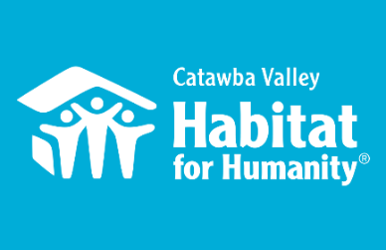
September 22nd Board Report
Community Outreach

Messaging & Media
- Launched an email funnel to increase our electronic mailing list, and steward audience members according to their engaged interests; funnel delivers a series of building plans and planting instructions for raised bed gardens. Included an ask at the end of funnel, added a new entry point for existing subscribers, and implemented analytics to measure our impact.
- Home is the Key
  - Met with FMC to finalize the structure of the program and determine tech needs
  - Met with Nathan of FMC and homeowner services to develop video content, identify homeowner speakers, and establish a timeline
  - Coordinating to-do items between FMC and staff
  - Print materials and web pages in development
- Fall Mail Appeal
  - Wrote content for fall mail appeal
  - Coordinated layout and design with FMC
  - Mailer is set to drop Oct 2-5
- Developing content for 2019-2020 Annual Report

Outreach
- LiveWell Board Meeting, Zoom 8/18
- Leadership Catawba Advisory Board Meeting, 8/19
- Leadership Catawba Advisory Board Meeting, 8/26
- Leadership Catawba Advisory Board Meeting, 9/11
- LiveWell Catawba Board Meeting, 9/15

Development
- Attended Benevon Virtual Event for another organization as reference point, 8/19
- VIP session with Development Consultant, 9/8
- Development Consultant phone call, 9/14

Volunteers
- Volunteer Reactivation continues with regular volunteers in the ReStore and Repairs
- LR Men’s Soccer team completed a packet of letters to be sent to our elderly repair clients who may be experiencing loneliness as a result of the pandemic
- Volunteer Hours 8/18-9/15:
  - 27 volunteers
  - 511.25 hours served

The ReStore Report September 2020
Donations and Sales – Sales for August 70,379.86. This is a combination of in-store and online sales ($1143.00 total sales). Wednesdays are a success! Extended hours and an extra day, the store is now open Wednesday through Saturday 10am to 4pm with a donation drop off schedule of Monday through Saturday 10am to 3pm.
Donations continue to come in daily both individual drop off and scheduled truck pickups. Donations are great. Our community loves Habitat. It may be a side effect of covid-19 and people having more time to organize, clean out, and remodel but the store stays packed. Our efforts to provide a safe and open shopping and donation experience are paying off.
Heads up! Fingers crossed for a rather large donation coming all the way from London, UK. It is in the final stages of negotiating more details soon.
Thriftcart online platform. We continue to learn our new POS and donations system. We are collecting email addresses and developing a plan to send out on marketing and thank-you campaigns.
www.shopcatawbarestore.org. We continue to add inventory weekly for online offerings. Want to help keep our online store growing? We have “safer” volunteer days available every Monday and Tuesday. Our latest push…How to grow online sales?
Safety is still Priority #1 for Staff and Volunteers “Wash your hands” – we’re still following the CDC, county and state health departments websites for advisories and warnings https://www.cdc.gov/coronavirus/2019-ncov/index.html, http://www.catawbacountync.gov/county-services/public-health/, https://www.ncdhhs.gov/divisions/public-health/coronavirus-disease-2019-covid-19-response-north-carolina focusing on Awareness, Communication, and Training.

Jeff Mingus, ReStore General Manager

__________________________________________________________________

Construction Report - Derek Ross September 28, 2020
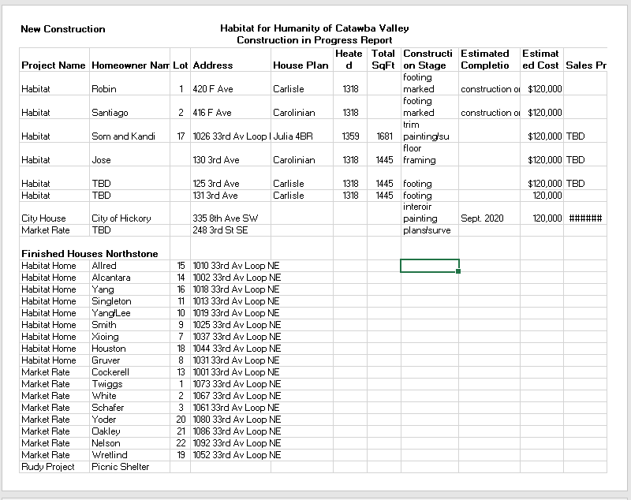
__________________________________________________________________

Homeowner Services:

Homeowner Support
House Payment Delinquency Report

Reporting Period 8/31/2020 Total Mortgages: 97
Delinquent | # Mortgages Delinquent | Arrearage | % Delinquent
31-60 days | 6 | $ 3,368 | 6.2%
61-90 days | 2 | $ 2,329 | 2.1%
90 plus days | 9 | $ 8,691 | 9.3%
Total this month | 17 | $ 14,388 | 17.6%
Total 6/30/20  (98 mtgs) | 18 | $ 14,615 | 18.7%
Total same mo. prior yr:  8/30/19 (99 mtgs) | 22 | $ 19,839 | 22.2%
Jun. 2013, last mo. prior to MF (119 mtgs.) | 12 |  | 10.1%

Homeowner Services News
Total delinquencies have gone down by another 1% during August, which means that they’ve gone down by 3% in July and August, which is unusual for this time of year regardless of the pandemic. They also continue to be lower than they were at this time last year.

There are no new homeowners who we know of who are struggling with payments due to a COVID related loss of income. That total is still twelve.

We have been approached with an offer of food assistance for our families from a business in Lenoir that is offering this assistance to homeowners of four or five Habitat affiliates in our area. We have worked out a partnership with St. Luke’s Methodist Church to help us with the logistics of receiving and distributing this food, and we have twelve families who have expressed interest in receiving this help.

The appraisal for the last home in Northstone came in at $141,000. We expect to close on that house with Som Lor and Kandi Xiong in late October or early November.

Repairs! Program
The Repairs! Program is continuing to respond to inquiries for repairs work. Due to the steady amount of inquiries, staff are able to invite those who inquire to apply for the program. A waiting list is not being used as there is a good “flow” from when the inquiry comes in to acceptance and to completion of work. Since the last Board meeting, 6 more applications were sent out to individuals who have inquired about getting repairs work done on their homes. 3 applications are being assessed for program qualifications. 2 contracts have been completed since the August Board meeting, and 1 contract is in process.
The City of Hickory reached out to Habitat staff about the City assisting with repairs work for applicants whose income was either less than 50% of the AMI or less than 30% of the AMI. Staff were coordinating with the City to share project costs and manpower in order to increase the amount of individuals Habitat could help. Unfortunately, the City filled its two programs and were unable to take any of the 4 applicants who had applied to Habitat and qualified for the City’s programs. Habitat is continuing to move forward with these 4 applications.

Homeowner Program

The Homeowner Program is gearing up for a new round of homeowner selection. The Homeowner Selection Committee will be looking for applicants who are interested in purchasing one of the homes we are building in Ridgeview. Our next open application period will be September 21st – October 2nd with applications due on October 9th. AIM meetings will be held on September 22nd in the morning and evening in the parking lot of Morning Star Baptist Church. A big thank you to Morning Star Baptist Church for agreeing to host our AIM meetings.

The Homeowner Program will be holding the AIM meetings with strict adherence to local, state, and federal recommendations for gathering during the pandemic. Meeting numbers will be restricted. The meetings will be held outside in a parking lot; it will be recommended that individuals remain in their cars during the meeting. For those individuals who arrive at the meeting by walking or public transportation, seating will be provided with appropriate social distancing. All individuals attending the meeting will be required to wear a mask.

The Homeowner Program has finished the Homebuyer Program orientation with all our new homebuyers-in-progress. We are excited to walk with our new homebuyers-in-progress on their journey towards homeownership. Our homebuyers-in-progress continue to maintain regular work hours and remain healthy during the pandemic. They have shown steady commitment to their program responsibilities; turning in budget paperwork, completing sweat equity hours, and adding to their savings.

HABITAT REPAIRS! BOARD REPORT
September 2020
The repairs program has continued completing outside repairs with volunteers . We completed two projects that consisted of exterior trim and entrance repairs.
In addition, one roof was installed, two plumbing and one electrical repair were completed utilizing subcontract work.
Current repair status: (Since last board meeting.)
- Jobs in completed. 2
- Jobs in progress. 12
- Jobs approved waiting start. 7
- Jobs pending Scope of Work. 4

Repair of the Month
The repair featured this month is for Ella England. She is an 80-year-old widow who lives alone in her home in Newton.
We will be doing the following work with Habitat funds.
- Repairing her roof. Her back-porch roof has some real issues.
- Making front porch repairs.
- Plumbing repairs.
- Gutter repairs.
- Electrical repairs.
- Replacing cellar door.
We also be installing a new HVAC system and weatherizing her home utilizing PNG funds.

. 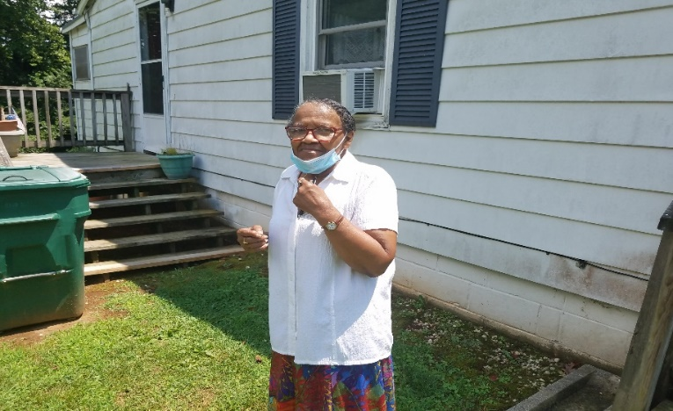

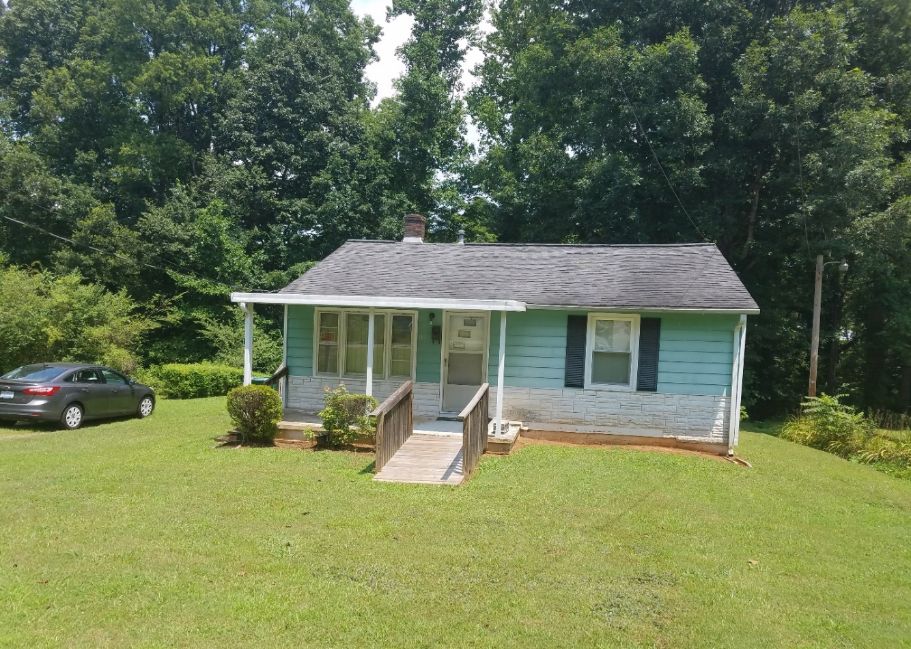
Ms. England’s Home

Back porch Repairs
____________________________________________________________________________________
Development Report
August/September 2020
Grant Updates
- Grants Submitted:
  - Leon Levine Foundation - $25,000.00 General Support
  - Publix Charities - $10,000.00 Construction/General Support
  - Catawba Valley Community Foundation $2,500 Habitat Repairs! Program
  - Truist Bank - $25,000 General Support
- Grants Awarded:
- City of Hickory - $20,000 Habitat Repairs!
- TSH Foundation - $50,0000 ($25,000 per year for 2 years for new construction)
- Zoom meetings and phone communication with grant writer, Amy Clinton.
- 3rd & 4th Quarter Grant Review – City of Hickory CRC, Millholland Endowment Fund, PNC Bank, George Foundation, Pepsi, ER Carpenter. Research on AARP, Ameriprise, American Woodmark Foundation and Truist Foundation
Communication/Donors
- Continuing with personal thank you calls and handwritten thank you cards on incoming donations. We are striving to reach out and connect with our donors through this time of sheltering in place
- Fall direct mail piece, letter and mailing list in process
- Continuing email pledge payment notifications and lapsed donor phone calls
- Christmas and Thanksgiving cards – envelopes addressed and stamped, signatures in process
- Monthly zoom and phone meetings and with Mandy Pearce/Development
- Staff connections via ZOOM – Meet Tuesdays and Thursdays for staff meetings, meet Wednesdays for Development Meetings
Events
- Home is the Key – In Process
  - Table Captain ask letter completed and mailed.
  - Sponsorship levels, updated and completed.
  - Vendor list for sponsorship ask letter completed and mailed.
  - Table Captain role and responsibilities updated.
  - Table Captain training packet, in process, updating
  - Event save the date and registrant packet, in process.
  - Working with FMC on event pre-recordings, story video and event technology
- Attended fundraising virtual event.

Action Items:

1) None this meeting

Informational Items:

1) Home is the Key Update:
The program combines speakers and videos of volunteers, house construction, home repairs and homeowners. The theme of this year’s event will be: “Homes, Community, Hope and +You,” the current HfHI theme.
Fundraising will rely primarily on Table Captains to invite friends and family to virtually “attend” the event. Currently we have 12 confirmed Table Captains with 6 declining to participate.
Another key component to the event’s success will be securing sponsors. Currently we have sponsors contributing $13,500 toward our goal of $80,000.
Request to Board:
1) serve as a Table Captain and recruit a minimum of 9 guests
2) secure one sponsorship. Sponsors are asked to contribute $1,000 – 5,000

2) Policy Proposals – Mitzi (see attached)

a) Restricted and Designated Funds Policy (DRAFT)

Habitat for Humanity of Catawba Valley, Inc.,
Policy on Restricted and Designated Funds

Policy Background: This policy has been recommended by Whisnant and Co. auditors to address a donor’s designation or restrictions that may be indicated at time of the donation. This intent will be reflected in the affiliate’s donor software tracking and reconciled monthly with the accounting general ledger.
POLICY Statement:
Donor Restricted Funds - Restricted but qualifies under GAAP Simultaneous release option.
Habitat for Humanity of Catawba Valley will apply the new ASU Standards to its general construction, construction material purchases, and general repair program and record the contribution as without donor restrictions.
The Organization will make every effort to meet the donor’s imposed restrictions but the Board (Finance Committee) does reserve the right to use these funds for other needed purpose(s) as it may deem appropriate.
The primary reason for this reserved right is because a charitable contribution is a gift, and a gift is a transfer of all a donor’s “dominion and control” over the donated property. If after accepting a restricted gift, events occur which impact the ability to meet the donor’s designation, then the donor will be notified.
(The new ASU 958 provides a not-for-profit entity with the ability to elect a policy to report donor-restricted contributions whose restrictions are met in the same reporting period as the revenue is recognized as support within net assets without donor restrictions, reports consistently from period to period, and discloses its accounting policy.)

PURPOSE:
The policy on Restricted and Designated Funds provides policy, information, and guidance for receiving and disbursing restricted and designated funds due to ASU 2018-08 Not-for-Profit Entities (Topic) Clarifying the Scope and the Accounting Guidance for Contributions Made and ASC Topic 606 Revenue from Contracts with Customers

CATEGORIES OF FUNDS
There are several categories of funds each of which has its own benefits and
constraints:
  - Donor Restricted Funds - The donor determines if the funds are to be restricted. Fund designation is specified in writing or through an understood agreement with the nonprofit. Foundations that provide restricted funds often describe how they want their money allocated when they distribute the award.

  - Board Designated Funds - funds without donor restrictions. The board decided to set these funds aside for a specific use or to be used at a specific time. The board can vote to free up the funds or change the purpose of the designated funds.

  - Without Donor Restriction Fund – These funds are available for general use.

DONOR RESTRICTED FUNDS:
It is important for the organization to identify what the donor’s intent was at the time the donation was given in order to determine if a restriction exists. There are several Donor Restricted Funds which we have identified:
General Construction
Construction material purchases
General Repair program
Specific Repair program
House sponsorship
Land acquisition
Capital expenditure

b) Executive Succession Plan Policy (DRAFT)
Policy Background: Several Charitable Foundations request a copy of the organization’s Executive Succession Plan as part of their application process. This policy is presented to the Board of Directors for their consideration.

Policy Statement:
A change in executive leadership is inevitable for all organizations and can be a very challenging time. Therefore, it is the policy of Habitat for Humanity of Catawba Valley to be prepared for an eventual permanent change in leadership—either planned or unplanned—to ensure the stability and accountability of the organization until such time as new permanent leadership is identified.
The Board of Directors shall be responsible for implementing this policy and its related procedures. It is also the policy of the board to assess the permanent leadership needs of the organization to help ensure the selection of a qualified and capable leader who is representative of the community; a good fit for the organization’s mission, vision, values, goals and objectives; and has the necessary skills for the organization.
To ensure the organization’s operations are not interrupted while the Board of Directors assesses the leadership needs and recruits a permanent executive officer, the board will appoint interim executive leadership as described below.
The interim chief executive officer shall ensure that the organization continues to operate without disruption and that all organizational commitments previously made are adequately executed, including—but not limited to—loans approved, reports due, contracts, licenses, certifications, memberships and obligations to lenders or donors (investors) of Habitat for Humanity of Catawba Valley. It is also the policy of Habitat for Humanity of Catawba Valley to develop a diverse pool of candidates and consider at least three final candidates for its permanent Executive Director position.
Habitat for Humanity of Catawba Valley shall implement an external recruitment and selection process, while at the same time encouraging the professional development and advancement of current employees. The interim Executive Director and any other interested internal candidates are encouraged to submit their qualifications for review and consideration by the transition committee according to the guidelines established for the search and recruitment process.

Procedures for Succession:
For a temporary change in executive leadership (e.g., illness or leave of absence) refer to the organization’s personnel handbook. In the event the Executive Director (ED) of Habitat for Humanity of Catawba Valley is no longer able to serve in this position (e.g., leaves the position permanently), the executive committee of the board of directors shall do the following:
1. Within five business days, appoint an interim Executive Director according to the following line of succession: a. Assistant Executive Director of Habitat for Humanity of Catawba Valley b. External consultant (with experience as an interim executive director)
2. Within 15 business days, appoint an executive transition committee, in the event that a permanent change in leadership is required. This committee shall be comprised of 2 members (at least one member of the executive committee and two members of the board of directors.) It shall be the responsibility of this committee to implement the following preliminary transition plan:
a. Communicate with key stakeholders regarding actions taken by the board in naming an interim successor, appointing a transition committee and implementing the succession policy. The organization shall maintain a current list of key stakeholders who must be contacted, such as lenders and donors (investors) of Habitat for Humanity of Catawba Valley, foundations and government agencies.
b. Consider the need for consulting assistance (e.g., transition management or executive search consultant) based on the circumstances of the transition.
c. Review the organization’s strategic plan and conduct a brief assessment of organizational strengths, weaknesses, opportunities and threats to identify priority issues that may need to be addressed during the transition process and to identify attributes and characteristics that are important to consider in the selection of the next permanent leader.
d. Establish a time frame and plan for the recruitment and selection process.
e. Refer to the personnel handbook for additional procedures.

