Habitat for Humanity of Catawba Valley
Board of Directors’ Meeting
August 24, 2020

Devotion – Tina Morgan

Adoption of Agenda — Charlotte Williams

Consent Agenda:
Items are considered routine by the Board of Directors and will be enacted by one motion. There will be no separate discussion of these items unless requested by a member. The item will be removed from the Consent Agenda, then added to Action or Informational Items.

1) Minutes from July Board Meeting
2) July Financial Reports
3) Staff Reports

Action Items:
1) 1) Mortgage Origination Policy Update

Informational Items:
1) Home is the Key Update

Upcoming Events:
Next Board Meetings: September 28th, October 26th, November 23rd OR November 30th

Consent Agenda:

1) Minutes from July Board Meeting
2) July Financial Reports (separate attachment)
3) Staff Reports

Habitat Board of Directors’ Meeting
Minutes of June 1, 2020

Members Present: Doug Dickson, Scott Echelberger, Lori Greveling, Frances Hilton, Ander Horne, Troy Howard, Pat Jones, Whit Malone, Cliff Moone, Margaret Pope, Charlotte Williams
Members Not Present: Bill Burnham, Rodney Garren, Robin Creel, Graham Hunsucker, William Pleasant
Staff Present: Mitzi Gellman, Richard Greathouse, Andrew Isola, Jeff Mingus, Tina Morgan, Melissa Neal, Derek Ross, Jenna Ross, Hannah Yost

Welcome and President’s Remarks
There being a quorum, the June meeting of the Habitat for Humanity of Catawba Valley Board of Directors was called to order by Board President Charlotte Williams at 12:03 pm. Due to COVID-19, the Board meeting was held via Zoom Meeting.
Devotion
Tina Morgan led the group in a devotion, and then invited Board Member Whit Malone to lead the group in prayer for “a Time of Anger, Unrest, and Injustice”.
Adoption of Agenda
Upon a motion and second, the Board unanimously adopted the June meeting.
Consent Agenda
The Board adopted the Consent Agenda of the May Board Meeting Minutes and the April Financials by motion and second without dissent.

Action Items
- Following a motion and second, the Board unanimously voted to submit a grant request to the Peeler-Casey Funds.
Informational Items
Staff members presented the department reports.

Adjourn
President Charlotte Williams adjourned the meeting at 1:00 pm. The next Board Meeting will be held on Monday, July 27th at 12:00pm via Zoom.
Upcoming Events
- Virtual Gathering of Gratitude, Thursday June 4th, 5:30 pm via Zoom
- Corinth Legacy House Virtual Dedication, Wednesday June 10th, 7:00 via Zoom

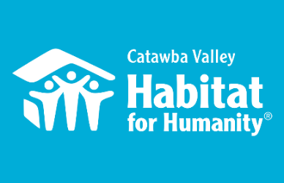
August 24th Board Report
Community Outreach

Messaging & Media
- Continued with Phase 2 messaging across all communication platforms.
- Created an email funnel to increase our electronic mailing list, and steward audience members according to their engaged interests; funnel delivers a series of building plans and planting instructions for raised bed gardens
- Home is the Key – outlined format for moving Home is the Key to virtual event; coordinated with FMC and homeowner services to identify key speakers to feature in video content and to shape narrative arc of event
- Developing content for 2019-2020 Annual Report

Outreach
- LiveWell Board Meeting, Zoom 7/21
- Leadership Catawba Advisory Committee, 8/12
- Leadership Catawba Advisory Committee, 8/18

Development
- One on One session with Development Consultant to focus on Giving Tuesday, 7/22
- Home is the Key team meeting with Full Metal Chicken, 7/29
- One on One session with Development Consultant, email marketing 8/5

Volunteers
- Volunteer Reactivation Plan – Developed comprehensive COVID-19 Volunteer Reactivation Plan, in consultation with HFHI and in collaboration with relevant departments and volunteer leaders
- Resumed volunteers at the ReStore with a core group of regular volunteers and limited hours
- Resumed volunteers in Repairs with a core group of regular volunteers
- Aiming to resume volunteers in New Construction with a core group of regular volunteers once framing begins in Ridgeview
- Volunteer Hourse 7/18 – 8/18:
  - 26 volunteers
  - 406.75 hours served

__________________________________________________________________
The ReStore Report August 2020
Donations and Sales – Sales for July $61,299.52. This is a combination of in-store and online sales ($1605.00 total sales). Extended hours and an extra day, the store is now open Wednesday through Saturday 10am to 4pm with a donation drop off schedule of Monday through Saturday 10am to 3pm. Donations continue to come in daily both individual drop off and scheduled truck pickups.
Thriftcart online platform. www.shopcatawbarestore.org. We continue to add inventory weekly for online offerings. Want to help keep our online store growing? We have “safer” volunteer days available every Monday and Tuesday. Our latest push…How to grow online sales?
We’ve successfully added a second Thrifcart register system. The old cash registers are being held in reserve for the time being.
Safety is still Priority #1 for Staff and Volunteers “Wash your hands” – we’re still following the CDC, county and state health departments websites for advisories and warnings https://www.cdc.gov/coronavirus/2019-ncov/index.html, http://www.catawbacountync.gov/county-services/public-health/, https://www.ncdhhs.gov/divisions/public-health/coronavirus-disease-2019-covid-19-response-north-carolina focusing on Awareness, Communication, and Training.

Jeff Mingus, ReStore General Manager
_____________________________________________________________________________

Construction Report - Derek Ross
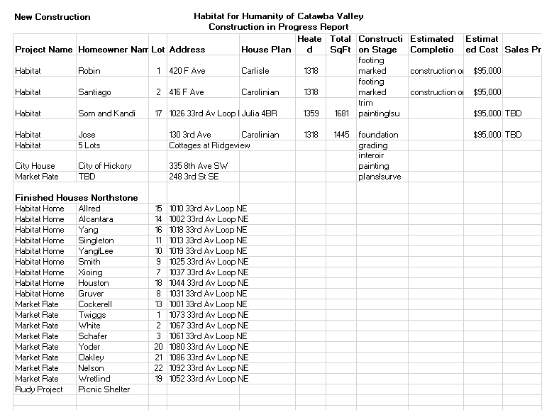

Homeowner Services: Selection and Homeowners-in-Progress
Report for Board of Directors August 2020
The Homeowner Program welcomes the four new Homeowner in Progress households who were accepted at the July board meeting. They are:
- Niya Mayfield who works at Aramark and has 2 sons, Chrisshaw and Cam’ron.
- Yeng Moua and Shirley Yang have 1 son, Eli, and another child on the way. Yeng works at the Target Distribution Center.
- Nande Rhinehardt who works at Unitape USA and has 1 son, Brixton.
- Keng Yang and Mailia Vang who have 4 sons, Kongcha, Yengchue, Chuezang, and Fuechy, 1 daughter, Kashia, and a baby on the way. Keng works at ZF Chassis Components.

Homeowner Services is excited to now have eight Homeowners in Progress. We look forward to working with our four new families as they make the journey towards homeownership.

We have updated the Homebuyer Manual to reflect the current practices of the homebuyer process. Our new homebuyers will meet with staff soon to review the manual and sign their Partnership Agreements. They will then be able to start earning sweat equity hours. We look forward to seeing them working on the construction site and at the ReStore. Please welcome them to Habitat as you meet them.

The Homeowner Services department continues to update the Homeowner Selection and Mortgage Origination Policy. The Homeowner Selection Committee has begun to review the first few sections of this policy.

Homeowner Services: Habitat Repairs!
Report for Board of Directors August 2020
Currently, five repair applications are under initial review, and eight applications are in the process of getting site visits and scopes of work from construction staff before a contract can be completed. Four contracts have been mailed to the homeowners to be signed and returned. Since the last Board meeting, two contracts have been completed.
Four homeowners from the Ridgeview community inquired about repair work after the initial date given for inquiring about the Ridgeview Neighborhood Project. These four homeowners were sent applications at the end of July and invited to apply to the repairs program. None of these applications have been received yet, but staff are hoping that the homeowners will submit them by the end of the month.

Homeowner Services: Homeowner Support
Report for Board of Directors August 2020
Delinquency Report
Reporting Period 7/31/2020 Total Mortgages: 98
Delinquent | # Mortgages Delinquent | Arrearage | % Delinquent
31-60 days | 4 | $ 3,378 | 4.1%
61-90 days | 6 | $ 2,602 | 6.4%
90 plus days | 8 | $ 8,635 | 8.2%
Total this month | 18 | $ 14,615 | 18.7%
Total 6/30/20  (98 mtgs) | 20 | $ 14,404 | 20.5%
Total same mo. prior yr:  7/31/19 (99 mtgs) | 21 | $ 20,186 | 21.2%
Jun. 2013, last mo. prior to MF (119 mtgs.) | 12 |  | 10.1%

Homeowner Services News
Total delinquencies have gone down by about 2% over the past month and are lower than they were at this time last year, in spite of the pandemic. However, the delinquencies in the 2-3 month past due range have gone up by three accounts.

As noted last month, it is usual for delinquencies to rise each summer when children are out of school, so with children studying from home this fall, this impact may continue, and to a greater extent. There are two issues: the additional expenses of having children at home, and the impact on the parent’s earning potential. At least one homeowner is trying to find a second shift job so that she can help her kids with schoolwork during the day; then she’ll take her kids to their grandmother’s house for the night.

We now have about twelve homeowners who we know of who are struggling with payments due to a COVID related loss of income. This is three more than last month this time; two of these three are now back to work and making up payments. Of course, there continue to be many we haven’t heard from.

Due largely to a period of unstable employment, Amanda Eskridge had a very large delinquency which she chose to pay down herself rather than apply for a modification. Over the last couple of years, she has made slow and mostly steady progress toward being paid up, and now she’s done it. Hooray for a homeowner success!

Donna Blevins, Sharon Boyce, and Herbert and Charlene Shuford have recently paid off their mortgages. Hooray for more homeowner successes!
The sale of the Habitat home that belonged to Shirley Gray is being necessitated by the reverse mortgage that she needed to take out before her death. Rodney Garren is providing support for Shirley’s son, Michael Gray, as he works toward selling the Habitat home, so that the family can benefit from the remaining equity.

Nou Soua Chang, one of our Blue Sky Acres homeowners, was recently diagnosed with kidney failure. He’s now in dialysis three times per week. Their mortgage is current (and always has been), but since Nou was the breadwinner for his family, they are concerned about their ability to keep their payments up and are scrambling to find ways to replace their income. We’ll be working to support this family and to find a way for them to continue to be successful homeowners. Your prayers for them would be appreciated.

Emma Johnson’s family has been approached by Medicaid Recovery with a $39,000 claim on that house. Tina is working with the family to help them get support from Legal Aid and apply for a waiver or deferral of Medicaid’s claim based on disability or on financial hardship. It’s looking like they may meet requirements for deferral based on one or the other of these reasons.

Andrew has completed the requirements to be considered a Qualified Loan Originator, bringing the total of QLOs for our affiliate to two!

____________________________________________________________________________________

HABITAT REPAIRS!
BOARD REPORT
August 2020
THEY ARE BACK!

Habitat Repairs! is pleased to report that we are back in action with our core group of volunteers. This is a closed group of five experienced repair volunteers that have been out on repair sites for the last three weeks. We have no more than two at a time with most days only one. They all have endorsed and enthusiastically our safety protocols as it protects not only them, but also our families and staff.

Here is a photo of a work day at Darlene Pinnix’s home which was featured as the repair of the month in the July board report.

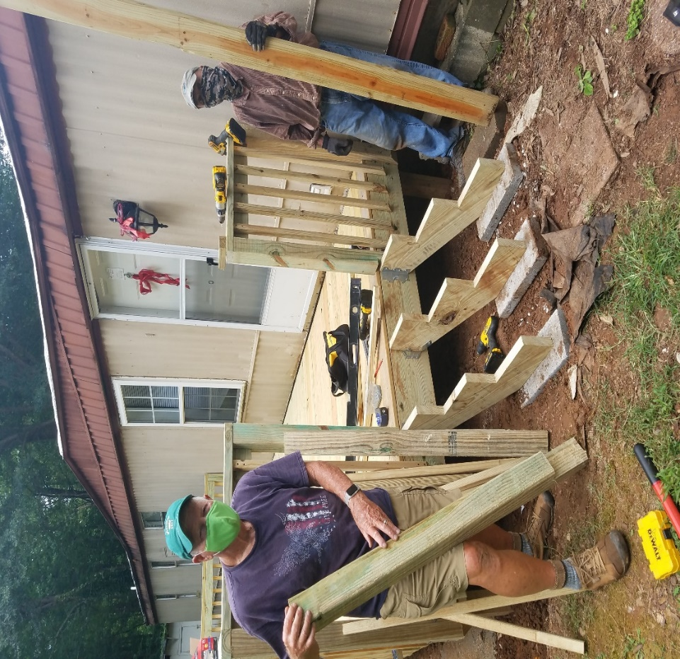
The masked volunteers are Jim Voelbel and Doug Wells
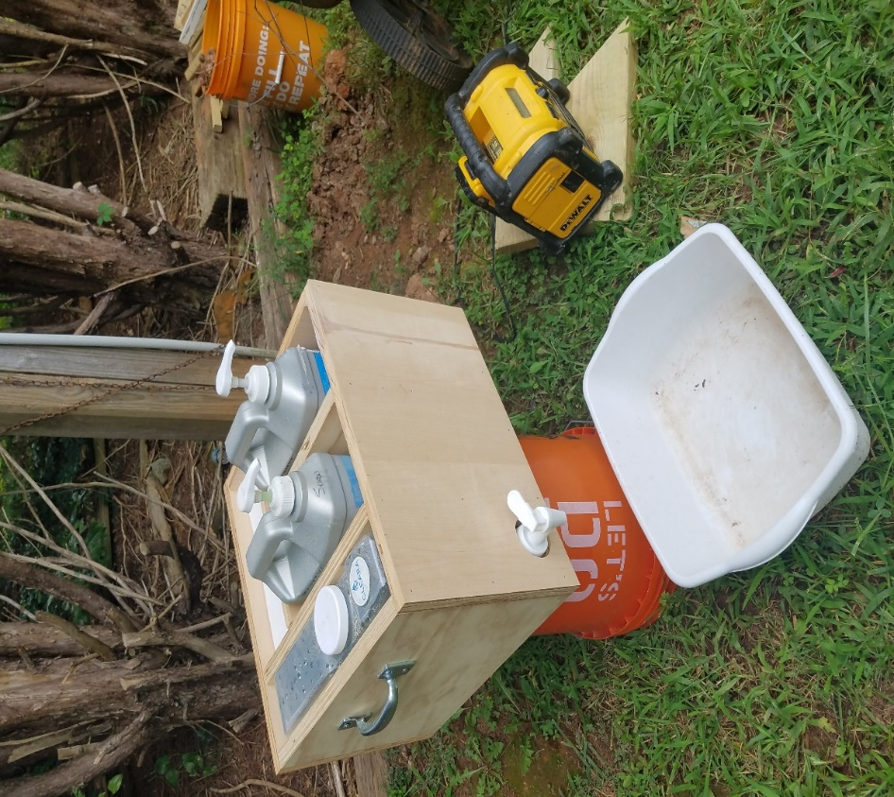
Hand cleaning and sanitizing station

Current Repairs Status
- Jobs completed 2
- Jobs in Progress 19
- Approved waiting to start 4
- Jobs vetted, waiting for scope of work 3

Development Report
August 2020
Grant Updates
- Grants/LOI/Renewal recently submitted:
  - US Bank – Submitted a Letter of Intent (LOI) – denied
  - Philip Van Every Foundation – Submitted and LOI
  - Leon Levine Foundation – Submitted Renewal Request form
  - Catawba Valley Community Foundation - $2,500 Habitat Repairs!
- Grants In Process:
  - Leon Levine Foundation - $25,000.00 General Support
  - Publix Charities - $10,000.00 Ridgeview
- Grants Awarded:
- Titmus Foundation - $5,000 Habitat Repairs!
- Sisters of Mercy - $35,000 Habitat Repairs!
- E. Rhodes & Leona B. Carpenter Foundation - $30,000
- Zoom meetings and phone communication with grant writer, Amy Clinton.
Communication/Donors
- Our focus has shifting from thank you letters to personal thank you calls and handwritten thank you cards on incoming donations. We are striving to reach out and connect with our donors through this time of sheltering in place.
- Continuing email pledge payment notifications and lapsed donor phone calls.
- Monthly zoom and phone meetings and with Mandy Pearce/Development.
- Staff connections via ZOOM – Meet Tuesdays and Thursdays for staff meetings, meet Wednesdays for Development Meetings.
- Moves Management – (Donor Segmentation) In process of segmenting donors to promote donors to new giving level.
Events
- Home is the Key – In Process
  - Table Captain list and ask
  - Vendor list for sponsorship ask
  - Working with FMC on event prerecordings, story video and event technology
- Attended virtual event webinar by Turnkey.
Misc
- Audit – Working with auditors to provide requested documentation for annual audit.

Action Items:

1) Mortgage Origination Policy Update:
The Habitat International Homeowner Selection/Mortgage Origination Policy template suggests that affiliates have someone designated by the board of directors to be the person who makes final decisions regarding any exceptions to the policy that may come up.
Here’s the pertinent except from Section 1.2 of the new policy:
Habitat for Humanity of Catawba Valley, Inc (hereinafter referred to as “Habitat” in the policy documents) commits to complying with each policy. If an exception is required, the board designate, in accordance with all applicable mission statements, policies, guidelines, and bylaws, must make the final decision.
As a member of the Family Selection Committee, Margaret Pope will be making a motion that the board designate the HSC chairperson in this way.

Informational Items:
1) Home is the Key Update:
In last month’s meeting staff announced the decision hold Home is the Key, Habitat’s signature fundraiser, as a virtual event. The Development Staff is reviewing different formats from other nonprofit organizations. To date we have determined that the program combine speakers and videos of volunteers, house construction, home repairs and homeowners. The theme of this year’s event will be: “Homes, Community, Hope and +You,” the current HfHI theme.
Fundraising will rely primarily on Table Captains to invite friends and family to virtually attend the event. Another key component to the event’s success will be securing sponsors. Currently we have 3 sponsors contributing $11,000 toward our goal of $80,000.
Request to Board:
1) serve as a Table Captain and recruit a minimum of 9 guests
2) secure one sponsorship. Sponsors are asked to contribute $1,000 – 5,000

