Habitat for Humanity of Catawba Valley
Board of Directors’ Meeting
July 27, 2020

Devotion – Tina Morgan

Adoption of Agenda — Charlotte Williams

Consent Agenda:
Items are considered routine by the Board of Directors and will be enacted by one motion. There will be no separate discussion of these items unless requested by a member. The item will be removed from the Consent Agenda, then added to Action or Informational Items.

1) Minutes from June Board Meeting
2) May and June Financial Reports

Action Items:
1) 2020-21 Budget – Mitzi Gellman & Lisa Brown
2) Family Selection Committee – Troy Howard & Tina Morgan

Informational Items:
1) Staff Reports

Upcoming Events:
Next Board Meetings: August 24th, September 28th, October 26th,
November 23rd OR November 30th

Consent Agenda:

1) Minutes from June Board Meeting
2) May and June Financial Reports (separate attachment)

Habitat Board of Directors’ Meeting
Minutes of June 1, 2020

Members Present: Doug Dickson, Scott Echelberger, Lori Greveling, Frances Hilton, Ander Horne, Troy Howard, Pat Jones, Whit Malone, Cliff Moone, Margaret Pope, Charlotte Williams
Members Not Present: Bill Burnham, Rodney Garren, Robin Creel, Graham Hunsucker, William Pleasant
Staff Present: Mitzi Gellman, Richard Greathouse, Andrew Isola, Jeff Mingus, Tina Morgan, Melissa Neal, Derek Ross, Jenna Ross, Hannah Yost

Welcome and President’s Remarks
There being a quorum, the June meeting of the Habitat for Humanity of Catawba Valley Board of Directors was called to order by Board President Charlotte Williams at 12:03 pm. Due to COVID-19, the Board meeting was held via Zoom Meeting.
Devotion
Tina Morgan led the group in a devotion, and then invited Board Member Whit Malone to lead the group in prayer for “a Time of Anger, Unrest, and Injustice”.
Adoption of Agenda
Upon a motion and second, the Board unanimously adopted the June meeting.
Consent Agenda
The Board adopted the Consent Agenda of the May Board Meeting Minutes and the April Financials by motion and second without dissent.

Action Items
- Following a motion and second, the Board unanimously voted to submit a grant request to the Peeler-Casey Funds.
Informational Items
Staff members presented the department reports.

Adjourn
President Charlotte Williams adjourned the meeting at 1:00 pm. The next Board Meeting will be held on Monday, July 27th at 12:00pm via Zoom.
Upcoming Events
- Virtual Gathering of Gratitude, Thursday June 4th, 5:30 pm via Zoom
- Corinth Legacy House Virtual Dedication, Wednesday June 10th, 7:00 via Zoom

Action Items:
1) 2020-21 Budget – Mitzi Gellman & Lisa Brown (separate attachment)
2) Family Selection Committee – Troy Howard & Tina Morgan

Homeowner Selection Committee
Recommendations
July 27, 2020

All of the applicants listed below meet Habitat for Humanity of Catawba Valley’s (HFHCV) selection criteria for ability to pay, need, and willingness to partner. The Homeowner Selection Committee recommends that they be conditionally approved for HFHCV’s Homeownership Program and pre-approved for a Habitat loan.

Household of 7 (2 adults/5 children, 1 more to be born prior to closing)
Employer: ZF Chassis Components, Bangkok Pho
Annual Income: $44,595.54
Percentage of Area Median Income: for household of 7 - 60%; for household of 8 - 57%
Credit: meets requirements
Consumer Debt to Income Ratio: 36% (back end)
Current Rent: $375/month
Need: overcrowding, pest issues
Willingness to partner: meets requirements

Household of 2 (1 adult/1 child)
Employer: Unitape, USA
Income: $23,166.00
Percentage of Area Median Income: 49%
Credit: meets requirements
Consumer Debt to Income Ratio: 30% (back end)
Current Rent: $625/month (32% of monthly gross income)
Need: rent unaffordable, concern for child’s safety
Willingness to partner: meets requirements

Household of 3 (2 adults/ 1 child, 1 more to be born prior to closing)
Employer: Target Distribution
Income: $29,267.51
Percentage of Area Median Income: for household of 3 - 55%; for household of 4 - 49%
Credit: meets guidelines
Consumer Debt to Income Ratio: 28% (back end)
Current Rent: $500/month
Need: living with family members, overcrowding, unsafe neighborhood, unsafe housing conditions
Willingness to partner: meets requirements

Household of 3 (1 adult/ 2 children)
Employer: Aramark
Income: $20,230.12
Percentage of Area Median Income: 38%
Credit: meets requirements
Consumer Debt to Income Ratio: 24% (back end)
Current Rent: $160/month, receives Section 8 voucher to cover $650/month total
Need: unsafe housing conditions
Willingness to partner: meets requirements

Informational Items:
1) Staff Reports

Executive Director Report - Mitzi Gellman
As a global update on Habitat operations:
- the administrative staff is mostly continuing to work remotely, except for myself and Melissa.
- New construction and Habitat Repairs! are working, but without volunteers. (The initial plan was to bring construction volunteers back by mid-July, but increases in Catawba County COVID cases has postponed that decision until August 7th with Gov. Cooper’s next evaluation.)
- The ReStore continues to operate limited hours: 10am-3pm, Thursday – Saturday. “Contact free” pick-ups have resumed for residential donors.
Home is the Key Update:
The decision has been made to continue with Home is the Key, Habitat’s signature fundraiser, but with a different format. This year we will hold a virtual event due to the uncertainty of the pandemic. The format will be a combination of real-time speakers and recorded homeowner and donor testimonials. Staff is exploring options for the event location. We will still depend on Table Captains to invite friends and family to virtually attend the event. Another key component to the event’s success will be securing sponsors. Currently we have 3 sponsors contributing $11,000 toward our goal of $80,000.
Request to Board:
1) serve as a Table Captain and recruit a minimum of 9 guests
2) secure one sponsorship. Sponsors are asked to contribute $1,000 – 5,000
FlexCAP Loan with Habitat International:
Habitat International has granted a forbearance on loan payments to the FlexCAP loan through March 2021. Deferred payments will be added onto the end of the loan period, and principle payments of $13,000 made April – June were redeposited to the affiliate on July 21. An additional forbearance was granted for mortgage substitutions (the collateral securing the loan) from March 2020-2021. Substitutions of one mortgage for another are required if a homeowner is delinquent 3 months.
Paycheck Protection Program:
We will meet the requirements of the PPP loan in August and will file required documentation to satisfy the loan. Lisa’s most recent calculation indicates that we will not be required to repay any of the $190,000. We qualified for an additional SBA loan of $10,000 that is required to be repaid (receipt of the larger SBA loan triggers repayment of the $10,000) later this year.
Board of Directors’ Membership:
I have spoken to several of my Habitat colleagues regarding board membership during the pandemic. The consensus has been asking current board members to continue in their roles through 2020. Please give this consideration and we will discuss on Monday. Thanks!

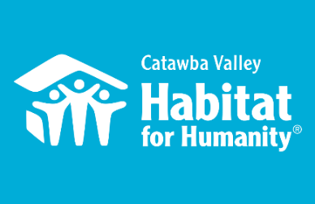
June 27th Board Report
Community Outreach

Messaging & Media
- Continued with Phase 2 messaging across all communication platforms.
- Filmed video on Raised Bed Gardens for Website Download + List Builder
- Mission and Marketing Intern: Created position and accepted summer intern
- + You Campaign: launched the Homes, Communities, Hope + You campaign across print, social media, and website
- Spring Appeal: Coordinated content and design for spring mailer, adapted for social media and eblast
- Rack Cards: Updated design, content, and branding for Homeownership, Repairs, and ReStore rack cards in collaboration with other team members
- Homeowner Thank-You Notes: Launched new stewardship program where homeowners in process write personalized thank-you notes to major donors

Events
- Director’s Corner Virtual Update – June 4th, 19 attendees, special gathering with Major Donors to provide behind the scenes update on Habitat’s work and the path forward
- Stories from Home: Homeowner Panel – July 16th, 16 attendees, interactive opportunity to hear from a panel of 4 Habitat families about their experience with Habitat, Home, and Hope.

Outreach
- Chronic Disease Workgroup, Zoom 6/9
- LiveWell Board Meeting, Zoom 6/16
- Leadership Catawba Advisory Board, Zoom 6/18
- Chronic Disease Workgroup, Zoom 7/14
- Leadership Catawba Advisory Board, Zoom 7/17
- LiveWell Board Meeting, Zoom 7/21

Volunteers
- Volunteer Reactivation Plan – Developed comprehensive COVID-19 Volunteer Reactivation Plan, in consultation with HFHI and in collaboration with relevant departments and volunteer leaders
- Resumed volunteers at the ReStore with a core group of regular volunteers and limited hours
  - 22 volunteers
495.5 hours served
___________________________________________________________________

The ReStore Report – Jeff Mingus, ReStore General Manager
Donations and Sales – Sales for June $64,561.02. This is a combination of in-store and online sales ($1614.63 total sales). The store remains on a Thursday through Saturday 10am to 3pm open to the public schedule. Monday through Wednesday the ReStore team and select volunteers work to rebuild, clean, price, merchandise and sanitize the store. Donations continue to come in daily both individual drop off and scheduled truck pick ups
Safety First – Masks – we still have 1200 at the ready. Shoppers are asked to wear a mask while in store as we comply with the NC Safer at Home Order. We also have added sanitizer stations around the store for shopper’s convenience.
Thriftcart online platform. www.shopcatawbarestore.org. We have a dedicated volunteer who helps add product weekly… Thanks Ann! Want to help keep our online store growing? We have “safer” volunteer days available every Monday – Wednesday.
#1 Priority for Staff and Volunteers “Wash your hands” – we’re still following the CDC, county and state health departments websites for advisories and warnings https://www.cdc.gov/coronavirus/2019-ncov/index.html, http://www.catawbacountync.gov/county-services/public-health/, https://www.ncdhhs.gov/divisions/public-health/coronavirus-disease-2019-covid-19-response-north-carolina focusing on Awareness, Communication, and Training.

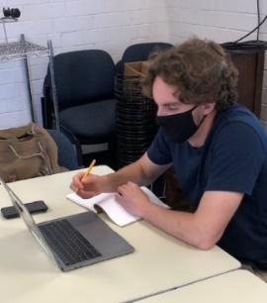
Introducing Alex – Every cloud a silver lining, with the covid-19 pandemic came all sorts of unexpected closures, obstacles, and a few opportunities. If you’ve noticed some improvement and regularity in the ReStore social media? If you’ve liked any of the recent emails? If you follow FB stories or Instagram? Website updates…the works? Please, thank Habitat’s new intern Alex.

_____________________________________________________________________________
Construction Report - Derek Ross
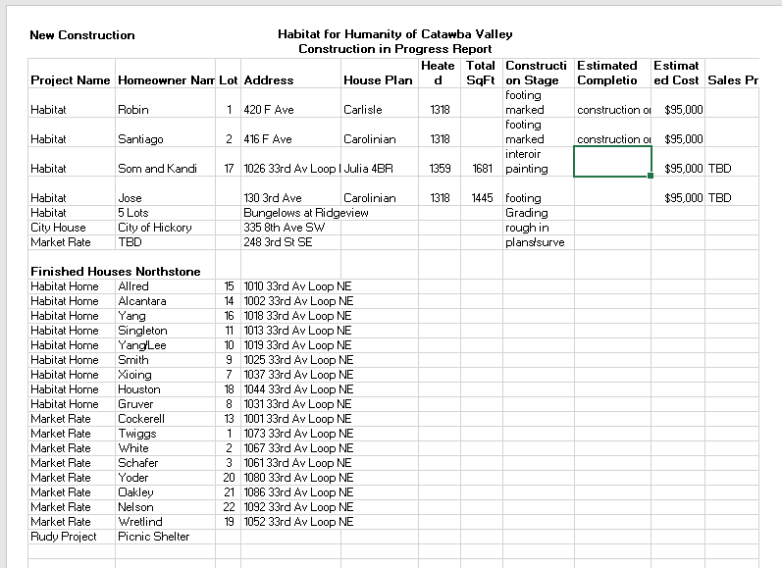
Homeowner Services: Selection and Homeowners-in-Progress
Report for Board of Directors July 2020
The current selection round continued with assessment of the remaining applications for the program. The Homeowner Selection Committee conducted all its home visits safely and successfully. These home visits were conducted via video phone call and regular phone call. Additionally, photographs were shared between applicants and committee members. Committee members took extra time and care to drive by the applicants’ current housing to make a personal assessment. The Homeowner Services staff offer much deserved recognition and thanks to committee members for their flexible, innovative, and thorough work to complete the selection process during the COVID-19 pandemic. The committee met by Zoom to review all application information and make a recommendation to the board. The Homeowner Selection Committee recommends 4 applicants for acceptance into the Homeowner Program.

Our homebuyers continue to do well personally and have seen their work hours restored. We have been able to resume sweat equity opportunities for them. Most recently, they assisted the development team in writing thank you notes to many Habitat donors. Some of them will be participating in donor related Zoom meetings to share the story of their journey in the Homeowner Program.

In our current political and social environment, the Homeowner Program has begun to study the ways in which racial equality can be strengthened through affordable housing. This study has included a reading of the book “The Color of Law” by historian Richard Rothstein. This book is recommended reading for anyone interested in this subject.

Homeowner Services: Habitat Repairs!
Report for Board of Directors July 2020
Habitat Repairs! staff are continuing to process applications for repair work. Currently, two applications are in initial assessment, and nine applications are in the site visit phase being evaluated by construction staff before final acceptance and contract completion. Four contracts are in the process of being mailed to the homeowner, signed, and returned. Since the last board meeting, two contracts have been completed.
Per the Habitat Repairs! Policy Recapture Agreement, homeowners are requested to pay all or part of the project cost if their home is no longer their primary residence or is sold or transferred to a new owner within 5 years of having repair work completed by Habitat Catawba Valley. Staff found a computer program through the county’s Register of Deeds to monitor whether a house is sold or ownership transferred. The computer program through the Register of Deeds allows staff to input the homeowners’ names and receive an email notification if their deed is transferred. The goal of this process is to make sure the homeowners who applied for the Habitat Repairs! Program continue to live in that residence and enjoy the repairs work done on their home, and if they don’t, to recapture those funds so that others may benefit by an opportunity to stay safe, warm, and dry.
Homeowner Services: Homeowner Support
Report for Board of Directors July 2020
Delinquency Report
Reporting Period 6/30/2020 Total Mortgages: 98
Delinquent | # Mortgages Delinquent | Arrearage | % Delinquent
31-60 days | 9 | $ 3,654 | 9.2%
61-90 days | 3 | $ 2,113 | 3.1%
90 plus days | 8 | $ 8,637 | 8.2%
Total this month | 20 | $ 14,404 | 20.5%
Total 4/30/20  (96 mtgs) | 16 | $ 15,462 | 16.7%
Total same mo. prior yr:  6/28/19 (101 mtgs) | 17 | $ 18,925 | 16.9%
Jun. 2013, last mo. prior to MF (119 mtgs.) | 12 |  | 10.1%

Homeowner Services News
Although delinquencies overall have gone up by nearly 4% in the past two months, the more serious delinquencies (more than 60 days past due) have gone down by 2%. It is usual for delinquencies to rise each summer when children are out of school, so particularly with the current pandemic, the rise is not unexpected. If children continue out of school this fall, there may be a greater impact on delinquencies.

We have heard from one homeowner that she tested positive for COVID-19 but had no symptoms. She lost her job at WalMart pursuant to the required 14-day quarantine. She has entered into a repayment agreement for her missed house payments and has now secured a temporary job. Interestingly, she was not eligible for unemployment because she had been on it earlier for another COVID related job loss. If she had not gone off of unemployment to take the job at WalMart, she could have still been receiving it.

We are hearing from progressively more homeowners that they have friends and family members who have tested positive. We now have about nine homeowners who we know of who are struggling with payments due to a COVID related loss of income. Of course, there are many who we haven’t heard from.

Xia Yang’s closing was on June 17th; due to safety precautions it was held with extreme social distancing and masks in the big front room at the Habitat office.

Homeowner Services staff members are working on HS website pages and public relations materials.

Tina has completed the American Bankers Association courses required for annual recertification as a Qualified Loan Originator.

____________________________________________________________________________________
HABITAT REPAIRS! Richard Greathouse

The repairs program has continued completing outside repairs with staff only.
We are pleased to announce that repairs will be opening to our core group of volunteers on July 22. This will be limited to 5 regulars who have indicated a desire to come out and help us on repairs. We will not be opening to everyone until later when the spread is under control.

The first repair for volunteers is for Darlene Pinnix 3269 Hamlett Drive, outside of Claremont. She lives alone in a double wide mobile home that needs the following repairs:
- Roof re-sealed.
- New and safer front entry deck.
- Repairs and safety enhancements to rear deck.
- Repairs to holes in eves.
- Gutter repairs, and installation of leaf guards.
- Underpinning repairs.

Current repair status: (Since last board meeting.)
- Jobs in completed. 4
- Jobs in progress. 16
- Jobs approved waiting start. 5
- Jobs vetted, waiting for scope of work. 3
We have a higher number of jobs in progress due to some that involve inside repairs that will not be completed until it is safe to do interior work.

Here is our volunteer safety protocol for repairs.
- Only one or two volunteers per job site.
- Masks are mandatory and social distancing whenever possible.
- Tools are not to be shared.
- Volunteers are asked to bring their own tools if they have them.
- Volunteers will bring their own snacks.
- We have made a wash station and will provide hand sanitizer
- Volunteers will be asked to self-monitor for possible Covid symptoms and cancel any are showing. We ask them to err on the side of caution.
Here are photos of the front and rear of Ms. Pinnix’s home.

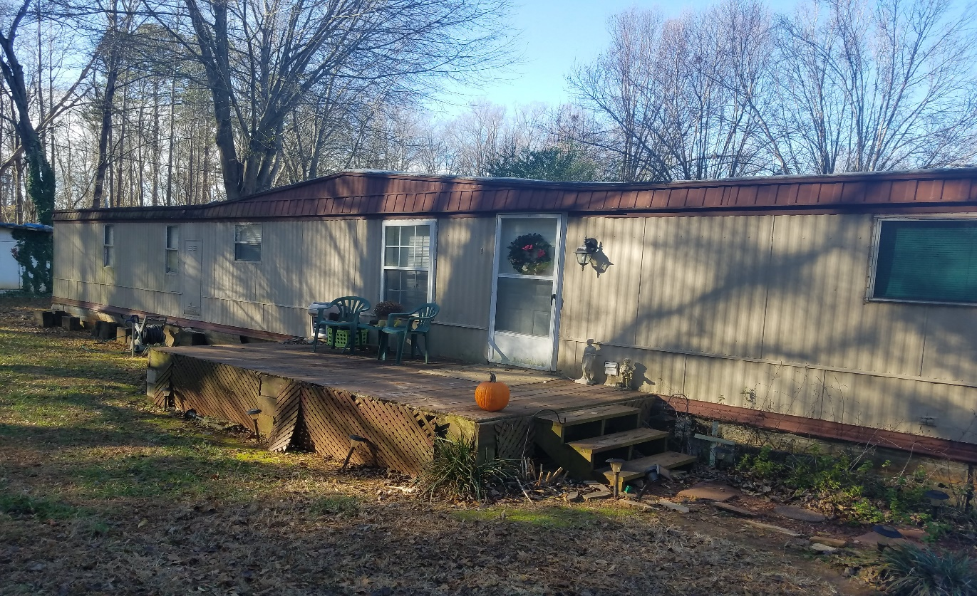
Front Entry
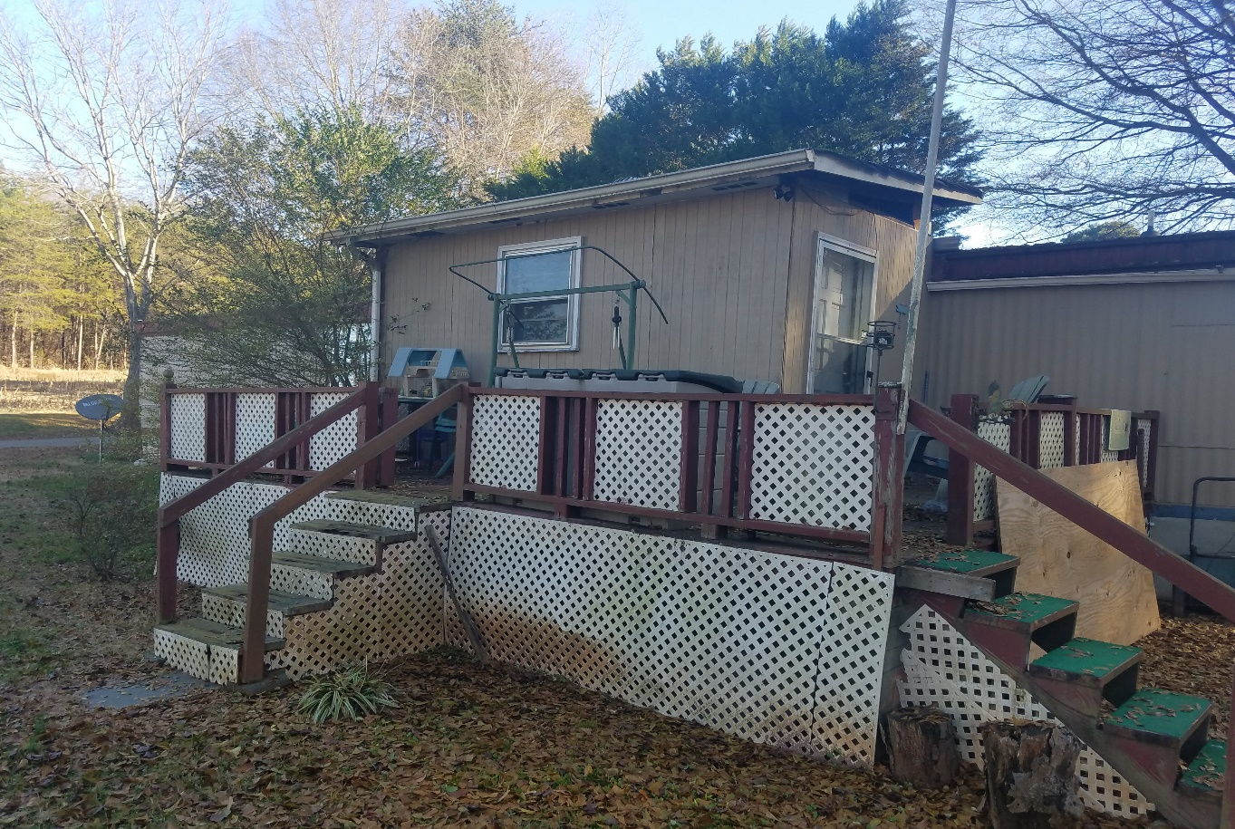
Rear entry, unsafe deck and steps, and upper hole in wall to storage room.

Development Report - Lynn Nelson

Grant Updates
- Grants recently submitted:
  - Titmus - $15,000 Habitat Repairs!
  - Peeler/Casey Funds - $6,500 Habitat Repairs!
  - TSH Charitable Foundation - $50,000 Ridgeview Community
  - Big Lots - $6,500 Habitat Repairs!
  - Merancas – LOI for new construction
- Grants Awarded:
  - The Bolick Fountation - $10,000.00 Habitat Repairs!
  - Kulynych Foundation - $20,000.00 General Support
  - The Unifour Foundation - $10,000.00 Ridgeview Community
  - Underdown Family Foundation - $5,000.00 Ridgeview Community
  - Corning - $6,500.00 Habitat Repairs!
  - Sisters of Mercy - $35,000.00 Habitat Repairs! (Awaiting funds)
- Zoom meetings and phone communication with grant writer, Amy Clinton.
Communication
- Our focus has shifting from thank you letters to personal thank you calls and handwritten thank you cards on incoming donations. We are striving to reach out and connect with our donors through this time of sheltering in place.
- Continuing email pledge payment notifications and lapsed donor phone calls.
- Monthly zoom and phone meetings and with Mandy Pearce/Development.
- Staff connections via ZOOM – Meet Tuesdays and Thursdays for staff meetings, meet Wednesdays for Development Meetings.
- Legacy Builder’s Society – ZOOM meeting on Thursday, June 4 and Thursday July 16.

Events
- Reviewing, monitoring and updating our annual event – Home is the Key.
- Attended virtual event webinar.

