Habitat for Humanity of Catawba Valley
Board of Directors’ Meeting
October 26, 2020

Devotion – Tina Morgan

Adoption of Agenda — Charlotte Williams

Consent Agenda:
Items are considered routine by the Board of Directors and will be enacted by one motion. There will be no separate discussion of these items unless requested by a member. The item will be removed from the Consent Agenda, then added to Action or Informational Items.

1) Minutes from September Board Meeting
2) September Financial Reports (Separate Attachment)
3) Staff Reports

Action Items:

1) Policy Proposals - Mitzi

Informational Items:
1) Home is the Key Update – Lynn & Jenna
2) Habitat Economic Impact – Mitzi & Jenna

Upcoming Events:
Next Board Meetings: November 23rd OR November 30th,
December 14th (possible)

Consent Agenda
1) September Board Minutes

Habitat Board of Directors’ Meeting
Minutes of September 28, 2020

Members Present: Bill Burnham, Robin Creel, Doug Dickson, Scott Echelberger, Lori Greveling, Frances Hilton, Troy Howard, Graham Hunsucker, Pat Jones, Whit Malone, Cliff Moone, William Pleasant, Charlotte Williams
Members Not Present: Rodney Garren, Ander Horne, Margaret Pope
Staff Present: Mitzi Gellman, Richard Greathouse, Andrew Isola, Jeff Mingus, Tina Morgan, Melissa Neal, Lynn Nelson, Derek Ross, Jenna Ross
Welcome and President’s Remarks
There being a quorum, the September meeting of the Habitat for Humanity of Catawba Valley Board of Directors was called to order by Board President Charlotte Williams at 12:00 pm. Due to COVID-19, the Board meeting was held via Zoom Meeting.
Devotion
Tina Morgan led the devotion by sharing and discussing scripture from Proverbs 18:2, 21:2 and Ephesians 4:1-4, followed by prayer.
Adoption of Agenda
Upon a motion and second, the Board unanimously adopted the September Agenda.
Consent Agenda
The Board adopted the Consent Agenda of the August Board Meeting Minutes, the August Financial Reports, and the Staff Reports by motion and second without dissent.
Action Items
- No Action Items.
Informational Items
- Home is the Key - Updates were given by Lynn Nelson -Development Assistant, and Jenna Ross -Community Outreach Coordinator, relating to the overall format of the virtual event (to be prerecorded) and the status of table captains and sponsors.
- Policy Proposals – Mitzi Gellman, Executive Director, reviewed the draft of the Restricted and Designated Funds Policy and the Executive Succession Plan Policy. Draft policies will be reviewed in Executive Committee and presented to the Board.
Executive Director’s Update
Mitzi Gellman, Executive Director, gave a brief update on The Cottages at Ridgeview (building schedule is currently 1 home in progress with 2 others to begin soon), WPCOG funding (waiting for confirmation on funding disbursement), City of Hickory (land exchange between Habitat and

the City of Hickory) and Habitat has received a letter from Young, Morphis, Bach & Taylor, LLP representing Pebble Creek Homeowners Association in regards to water runoff from the Northstone subdivision causing flooding for Pebble Creek residents (Patrick, Harper & Dixon, LLP on behalf of Habitat is currently in communication with Young, Morphis, Bach & Taylor.)
Adjourn
Prior to adjournment, President Charlotte Williams discussed the need to fulfill Board Officer roles for Treasurer and Vice President. The Executive Committee will begin to develop a slate of officers. President, Charlotte Williams adjourned the meeting at 1:00 pm. The next Board Meeting will be held on Monday, October 26th at 12:00pm via Zoom.

2) September Financials (available as separate attachment)

3) Staff Reports

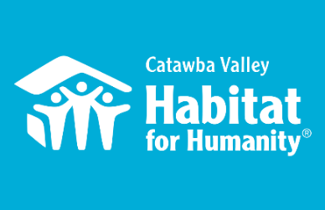
October 26th Board Report
Community Outreach

Messaging & Media
- Collaborating with ReStore & FMC to establish 3 levels of email funnels in order to:
  - Convert ReStore gift in kind donors & shoppers into affiliate financial donors
  - Convert ReStore website visitors into mailing list members
  - Drive online sales among current ReStore email subscribers & social media followers
- Working with Media and Messaging intern to increase our Facebook, Instagram, and Blog presence
- Home is the Key
  - Prepped video speakers for virtual HITK event
  - Filmed 5 interviews for HITK virtual event & spotlight video
  - Developed necessary websites for:
    - Event day
    - Online donation pathways
  - Print materials in development, to be mailed to guests by Monday, 11/9
- Fall Mail Appeal
  - Mailer dropped Monday 10/5
  - Created eblast which delivered Tuesday, 10/6
  - Social Media asset Wednesday, 10/14
- The Legacy Build Dedication
  - Created postcard invitations, mailed Sat 10/3
  - Created eblast invitations, delivered Friday 10/10 and Friday 10/16
  - Created event program
  - Created House sponsorship sign
- Developing content for 2019-2020 Annual Report

Outreach
- LiveWell Catawba Board Meeting, 9/15
- Leadership Catawba Advisory Board meeting, 9/18
- Update meeting with Corinth, 9/22
- Leadership Catawba October Session: Telling Our Story, 10/1
- Orientation phone call with community partner to Family Selection Committee, 9/30
- LiveWell Catawba Board Meeting 10/5
- Orientation phone call with Groundbreaking presenter, 10/7

Development
- One on One consultation session with Development Consultant, 9/30
- VIP session with Development Consultant, 10/2
- Church Strategy Consultation session, 10/5
- One on One consultation session with Development Consultant, 10/13

Events
- Virtual Table Captain Training, 10/8
- Panelist at Villanova University’s Service and Justice Virtual Experience, 10/12

Volunteers
- Volunteer Reactivation continues with regular volunteers in the ReStore and Repairs
- LR Men’s Soccer team completed a packet of letters to be sent to our elderly repair clients who may be experiencing loneliness as a result of the pandemic
- Discover High School Outdoors Club writing letters to welcome Suwaina home since she has to quarantine for her work and can’t participate in a Dedication at this time
- Volunteer Hours 8/18-9/15:
  - 30 volunteers
  - 422.5 hours served

__________________________________________________________________

The ReStore Report September 2020
Donations and Sales – Sales for September 2019 $65,581.52 September 2020 $70,701.05. This is a combination of in-store and online ($1765.50) sales. Another good result from Thriftcart is “round-up your purchase donations” Cashiers have collected $1255.42 from July through September.
On hold, the large donation Sandler Seating, coming all the way from London, UK waiting for more details soon. But we did get a rather large donation, approx. 60 pieces plus 3 pallets of fabric from Leathercraft here in Hickory. Our regular corporate donors continue to support Habitat and the ReStore.
Our community loves Habitat. Individual drop off donations and scheduled truck pickups remain steady. People now are taking the time to organize, clean out, and remodel so the store stays packed. Our efforts to provide a safe and open shopping and donation experience are paying off.
www.shopcatawbarestore.org. New inventory added weekly for online offerings. Want to help keep our online store growing? We have “safer” volunteer days available every Monday and Tuesday. Our latest push…How to grow online sales?
Meet Ann, our ReStore volunteer and online specialist.
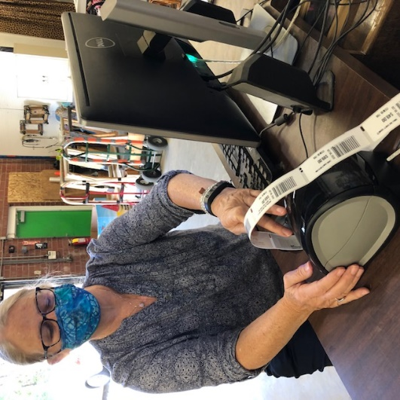
Meet the Staff – We have been making some positive changes. Melissa has joined the team part-time and helps primarily at the sales counter but also filling in with pricing and merchandising the shelves. She is a go getter and likes to stay busy.
Next, we have Cody and Parker, who have taken over the role of Donation Ambassadors after dan and Enoch’s retirement. These guys literally are where the rubber meets the road all over Catawba County. They do a great job representing Habitat in our community.
\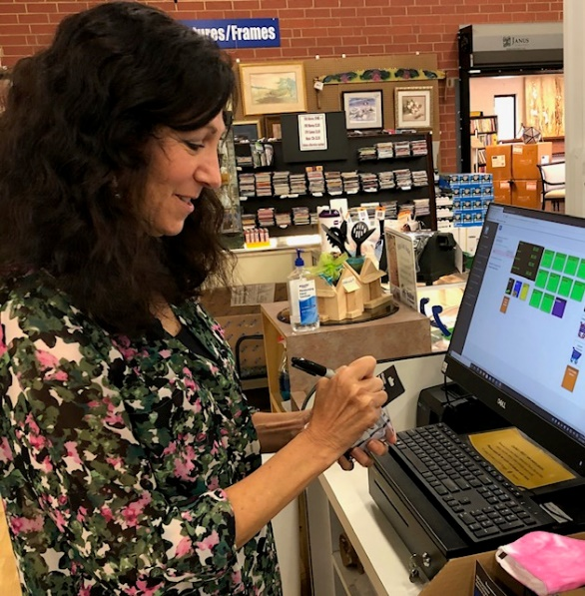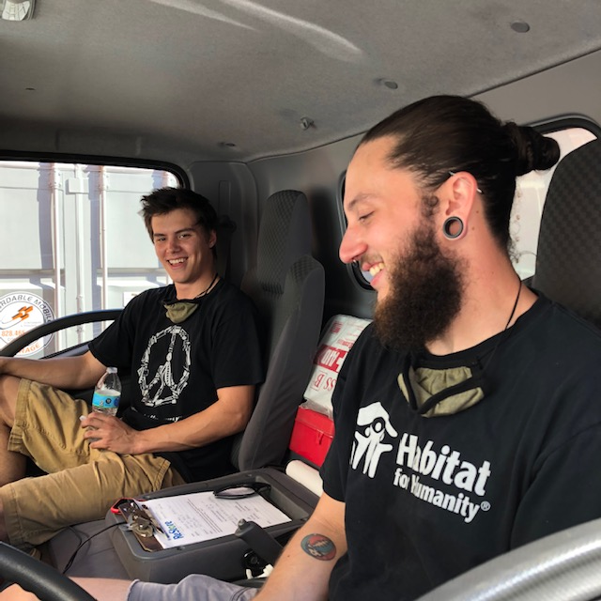
ReStore Volunteer Opportunities cont. – We have a core group of dedicated volunteers who weekly work regular shifts of a couple hours. It’s a big challenge to keep the ReStore running safe and open. There are several ways you or someone you know can still help. We need cashiers, book advocates, fabric rollers, and social media gurus. We’re updating our ReStore webpage so here’s your chance to go worldwide.
Safety is still Priority #1 for Staff and Volunteers “Wash your hands” – we’re still following the CDC, county and state health departments websites for advisories and warnings https://www.cdc.gov/coronavirus/2019-ncov/index.html, http://www.catawbacountync.gov/county-services/public-health/, https://www.ncdhhs.gov/divisions/public-health/coronavirus-disease-2019-covid-19-response-north-carolina focusing on Awareness, Communication, and Training.

Jeff Mingus, ReStore General Manager
__________________________________________________________________

Construction Report - Derek Ross
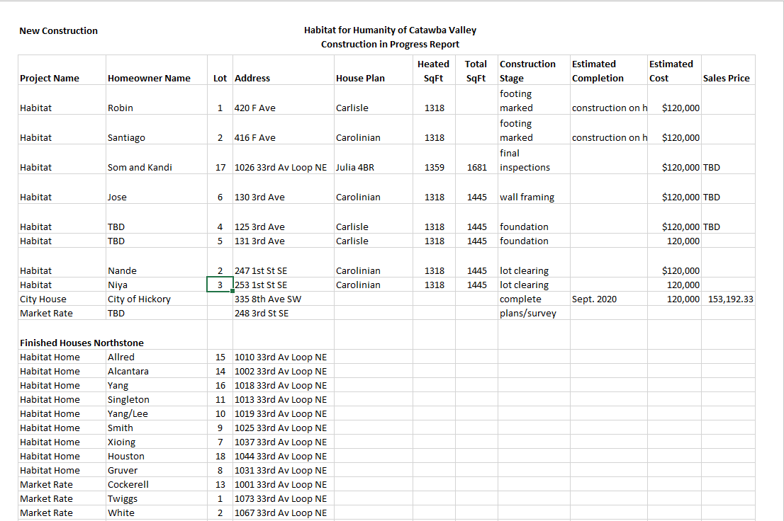
__________________________________________________________________

Homeowner Services:
Homeowner Support
Homeowner Services: Selection and Homeowners-in-Progress
Report for Board of Directors October 2020
The Homeownership Program held a new round of AIM meetings on September 22nd at 10am and 6pm. The meetings were held in the parking lot of Morning Star First Baptist Church. A big thank you to Pastor David Roberts and the congregation of Morning Star First Baptist Church for their help during the AIM meetings and for the use of their facilities. The AIM meetings were different than the typical AIM meeting but seemed to be a big success with over 40 people attending. Each participant stayed in their car and the meeting was conducted using a sound system provided by Morning Star Baptist.

The open application period and due date for applications for the Homeownership Program has passed. 41 applications were distributed in person during the open application period. Applications were also available on the Habitat website. 30 applications were received by the due date. The staff and the Homeowner Selection Committee will now begin the work of processing these 30 applications. The Committee hopes to have recommendations for new homebuyers to the board by the end of the year.

Homebuyers in progress have continued to participate in sweat equity opportunities over the past month. They have been very helpful at the ReStore, on our sites at Northstone and Ridgeview, and with work at the Habitat office. Our homebuyers in progress have also begun to participate in two financial literacy programs. The FDIC Money Smart program offers our homebuyers in progress basic information about the U.S. financial system and personal banking. The National Endowment for Financial Education offers the ‘Smart About Money’ program which teaches individuals about several personal finance topics.

Homeowner Services: Habitat Repairs!
Report for Board of Directors October 2020
The Repairs! Program is continuing to respond to inquiries for repair work. Due to the steady number of inquiries, staff are able to invite those who inquire to apply for the program right away. Since the last board meeting, seven more applications have been sent out to individuals who have inquired about getting repair work done on their homes. Two applications are being assessed for program qualifications. One contract has been completed since the September board meeting, and two contracts are in process.
Homeowner Services staff attended some sessions through NC Camp Habitat. One session discussed the application process for repairs; it was helpful to see how different organizations are handling their application process. Another session, led by the NC Justice Center, discussed access to utility services during the COVID pandemic. The following are some numbers that put the housing crisis into perspective: from March until the end of July, there were 1.07 million utility accounts in arrears, and during that same time, the total of the arrearages was $226.15 million. As we continue to serve repair clients in our county, it is helpful to remember that many are living on minimal budgets and truly need assistance from the Repairs! Program.

Homeowner Services: Homeowner Support
Report for Board of Directors October 2020
Delinquency Report
Reporting Period 9/30/2020 Total Mortgages: 97
Delinquent | # Mortgages Delinquent | Arrearage | % Delinquent
31-60 days | 7 | $ 3,432 | 7.2%
61-90 days | 0 | $ 0 | 0.0%
90 plus days | 10 | $ 9,242 | 10.3%
Total this month | 17 | $ 12,674 | 17.5%
Total 8/31/20  (97 mtgs) | 17 | $ 14,388 | 17.5%
Total same mo. prior yr:  9/30/19 (98 mtgs) | 25 | $ 20,926 | 25.5%
Jun. 2013, last mo. prior to MF (119 mtgs.) | 12 |  | 10.1%

Homeowner Services News
Remarkably, our delinquencies are about 32% fewer than they were this time last year.

Delinquencies usually rise at this time of year and would be expected to follow that trend especially due to COVID. However, the number of delinquencies is about the same this month as last, and the dollar amount of delinquencies is almost two thousand dollars less than last month.

The closing for Som Lor and Kandi Xiong is tentatively scheduled for November 6th. Som and Kandi have signed their early disclosures, shopped for their homeowners’ insurance, and are ready to order their professional inspection. Applications and underwriting packages have been submitted to NCHFA, First Bank, and WPCOG.

There are no new homeowners who we know of who are struggling with payments due to a COVID related loss of income. That total is still twelve.

Angela Thompson, one of our Kenworth homeowners, may have to move to Greensboro to provide long term care for her father. She has spoken with us about putting her Habitat home on the market and will keep us posted on her situation.

__________________________________________________________________
HABITAT REPAIRS!
BOARD REPORT
October 2020
HABITAT REPAIRS IS CELEBRATING IT’S 150th REPAIR PROJECT

With the help of dedicated volunteers and through generous private and corporate donors, and grants from Piedmont Natural Gas and the City of Hickory and other granting entities, We have completed 150 projects while helping 303 clients stay safe warm and dry in their own homes.

Repair of the Month
The repair featured this month is for Glenn and Martha Wilfong. Glenn 71, is a Veteran who has been living with his wife Martha 69, for over 35 years where they raised their family.
We will be doing the following work with funding from the City of Hickory:
- Rebuilding the unsafe front doorsteps
- Installing a handrail from the front walk to the driveway.
- Gutter repairs
- Repairing and Painting exterior trim.
We will be utilizing PNG funds to:
- Install a new HVAC system.
- insulate the first floor and attic. Currently the floor does not have any insulation and the attic has about six inches at most.
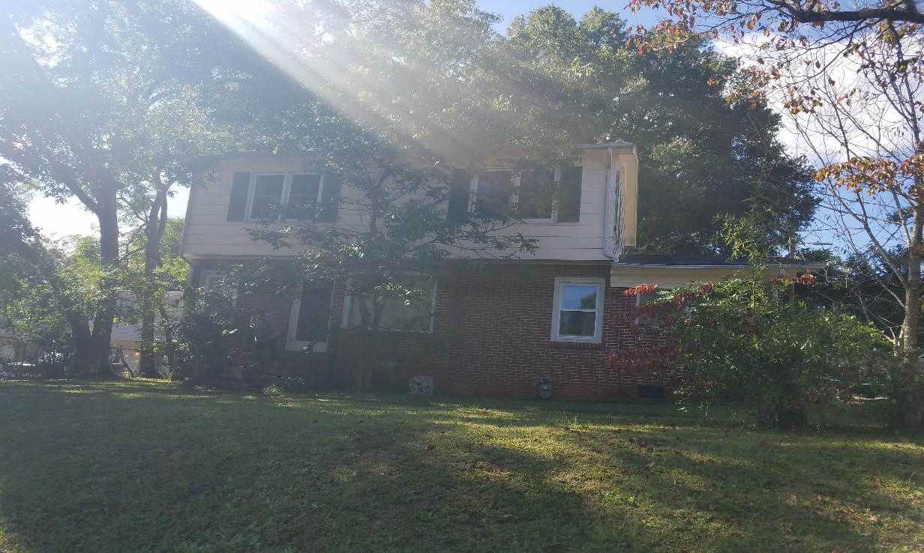

The Wilfong’s Home
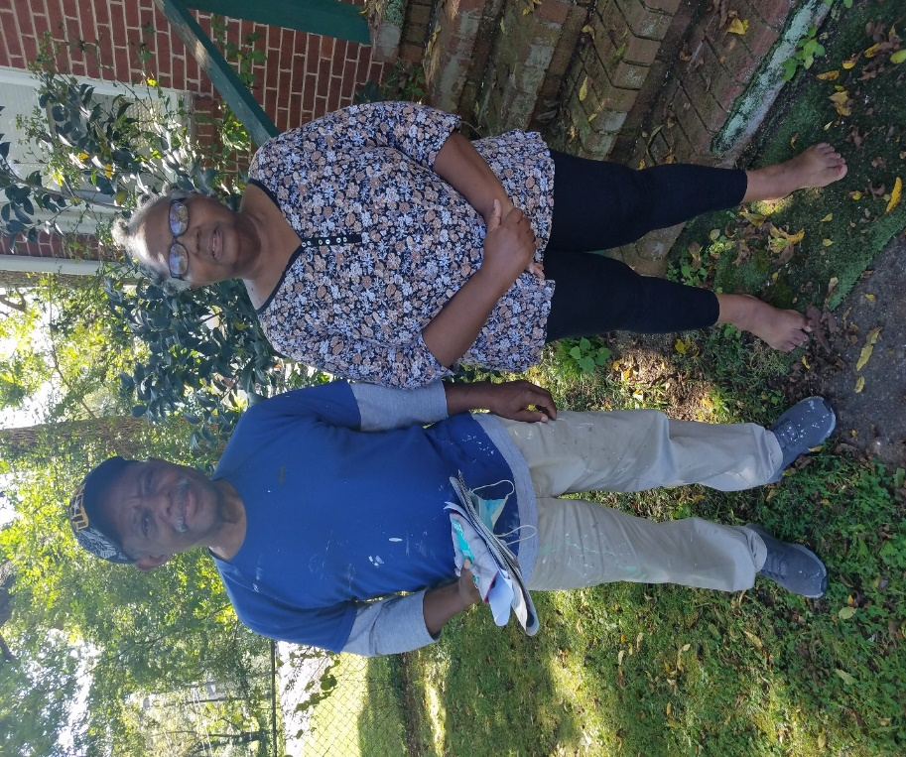
Glenn and Martha Wilfong

Current Repair Status

- Jobs completed 3
- Jobs in progress 14
- Jobs approved waiting start 5
- Jobs pending approval 4

____________________________________________________________________________________
Development Report
September/October 2020

Grant Updates
- Grants Submitted:
  - City of Hickory/Community Relations Council - $1,000
  - Pepsi Bottling Company Hickory - $2,500/2021 HITK Event Sponsorship
- Grants In Process:
  - Millholland Endowment Fund - $5,000/Habitat Repairs!
  - George Foundation - $30,000/Habitat Repairs!
- Grants Awarded:
- Truist Bank - $25,000 Habitat Repairs!
- Zoom meetings and phone communication with grant writer, Amy Clinton.
Communication/Donors
- Continuing with personal thank you calls and handwritten thank you cards on incoming donations. We are striving to reach out and connect with our donors through this time of sheltering in place
- Fall direct mailer – Completed
- Thanksgiving & Christmas Postcards (design, print & mail) – In Process
- Christmas Appeal Letter – In Process
- Christmas and Thanksgiving cards – signatures in process
- Email pledge payment notifications and lapsed donor phone calls
- Monthly zoom and phone meetings and with Mandy Pearce/Development
- Staff connections via ZOOM – Meet Tuesdays and Thursdays for staff meetings, meet Wednesdays for Development Meetings

Events
- The Vargas Family Groundbreaking
  - Saturday, October 17 at 10am Ridgeview
  - Invitations completed/mailed
  - Speakers, program, prep work – in process
- Northstone Dedications – Prep for scheduling and filming
- Home is the Key
  - Table Captain orientation meeting October 8
  - Table Captain guest list due October 16
  - 2nd Sponsorship request letters mailed
  - Sponsorship currently at $17,500 with a goal of $25,000
  - Program, pledge form and annual report in process/to be mailed to guest prior to the event.
  - Working with FMC on event prerecordings, video and event technology
- Attended virtual Blackbaud Conference (bbcon) Oct. 6-8.

__________________________________________________________________

Action Items:

1) Policy Proposals – Mitzi (see attached)

a) Restricted and Designated Funds Policy

Habitat for Humanity of Catawba Valley, Inc.,
Policy on Restricted and Designated Funds

Policy Background: This policy has been recommended by Whisnant and Co. auditors to address a donor’s designation or restrictions that may be indicated at time of the donation. This intent will be reflected in the affiliate’s donor software tracking and reconciled monthly with the accounting general ledger.
POLICY Statement:
Donor Restricted Funds - Restricted but qualifies under GAAP Simultaneous release option.
Habitat for Humanity of Catawba Valley will apply the new ASU Standards to its general construction, construction material purchases, and general repair program and record the contribution as without donor restrictions.
The Organization will make every effort to meet the donor’s imposed restrictions but the Board (Finance Committee) does reserve the right to use these funds for other needed purpose(s) as it may deem appropriate.
The primary reason for this reserved right is because a charitable contribution is a gift, and a gift is a transfer of all a donor’s “dominion and control” over the donated property. If after accepting a restricted gift, events occur which impact the ability to meet the donor’s designation, then the donor will be notified.
(The new ASU 958 provides a not-for-profit entity with the ability to elect a policy to report donor-restricted contributions whose restrictions are met in the same reporting period as the revenue is recognized as support within net assets without donor restrictions, reports consistently from period to period, and discloses its accounting policy.)

PURPOSE:
The policy on Restricted and Designated Funds provides policy, information, and guidance for receiving and disbursing restricted and designated funds due to ASU 2018-08 Not-for-Profit Entities (Topic) Clarifying the Scope and the Accounting Guidance for Contributions Made and ASC Topic 606 Revenue from Contracts with Customers

CATEGORIES OF FUNDS
There are several categories of funds each of which has its own benefits and
constraints:
  - Donor Restricted Funds - The donor determines if the funds are to be restricted. Fund designation is specified in writing or through an understood agreement with the nonprofit. Foundations that provide restricted funds often describe how they want their money allocated when they distribute the award.

  - Board Designated Funds - funds without donor restrictions. The board decided to set these funds aside for a specific use or to be used at a specific time. The board can vote to free up the funds or change the purpose of the designated funds.

  - Without Donor Restriction Fund – These funds are available for general use.

DONOR RESTRICTED FUNDS:
It is important for the organization to identify what the donor’s intent was at the time the donation was given in order to determine if a restriction exists. There are several Donor Restricted Funds which we have identified:
General Construction
Construction material purchases
General Repair program
Specific Repair program
House sponsorship
Land acquisition
Capital expenditure

b) Executive Staff Succession Plan Policy
Policy Background: Several Charitable Foundations request a copy of the organization’s Executive Succession Plan as part of their application process. This policy is presented to the Board of Directors for their consideration.

Policy Statement:
A change in executive leadership is inevitable for all organizations and can be a very challenging time. Therefore, it is the policy of Habitat for Humanity of Catawba Valley to be prepared for an eventual permanent change in leadership—either planned or unplanned—to ensure the stability and accountability of the organization until such time as new permanent leadership is identified.
The Board of Directors shall be responsible for implementing this policy and its related procedures. It is also the policy of the board to assess the permanent leadership needs of the organization to help ensure the selection of a qualified and capable leader who is representative of the community; a good fit for the organization’s mission, vision, values, goals and objectives; and has the necessary skills for the organization.
To ensure the organization’s operations are not interrupted while the Board of Directors assesses the leadership needs and recruits a permanent executive officer, the board will appoint interim executive leadership as described below.
The interim chief executive officer shall ensure that the organization continues to operate without disruption and that all organizational commitments previously made are adequately executed, including—but not limited to—loans approved, reports due, contracts, licenses, certifications, memberships and obligations to lenders or donors (investors) of Habitat for Humanity of Catawba Valley. It is also the policy of Habitat for Humanity of Catawba Valley to develop a diverse pool of candidates and consider at least three final candidates for its permanent Executive Director position.
Habitat for Humanity of Catawba Valley shall implement an external recruitment and selection process, while at the same time encouraging the professional development and advancement of current employees. The interim Executive Director and any other interested internal candidates are encouraged to submit their qualifications for review and consideration by the transition committee according to the guidelines established for the search and recruitment process.

Procedures for Succession:
For a temporary change in executive leadership (e.g., illness or leave of absence) refer to the organization’s personnel handbook. In the event the Executive Director (ED) of Habitat for Humanity of Catawba Valley is no longer able to serve in this position (e.g., leaves the position permanently), the executive committee of the board of directors shall do the following:
1. Within five business days, appoint an interim Executive Director according to the following line of succession: a. Assistant Executive Director of Habitat for Humanity of Catawba Valley b. External consultant (with experience as an interim executive director)
2. Within 15 business days, appoint an executive transition committee, in the event that a permanent change in leadership is required. This committee shall be comprised of 2 members (at least one member of the executive committee and two members of the board of directors.) It shall be the responsibility of this committee to implement the following preliminary transition plan:
a. Communicate with key stakeholders regarding actions taken by the board in naming an interim successor, appointing a transition committee and implementing the succession policy. The organization shall maintain a current list of key stakeholders who must be contacted, such as lenders and donors (investors) of Habitat for Humanity of Catawba Valley, foundations and government agencies.
b. Consider the need for consulting assistance (e.g., transition management or executive search consultant) based on the circumstances of the transition.
c. Review the organization’s strategic plan and conduct a brief assessment of organizational strengths, weaknesses, opportunities and threats to identify priority issues that may need to be addressed during the transition process and to identify attributes and characteristics that are important to consider in the selection of the next permanent leader.
d. Establish a time frame and plan for the recruitment and selection process.
e. Refer to the personnel handbook for additional procedures.

Informational Items:

1) Home is the Key Update:
This year’s program includes Board Members, Margaret Pope and Whit Malone and both new construction and Home Repairs clients. The theme Homes, Community Hope and You focuses on Habitat new work in the Ridgeview Community.
Full Metal Chicken is continuing to film segments of the virtual event. The shift to a totally online event has been challenging but successful.
Currently 25 Table Captains are participating and will invite friends and family to virtually “attend” the event.
The good news is that we have met and possibly exceeded our goal to raise $20,000 from corporate sponsors with 15 participating local businesses. This places us at 20% of our $80,000 goal before the event begins!

2) Habitat’s Economic Impact on Catawba County (separate attachment)

Habitat International recently provided an economic analysis of our affiliate’s impact on the local economy in 2019. The information is provided as an infographic and is included in the Board Packet.

Some of the more interesting data points:

- 44 jobs were supported generating $1,732,754 in wages to the local economy (this includes current Habitat staff and subcontractor staff)
- $3,888,897 economic impact of Habitat investments
- $1.57 dollars injected into economy for each dollar invested

During the pandemic Habitat has continued to operate at full capacity:
OUR IMPACT:
Homeowner Services
- Mortgages serviced: 96 in April, gradually up to 99 in August
- Conversations about mortgage support: Many! Avg # of homeowners needing particular delinquency support– about 7 per month, with several conversations with each, plus coordination with Affiliate Mortgage Services.

Repairs
- Repair inquiries: 35
- Repair applications received: 16
- Repair applications approved: Only one of these 16 has been denied (their income was too high for our program)
- Site Visits: The 15 approved have either had a site visit or will be receiving a site visit soon.
- Repairs undertaken (can be begun or completed): Richard or Ben would have this number.
New Homeownership
- Homeownership inquiries: 118
- AIM Meetings: 2
- Applications received: 7
- Homeowners approved: 4
- Hours of class time completed (# of applicants x number of class hours): 50 hours
- Hours of Sweat equity completed: 440 hours
- Applications distributed: 41
- Applications Returned: 30+
- Closings (completed or under way): one closing each in March (the 3rd), May, and June, plus Som and Kandi coming up.
- Housing Assignments: If you include Santiago in February, then it’s 5 so far, although the latest two aren’t official yet. They will be by HITK, though.
- Families in Process: Including all who have closed since March 1, as well as all accepted to this point: 11 families = 41 people including 25 children

Construction
- Foundations dug: by HITK, maybe three in Ridgeview and two on F Ave. – so 5?
- 1 house finished
- 2 houses close to finished
- 3 footings 1 of which is being framed
- 3480 total new construction staff hours since march 13
- (Derek, Josh, Billy)
- 2320 hours on site (Josh, Billy)
- Cottages at Ridgeview layout and site plan completed

THE NEED
- Inquiries for assistance –15 from current homeowners
- Inquiries for assistance outside the scope of our programs: 20 inquiries referred to community partners
- Delinquency support – see above
- #’s of HO’s with jobs, lives, or money directly COVID impacted: Still only about 12 that we know of, so we’re grateful it hasn’t been more. We’ve had one actually confirmed sick, several more who probably had it and missed work, but never took a test, some laid off for weeks or months, several who had hours severely cut and others who lost jobs. The big impact yet to be felt will be from our homeowners who are parents and who will now have their ability to work impacted by their need to be home to support their children who are in virtual school – and whose finances are also hit by the loss of free and reduced price lunch and breakfast for their children at school. I know of at least one homeowner who has changed to a second shift job so that she can be with her children to help with school during the day, and then she’ll take them to their grandmother’s house for the night while she works. This is a story very likely being repeated in some version in many of our homeowner households; I just don’t know about them all yet.
  - I used words like some and several because the actual numbers don’t don’t sound like much – although there could well be many that I don’t know about but who have managed to keep payments current and haven’t been in touch. We have many homeowners who are very independent and self- sufficient, so we don’t hear from them often and there are probably a number of them who are overcoming COVID challenges on their own.
- Families indicating a need for support with Food – so far, 13.

