Habitat for Humanity of Catawba Valley
Board of Directors’ Meeting
November 23, 2020

Devotion – Tina Morgan

Adoption of Agenda — Charlotte Williams

Consent Agenda:
Items are considered routine by the Board of Directors and will be enacted by one motion. There will be no separate discussion of these items unless requested by a member. The item will be removed from the Consent Agenda, then added to Action or Informational Items.

1) Minutes from October Board Meeting
2) October Financial Reports (Separate Attachment)
3) Staff Reports

Action Items:

1) none this meeting

Informational Items:
1) Home is the Key Summary – Lynn & Jenna
2) Executive Director Update - Mitzi

Upcoming Events:
Next Board Meetings: December 14th (if needed), January 25th, February 22nd, March 22nd

Consent Agenda
1) October Board Minutes
Members Present: Bill Burnham, Doug Dickson, Scott Echelberger, Lori Greveling, Frances Hilton, Ander Horne, Troy Howard, Pat Jones, Whit Malone, Cliff Moone, William Pleasant, Margaret Pope, Charlotte Williams
Members Not Present: Rodney Garren, Graham Hunsucker
Staff Present: Mitzi Gellman, Andrew Isola, Jeff Mingus, Tina Morgan, Melissa Neal, Lynn Nelson, Derek Ross, Jenna Ross, Hannah Yost
Welcome and President’s Remarks
There being a quorum, the October meeting of the Habitat for Humanity of Catawba Valley Board of Directors was called to order by Board President Charlotte Williams at 12:00 pm. Due to COVID-19, the Board meeting was held via Zoom Meeting.
Mitzi Gellman, Executive Director, informed the Board of the resignation of Board member Robin Creel effective immediately.
Devotion
Tina Morgan led the devotion by sharing scripture from Job 2:10 followed by prayer.
Adoption of Agenda
Upon a motion and second, the Board unanimously adopted the October Agenda.
Consent Agenda
The Board adopted the Consent Agenda of the September Board Meeting Minutes, the September Financial Reports, and the Staff Reports with the exclusion of the Construction Report which was moved to Informational Items by motion and second without dissent.
Action Items
- Mitzi Gellman, Executive Director, presented an Executive Committee recommendation to approve the Restricted and Designated Funds Policy. With all in favor, the Policy was approved.
- The Executive Committee’s recommendation to approve the Executive Staff Succession Plan Policy was presented by Mitzi Gellman. With all in favor, the Policy was approved.
Informational Items
- Derek Ross, Director of Construction, presented the Construction Report stating the City of Hickory through a federally funded grant opened bidding opportunities for the construction of two affordable homes on city property. Habitat submitted a bid for one home of $153,192.30 which was accepted. Construction is now complete, and our final costs were $107,813.00; giving Habitat net a profit of $45,379.30.
- Home is the Key - Updates were given by Lynn Nelson - Development Assistant, and Jenna Ross - Community Outreach Coordinator, relating to the overall format of the virtual event (to be prerecorded) and the status of table captains and sponsors.
Executive Director’s Update
Mitzi Gellman, Executive Director, gave a brief update on The Cottages at Ridgeview stating we are in a strong position to start building all six homes concurrently. The homes at The Cottages at Ridgeview will consist of 4 Habitat Homes and 2 market rate homes. All four Habitat homes have been selected by homeowners in process. We currently have one home scheduled to begin work on trusses and two homes with footings complete. Having multiple homes in progress will enable Habitat to open volunteer opportunities to our regular volunteers. Mitzi also stated we have an interest in purchasing two additional abandoned homes in the neighborhood with the intent to scrap the home and rebuild.
Adjourn
President, Charlotte Williams adjourned the meeting at 12:45 pm. The next Board Meeting will be held on Monday, November 23rd at 12:00pm via Zoom.

2) September Financials (available as separate attachment)

3) Staff Reports
Messaging & Media
- Home is the Key
  - Finalized HITK digital platform
    - Had staff and board test-drive the platform for ease of usage and clarity
  - Reviewed and finalized HITK event video
  - Finalized Print materials for advanced guest packets
    - Invitation
    - Program
    - Economic Impact Data
    - Pledge Form
  - Identified key list of potential HITK guests
    - Wrote form guest invitation letter
    - Handwrote targeted personal invitations to accompany letter
    - Mailed letters
  - Social Media:
    - 11/4 – lead up
    - 11/6 – lead up
    - 11/12 – day of
    - 11/13 – thank you
  - Eblasts:
    - 10/29 – Lead up, general audience
    - 11/11 – reminder, RSVP guests only
    - 11/12 – day of, general audience
    - 11/13 – thank you, RSVP guests only
    - 11/13 – thank you/results, general audience
  - Website:
    - https://habitatcatawbavalley.org/ Updated Cover Message on home page, schedule to go live 7:15am 11/12
    - https://habitatcatawbavalley.org/home-is-the-key/ Navigation pathway scheduled to go live 7:15 am, 11/12
    - https://habitatcatawbavalley.org/home-is-the-key-2020/ event page content scheduled to go live 7:15, 11/12

- Christmas Mail Appeal
  - Created content for Christmas mail appeal
  - Materials in design with FMC
  - Social media, email, and web campaign to accompany release

- Giving Tuesday
  - Lead-up posts scheduled on a weekly basis for the 5 weeks prior to event
  - Eblasts created and scheduled to be delivered in lead-up to event
  - List of secured donors created to ensure steady giving throughout the day
- Stewardship
  - Thanksgiving postcard created and ready to mail
  - Thanksgiving eblast created and scheduled to send day-of
  - Christmas postcard created and ready to mail
  - Christmas eblast created and ready to send day-of
  - Christmas card insert handwritten for VIP list

Outreach
- LiveWell Catawba Board Meeting, 10/20
- Recorded Celebration video message in honor of the 10 year anniversary of Apple’s Data Center in Maiden, 10/26

Development
- One on One consultation session with Development Consultant, 10/13
- One on One consultation session with Development Consultant, 10/22

Events
- Panelist at Villanova University’s Service and Justice Virtual Experience, 10/12
- Home is the Key, 11/12

Volunteers
- Volunteer Hours 8/18-9/15:
  - 30 volunteers
  - 428.5 hours served

__________________________________________________________________

The ReStore Report October 2020
Donations and Sales – Sales for October 2020 $71,086.04. This is a combination of in-store and online ($1668.00) sales. “Round-up your purchase donations” continue strong in October $612.25.
This month’s big donations 4 pallets of fabric from Leathercraft, 25 sectional component pieces from Zenith Freight, and 30 pieces from Cargo Integrated Logistics. Lowe’s Hardware Hwy 127 has started giving regularly, but Home Depot continues to be our best for donating.
Our community loves Habitat. Individual drop off donations and scheduled truck pickups remain steady. The three container system continues to work good. Followed by a disinfecting sanitizer spray before being brought into the store for clean-up, pricing, and merchandising.
We have a new webpage feature to promote shopping online. FMC has created a sign up and save page that when completed creates an online coupon. https://habitatcatawbavalley.org/restore/sign-up/. In addition as part of our thank you program our current email list was sent a thank you coupon code to save 20% when shopping online. www.shopcatawbarestore.org.
We still need help growing and maintaining the online shop. New inventory added weekly for online offerings. Want to help keep our online store growing? We have “safer” volunteer days available every Monday and Tuesday. Our latest push…How to grow online sales?
ReStore Volunteer Opportunities cont. – We have a core group of dedicated volunteers who weekly work regular shifts of a couple hours. It’s a big challenge to keep the ReStore running safe and open. There are several ways you or someone you know can still help. We need cashiers, book advocates, fabric rollers, and social media gurus. We’re updating our ReStore webpage so here’s your chance to go worldwide.
Safety is still Priority #1 for Staff and Volunteers “Wash your hands” – we’re still following the CDC, county and state health departments websites for advisories and warnings https://www.cdc.gov/coronavirus/2019-ncov/index.html, http://www.catawbacountync.gov/county-services/public-health/, https://www.ncdhhs.gov/divisions/public-health/coronavirus-disease-2019-covid-19-response-north-carolina focusing on Awareness, Communication, and Training.

Jeff Mingus, ReStore General Manager
__________________________________________________________________
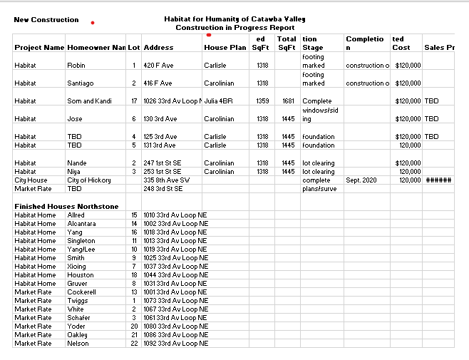

__________________________________________________________________

Development Report
October 2020

Grant Updates
- Grants Submitted:
  - Philip Van Every Foundation - $15,000 Habitat Repairs!
  - Millholland Endowment Fund - $5,000 Habitat Repairs!
- Grants In Process:
  - George Foundation
- Grants Awarded:
- Catawba Valley Community Foundation - $2,500 Habitat Repairs!
- Zoom meetings and phone communication with grant writer, Amy Clinton.
Communication/Donors
- Continuing with personal thank you calls and handwritten thank you cards on incoming donations. We are striving to reach out and connect with our donors through this time of sheltering in place
- Fall direct mailer – Completed
- Thanksgiving & Christmas Postcards (design, print & mail) – In Process
- Christmas Appeal Letter – In Process
- Christmas and Thanksgiving cards – signatures in process
- Email pledge payment notifications and lapsed donor phone calls
- Monthly zoom and phone meetings and with Mandy Pearce/Development
- Staff connections via ZOOM – Meet Tuesdays and Thursdays for staff meetings, meet Wednesdays for Development Meetings
Events
- The Vargas Family Groundbreaking - Saturday, October 17 at 10am Ridgeview
- Northstone Dedications – Filmed
- Home is the Key
  - Table Captain orientation meeting held October 8
  - Table Captain guest list due date October 16
  - 2nd Sponsorship request letters completed
  - Sponsorship currently at $23,500
  - Program, pledge form, impact sheet and postcard invitation printed
  - HITK guest packets to be mailed Nov. 2
  - Finalizing all items for HITK event

__________________________________________________________________
HABITAT REPAIRS!
BOARD REPORT
November 2020

This month’s report features the Habitat Partners Program. This program was started to as a way increase our outreach with a minimum of staff time and resources. Here is a brief synopsis of the program.
- Each group is vetted to make sure they have the experience and tools to properly complete the repair.
- We can grant up to $1,500.00 for materials.
- Since this is a project controlled by the groups themselves, we do not have staff present during the repair.
- Each group is responsible for seeing that the client meets our income and property requirements.
- We have four churches that have participated in the program so far. They are Calvary Baptist in Newton, First Baptist in Hickory, Highland Baptist in Hickory, and most recently First Methodist in Hickory.
- Since the program inception a little over two years ago, 24 repairs have been completed with one in progress. The repairs consisted of 21 ramps, 1 roof and one exterior trim repairs and painting.
- Average costs have been $850.00.
The latest project was led by Troy Howard from First Methodist, Hickory, who organized a work group consisting of Bob Thompson, and Paul Cumming from Corinth Church in Hickory, Whit Malone from First Presbyterian, Hickory, and Jennifer Forrester and Emily Fisher of First Methodist, Hickory.
A big shout out to Troy for leading this project which consisted of building an access ramp for Gregory James, who is a veteran.

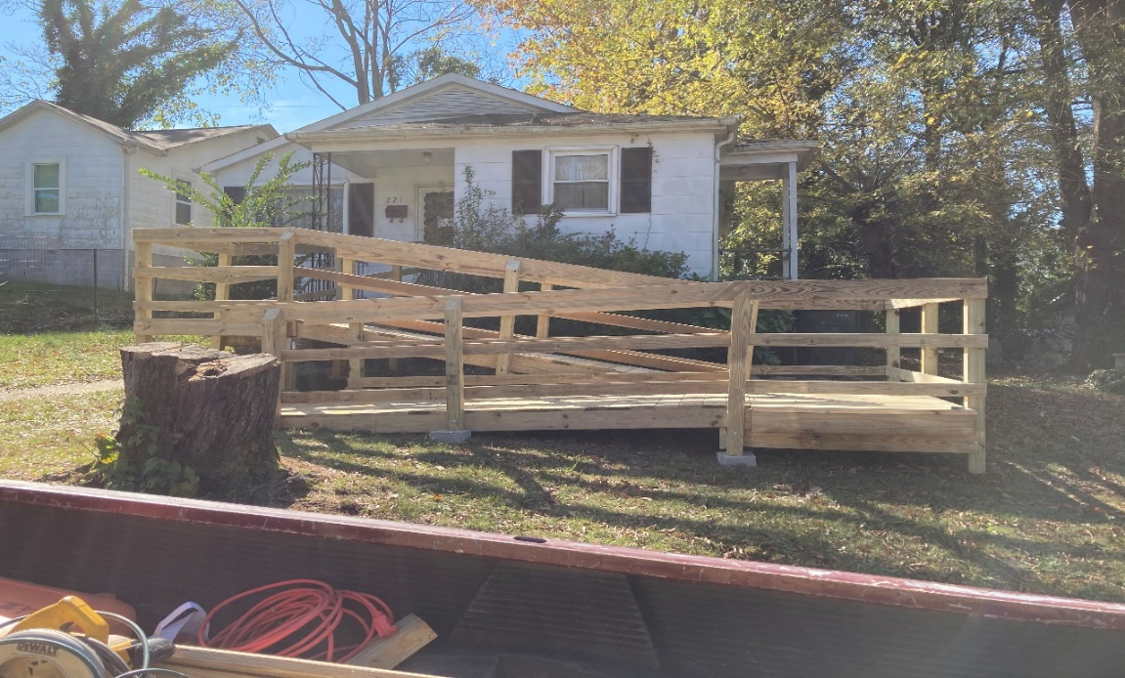
____________________________________________________________________________________

Homeowner Services: Selection and Homeowners-in-Progress
Report for Board of Directors November 2020
The Homeownership Program received 27 applications during the latest open application period. These applications are being screened by staff according to policy guidelines for ability to pay, which includes a review of each applicant’s income, credit, and debt load. Applicants who meet ability to pay requirements will be considered for home visits by the Homeowner Selection Committee at their meeting on December 2nd.

Habitat selection guidelines stipulate that an application for the homeownership program must be complete and submitted prior to the due date before it can be considered for acceptance. In the latest open application period, we implemented a new process to reduce the number of applications that are denied because they are incomplete. The new process was a success, reducing incomplete applications by 67%.

Homebuyers in progress participated in the groundbreaking ceremony for homebuyer Jose Vargas on Saturday, October 17th. They were excited to get to know Jose and each other better. They have also had the opportunity to earn sweat equity on the construction of Jose’s house. Jose states, “I have started driving from work to the building site to practice what it will be like to drive home someday.”

Homeowner Services: Habitat Repairs!
Report for Board of Directors November 2020
Since the last board meeting, twelve applications have been sent to individuals who inquired about getting repair work done on their homes. Four applications are being assessed for program qualifications and are awaiting paperwork from the applicants. One application has been passed to construction for a site visit. Contracts have been completed for two projects which are now ready for repairs to begin.
A social worker through Chess Health Solutions has become an excellent referral source for us. Over the past month, she has referred three new Habitat Repairs! applicants, and she plans to continue to refer clients as the need arises.
Staff are working to ensure that there are enough repair projects in hand to keep construction busy during Hannah’s maternity leave which is expected to begin around the end of December. It’s looking like we will have the needed projects ready to go. However, to ensure that we meet that goal, Habitat Repairs! signs were placed on the new construction sites in Ridgeview to increase inquiries to the program for the next few weeks. Staff are also creating a new system to respond to inquiries to Habitat Repairs! while Hannah is on leave.
Homeowner Services: Homeowner Support
Report for Board of Directors November 2020
Delinquency Report
Reporting Period 10/30/2020 Total Mortgages: 96
Delinquent | # Mortgages Delinquent | Arrearage | % Delinquent
31-60 days | 9 | $ 3,724 | 9.4%
61-90 days | 4 | $ 1,984 | 4.2%
90 plus days | 5 | $ 8,827 | 5.2%
Total this month | 18 | $ 14,535 | 18.8%
Total 9/30/20  (97 mtgs) | 17 | $ 12,674 | 17.5%
Total same mo. prior yr:  10/31/19 (97 mtgs) | 25 | $ 21,371 | 25.8%
Jun. 2013, last mo. prior to MF (119 mtgs.) | 12 |  | 10.1%

Homeowner Services News
We have one more delinquent loan this month than last, but the great news is that we have 5 fewer loans (half as many!) that are 90+ days past due. Overall, this represents terrific progress, especially for these difficult times.

The closing for Som Lor and Kandi Xiong is scheduled for November 19th. First Bank, NCHFA, and WPCOG have all committed their funds and approved the closing date. The professional inspection, final construction tasks, and energy efficiency inspections for Som’s and Kandi’s house are underway.

Our last homeowner to get back to full-time work after a COVID lay-off is now working. It’s a temp job, but she has applications in for permanent jobs and high hopes for getting her mortgage back on track. We have one homeowner (who we know of) who has tested positive for COVID-19 in the past month. We continue to have many homeowners whose work hours are limited by having children at home attending virtual school, and whose budgets (necessities only even before COVID-19) are stretched by the increased costs of food and by the increased food needs and power, water, and internet usage caused by having children at home more.

Angela Thompson, one of our Kenworth homeowners who was anticipating a move to Greensboro to provide long term care for her father, is now hoping that she will be able to stay in her Habitat home.

Nou Soua Chang, who recently suffered sudden and near complete kidney failure, has completed his application for disability. His wife, Mai Thao, is looking for work, since their roles as breadwinner and full-time parent have suddenly reversed.
____________________________________________________________________________________
Development Report
September/October 2020

Grant Updates
- Grants Submitted:
  - City of Hickory/Community Relations Council - $1,000
  - Pepsi Bottling Company Hickory - $2,500/2021 HITK Event Sponsorship
- Grants In Process:
  - Millholland Endowment Fund - $5,000/Habitat Repairs!
  - George Foundation - $30,000/Habitat Repairs!
- Grants Awarded:
- Truist Bank - $25,000 Habitat Repairs!
- Zoom meetings and phone communication with grant writer, Amy Clinton.
Communication/Donors
- Continuing with personal thank you calls and handwritten thank you cards on incoming donations. We are striving to reach out and connect with our donors through this time of sheltering in place
- Fall direct mailer – Completed
- Thanksgiving & Christmas Postcards (design, print & mail) – In Process
- Christmas Appeal Letter – In Process
- Christmas and Thanksgiving cards – signatures in process
- Email pledge payment notifications and lapsed donor phone calls
- Monthly zoom and phone meetings and with Mandy Pearce/Development
- Staff connections via ZOOM – Meet Tuesdays and Thursdays for staff meetings, meet Wednesdays for Development Meetings
Events
- The Vargas Family Groundbreaking
  - Saturday, October 17 at 10am Ridgeview
  - Invitations completed/mailed
  - Speakers, program, prep work – in process
- Northstone Dedications – Prep for scheduling and filming
- Home is the Key
  - Table Captain orientation meeting October 8
  - Table Captain guest list due October 16
  - 2nd Sponsorship request letters mailed
  - Sponsorship currently at $17,500 with a goal of $25,000
  - Program, pledge form and annual report in process/to be mailed to guest prior to the event.
  - Working with FMC on event pre-recordings, video and event technology
- Attended virtual Blackbaud Conference (bbcon) Oct. 6-8.

__________________________________________________________________

Action Items: none for this meeting.

Informational Items:

- Home is the Key Summary: Information to be provided at meeting.

- Executive Director Update: Information to be provided at meeting.

