**Habitat for Humanity of Catawba Valley**

**Board of Directors Meeting**

January 27, 2020

**Devotion**

**Adoption of Agenda** — Charlotte Williams

**Consent Agenda:**

Items are considered routine by the Board of Directors and will be enacted by one motion. There will be no separate discussion of these items unless requested by a member. The item will be removed from the Consent Agenda, then added to Action or Informational Items.

1) Minutes from November Board Meeting

2) December Financial Reports

**Action Items:**

None this meeting

**Informational Items:**

1) Staff Reports – Kick Off to 2020!

**Upcoming Events:**

2/6/20 @ 5-7pm - Your Generosity is Building Donor Reception @The Room on Union Square in Downtown Hickory

2/15/20 @ 10am LaToya Ramseur House Dedication @ Northstone

Next Board Meetings: January 27th, February 24th, March 23rd.

**Consent Agenda**

**1) Minutes from November Board Meeting**

**Habitat for Humanity**

**Board of Directors’ Meeting**

**11-25-19**

**Members Present:**  Bill Burnham, Rodney Garren, Lori Greveling, Frances Hilton, Kelly Hipps, Ander Horne, Robin Creel, Pat Jones, Whit Malone, Cliff Moone, William Pleasant, Margaret Pope, Charlotte Williams, Doug Dickson, Scott Echelberger, Graham Hunsucker

**Members Not Present:** Troy Howard

**Staff Present:** Mitzi Gellman, Richard Greathouse, Jeff Mingus, Hannah Yost, Melissa Neal, Andrew Isola, Jenna Ross

**Other Guests:** Lindsay Keisler, Meg Robertson, Toinette WIlkinson

**Welcome**

There being a quorum, the November meeting of the Habitat for Humanity of Catawba Valley Board of Directors was called to order by Charlotte Williams at 12:00pm.

**Devotion**

Kelly Hipps led the devotion from Psalm 127:1 and 1 Corinthians 12. Kelly also read a poem called Who are the hands of Christ and then closed us in prayer.

**Adoption of Agenda**

Upon motion and second, the Board unanimously adopted the November Meeting Agenda.

**Consent Agenda**

The Board then adopted by consensus the Consent Agenda of the October Board Meeting Minutes, Staff Reports and the October Financial Reports. There was one change to the consent agenda which was 2 houses on F Avenue that should be listed on Derek’s report. Rodney made a motion and then Whit Malone seconded the motion.

**Action Items**

Margaret Pope, Board Member presented the Family Selection Committee Recommendation for acceptance of four families into the Homeownership Program and also denial of two families. With all in favor, the Board approved the recommendations for acceptance and for the denial.

**Information Items:**

Lindsay Keisler talked about the future of homes in Catawba County. Lindsay said that Habitat for Humanity of Catawba Valley was the hands that build the community. She thanked Habitat for our leadership. She did a presentation on the housing survey that was conducted and one of the key questions was how do we put the data to action?

Jeff Mingus gave out awards to a couple of the table captains.

Jenna Ross did a presentation about the Home is the Key Breakfast. The Breakfast has raised $165,000. Jenna had a power point presentation regarding giving units, average guest gift. We had 34 table captains and 18 new legacy society. One out of every two guest made a gift.

We need to stay connected with the guests that came to the breakfast. One way is to invite someone to come to job site. Next year we will have pictures of the families at the breakfast and stations that tell the story of the families.

**Adjourn**

With a motion and second, Charlotte Williams adjourned the meeting at 1:10 pm.

**Upcoming Events**

* Next Board Meetings: December 16 (Christmas Social), January 27, February 24

**Staff Reports**

**Development Report**

**December 2019/January 2020**

Grant Updates

* Awarded and received $2,500.00 from Kenneth K. and Suzanne G. Millholland Foundation for Bears Build (new construction).
* Submitted, awarded and received $25,000 from the George Foundation for Habitat Repairs!
* Received BB&T grant of $25,000 for Ridgeview Development.
* Submitted the E. R. Carpenter grant request of $60,000 for renovations for Homeowner Services Department.
* Awarded Publix grant of $6,000 for new construction.
* Grants in process: Sisters of Mercy and Corning.
* Updating and coordinating the 2020 Grant Schedule.
* Continuing to collaborate with Jason Rogers, grant writer.

Events

* Home is the Key

1. Completed all thank you calls.
2. Total Raised - $168,433.00.
3. Booking and date selection for HITK 2020 at Moretz Mills.

* Prepping and organizing a thank you event scheduled for Thursday, February 6 from 5:30-7:00pm at The Room (Union Square).
* Planning for Dedication of Latoya’s home (Apostle Build 2019 House) to be held Saturday, February 15 at 10:00am.

Communication

* Fall Appeal total raised to date $6,635.
* Christmas postcard completed and mailed.
* Christmas Appeal letter completed and mailed 12/13/19. Current total raised $15,890.
* End of Year Donation Tax Statements in process to be mailed in January.
* Met with Full Metal Chicken to discuss 2020 marketing schedule and procedures.
* Monthly communications with LYBUNT donors (donors who gave last year but not this year).
* Donor contact through thank you calls and handwritten notes of appreciation.
* Development Planning Meeting with Mandy Pearce to set 2020 development calendar.

Misc.

* In process - Strategic Plan.
* Pledge reminders for HITK and Capital Campaign completed for December & January.

**___________________________________________________________________**

**Homeowner Services: Selection**

**Report for Board of Directors January 2020**

**Homebuyer Program:**

The newest open application period for the Homebuyer Program runs from Jan 20th - 31st with applications due on Feb. 14th. The Homebuyer Program held three Applicant Information Meetings on Jan 21st and 22nd. The meetings were well received with 70+ individuals attending the 3 meetings.

The Homebuyer Program welcomed 4 new homebuyers into the program: Melissa Alvarez, Santiago Agreda Parker, Robin Jakubowski, and Jose Vargas. All 4 have attended their program orientation, signed their partnership agreement, and begun their sweat equity hours. We have high hopes for all 4 home buyers and are proud to work alongside them in their journey towards homeownership.

The Homebuyer Program plans to begin Personal Finance classes with homebuyers in early Feb. These classes will cover basic budgeting, managing debt, saving for the future, and the emotional and psychological influences surrounding personal finance, as well as other financial topics.

**Repairs Program:**

Staff members continue to work through the backlog of inquiries with 16 inquiries left from 2019, and 2 so far in 2020.

In an effort to utilize allocated funding from the City of Hickory, we have sent out applications to Habitat homeowners who are in older homes within the city limits. These homeowners will be offered the limited opportunity to apply for roof, HVAC, plumbing, and/or weatherization work which are largely subcontractor jobs that will allow us to move forward in meeting needs and using allocated funding without overwhelming staff.

Staff are brainstorming ways to reach out to the broader Ridgeview neighborhood with a variety of services. We hope that, when we’re there doing new construction, we can have a larger community impact by also concentrating repair work in the area.

**Economics Update:**

The Winter 2019 *Economic Indicators Newsletter* for the Hickory-Morganton-Lenoir MSA says that average annual wages in our MSA between 2014 and 2018 have increased by 14.7%, while inflation only rose by 5.8% in the same period. However, it also clarifies that this increase is due in part to job growth in higher-paying sectors, so it may not indicate the economic improvement that it seems for many Habitat homeowners. Nevertheless, it appears that the trend of inflation outpacing lower income wages may have shifted.

**Homeowner Services: Resource**

**Report for Board of Directors January 2020**

**Delinquency Report**

**Reporting Period 12/31/2019 Total Mortgages: 98**

|  |  |  |  |
| --- | --- | --- | --- |
| Delinquent | # Mortgages Delinquent | Arrearage | % Delinquent |
| 31-60 days | 7 | $ 3,930 | 7.1% |
| 61-90 days | 7 | $ 2,854 | 7.1% |
| 90 plus days | 8 | $ 14,708 | 8.2% |
| Total this month | 22 | $ 21,492 | 22.4% |
| Total 10/31/19  (97 mtgs) | 25 | $ 21,371 | 25.8% |
| Total same mo. prior yr:  12/31/18 (103 mtgs) | 24 | $ 24,290 | 23.3% |
| Jun. 2013, last mo. prior to MF (119 mtgs.) | 12 |  | 10.1% |

**Homeowner Services News**

Delinquencies have decreased by over 3% in the past two months, which is unusual at the end of the year.

There were no other bidders at the foreclosure sale on Shawnte Eskridge’s house. If there are no upset bids, then the sale will confirm to Habitat Catawba Valley on January 21. Suwaina Rippy, one of our home buyers, has expressed interest in the house.

We expect LaToya Ramseur to be able to close on her new home in February, 2020. Her house appraised for $165,000. We’ll be celebrating the dedication of her house with the Apostle Build churches on Saturday, February 15th, at 10 a.m.

Rahima Mumed, the 10th grade daughter of homeowners Abdalla Mumed and Chaltu Mussa, has been accepted into the NC School of Science and Math.

Kandi and Som have completed the first 20% of their sweat equity hours and earned their place on the construction list. We’ll be having a house start meeting with them the week of January 27.

WPCOG is increasing the amount of their down payment assistance loans in 2020. The amount may vary by situation. The amount for LaToya Ramseur’s closing will be $15,000.

The North Carolina Housing Finance Agency will continue to contribute $35,000 to our shared mortgages in 2020. Their member fee (they pay us) has increased from $1,200 to $1,500, and the System Vision incentive amount for new homes with crawl spaces has increased from $4,500 to $4,800.

We’ve completed four contracts with repair homeowners since the last board report.

**__________________________________________________________________**

Repair Project of the Month

January 2020

The repair of the month is located at 3 South Erwin Avenue in Newton. The home is owned by Lori Fleming who lives by herself. Ms. Fleming lives in double wide mobile home that sits on a chassis and is underpinned by a non-structural brick curtain wall that has settled in places.

Habitat Repairs! will be doing the following work.

1. Tear off and install new shingles.
2. Take out and replace rear crawlspace curtain wall.
3. Replace front entry deck and steps.
4. Replace rear entry stoop and steps.
5. Repair facia.
6. Install new gutters and leaf guards.
7. Repair HVAC floor vents.
8. Paint Exterior trim.
9. Clean mold off siding.

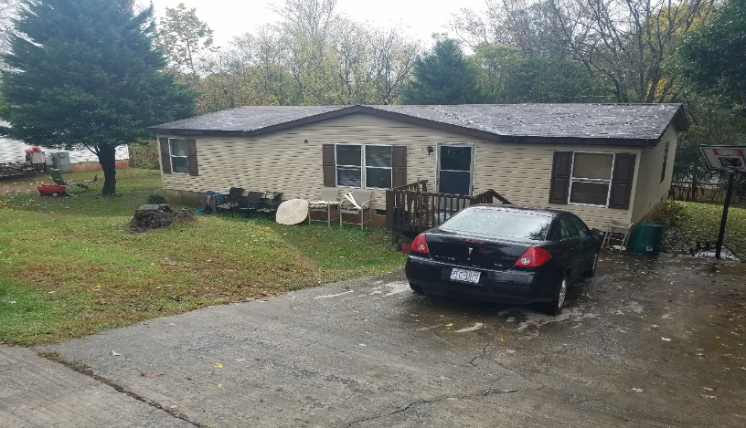 **Front view of house**

 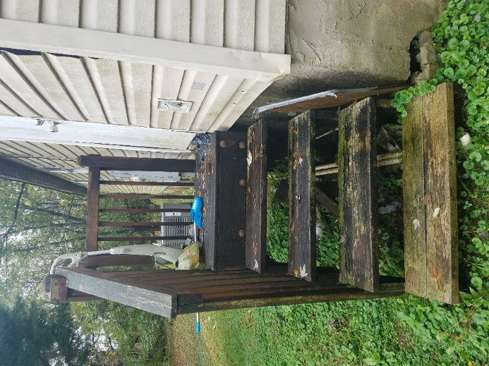 Ms. Fleming & her granddaughter Rear entry steps & curtain wall settlement

**The ReStore Report**

**The ReStore Report December 2019**

**Donations and Sales –** We’ve made it to the half fiscal year mark. Whew! The numbers are on target to hit $900,000.00. End of year giving was strong with several truck loads tile, furniture, and home goods. December finished ahead of same time last year. January is unpredictable but has started on a positive note. Here’s to an exciting and energized second half.

|  |  |  |  |  |
| --- | --- | --- | --- | --- |
| **ReStore CV Monthly Sales** | |  |  |  |
|  | **FY 16-17** | **FY 17-18** | **FY 18-19** | **FY 19-20** |
| **July** | $67,253.41 | $71,625.33 | $80,146.76 | $82,539.22 |
| **August** | $71,891.46 | $77,407.89 | $83,504.60 | $80,360.55 |
| **September** | $71,337.90 | $56,283.67 | $77,744.76 | $65,581.02 |
| **October** | $58,345.82 | $77,230.73 | $61,195.95 | $75,545.59 |
| **November** | $63,641.08 | $66,987.67 | $68,489.54 | $69,951.60 |
| **December** | $77,482.20 | $72,131.82 | $68,411.76 | $73,286.57 |
| **January** | $63,111.57 | $57,343.17 | $58,732.51 |  |
| **February** | $70,043.98 | $68,622.18 | $76,735.03 |  |
| **March** | $76,671.33 | $77,237.35 | $85,598.29 |  |
| **April** | $67,531.30 | $73,001.38 | $73,814.56 |  |
| **May** | $80,323.70 | $78,168.17 | $73,717.21 |  |
| **June** | $84,432.78 | $71,772.57 | $71,653.58 |  |
|  | $852,066.53 | $847,811.93 | $879,744.55 | $447,264.55 |

There’s so much more potential…who do you know? We’re always looking for new donors, business contacts, corporate connections. We can help clear up inventories, storage costs, and provide a tax credit too.

_______________________________

**The results are in!** - ReStore Support group has published the overall ReStore Report. Sales numbers and statistics from 829 ReStores across the US and Canada. How did we do overall?

**#133 of 829** in National Gross Sales / **#92 of 829** in National Net Profit

The numbers are staggering to look at and tell all types of stories from employees to volunteers, donations to purchased product. Here’s a smaller look at the top 45 of 79 NC locations reporting. Sorted by gross sales, with several of our closest neighbors highlighted. I think the one in yellow is pretty cool.

|  |  |  |  |  |  |  |
| --- | --- | --- | --- | --- | --- | --- |
|  | **City** | **State** | **Gross Revenue** | **Profit** | **Sales Per SQ Ft** | **Total FTEs** |
| **1** | Asheville | NC | $2,951,093 | $974,567 | $61.48 | 23.4 |
| **2** | **Wake Raleigh Main** | **NC** | **$2,607,315** | **$1,055,906** | **$52.15** | **15.9** |
| **3** | **Charlotte Wendover** | **NC** | **$2,447,535** | **$905,157** | **$69.55** | **13** |
| **4** | **Durham** | **NC** | **$1,682,286** | **$542,393** | **$46.29** | **9.9** |
| **5** | **Our Towns Mooresville** | **NC** | **$1,476,471** | **$381,554** | **$61.39** | **11.3** |
| **6** | **Charlotte Wilkinson** | **NC** | **$1,211,235** | **$269,339** | **$52.66** | **9.6** |
| **7** | **Wilmington** | **NC** | **$1,179,744** | **$401,228** | **$73.73** | **20.3** |
| **8** | **Greensboro** | **NC** | **$1,176,949** | **$312,607** | **$30.57** | **9.6** |
| **9** | **Our Towns Cornelius** | **NC** | **$1,113,814** | **$411,905** | **$66.30** | **8.8** |
| **10** | **Forsyth Winston-Salem** | **NC** | **$1,055,518** | **$256,662** | **$45.89** | **15.8** |
| **11** | **Wake Cary** | **NC** | **$1,024,519** | **$264,238** | **$116.42** | **7.9** |
| ***12*** | *Hickory* | *NC* | *$879,745* | *$323,373* | *$48.87* | *7.4* |
| **13** | **Wake Raleigh II** | **NC** | **$876,491** | **$264,989** | **$56.19** | **7.1** |
| **14** | **Sandhills Aberdeen** | **NC** | **$825,175** | **$377,190** | **$43.36** | **6.1** |
| **15** | **Wilmington** | **NC** | **$774,985** | **$315,325** | **$77.50** | **6.8** |
| **16** | **Raleigh Wake Forest** | **NC** | **$765,387** | **$230,731** | **$65.98** | **7.1** |
| **17** | **Charlotte University** | **NC** | **$713,857** | **($45,237)** | **$38.59** | **9.2** |
| **18** | Kannapolis | NC | $701,435 | $163,228 | $26.71 | 8.1 |
| **19** | Gastonia | NC | $669,725 | $132,742 | $30.44 | 11.5 |
| **20** | **Charlotte Pineville** | **NC** | **$649,678** | **($67,413)** | **$53.03** | **8.6** |
| **21** | **Wake Fuquay- Varina** | **NC** | **$632,988** | **$136,239** | **$50.64** | **6.5** |
| **22** | **Monroe** | **NC** | **$628,952** | **$333,748** | **$26.21** | **7.3** |
| **23** | Morganton | NC | $622,771 | $287,227 | $44.57 | 4.5 |
| **24** | **Wake Apex** | **NC** | **$601,320** | **$163,465** | **$70.74** | **7.1** |
| **25** | Matthews | NC | $559,242 | $281,373 | $53.05 | 5.9 |
| **26** | **Our Towns Statesville** | **NC** | **$554,000** | **$35,634** | **$71.03** | **6.8** |
| **27** | Boone | NC | $531,107 | $188,169 | $36.63 | 5.5 |
| **28** | **Greensboro** | **NC** | **$511,122** | **($77,512)** | **$42.59** | **9.6** |
| **29** | Brevard | NC | $489,420 | $145,946 | $43.39 | 6.6 |
| **30** | **Forest City** | **NC** | **$452,695** | **$270,077** | **$28.29** | **4** |
| **31** | **Wake Clayton** | **NC** | **$448,063** | **$85,326** | **$44.81** | **6.1** |
| **32** | Lenoir | NC | $419,022 | $215,697 | $57.03 | 4.8 |
| **33** | Waynesville | NC | $397,443 | $127,880 | $43.04 | 4.8 |
| **34** | **Newport** | **NC** | **$387,143** | **$80,807** | **$49.86** | **6.1** |
| **35** | **Hendersonville** | **NC** | **$377,263** | **$350,343** | **$75.45** | **4.8** |
| **36** | Wilkesboro | NC | $369,278 | $101,341 | $20.79 | 5.3 |
| **37** | New Bern | NC | $351,184 | $112,754 | $54.03 | 5.5 |
| **38** | Taylorsville | NC | $321,000 | $39,300 | $13.96 | 7.1 |
| **39** | **Hendersonville** | **NC** | **$317,716** | **$66,716** | **$22.69** | **3** |
| **40** | **Forsyth Lewisville** | **NC** | **$314,228** | **$53,248** | **$39.28** | **6.2** |
| **41** | Fayetteville | NC | $310,499 | $126,157 | $23.80 | 3.5 |
| **42** | Sanford | NC | $279,087 | $139,307 | $11.14 | 4.8 |
| **43** | **Franklin** | **NC** | **$278,100** | **$136,700** | **$30.90** | **5.4** |
| **44** | Laurinburg | NC | $250,643 | $29,054 | $24.29 | 5.8 |
| **44** | **Forsyth Kernersville** | **NC** | **$250,398** | **($8,931)** | **$29.63** | **6** |
| **45** | Shelby | NC | $214,813 | $2,232 | $34.37 | 3.5 |

**Dewey’s Cookies in the House!** – It was a pretty sweet deal with local Habitat’s making 30%, and Habitat NC making 10% from each sale. Until next season Dewey’s. YUM!

**Volunteers Needed** - The ReStore needs volunteers! Cashiers, warehouse receiving and loading, customer service, sales floor merchandisers, thank-you ambassadors, greeters, and so much more.

Flexible volunteer shifts and work schedules. If you know someone or would like to help or need more information, please contact Kristi Biggar, ReStore Coordinator at 828-327-7467 or [kristi@habitatcatawbavalley.org](mailto:kristi@habitatcatawbavalley.org).

**New ReStore Phone Number–** 828-327-7467(SHOP) **Website -** www.restorecatawbavalley.org

Jeff Mingus ReStore General Manager

**___________________________________________________________________**

**January Construction Report**

**Derek Ross**

