Habitat for Humanity of Catawba Valley
Board of Directors Meeting

September 23, 2019

Swearing in of New Members

Devotion

Adoption of Agenda — Doug Dickson

Consent Agenda:
Items are considered routine by the Board of Directors and will be enacted by one motion. There will be no separate discussion of these items unless requested by a member. The item will be removed from the Consent Agenda, then added to Action or Informational Items.

1) Minutes from August Board Meeting
2) Staff Reports
3) August Financial Reports

Action Items:
*As of the preparation date of the agenda, there are not action items to be considered for the September meeting.

Informational Items:
1) Home is the Key Update - Lynn
2) Director’s Report – Mitzi (Distributed at meeting)
3) How Does Habitat Select Homeowners? – Hannah and Tina

Upcoming Events:
World Habitat Day & Dedication of The Rudy Project 6pm Oct 12 @ 6pm
Next Board Meetings: October 28th, November 25Th , December 16th (Christmas Social)

Consent Agenda/Staff Reports
Habitat Board of Directors’ Minutes
August 26, 2019

Members Present: Bill Burnham, Robin Creel, Doug Dickson, Scott Echelberger, Lori Greveling, Frances Hilton, Kelly Hipps, Ander Horne, Graham Hunsucker, Troy Howard Whit Malone Cliff Moone, William Pleasant, Margaret Pope, Charlotte Williams,
Members Not Present: Rodney Garren, Pat Jones
Staff Present: Mitzi Gellman, Richard Greathouse, Jeff Mingus, Tina Morgan, Melissa Neal, Lynn Nelson, Hannah Spahn, Jenna Ross

Welcome and President’s Remarks
There being a quorum, the August meeting of the Habitat for Humanity of Catawba Valley Board of Directors was called to order by Board President Whit Malone at 12:00pm. President Malone welcome and introduced the new board members present: Bill Burnham, Robin Creel, Kelly Hipps, Graham Hunsucker and Margaret Pope.
Devotion
Jenna Ross, Community Outreach Coordinator, led the devotion with a prayer for open doors.
Adoption of Agenda
Upon motion and second, the Board unanimously adopted the August Meeting Agenda.
Consent Agenda
The Board then adopted by consensus the Consent Agenda of the June Board Meeting Minutes, Staff Reports, and July Financial Reports.
Action Items:
- Troy Howard, Board Member/Homeowner Selection Chair, presented a motion from the Homeowner Selection Committee to approve two families into the Habitat program. With all in favor, the motion was approved to accept the two new families. A motion to Deny Partnership to other applicants (due to incomplete applications or they did not meet the ability to pay requirements) was also presented from the Homeowner Selection Committee. With all in favor, the motion to Deny Partnership was passed.
- Tina Morgan, Director of Homeowner Services, presented the Repairs Policy revisions. Following a motion and second, the board unanimously voted to adopt the revisions.
Information Items:
- Lynn Nelson, Development Assistant, gave an overview and update on the Home is the Key breakfast discussing date, location, caterer, table captain, training sessions and role, video and corporate sponsors.
- Jenna Ross, Community Outreach Coordinator, discussed the Board Member Profiles which included Board Member Bio Form, Statement of Board Responsibilities and Board Engagement Form.
Other Business:
- Mitzi Gellman, Executive Director, gave updates on Northstone and the Ridgeview Communities. Mitzi stated in the Northstone Community one building lot remains and the picnic shelter is now complete. In the Ridgeview Community, Mitzi presented an aerial view of the lots discussing total number of homes is 7 with 3 market rate and 4 Habitat.
Adjourn
Whit Malone adjourned the meeting at 12:58 pm.
Upcoming Events
- Table Captain Training (final date): Monday, Sept. 9 at the ReStore from 5:30-6:30pm.
- Corinth Legacy House Groundbreaking: Saturday, September 14 at Northstone, 12:00 noon
- World Habitat Day & Dedication of The Rudy Project: Saturday, October 12 at Northstone, 12:00 Noon
- Next Board Meetings: September 23, October 28, November 25

___________________________________________________________________

Development Report
September 2019
Lynn Nelson

Grant Updates
- Submitted Catawba Valley Community Foundation Grant – Request for Ridgeview Site Prep, $2,500
- Submitted & Awarded BB&T Grant – Request for Ridgeview Site Prep, $25,000.
- Submitted Leon Levine Foundation Grant – Request for General Support, $25,000.
- Submitted Publix Grant – Request for Partial House Sponsorship, $10,000.
- Awarded Wells Fargo Foundation Grant - New Construction, $6,000
- Received $25,000 - TSH Foundation Grant - Habitat Repairs!
- Received $30,000 - E. R. Carpenter Grant – Construction/Repairs.
- Continuing to collaborate with Jason Rogers, grant writer.

Dedication/Groundbreaking Events
- Sent out invitations and prepping for Corinth House Groundbreaking scheduled for Saturday, September 14, at 12:00 noon.
- In Process – Prep for The Rudy Project/Picnic Shelter Dedication scheduled for October 12, at 12:00 noon.

Home is the Key Event
- Completed Table Captains training sessions (Wednesday, August 14 at 12:00 noon and Thursday, August 22 at 5:30pm in the ReStore Conference Room). Sessions were well attended with enthusiastic TCs.
- Communication with TCs on weekly basis.
- Current count is 32 TCs with 3 additional tables for overflow and/or corporate sponsors.
- 3 confirmed corporate sponsors:
  - CommScope
  - First Citizens Bank
  - David E. Looper & Co.
- Video is in process
- Décor is in process
- Event Program in process

Communication - Mailers (Consultant Mandy Pearce)
- Direct Mail – Spring Mailer as of 8/31, we have received 10,025.00
- In process - Fall Mailer slated for October
  - FMC currently in design phase of letter, reply cards and envelopes.
  - In communication with Allegra and B&M regarding printing and mailing.
  - Mailer to target 5 groupings: current donors, lapsed donors (LYBUNT & SYBUNT). acquisition and volunteers).
- In process – Thanksgiving & Christmas postcards (design and mailing lists).
- In process – End of Year mailer (letter content).
- Monthly communications with LYBUNT donors (donors who gave last year but not this year).
- Continuing with scheduled meetings with Mandy Pearce (design, prep, track, record, analyze and steward gifts relating to Direct Mail, continue to monitor and review income streams, review grant options).

Misc
- Board Orientation session was held on Monday, August 5 at BOCA Restaurant
- Next Board Orientation session is scheduled for Wednesday, August 21, at 11:00 am – 1:00pm at Habitat offices (lunch will be provided).
- Attended Transportation Insight Wellness Fair – Wednesday, August 7.
- In process - Strategic Plan.
- Pledge reminders for HITK and Capital Campaign completed for August.

Construction Report
August 2019

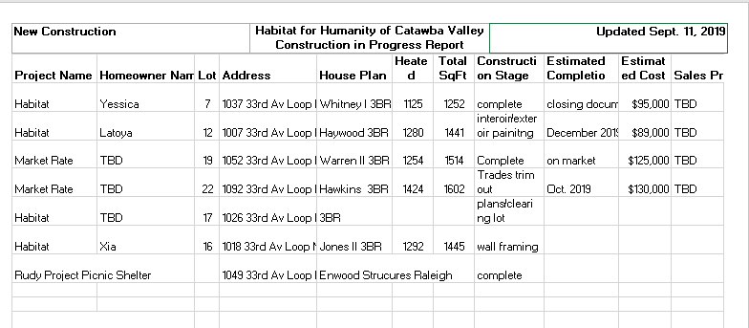
___________________________________________________________________
Homeowner Services: Selection
Report for Board of Directors September 2019

Homebuyer Program:
During this current application cycle, 45 total applications were handed out and 26 were submitted by the September 6th deadline. The applications are currently being evaluated. The Homeowner Selection Committee will meet on November 19th to make recommendations to the Board during the Board meeting on November 25th.
We are excited to welcome Suwaina Rippy and Kandi Xiong&Som Say Lor into the Habitat community. Both homebuyers have signed their Partnership Agreements and are beginning to work on their sweat equity hours. They will be the last homes in the Northstone neighborhood.
Repairs Program:
We continue to send out applications in our “soft opening” to those who have previously inquired about the program. There are still 18 inquiries from 2018 that we will send applications to and over 40 inquiries since the beginning of 2019. The goal is to send out another round of applications to those inquiries by the end of September.
Homeowner Services: Resource
Report for Board of Directors September 2019
Delinquency Report
Reporting Period 8/30/2019 Total Mortgages: 99
Delinquent | # Mortgages Delinquent | Arrearage | % Delinquent
31-60 days | 10 | $ 4,061 | 10.1%
61-90 days | 3 | $ 2,290 | 3.0%
90 plus days | 9 | $ 13,488 | 9.1%
Total this month | 22 | $ 19,839 | 22.2%
Total 7/31/19  (99 mtgs) | 21 | $ 20,186 | 21.2%
Total same mo. prior yr  8/31/18 (104 mtgs) | 21 | $ 20,822 | 20.2%
Jun. 2013, last mo. prior to MF (119 mtgs.) | 12 |  | 10.1%

Homeowner Services News

We expect Yesica Xiong’s closing to be in October. Hers will be our first closing to participate in an amortizing participation loan with the NCHFA in the position of the second lien. The advantage of doing this is that it leaves the first lien in Habitat Catawba Valley’s name alone, making the Deed of Trust and Note eligible for leveraging if/when we decide to do that. Both of her amortizing mortgages will be serviced by Affiliate Mortgage Services, so that she will only have to make one payment per month.

Frances Gardner Baker has paid off her mortgage.

Latoya Ramseur, our next new homeowner-to-be after Yesica, has been accepted into the Section 8 Homeownership Program, which will be a terrific support to her successful homeownership.

Terri Roland, a homeowner who closed on her Habitat home in our newer Highland neighborhood about 11 years ago, has put her home on the market. Her realtor has advised a price of $135,000, and she is getting some interest at that amount. The appraised value and purchase price of her home in 2008 was $114,900. Since then, her family has grown and her household’s income has increased, making it both desirable and possible for them to “move on up”!

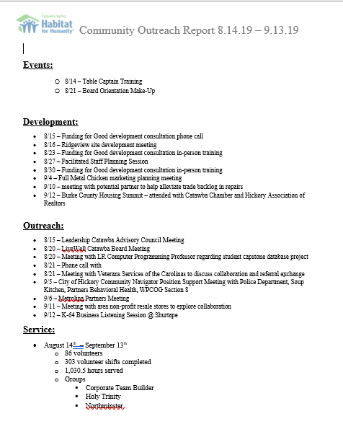

Repair Project of the Month
September 2019
Richard Greathouse

The repair of the month is located at 1800 North Rankin Ave. in Newton. The owners are Abdel Zourafi and Erika Aldana. They have one daughter.

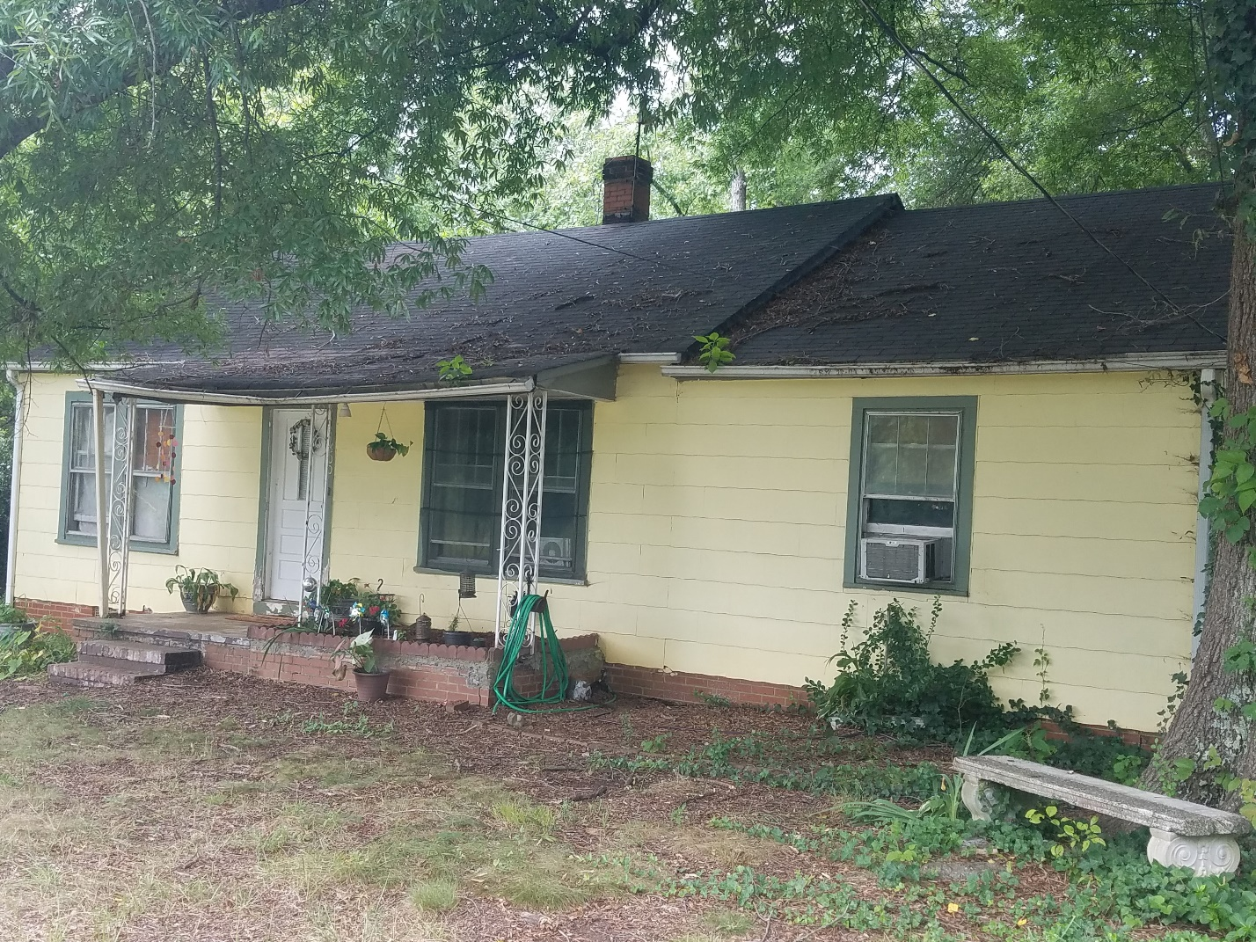
Front view of house

Habitat Repairs! will be making roof repairs and installing new shingles, adding new gutters, repairing exterior window trim, repairing facia in various locations, modifying rear entrance steps, and cleaning up the yard using habitat funding. Subcontractors will be installing new HVAC equipment and ducts and adding additional insulation where possible using funds from Piedmont Natural gas.
This repair is a bit unusual in that the owners are younger than most of our clients and will be assisting in more of the work than our older homeowners are able to do.
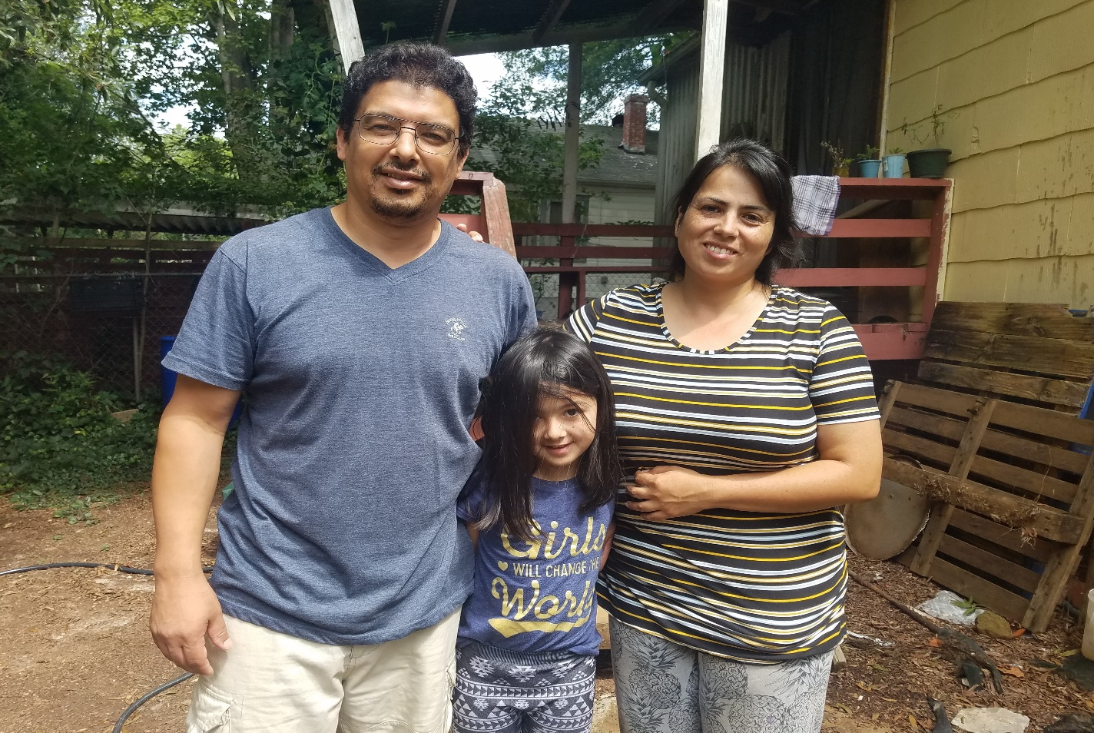
Abdul, Erica and their daughter
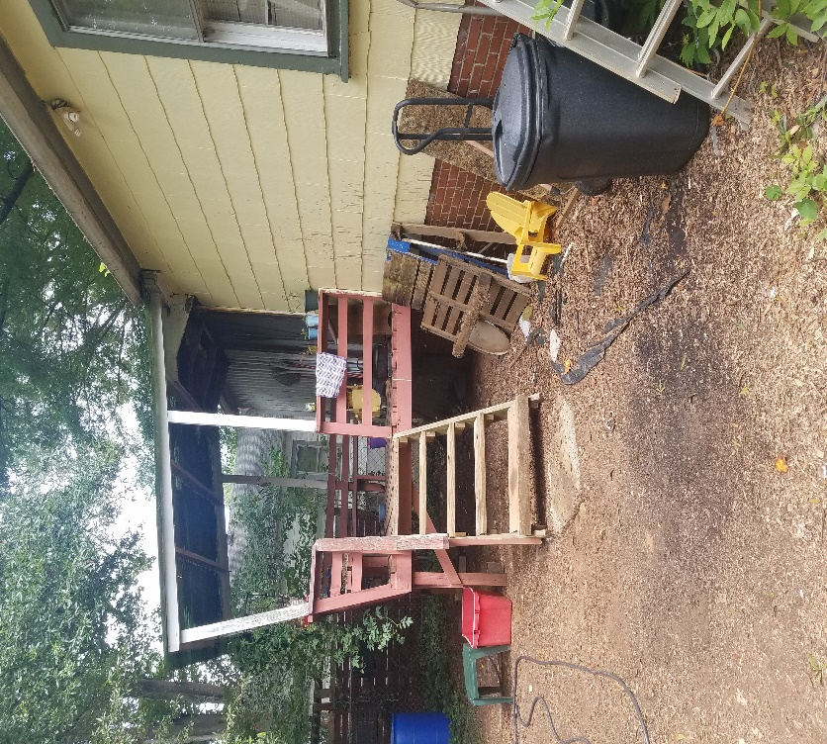
Unsafe rear steps
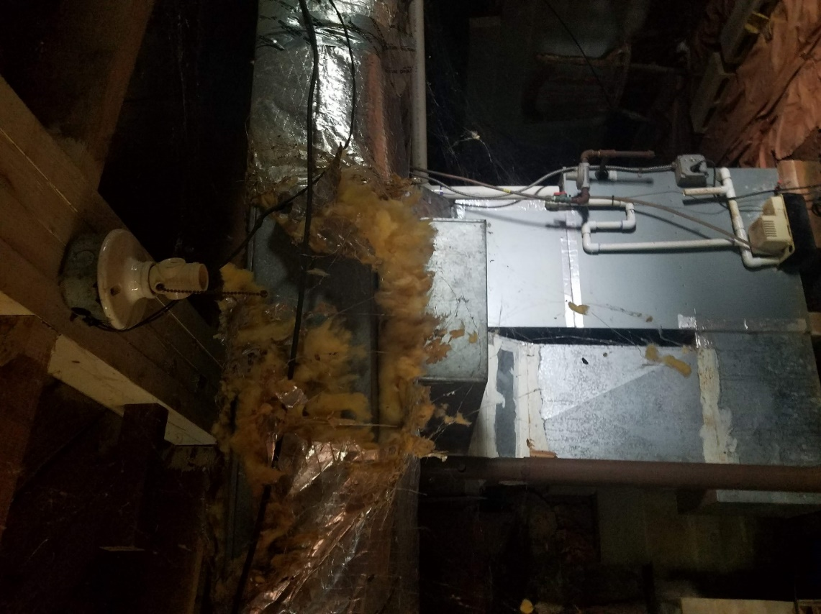
Inoperable HVAC equipment and damaged ducts

Repair status August 2019
- Repairs in progress 19
- Pending start date 3
    - Pending site visit 54
    - Finished in in August 3

The ReStore Report
August 2019
Jeff Mingus

Donations and Sales – August delivers the heat! Sales remain strong at $80,360.55 Surprise donations and new connections. Hickory Park keeps delivering…literally. Three full truckloads of great donations delivered in their trucks. Doesn’t get much better. Who wants to join me in some Corporate Outreach? One of our newest donors, Sandler Seating, has corporate headquarters in London UK. I think we should make a personal visit.
Who remembers the Metrolina Partners, a collaborative effort for communication, product sharing, uniformity, and growth? Originally formed and managed out of the Charlotte affiliate. Interest has been renewed by the Rock Hill affiliate. Looking forward to new possibilities. Any ideas for new donors, business contacts, corporate connections? We’ve barely scratched the surface in Catawba County. There’s so much more potential…who do you know? Any suggestions?
Volunteers Needed - The ReStore needs volunteers!
All areas of the store have openings and opportunities. Our current greatest need is warehouse and weekends
Warehouse – Receiving and Loading: Tasks may include greeting donors, helping to load or unload vehicles, stocking and merchandising the sales floor, testing household appliances, making repairs, cleaning and cleaning.
For community service hours for school or civic groups or just have some spare time and want to contribute to a good cause in an enjoyable social environment.
Flexible volunteer shifts and work schedules. If you know someone or would like to help or need more information, please contact Kristi Biggar, ReStore Coordinator at 828-327-7467 or kristi@habitatcatawbavalley.org.

Looking forward, Camp Habitat 2019 – Our ReStore is growing! Black Mountain Sept 18-20, Rick, Kristi, and I will be attending the NC Habitat Conference. Our goal is to pick up and share our best practices on general ReStore information and common practices on a wide range of topics. Included this year are the new ReStore safety standards, unified branding, volunteer recruitment and retention, marketing and social media strategies, donor recognition, and more. My favorite part of the conference…making connections with other ReStore across NC.
New ReStore Phone Number– 828-327-7467(SHOP)
Website - www.restorecatawbavalley.org
1 in 6 families are denied
Action Items

*As of the preparation date of the agenda, there are not action items to be considered for the September meeting.

