Habitat for Humanity of Catawba Valley
Board of Directors Meeting

August 26, 2019

Swearing in of New Members

Devotion – Jenna Ross

Adoption of Agenda — Whit Malone

Consent Agenda:
Items are considered routine by the Board of Directors and will be enacted by one motion. There will be no separate discussion of these items unless requested by a member. The item will be removed from the Consent Agenda, then added to Action or Informational Items.

1) Minutes from Board Meeting
2) Staff Reports
3) July Financial Reports

Action Items:
1) Family Selection Committee – Troy Howard
2) Repairs Policy Revisions – Tina

Informational Items:
1) Home is the Key Update - Lynn
2) Board Member Profiles – Jenna

Other Business:
1) Northstone and Ridgeview Community Update - Mitzi

Upcoming Events:
Table Captain Training (Final Date) 5:30pm Sept 9, @ ReStore
Corinth Groundbreaking 10:00am Sept 14th @ Northstone
World Habitat Day & Dedication of The Rudy Project 6pm Oct 12 @ 6pm
Next Board Meetings: September 23rd, October 28th, November 25th

Consent Agenda/Staff Reports

Minutes:
Habitat for Humanity of Catawba Valley
Board of Directors’ Meeting
June 24, 2019

Members Present: Doug Dickson, Steve Elledge, Lori Greveling, Ander Horne, Troy Howard Whit Malone Cliff Moone, William Pleasant, Charlotte Williams,
Members Not Present: Scott Echelberger, Frances Hilton, Pat Jones
Staff Present: Mitzi Gellman, Jeff Mingus, Tina Morgan, Lynn Nelson, Hannah Spahn, Jenna Ross
Guest Speakers: Toinette Wilkinson, Meg Robertson

Welcome and President’s Remarks
There being a quorum, the June meeting of the Habitat for Humanity of Catawba Valley Board of Directors was called to order by Board President Whit Malone at 12:00pm.
Devotion
Lori Greveling led the devotion quoting 1 Peter 4:7-11. Lori then shared an inspiring story of a Habitat Repairs! volunteer experience and concluded with prayer.
Adoption of Agenda
Upon motion and second, the Board unanimously adopted the June Meeting Agenda.
Consent Agenda
Jeff Mingus, ReStore, announced ReStore sales update for the year. As of Saturday, June 22, the ReStore has achieved a new annual sales record of $863,000.00 (the previous annual sales record was $852,000.00). The Board then adopted by consensus the Consent Agenda of the May Board Meeting Minutes, June Staff Reports, and May Financial Reports.

Information Items:
Home is the Key update was presented by Toinette Wilkinson and Meg Robertson. Their presentation included the following items:
- The importance of the fundraiser (Habitat’s signature fundraising event)
- The structure of the Benevon model
- Point of Entry Events (POEs)
- Table Captains
- Corporate Sponsors
- Goal and Budget
Adjourn
Whit Malone adjourned the meeting at 1:00 pm.
Upcoming Events
- 12:00 June 29th – ReStore House Dedication (Xiong Family), Northstone
- Table Captain Trainings:
  - August 14th - 12:00pm
  - August 22nd - 5:30pm
  - September 9th - 5:30pm
- Upcoming Board Meeting Dates:
  - August 26th
  - September 23rd
  - October 28th
  - November 25th

Development Report
July - August 2019
Grant Updates
- Completed Leon Levine Foundation Letter of Intent (Invitation to apply for grant)
- Completed 3M Letter of Intent.
- Completed Michael Peeler/Virginia Casey Funds Grant – Request for Habitat Repairs!, $13,000.
- Completed Catawba Valley Community Foundation Grant – Request for Ridgeview Development, $2,500
- Completed BB&T Grant – Request for Ridgeview Development, $25,000.
- Completed and Awarded TSH Foundation Grant - Habitat Repairs!, $25,000.
- Completed and Awarded Wells Fargo Foundation Grant - New Construction, $6,000.
- Awarded the Underdown Family Foundation Grant – Ridgeview Development, $10,000.
- Awarded Bolick Foundation Grant – Habitat Repairs! - $5,000.
- Awarded E. R. Carpenter Grant - $30,000.
- In process Leon Levine Foundation Grant request $25,000.
- In process Publix Grant.
- Continuing working with grant writer, Jason Rogers.
Dedication/Groundbreaking Events
- The Dedication of Yesica Xiong’s home was celebrated on Saturday, June 29th at 12:00 noon in the Northstone neighborhood.
- Upcoming Corinth House Groundbreaking scheduled for Saturday, September 14, at 12:00 noon.
Home is the Key Event
- Table Captains training sessions are set for Wednesday, August 14 at 12:00 noon, Thursday, August 22 at 5:30pm and Monday, September 9 at 5:30pm. All training to be held in the ReStore Conference Room. All 32 TCs are registered for training.
- Continuing to complete the goal of 35 TCs.
- CommScope has agreed to sponsor the Home is the Key event for 3 years at the $5,000 level (2019, 2020 and 2021).
- Video is in process
- Décor is in process
Development (Consultant Mandy Pearce)
- Direct Mail – Spring Mailer as of 8/12, we have received $9,815.00
- In process - Fall Mailer scheduled for October (mailer will be sent to current donors, lapsed donors and volunteers)
- In process – Thanksgiving & Christmas postcards (design and mailing lists).
- Continuing with scheduled meetings with Mandy Pearce (design, prep, track, record, analyze and steward gifts relating to Direct Mail, continue to monitor and review income streams, review grant options).

Misc
- Board Orientation session was held on Monday, August 5 at BOCA Restaurant
- Next Board Orientation session is scheduled for Wednesday, August 21, at 11:00 am – 1:00pm at Habitat offices (lunch will be provided).
- Attended Transportation Insight Wellness Fair – Wednesday, August 7.
- In process - Strategic Plan.
- To be scheduled – the Rudy Project House/Picnic Shelter Dedication
- Social Media – working with Full Metal Chicken.
- Pledge reminders for HITK and Capital Campaign completed for July and August.

Construction Report
August 2019

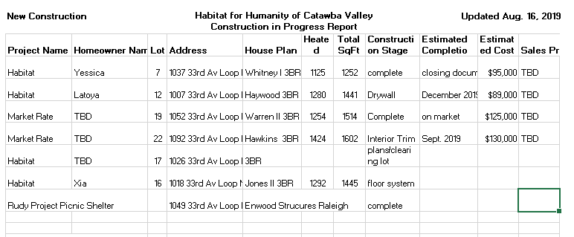

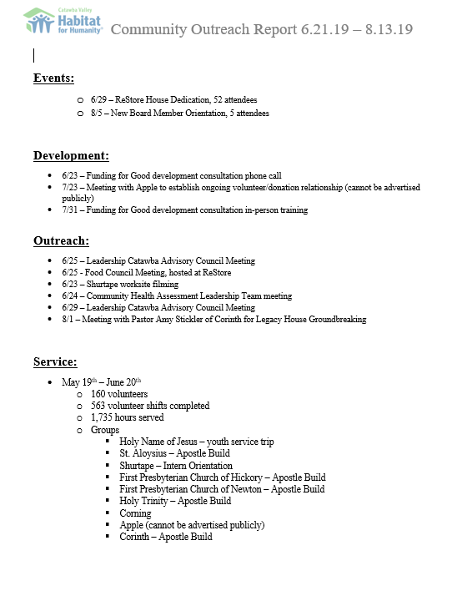

Repair Project of the Month
August 2019
The repair of the month is located at 626 8th Street SW in Hickory. The owner is Shannon Jones who is a single parent with two children.
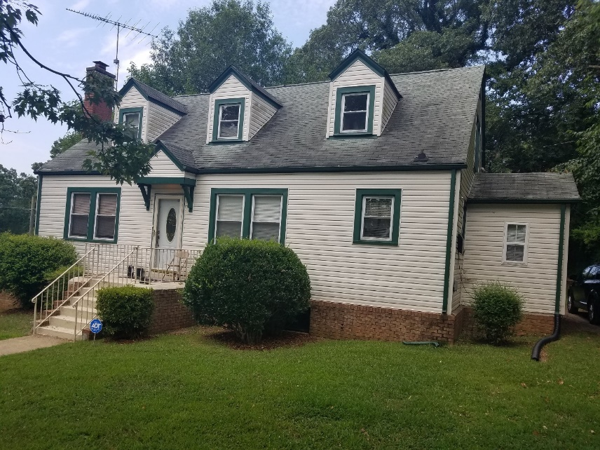Front view of house.

Habitat Repairs! will be installing new shingles utilizing Hickory CDBG funding, replacing one patio door with Habitat funding, adding insulation and repairing the HVAC system using Piedmont Natural Gas funding.

Repair status August 2019
- Repairs in progress 23
- Pending start date 14
    - Pending site visit 5
    - Finished in in June 4

Homeowner Services: Selection
Report for Board of Directors August 2019
Homebuyer Program:
During the HSC meeting on July 23rd, the HSC voted to recommend denial for 8 applicants for denial due to incomplete applications, and 17 applicants for denial due to not meeting the Ability to Pay criteria. From the round of applications in May, 3 applicants have moved forward to have home visits. The Homeowner Selection Committee (HSC) will present their recommendations to the board at the August meeting for both acceptance and denial. More details will be supplied at the meeting.
Applicant Information Meetings (AIMs) were held on August 13th and 14th at the Ridgeview Library. 30 individuals attended the meeting on the 13th, and 7 individuals attended the meeting on the 14th. 26 applications were handed out at the AIMs. Applications are due September 6th.
We’ve begun a new partnership with Operation Hope, a non-profit housed in the Capital Bank in Viewmont and devoted to increasing financial management skills and improving the credit scores of their clients. So far, it’s been mutually beneficial. Rita Purvis from Operation Hope attended the AIMs to share about the Operation Hope program and how it could have a positive impact on the Habitat applicants’ financial wellbeing.
Repairs Program:
Since we began the “soft opening” for the repair applications in May, 25 applications have been sent to past inquiries, and 9 of those applications were returned. Of those 9 applications, 2 were denied due to the type of work they requested being beyond the scope of our program; those applicants were provided referrals to additional maintenance and repair resources in the community. Another 11 applications will be mailed out by the end of August. Staff involved in Habitat Repairs! continue to meet regularly to work on creating more efficient systems, better channels of communication, and other program improvements.

Homeowner Services: Resource
Report for Board of Directors August 2019
Delinquency Report
Reporting Period 7/31/2019 Total Mortgages: 99
Delinquent | # Mortgages Delinquent | Arrearage | % Delinquent
31-60 days | 10 | $ 4,290 | 10.1%
61-90 days | 2 | $ 2,605 | 2.0%
90 plus days | 9 | $ 13,291 | 9.1%
Total this month | 21 | $ 20,186 | 21.2%
Total 5/31/19  (101 mtgs) | 14 | $ 18,420 | 13.9%
Total 12/31/18  (103 mtgs.) | 24 | $ 24,290 | 23.3%
Total same mo. prior yr  7/31/18 (104 mtgs) | 20 | $ 20,050 | 19.3%
Jun. 2013, last mo. prior to MF (119 mtgs.) | 12 |  | 10.1%

Homeowner Services News

Delinquencies have risen over the summer as is usual for Habitat mortgages, reflecting the additional expenses that come with having children out of school for the summer. Our delinquencies are within 1% of the same percentage that they were at the end of July in both 2017 and 2018, so very consistent across the years.

We expect Yesica Xiong’s closing to be in September.

Xia Yang and her three daughters - 6 years, 4 years, and 8 months old - will be the homeowner family for the Corinth house. Their groundbreaking is scheduled for Saturday, September 14th, at noon.

Chai Xiong has sold his Habitat home to a relation of his Habitat neighbor. We have received his payoff amount of approximately $21,000.

Jeramie Lee and Ie Yang have sold their home in Northstone back to Habitat in order to move to Minnesota to be close to Ie’s family.

Tina has completed the American Banking Association annual renewal courses required to be a Qualified Loan Originator.

The ReStore Report June 2019
Donations and Sales – It’s been a good year we are on target for a <4% increase over last year. As a donation center we are always grateful. Tracking GIK donations has helped identify the extreme kindness of these businesses and the need to recognize them in different ways. It’s an ongoing effort but saying thank-you is the best part of my job.
Worth repeating! We have a great donation base within Catawba County, but there are more contacts out there, more warehouses full of excess inventory. Inventory costing local businesses storage fees and taxes. The ReStore is driven by new and gently used donated product both from individuals and local businesses. The key to success is “who you know”. Sometimes reaching the right person can make all the difference. If you have contacts with business leaders and owners that could possibly become donors, please let Jeff or Rick know. We can follow-up and build a donor relationship for Habitat.
Volunteers Outreach – Please help us spread the word. We need volunteers. All areas of the store have openings and opportunities. Our current greatest need is warehouse and weekends. Please share with friends and family whether they need community service hours for school or civic group or just have some spare time and want to contribute to a good cause. Contact Kristi, Rick, or Jeff and let’s get started. Thanks
Social Media / Eblasts Updates – Began transition meetings with Houston Harris from Full Metal Chicken. The Perry Group, Kelsey and Avalin gave, us a fine introduction to marketing in the age of social media. Although we will be doing a lot of the same things, eblasts, Instagram, and Facebook the approach is going to be different. Fresh ideas and perspectives drive change and growth.
ReStore Committee? – Ideas? Events? Donors? Volunteers? Shoppers? One of our goals is to re-establish a working Board Committee. Over the course of the next few months goals and purpose will be established. Got ideas? Know someone who might want to help? Let’s talk, thanks.
New ReStore Phone Number– 828-327-7467(SHOP)
Jeff Mingus ReStore General Manager

1 in 6 families are denied

Action Items

1) Family Selection Committee – Troy Howard
FS Committee met on 8/20/19 to review candidates for Habitat homeownership. Due to confidentiality restrictions, information on applicants will be distributed during the board meeting.

2) Repairs Policy Revisions – Tina Morgan
Staff has recently reviewed the current Habitat Repairs! policy and recommends aligning the policy with our current operating procedures. Additional changes align our policy with HUD/City of Hickory regulations. All changes are highlighted in yellow for your review.

Habitat for Humanity
of
Catawba Valley
Habitat Repairs! Policy

PRIORITIES AND POLICY STATEMENTS

Priorities and Commitments

Habitat for Humanity of Catawba Valley (HFHCV) Habitat Repairs! will serve homeowners whose income falls at or below 75% of the AMI, who are willing to partner with HFHCV, and who have a need for help accessing repairs. Priority is given to the critical nature of required repairs, to severity of applicant’s financial need, to the elderly, the disabled, single parent families, and households with at least one minor child. The program is particularly designed to serve those homeowners who are most in need and who are unable to access services elsewhere.

HFHCV’s Habitat Repairs! has a responsibility to the community to preserve housing and neighborhoods. It also has a responsibility to the donors and other funding sources to find the best use of available funds.

Referrals, Project Cost, and Board Authority

When a completed application is received, all information will be processed and verified by the homeowner services staff. Staff will review the property record to confirm ownership, location, building value, and status of any loans on the property. Referrals to other repair programs will be made as they are appropriate.

After the homeowner services staff confirms that the property and homeowner criteria are met, the construction staff will do an inspection of the house to determine the scope and cost of the repair project. The usual maximum project cost will be $6,000 Habitat out-of-pocket costs and/or $15,000 total costs. With special approval, project costs may go above that amount only when it is required to keep the occupants of the home dry, safe, and warm. If the project meets program funding requirements, then staff will prepare a home repair contract that details the scope of work, the homeowner price and payment arrangements, and the sweat equity requirements. After the contract is signed, the repair work will be done. The project will be considered complete upon signed Certificate of Completion. A limited, one year warranty will be provided.

The number of houses to be repaired each fiscal year will be based on the affiliate budget and types of available restricted funding. The Board authorizes the homeowner services staff to process and conduct due diligence for all applications, to decline all applicants who do not meet the policy criteria, and to accept applicants who do meet the policy criteria.

Compliance and Non-Discrimination

HFHCV is required to comply with the Fair Housing Act and all Fair Housing Laws, the Equal Credit Opportunity Act, the Fair Credit Reporting Act, the Privacy Act, the Americans with Disabilities Act and any other applicable federal, state, or local regulations and laws pertaining to Mortgage Lending and related HFHCV affiliate policies. All selection policies and criteria are subject to immediate change and implementation not requiring Homeowner Selection Committee or Board approval to maintain compliance. The homeowner services staff will notify other staff members, Homeowner Selection Committee, and Board members of any changes. HFHCV makes every effort to base the affiliate policy on recommendations from Habitat for Humanity International (HFHI).

The integrity of HFHCV depends upon the consistent execution of all policies by administration, homeowner services staff, the Homeowner Selection Committee, and the Board, who will faithfully conduct its activities in accordance with the law in a fair, objective, non-discriminatory manner.

An applicant must be 18 years of age or older and have the legal capacity to enter into a binding contract. In selecting Habitat Repairs! homeowners, HFHCV does not discriminate on the basis of race, color, religion, national origin, gender, disability, familial status, marital status, sexual orientation, age (unless considered a minor), or because all or part of income is derived from any public assistance program.

Confidentiality

HFHCV shall follow a strict code of confidentiality in its homeowner selection practices. All information collected for the purposes of homeowner selection will be used for the sole purpose of evaluating an application and will be kept in the strictest confidence within the HFHCV staff, administration, Homeowner Selection Committee, and the Board except as authorized by the applicant. HFHCV staff, administration, Homeowner Selection Committee members, and the Board shall not discuss a potential Habitat Repairs! application with anyone other than the applicant, members of the Homeowner Selection Committee, HFHCV staff, administration, homeowner services volunteers, or members of the Board.

SELECTION CRITERIA

To qualify for HFHCV Habitat Repairs!, applications must meet three main criteria: Need for Repairs, Ability to Pay, and Willingness to Partner. All decisions will be based upon these criteria. Information that is not reasonably relevant to one of the criteria shall neither be sought, nor considered, during the selection process.

Selection criteria will be as listed below except in cases where funding sources carry different selection requirements, at which times selection criteria will match funding requirements as necessary.

NEED FOR REPAIRS

Financial need is defined by income guidelines. Other factors used to determine need are the severity and critical nature of required repairs, and the needs of the elderly, the disabled, single parent families, and families with at least one minor child.

In the U.S., the HFHI “Repair” category has three sub-categories: Home Preservation, Weatherization, and Critical Home Repairs. If an applicant’s home needs any of these types of repair, then repair need is established for this program.

Home Preservation - Exterior work that includes painting, patching, minor repair, landscaping, ramps, and other accommodations for accessibility, and repair or replacement of exterior building materials for maintaining good or sound condition.
Weatherization - Work done to improve the energy efficiency and indoor air quality of a structure. The scope of work of a weatherization project may be defined by a comprehensive energy audit. Testing of the home may be done upon completion. A homeowner education component may be included.

Critical Home Repairs – Potentially extensive interior or exterior work performed to address health and safety issues, issues of habitability, or code violations. Critical home repair includes such activities as repair or replacement of home materials or components (such as the roof); a reconfiguration of space; a modification for accessibility; and/or the repair, installation, or extension of plumbing, mechanical or electrical systems.

While this program does place a priority on responding to critical and urgent repair needs, it must be pointed out that this program is not designed to meet emergency needs. However, in the event that a need for emergency repairs is discovered in the normal course of doing a site visit for the selection process, the Habitat Repairs! Supervisor may ask the homeowner(s) to sign a limited contract in order to allow HFHCV to respond more quickly.

ABILITY TO PAY

Income and Financial Requirements

- An application will be considered whose combined gross income for the applicant homeowner(s) falls at or below 75% of the HUD Area Median Income for Catawba County. In rare cases where the resident(s) are members of the homeowner’s family, the resident(s) must also apply and meet the same income criteria.
  - Income of the entire household of the property in question must be disclosed on the application and generally will not exceed 80% of HUD Area Median Income or 200% of Federal Poverty Level depending upon funding source.
  - Executive Director and homeowner services staff together may consider acceptance of households with higher income on a case by case basis when there is need and when funding allows. (E.g., in the case of a homeowner whose household income is thrown over the limit by a temporary resident of the home.)
  - All income documentation must be current as of six (6) months from the date of application.
- Applicant’s home must not be in danger of a foreclosure process. A mortgage statement or a Certificate of Satisfaction for all existing liens will be required from applicant(s) to demonstrate that there is no indication of impending foreclosure.
- The value of the property, including lot, per the Tax Assessment Office, will not normally exceed the annual HOME homeownership value limits for existing housing set by HUD’s HOME Program, which is based on 95% of the median purchase price for existing housing in the area.
- Additional property holdings by the homeowner will be considered as assets in determination of need.
- Any income from additional property holdings will be calculated toward qualifying income.

WILLINGNESS TO PARTNER

Homeowner Requirements

At least one applicant must be an owner of the property. At least one applicant must be a resident of the property. Homeowners/residents will make payments as listed in the Home Repair Contract.

Eight sweat equity hours will be required for all projects with costs up to $4,000. Sixteen sweat equity hours will be required for all projects with costs between $4,000 and $8,000. A range of sweat equity opportunities will be available. Details will be discussed with the homeowner and included in the Home Repair Contract.

Homeowners will be required to complete sweat equity as listed. HFHCV at its sole discretion may adjust the sweat equity arrangement, depending on health of homeowner and/or when sub-contractor labor is involved. Amended expectations will be part of the signed contract.

Homeowners must not be delinquent with any commitments made in a previous HFHCV Limited Contract.

Appropriate accommodations and modifications will be made for households with disabilities in accordance with the Americans with Disabilities Act (ADA). Documented proof of the need for accommodations may be required. This proof may take the form of disability income, doctor’s statement, or other clear indication of need.

The applicant must be able to understand the program guidelines and requirements. The head of
household must be able to understand legal documents or have another responsible adult acting as
attorney–in-fact for the applicant.

Property Requirements

- All properties must be located within Catawba County limits, or located within the limits of a city or town primarily located in Catawba County and not located within the service area of any other Habitat affiliate that has a repair program.
- Repairs will not be done on rental properties.
- All properties must be owner-occupied, with the following possible exceptions:
- Living trusts, revocable trusts, life estates, and other kinds of claims on the property will be considered on a case-by-case basis.
- The home must be the permanent residence of the applicant(s), unless they were displaced due to the need for repairs within the 18 months prior to the application, and the applicant will return to the home when repairs are complete.
- HFHCV will consider acceptance on a case by case basis if the home is occupied by family members other than the homeowner/applicant.
- Deed/Title must show ownership for a minimum of one (1) year. There must be a likelihood that the applicant will be staying in the home long term.
- Exception: Homeowners who have owned their home for less than one year may be accepted on a case by case basis for limited work if it is required for accessibility needs, e.g., grab bars and ramps.
- Property may be a single-family, stick-built, mobile or manufactured home.
- HFHCV may repair owner-occupied duplexes, townhouses, condos, or multi-family homes on a case-by-case basis as long as it does not interfere with HOA restrictions.
- When the owner holds the title (not rent-to-own) on a mobile or manufactured home, HFHCV may do limited repairs on a case-by-case basis, such as ramps, steps, roofs, HVAC repair or replacement, or plumbing, to the extent that those repairs are within HFHCV’s capacity.

SELECTION DECISIONS

For a decision to be made regarding an application to the Habitat Repairs! program, a minimum of two homeowner services staff members must review the application to determine whether or not it meets the policy criteria. Depending on this decision, a Home Repair Contract may be presented to the applicant, or the denial letter may be sent.

Disqualification and Reapplication
- Applications should be returned fully completed, signed, and with all documentation included. The application may be denied if this condition is not met.
- Any application can be denied if HFHCV does not have the capacity to take on the nature or scope of repair work required. In this case, written documentation from the construction staff must be provided for the file before denial.
- If at any time during the entire Habitat Repairs! application process, information is discovered or documented to disqualify an application, the application will automatically be denied and the homeowner will be required to re-apply.
- Homeowners who have already received repairs through the Habitat Repairs! program may reapply for additional repairs any time after they have completed payment on their previous HFHCV repairs.
  - Note: Subsequent applications for additional repairs will have a lower priority, and therefore will likely have more wait time before repairs are completed.
  - Exception: Any false or fraudulent information will automatically disqualify any applicant indefinitely from the Habitat Repairs! program.

PRICING GUIDELINES

Purpose

The Habitat Repairs! Pricing Policy has been developed to ensure all homeowners receive a uniform pricing structure for HFHCV repair services.
Pricing will be according to this policy unless the funding source for the project requires HFHCV to have different payment arrangements, in which case payments will be as required by the funding source.
Every effort will be made to create payment arrangements that both empower homeowners through their investment, and that maintain the sustainability of the repair program by keeping it attractive to funding sources through its commitment to Habitat’s “hand up, not hand out” model.

Homeowner payments and sweat equity are evidence of the homeowners’ partnership with HFHCV. Payments create a way for homeowners to participate in the Habitat ministry and mission by “paying it forward”.

Determining Project Cost

The project cost of repair jobs will include the following components:
- Cost of purchased building materials
- Cost of professional services and contracted labor
- Direct costs (including, but not limited to permits, professional fees, landfill expenses, equipment rental, and general supplies)
- An administrative fee equal to 10% of total project cost

Project Subsidy
Each homeowner‘s price (total of all payments) will be based on a percentage of their monthly gross income. The remainder of the project cost will be considered the amount of that homeowner’s subsidy, and will be covered by HFHCV and its funding sources.

Terms of Payment and Payment Amount

There will be no loans made in payment for repairs.
Payments will always be set so as to be affordable for the homeowner, and will be based on the homeowner’s income, not the cost of the project. Homeowner price will always be less than the project cost.
The homeowner’s total price for repairs will be a maximum of 20% of the gross monthly income of all homeowner applicants. In cases in which the resident is a family member of the homeowner, the price may be based on the same percentage of the resident’s income instead of, or in addition to, the homeowner’s income. The price will be adjusted as necessary to ensure the homeowner’s and/or resident’s ability to pay for their household’s other required expenses.

This amount will be split into two payments that will each represent half of the total. The first payment will be due at the signing of the contract, and the final payment will be due within 30 days of completion of the work.

Method of Payment

Payments will be made by cashier’s check or money order to a post office box held by HFHCV.

Delinquency Procedures

If the first payment is not made by the time work is to begin, the homeowner services staff will make a call to the homeowner, urging payment and making sure that there are no misunderstandings or problems with the plan for repairs. In the event of non-payment, repairs may be postponed or discontinued.

If the second payment is not received within 30 days of the completion of work, a phone call reminder will be made. When an account becomes 60 days past due, HFHCV’s financial office will send a notice requesting that the homeowner bring the account current.

If there is no payment fifteen days after the notice is sent, the homeowner services staff will follow up on the delinquency notice with a phone call. If the homeowner is willing but unable to pay, an alternate payment arrangement may be made.

If the homeowner is unwilling to pay, then HFHCV may file a mechanic’s lien when the account becomes 90 days past due.

Recapture Agreement

Upon completion of the work, the homeowner(s) will sign a recapture agreement indicating willingness to repay the amount of their subsidy for repair costs if the home is no longer their principal residence, or if it is transferred, within five years from the date of assistance. If the resident is not a homeowner, the resident may also be asked to sign the recapture agreement.
Upon recapture, HFHCV will collect the full cost of the subsidy for repairs, decreased by 20% each year on the anniversary of the signing of the agreement, such that, at the end of the fifth year after signing, the funds will be entirely forgiven, and the agreement will be deemed null and void.

CONSTRUCTION CRITERIA

SCOPE AND COST OF WORK

HFHCV construction staff will do a home inspection in order to create the scope of work.

The repairs included in the scope of work will meet the following criteria:
- Repairs will be based on what is necessary to keep the occupants of the home safe, dry, and warm. Both urgency and habitability will be priorities in determining what will be done.
- Repairs will be those for which there is funding.
- Repairs will be ones that the homeowner wants, with the dual understanding that the construction staff may need to educate the homeowner regarding the critical nature of various repairs, and that some repairs (e.g., weatherization) may be required by funding sources in order to receive other repairs.

Construction staff will determine the project cost. The usual cost for any one project will be no more than $6,000 out-of-pocket HFHCV expenses and no more than $15,000 total expenses, with the option to go above those amounts when necessary in order to keep the home’s occupants dry, safe, and warm. To approve projects more costly than the amounts named above, funding decisions will be made jointly by the Executive Director, Office Manager, and Director of Construction.

In order to address the hazards associated with the improper removal of lead-based paint or lead-based paint hazards, Habitat Repairs! will conduct all repairs in such a way as to maintain compliance with the Lead-Based Paint Hazard Management Program (LHMP) established in North Carolina in 1998 under N.C. General Statute §130A-453.01 through 453.11 - Lead-Based Paint Hazard Management Program. Although HFHCV is a certified renovation firm, in most cases this will be done by hiring certified subcontractors to do the necessary work, thereby protecting volunteers from lead-based paint exposure and avoiding the need for extensive training of volunteers that would enable them to do the work safely. If there’s ever a question that HFHCV may not be able to do the work or see that the work is done correctly and safely, then the project will not be accepted.
ORDER OF REPAIRS
The Home Repair Manager will decide on the order that repairs will be done for accepted homeowners with the following priorities, in listed order:
- Urgency of repair need
- Efficiency of repair program, e.g., desire to complete all repairs in a particular neighborhood at one time
- Order applications were received

PROCUREMENT

General
HFHCV will follow the following procedures in procuring goods and services necessary to complete home repairs under the Habitat Repairs! program.
- No source of supplies or labor shall be utilized that would be a conflict of interest with any HFHCV employee, the Board of Directors, or Habitat for Humanity International.
- HFHCV will make reasonable effort to spread purchases and contracts evenly in the community.
- HFHCV will attempt to purchase materials that are environmentally sound wherever feasible.
- Materials available through in donations, federal surplus, etc. will be used whenever feasible.
- All subcontractors will be fully licensed and qualified to perform the work set forth for them. Consideration of subcontractors will include integrity, experience, financial stability and ability to complete the job in a timely manner.
- Any bid or proposal may be rejected for sound documented reasons.
- The Uniform Guidance Contract Provisions Under Federal Awards as provided by the City shall be made a part of all contracts where applicable.
- Attempts will be made to find and include Minority and Women owned businesses in the process of purchasing materials and securing labor.

Large Contracts and Purchases
Contracts and purchases over the Federal Micro Purchase amount (Currently $10,000.00) shall conform to the following procedures.
- HFHCV will prepare a bid proposal specifying the materials and or work to be performed.
- Bids will be solicited broadly from the community, including businesses in the project area or owned by area residents, and from minority and women owned businesses.
- Sealed bids will be obtained from at least two qualified subcontractors or suppliers and a firm bid price will generally be awarded to the lowest qualifying bidder based on the bid specifications.
- If a firm bid price is not obtainable, then a competitive contract may be used with a qualifying subcontractor or supplier. Attempts will be made to solicit more than one competitive contract proposal.
- Procurement by a noncompetitive proposal may be used when there is no other source, or there is an emergency that precludes the time it takes to secure competitive proposals.
- Competitive proposal contracts will be awarded to the responsible firm that is most advantageous to HFHCV.

Small Contracts and Purchases
Contracts and purchases under the current Federal Micro Purchase amount (Currently $10,000.00) shall conform to the following procedures.
- Materials and equipment purchased from suppliers may be procured without competitive bids and will be awarded by HFHCV if the cost is deemed to be reasonable.
- HFHCV will keep on file hourly rate quotes from each subcontractor and will utilize the one with the lowest rates when practical.
- HFHCV will periodically obtain rate quotes on materials commonly used to assure that fair prices are being charged by suppliers utilized under these micro purchase procedures.
- Emergency situations may require that the first available subcontractor or supplier may need to be used. Similarly, materials may be purchased from suppliers that are close to the project in order to save time and staff expenses.

Habitat Repairs! DEFINITIONS
Certificate of Completion: Document signed by the homeowner that certifies that the scope of work as set forth in the contract has been completed in its entirety and to the homeowner’s satisfaction.

Home Repair Contract or Homeowner Agreement: A written agreement signed by HFHCV and the homeowner. The contract documents the expectations of willingness to partner, the scope of work, payment, warranty, terms of acceptance, and cancellation. Any changes to the scope of work, sweat equity, or the homeowner price must be made as a written addendum to the contract and signed by both parties.

Contract Price or Homeowner Price: The total amount the homeowner will repay after applied subsidies.

Habitat Repairs! program: The program includes everything from initial inquiry, referrals, and selection process to scope and cost of work, repairs, and payments. The final decision to accept an applicant requires the approval of both the application and the project.

Habitat Repairs! project: Typically projects will be completed on individual residences. However, opportunities may arise to undertake repair work in other areas of service or community needs. Example: Ridgeview Library.

Project Cost: The total cost of materials, sub-contractors, and other job expenses for possible recapture, as listed in the Habitat Repairs! Pricing Policy.

Home is the Key Update
Toinette Wilkinson
Meg Robertson

Handouts provided during the board meeting

