Habitat for Humanity of Catawba Valley
Board of Directors Meeting

November 25, 2019

Devotion -

Adoption of Agenda — Charlotte Williams

Presentation by Lindsay Keisler,
President & CEO Catawba County Chamber of Commerce

Consent Agenda:
Items are considered routine by the Board of Directors and will be enacted by one motion. There will be no separate discussion of these items unless requested by a member. The item will be removed from the Consent Agenda, then added to Action or Informational Items.

1) Minutes from October Board Meeting
2) Staff Reports
3) October Financial Reports

Action Items:
1) Family Selection Committee Recommendation – Troy Howard

Informational Items:
1) Home is the Key Wrap Up - Jenna and Mitzi

Upcoming Events:
Home is the Key Breakfast:
Next Board Meetings: December 16th (Christmas Social), January 27th,
February 24th, March 23rd.

Consent Agenda
1) Minutes from October Board Meeting

Members Present: Bill Burnham, Rodney Garren, Lori Greveling, Frances Hilton, Kelly Hipps, Ander Horne, Troy Howard, Pat Jones, Whit Malone, Cliff Moone, William Pleasant, Margaret Pope, Charlotte Williams
Members Not Present: Robin Creel, Doug Dickson, Scott Echelberger, Graham Hunsucker
Staff Present: Mitzi Gellman, Richard Greathouse, Jeff Mingus, Tina Morgan, Melissa Neal, Lynn Nelson, Jenna Ross
Welcome and President’s Remarks
There being a quorum, the October meeting of the Habitat for Humanity of Catawba Valley Board of Directors was called to order by Whit Malone at 12:02pm. New Board President, Charlotte Williams, was sworn in by former Board President, Whit Malone. Charlotte thanked Whit for his service as President and presented him with an appreciation gift.
Devotion
Tina Morgan, Director of Homeowner Services, led the devotion from John 1:43-51 then followed with a prayer.
Adoption of Agenda
Upon motion and second, the Board unanimously adopted the October Meeting Agenda.
Consent Agenda
The Board then adopted by consensus the Consent Agenda of the September Board Meeting Minutes, Staff Reports with the exclusion that the Executive Report be moved to Informational Items, and the September Financial Reports.
Action Items
- Tina Morgan, Director of Homeowner Services, presented the Homebuyer Income Guidelines. Troy Howard, Family Selection Committee Chair, presented the Family Section Committee Recommendation for denial into the Homeownership Program. With all in favor, the Board approved the recommendations for denial.

Information Items:
- Mitzi Gellman, Executive Director, presented an update on funding for the Ridgeview Development stating WPCOG has agreed to fund $400,000 ($100,000 per home for 4 Habitat homes) through a $100,000 grant ($25,000 per home) and a $300,000 0% interest loan repayable after the closing of each home. Currently the total homes to be built in Ridgeview is 4 Habitat homes and 2 market rate homes; this is due to a sewer line which makes one lot not feasible for building.
- Lynn Nelson, Development Assistant, presented the Home is the Key update discussing table captains, corporate sponsors, program speakers/rehearsal, décor and event follow-up preparations.
- Jenna Ross, Community Outreach Coordinator, gave an update on the HITK video and a new format for the website which includes a page for HITK information.
- Mitzi Gellman, Executive Director, reviewed the Development Calendar.
Adjourn
With a motion and second, Charlotte Williams adjourned the meeting at 12:55 pm.
Upcoming Events
- Next Board Meetings: November 25, December 16 (Christmas Social), January 27, February 24

Staff Reports

Development Report
November 2019

Grant Updates
- Submitted Catawba Valley Community Foundation’s Kenneth K. and Suzanne G. Millholland grant for $5,000 Bears Build.
- In process George Foundation grant request.
- In process E. R. Carpenter grant request.
- Continuing to collaborate with Jason Rogers, grant writer.

Home is the Key Event
- Finalized all items for the breakfast event.
- Processing all donations and running detailed reports.
- Follow-Up Meeting and Thank You Calls

Communication - Mailers (Consultant Mandy Pearce)
- Thanksgiving postcard mailed.
- In process – Christmas postcards.
- In process – End of Year mailer.
- Handwritten notes/cards to donors.
- Monthly communications with LYBUNT donors (donors who gave last year but not this year).
- Continuing with scheduled meetings with Mandy Pearce (design, prep, track, record, analyze and steward gifts relating to Direct Mail, continue to monitor and review income streams, review grant options).

Misc
- In process - Strategic Plan.
- Pledge reminders for HITK and Capital Campaign completed for November.
- In process, setting up pledge reminders for 2019 HITK.

___________________________________________________________________

Homeowner Services: Selection
Report for Board of Directors November 2019
The Homeowner Services Department has been excited to welcome Andrew as the new staff person. Andrew has been hard at work familiarizing himself with the Homeowner Services Coordinator role and updating the homebuyer education classes. Staff are excited to see how the Homebuyer and Repairs Programs develop in the future. We have plans to build our services in a number of ways that should support successful homeownership for our buyers as well as strengthen the affiliate.

Homebuyer Program:
The Homeowner Selection Committee completed home visits and met on November 19th. The Committee’s recommendations for denials and acceptances are being brought to the Board for a final vote for the current round of applicants. The next application cycle will occur early in 2020.
The current homebuyers have been working hard to complete their sweat equity and education class requirements. Latoya may close on her home in January 2020, and Xia and Suwaina may also close early in 2020.
Repairs Program:
Due to the availability of funding from the City of Hickory, applications were sent to those who have inquired in 2019 who live within the city limits. 11 applications were sent and 2 have been returned from this round. 30 individuals from the county are still on the inquiry list, the first 15 of whom will be invited to apply by mid-December. The repairs team meets regularly to monitor progress and to continue to tweak the program for more efficiency and greater impact.
Homeowner Services: Resource
Report for Board of Directors November 2019
Delinquency Report
Reporting Period 10/31/2019 Total Mortgages: 97
Delinquent | # Mortgages Delinquent | Arrearage | % Delinquent
31-60 days | 9 | $ 4,409 | 9.3%
61-90 days | 7 | $ 2,993 | 7.2%
90 plus days | 9 | $ 13,969 | 9.3%
Total this month | 25 | $ 21.371 | 25.8%
Total 9/30/19  (98 mtgs) | 25 | $ 20,926 | 25.5%
Total same mo. prior yr  10/31/18 (104 mtgs) | 22 | $ 23,203 | 21.2%
Jun. 2013, last mo. prior to MF (119 mtgs.) | 12 |  | 10.1%

Homeowner Services News

The foreclosure sale on Shawnte Eskridge’s house has been scheduled for January 7th. The law allows Habitat to submit a bid for the total amount owed to the affiliate. If Habitat is outbid, we can then submit an upset bid. At the previous sale that was set aside by the bankruptcy filing, there were no other bidders.

Terri Roland’s sale of her Habitat house is scheduled for December 6th. The house is selling for $142,900. Inesha Parks, one of our Kenworth homeowners since 1999, has recently accepted a job in Charlotte and may sell her home.

Angela Geter has paid off her Habitat mortgages.

Beginning with any closings after August 1, 2020, our home buyers will have to complete at least 8 hours of HUD certified home buyer counseling. We are exploring options for how to provide that counseling either online and/or with local HUD certified homeownership counseling agencies including WPCOG and Consumer Credit Counseling.

We’re working on a reservation form and rules for use of the Northstone Picnic Shelter.

We’ve completed three contracts with repair homeowners since the last board report.

__________________________________________________________________

Repair Project of the Month
November 2019
The repair home of the month is a single-story frame house built in 1938 located at 5355 37th Street Drive NE Hickory.
The owner is a widow of a World War Two veteran and is 89 years old. She has been living in the house since 1968 and has expressed a desire to age in place in her own home for as long as possible.
In the course of the initial site visit, over 25 cats and kittens were discovered being fed by Ms. Hamby.
We contacted the Humane Society for help with the cat situation. They agreed to work with Ms. Hamby to catch the cats and take them in for examination. The older feral cats will be neutered and released, with the kittens held for adoption. No cats will be euthanized unless they are diseased.
Habitat will be doing the following:
- Coating the metal roof.
- Repairing the front ramp and bringing into ADA compliance.
- Repairing the facia and eve trim and covering with vinyl.
- Building safe rear exit and ramp.
- Installing new gutters and leaf guards.
- Cleaning yard debris and clearing out undergrowth.
- Repairing front door.

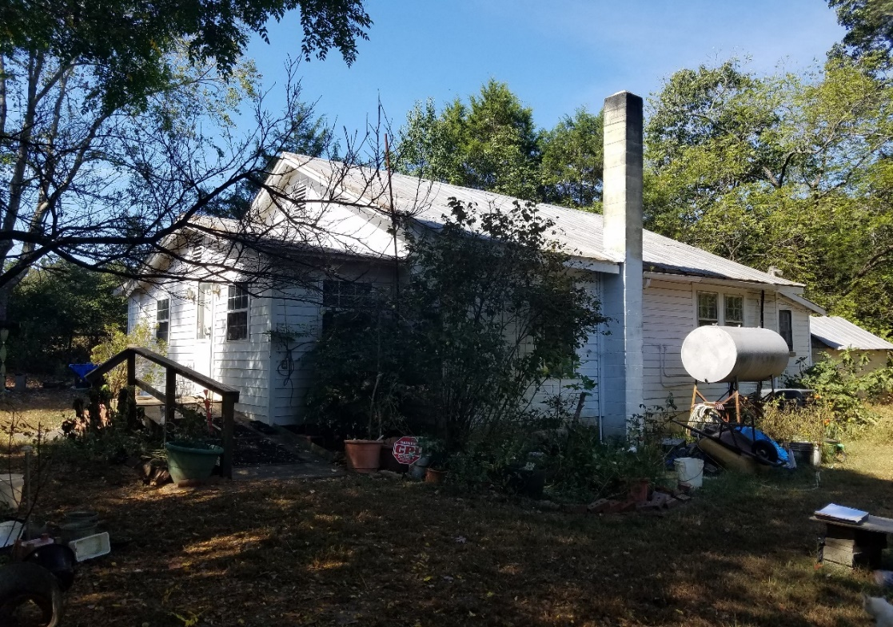
Front View of House

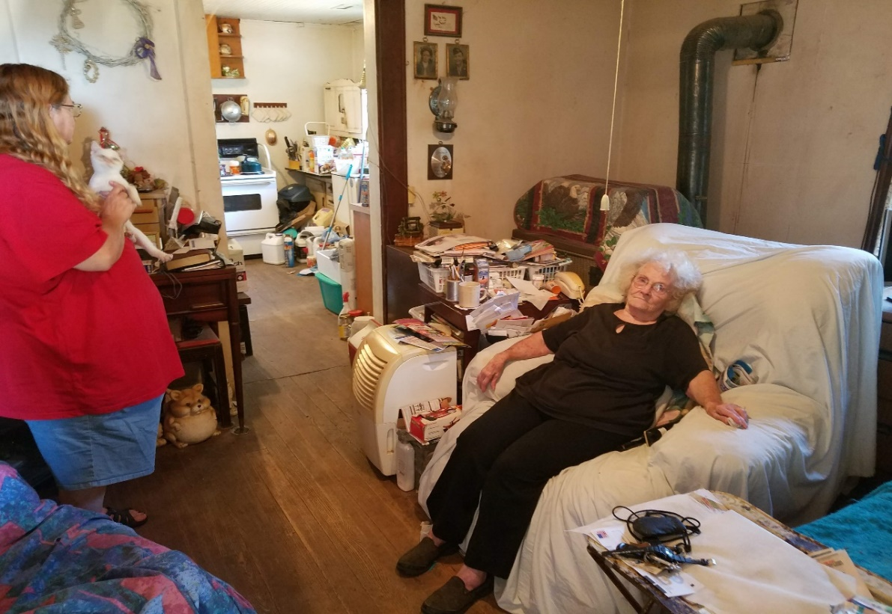
Ms. Hamby and her daughter

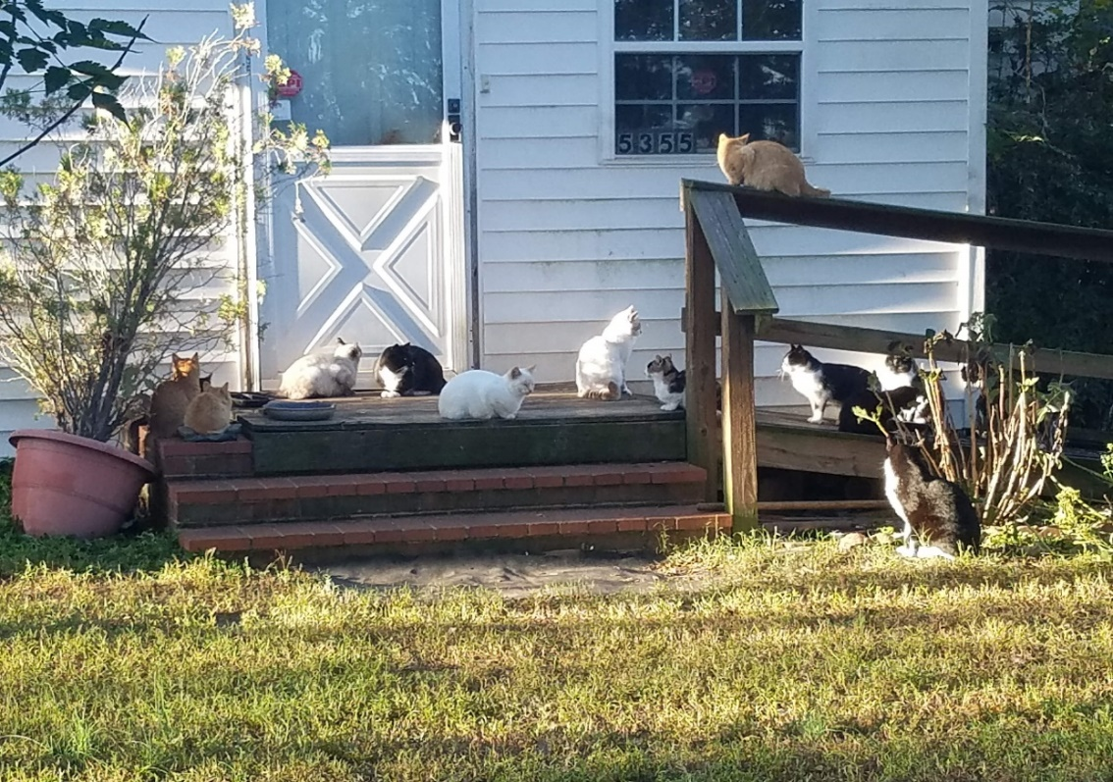
Some of the cats on the existing front ramp
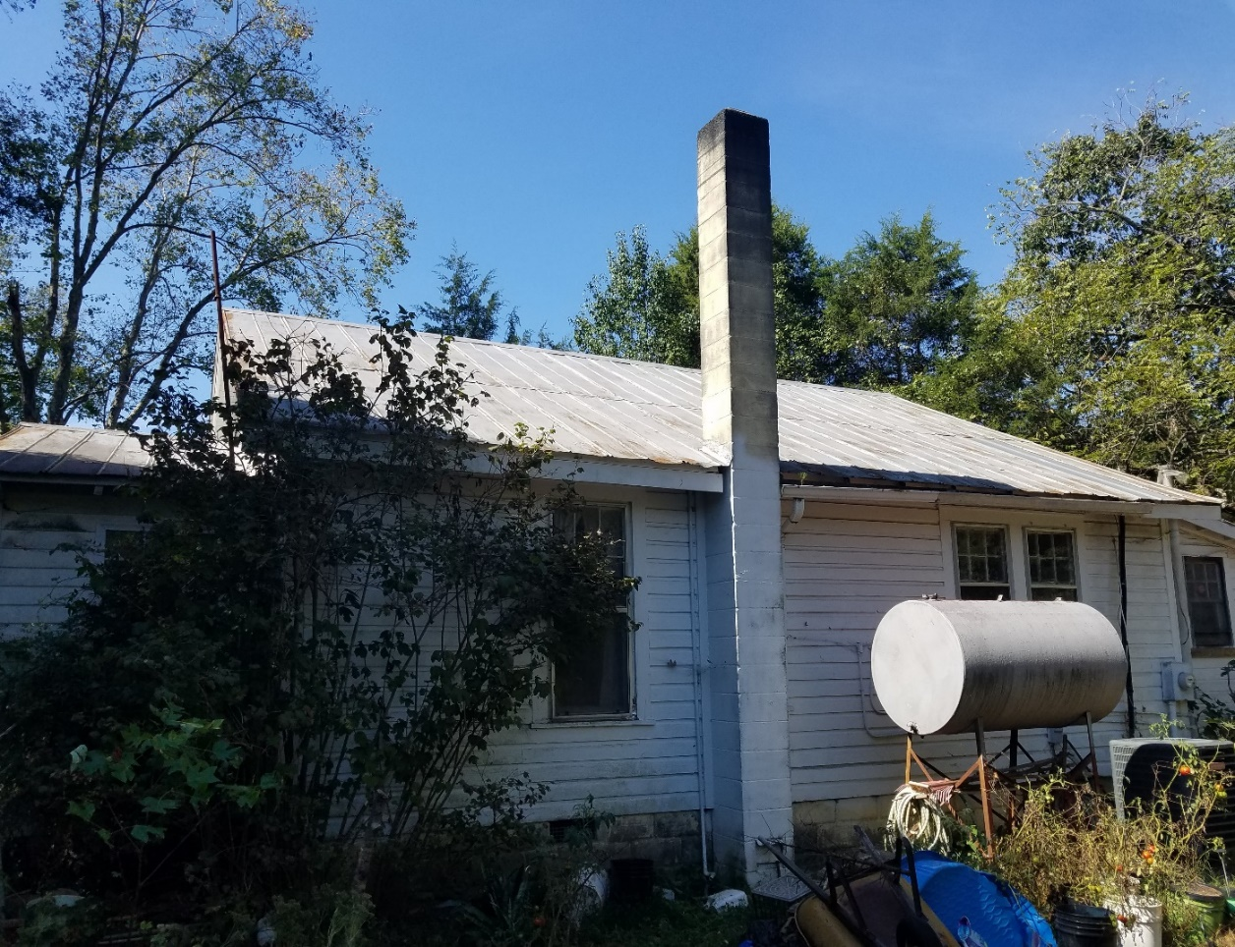
Side of house showing metal roof and current condition of the gutters and exterior trim

Repair Status November

- Repairs in progress 17
- Pending start date 6
    - Pending site visit 8
    - Finished in in October 4

The ReStore Report October 2019
Donations and Sales – The ol’ flip flop routine, September and October sales switched places from last year’s totals. October pulled us back on target with projected annual sales figures, $304,000.00 through October.

2018 |  | 2019
$80,146.76 | July | $82,539.22 | 2.99%
$83,504.60 | August | $80,360.55 | -3.77%
$77,744.76 | September | $65,581.02 | -15.65%
$61,195.95 | October | $75,545.59 | 23.45%

Donations are steady and back on track after the furniture market. We’re always looking for new donors, business contacts, corporate connections. We can help clear up inventories, storage costs, and provide a tax credit too. There’s so much more potential…who do you know?
Holiday Schedule – The ReStore will be closed for Thanksgiving Thursday 11/28 and Friday 11/29, for Christmas Tuesday 11/24 and Wednesday 11/25, for New Year’s Wednesday 1/1. Please watch for in store specials and promotions around each of these times.
Dewey’s Cookies in the House! – Sugar cakes are at the ReStore, fresh weekly. Pick up your Christmas stocking stuffers and holiday treats and help Habitat build homes too. In cooperation with Habitat NC and partnering with Dewey’s Bakery (famous for their Moravian Cookies and Cakes) we have a mini holiday shop at the ReStore. It’s a pretty sweet deal with local Habitat’s making 30%, and Habitat NC making 10% from each sale. Assorted sizes and variety of flavors to choose from. YUM!
Volunteers Needed - The ReStore needs volunteers! Cashiers, warehouse receiving and loading, customer service, sales floor merchandisers, thank-you ambassadors, greeters, and so much more.
Flexible volunteer shifts and work schedules. If you know someone or would like to help or need more information, please contact Kristi Biggar, ReStore Coordinator at 828-327-7467 or kristi@habitatcatawbavalley.org.

New ReStore Phone Number– 828-327-7467(SHOP)
Website - www.restorecatawbavalley.org
Jeff Mingus ReStore General Manager
___________________________________________________________________

November Construction Report
Derek Ross

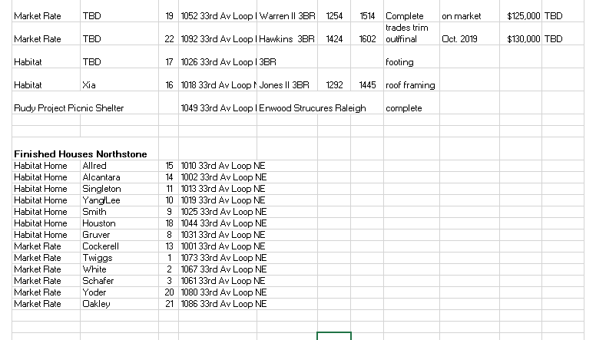
6 families are denied

Action Items

1) Selection Committee Recommendation – Troy Howard
Denial of applicants with incomplete applications.
(information to be distributed at the meeting)

Informational Items
1) Home is the Key – Wrap up (information to be distributed at meeting)
– Mitzi & Jenna

