Habitat for Humanity of Catawba Valley
Board of Directors Meeting

October 28, 2019

Swearing in of new members

Devotion -

Adoption of Agenda — Charlotte Williams

Consent Agenda:
Items are considered routine by the Board of Directors and will be enacted by one motion. There will be no separate discussion of these items unless requested by a member. The item will be removed from the Consent Agenda, then added to Action or Informational Items.

1) Minutes from September Board Meeting
2) Staff Reports
3) September Financial Reports

Action Items:
1) Family Selection Committee Recommendation – Troy Howard

Informational Items:
1) Home is the Key – countdown to 11/14! Lynn & Jenna

2) Review of Development Calendar – Lynn & Mitzi

Upcoming Events:
Home is the Key Breakfast:
Next Board Meetings: November 25Th, December 16th (Christmas Social), January 27th, February 24th

Consent Agenda

Habitat Board of Directors’ Minutes
September 23, 2019
Members Present: Bill Burnham, Robin Creel, Doug Dickson, Scott Echelberger, Rodney Garren, Lori Greveling, Frances Hilton, Kelly Hipps, Ander Horne, Graham Hunsucker, Troy Howard, Pat Jones, William Pleasant
Members Not Present: Whit Malone, Cliff Moone, Margaret Pope, Charlotte Williams
Staff Present: Mitzi Gellman, Jeff Mingus, Tina Morgan, Lynn Nelson, Hannah Spahn, Jenna Ross

Welcome and President’s Remarks
There being a quorum, the September meeting of the Habitat for Humanity of Catawba Valley Board of Directors was called to order by Board Treasurer Doug Dickson at 12:00pm. Doug stated the swearing in of new members would take place at next board meeting.
Devotion
Tina Morgan, Director of Homeowner Services, led the devotion with an excerpt from Daily Strength for Daily Needs highlighting Isaiah 38:14 followed by prayer.
Adoption of Agenda
Upon motion and second, the Board unanimously adopted the September Meeting Agenda.
Consent Agenda
The Board then adopted by consensus the Consent Agenda of the August Board Meeting Minutes, Staff Reports, and August Financial Reports.
Information Items:
- Lynn Nelson, Development Assistant, presented the Home is the Key update discussing table captains, corporate sponsors, program/speakers, décor and video.
- Mitzi Gellman, Executive Director presented the Director’s Report which included updates on Camp Habitat and Ridgeview Construction Funding.
- Hannah Spahn and Tina Morgan, Homeowner Services, presented a PowerPoint on How Does Habitat Select Homeowners.
Adjourn
Doug Dickson adjourned the meeting at 1:02 pm.
Upcoming Events
- World Habitat Day & Dedication of The Rudy Project: Saturday, October 12 at Northstone, 12:00 Noon
Next Board Meetings: October 28, November 25, December 16 (Christmas Social)

Staff Reports

Executive Director’s Report: Report
1) Ridgeview Construction Site Finalized:
The final plat for Habitat’s newest project in Ridgeview has been finalized. (See attached plats) There will be 5 new homes constructed behind the Safe Harbor complex. The original plan was for 6 homes, but a sewer line bisects one of the proposed lots and will prevent any construction on that site. An additional home will also be constructed across 3rd Ave SE on a lot donated by the nonprofit, CCOM. Currently the projection is for 4 Habitat homes and 2 Open Market homes. Construction is slated to begin mid-summer 2020.

Additionally, there has been some (small) encouraging changes related to Habitat’s purchase of the existing home on this site. Attorney Beth Williams continues to work with the current owners to resolve the lien issues on this lot.

Discussions are ongoing with WPCOG and BB&T for funding of this project.

2) Additional upcoming build information:
Derek’s report lists homes currently under construction and the good news is that we have started the last home slated for Northstone with a summer 2020 completion date. Our next building sites will be scattered site in the Highland and Kenworth neighborhoods and will included 2 Habitat homes and 1 Open Market home.

3) Administrative Office Renovations Update:
The final quote from DE Looper for the lower level office renovations was received earlier in October with a total expense of $162,000. We have approximately $60,000 raised toward the expense and are in conversations with a professional volunteer group to assist with construction. (Plan and Quote included)
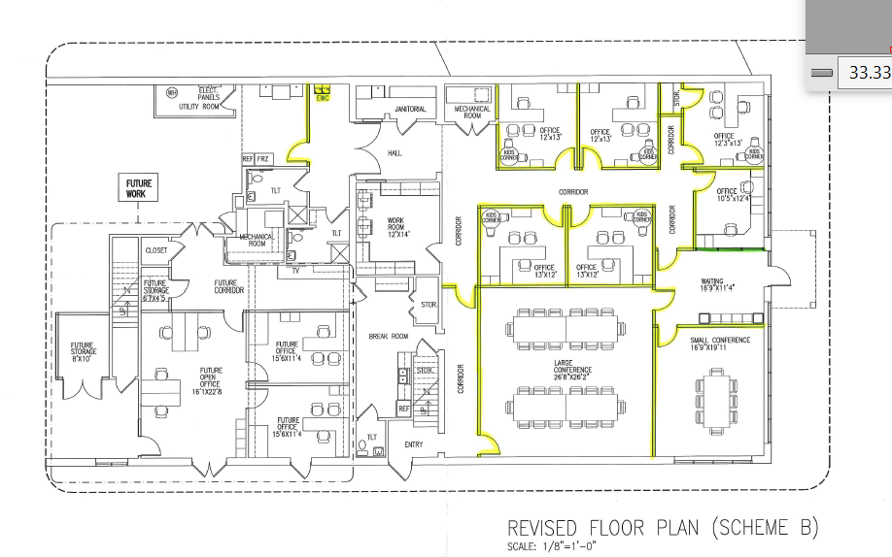

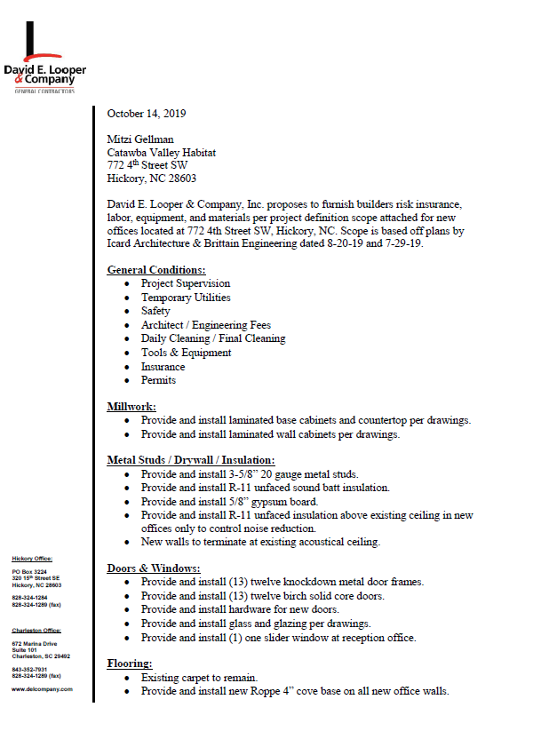

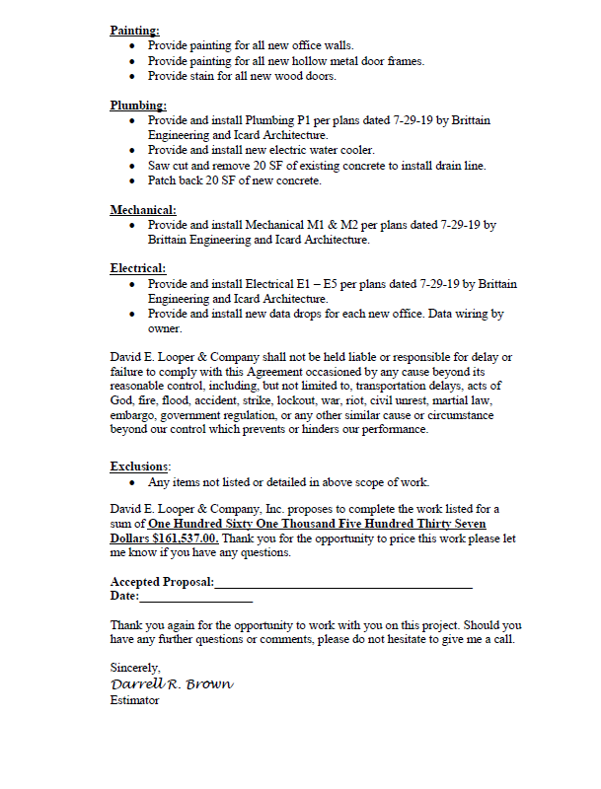

Development Report
October 2019
Grant Updates
- In process Catawba Valley Community Foundation’s Kenneth K. and Suzanne G. Millholland grant.
- In process George Foundation grant request.
- In process E. R. Carpenter grant request.
- Submitted, awarded and received Corning Optical Communications grant – Habitat Repairs!, $6,000.
- Awarded and received the Michael Peeler and Virginia Casey grant - Habitat Repairs, $5,000.
- Upcoming meeting with Leon Levine Foundation on Thursday, October 31.
- Continuing to collaborate with Jason Rogers, grant writer.
Dedication/Groundbreaking Events
- Prepped and completed arrangements for The Rudy Project Picnic Shelter Dedication held on Saturday, October 12, at 12:00 noon. The event included dedication of the Alcantara home (Crystal and her 3 children were in attendance), presentation of the plaque and ribbon cutting for the picnic shelter in honor of Rudy Wright and 6 mortgage burnings. Event ran smoothly with approximately 80 people in attendance.
Home is the Key Event
- Communication updates with TCs on weekly basis.
- Current count is 32 TCs with 3 additional tables for overflow and/or corporate sponsors.
- 3 confirmed corporate sponsors:
  - CommScope
  - First Citizens Bank
  - Joan Everett Killian/Berkshire Hathaway
- Full Metal Chicken has completed first draft of video. They are continuing to shoot footage and prepping for final edits.
- Décor is in process
- Event Program in process
- Table Captain’s confirmed guest lists due – October 15.
- Room layout and guest seating in process.
- In communication with 74 South and L&L Catering to finalize details.
- Scheduling rehearsal date for HITK speakers to be held 1 week in advance at 74 South.
- Prepping a reminder card for all confirmed guest (to be sent out by Habitat).
- Prepping for event follow-up.
Communication - Mailers (Consultant Mandy Pearce)
- Fall Mailer sent out Friday, October 11.
- Press Release sent out on Housing Innovation Award (leadership in net zero ready building).
- In process – printing and mailing of Thanksgiving postcard. Slated to be sent on November 14.
- In process – Christmas postcards (design and mailing lists).
- In process – End of Year mailer (letter content and design).
- Monthly communications with LYBUNT donors (donors who gave last year but not this year).
- Continuing with scheduled meetings with Mandy Pearce (design, prep, track, record, analyze and steward gifts relating to Direct Mail, continue to monitor and review income streams, review grant options).
Misc
- In process - Strategic Plan.
- Pledge reminders for HITK and Capital Campaign completed for October.

The ReStore Report
September 2019
Donations and Sales – Donations continued strong for September, but quality dropped off. Trades with Winston Salem and Charlotte brought in some different product and moved some duplicate overstock and slow-moving items. Locally new connections with Exodus, Hospice, CCM, and Safe Harbor may bring some collaboration soon.
Any ideas for new donors, business contacts, corporate connections? We’ve barely scratched the surface in Catawba County. There’s so much more potential…who do you know? Any suggestions?
Did you know? – We’re featured in both the Green Room and Hickory Community Theatre programs. Both theatres give our ReStore free ads. We in exchange let them borrow set pieces, furniture, accessories, and prints to create and stage plays. Please thank them when you attend a show.
Camp Habitat 2019 – Black Mountain, a secluded YMCA camp surrounded by streams and laurel bushes, was the setting for this year’s retreat. Attendance was above average with several ReStore staff and volunteers represented. Rick and Kristi joined the fun for two days of learning. Seminars featured volunteer recruitment, training, and retention; ReStore donations; ReStore safety (an entire manual of safety guidelines); and marketing strategies. Thank you for allowing us to attend.
Dewey’s Cookies in the House! – In cooperation with Habitat NC and partnering with Dewey’s Bakery (famous for their Moravian Cookies and Cakes) we have a mini holiday shop at the ReStore. It’s a pretty sweet deal with local Habitat’s making 30%, and Habitat NC making 10% from each sale. Assorted sizes and variety of flavors to choose from. YUM!
NEW Garage Door – The warehouse area was always hot with the door open and dark with the door closed. It’s hard on AC systems and power bills with a huge gapping hole in the building. Keeping the door closed was a challenge too. Donors couldn’t be seen and served in a timely manner. The fix added a motorized opener and two window panels. It’s a different warehouse space now, well-lit and climate controlled.
Volunteers Needed - The ReStore needs volunteers!
Flexible volunteer shifts and work schedules. If you know someone or would like to help or need more information, please contact Kristi Biggar, ReStore Coordinator at 828-327-7467 or kristi@habitatcatawbavalley.org.

New ReStore Phone Number– 828-327-7467(SHOP)
Website - www.restorecatawbavalley.org
Jeff Mingus ReStore General Manager

Homeowner Services: Selection
Report for Board of Directors October 2019
Homebuyer Program:
There were 26 applicants who submitted an application to the homebuyer program in the current selection round. The Homeowner Selection Committee met on October 15th. The committee has made a recommendation to the board to deny the applicants who it was determined in screening don’t meet the policy guidelines for Ability to Pay or whose applications were incomplete. That vote will be an action item at the October board meeting.
The committee is in the process of completing home visits with four applicants. They will meet again on November 19th to determine their final recommendations of acceptances or denials for the current round of applicants. The committee’s recommendations will be brought to the Board at the meeting on November 25th. The next application cycle will occur in early 2020.
Yesica closed on her house on October 16th. Yesica is very excited to move her family into her new home. The other homebuyers continue to make progress through the program, and Latoya may close on her house at the beginning of 2020.
Repairs Program:
The last inquiries from 2018 have received applications for the program. There have been over 50 inquiries about the Repairs Program since the beginning of 2019. The individuals requesting repairs have been sent a list of other resources in the area and included on our inquiry list.
We are continuing to work our way forward through the inquiry list. Due to funding, applications will be sent next to those who have inquired in 2019 and who live within Hickory City limits. Once those applications have been received, the next round will be sent to the individuals living in the county who inquired early in 2019.
Homeowner Services: Resource
Report for Board of Directors October 2019
Delinquency ReporReporting Period 9/30/2019 Total Mortgages: 98
Delinquent | # Mortgages Delinquent | Arrearage | % Delinquent
31-60 days | 12 | $ 4,410 | 12.2%
61-90 days | 3 | $ 2,555 | 3.1%
90 plus days | 10 | $ 13,961 | 10.2%
Total this month | 25 | $ 20.926 | 25.5%
Total 8/30/19  (99 mtgs) | 22 | $ 19,839 | 22.2%
Total same mo. prior yr  9/28/18 (104 mtgs) | 22 | $ 22,005 | 21.1%
Jun. 2013, last mo. prior to MF (119 mtgs.) | 12 |  | 10.1%

Homeowner Services News

Yesica Xiong closed on her new home on October 16. She and her kids, Aedry and Yestin, are busy moving in and getting settled.

William and Debbie Snider have paid off their Habitat mortgages. We have four more homeowners who we expect to pay off in the next year.

Shawnte Eskridge’s bankruptcy has been dismissed due to lack of payment. This allows Habitat to move forward with the foreclosure that was in progress when the bankruptcy was filed. Since nothing has changed from our perspective with Shawnte, we have contacted Hutchens Law and asked them to proceed. We expect the foreclosure sale to be in January.

Andrew Isola has been offered a position with Habitat’s Homeowner Services team. We are looking forward to all that he will bring to Habitat. His first day is scheduled to be November 4.

Foothills Veterans Helping Veterans has invited us to participate in their Stand Down in April, sharing information there about both our homeownership and repairs programs. They are also looking into joining our Habitat Partners repair program.

Ge Moua and Vicky Lee in our Green Park neighborhood have submitted plans and have been given the green light to add a back deck to their home.

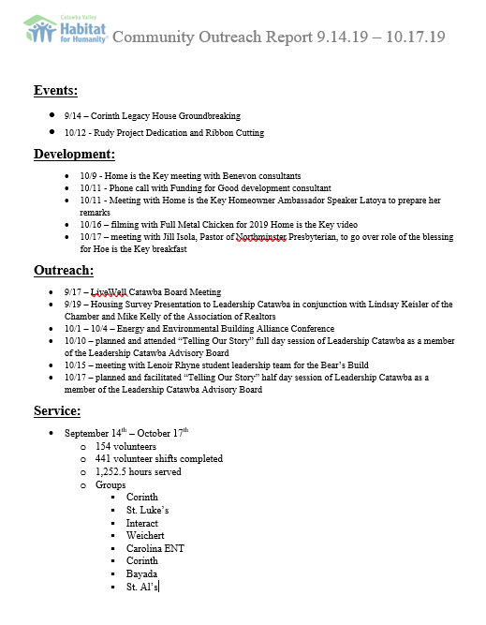

October Construction Report
Derek Ross

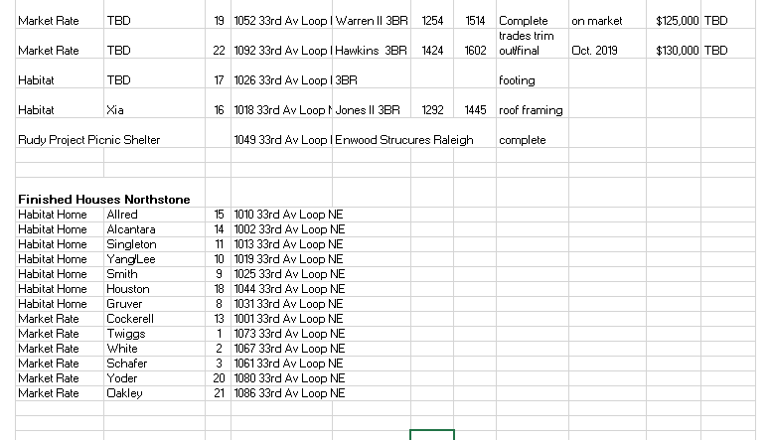
6 families are denied
Repairs Statistics
The First Four Years

Mission:
The Mission of our repair program is to enable our clients to stay SAFE, WARM AND DRY in their own homes.
We perform the most critical repairs, with many other non-critical items not being addressed. Given the fact that Catawba County has the oldest housing stock in the state along with an aging population the need is much greater than we can address with our current funding. We could easily double or triple the number of repairs completed if we had the resources.
The repair program accomplishes the following:
- Provides a safe and comfortable home environment.
- Enables our elderly owners to age in place.
- The taxpayer saves $35,000.00 to $40,000.00 for every year they can remain in their home since they would qualify for Medicaid assistance in a nursing home.
- Preserves Work force housing.

October 2015 – September 2019
- Total Repairs 114
- Roofs 23
- HVAC changeout 26
- HVAC repairs 3
- Plumbing 30
- Electrical 11
- Painting 26
- Gutters 49
- Weatherization (Add insulation) 31
- Ramps 48
- Exterior repairs 32
- Interior accessibility 4

Client Demographics
- Number of people served 257
- Average age 65
- Single female head of household 67
- Widows 33
- Single male head of household 4
- Married household 10
- Children 97
- Household with children 51
- Household with disability 48
- Tree Removal 9

Habitat Partners Program/18 Repairs Completed:

Habitat Partners with churches that have their own tools and the expertise to complete small repairs with a minimum of Habitat staff time required.
Habitat will fund up to $1,500.00 for materials per repair.
The type of work is generally ramp building, but occasionally they will do minor exterior repairs and roofing.
Client Profiles:

Carol, age 67 has been living in her house her deceased husband moved into in 1965. Her husband died 10 years ago. Currently she is taking care of an at-risk teenage granddaughter. She has COPD and is on oxygen.
She had been without central heat and air for several years. In the summer she used fans to try and keep cool. In the winter she heated with two kerosene heaters, alternating between turning on the heaters and her oxygen. Her roof was also leaking, and her gutters needed repairs.
Habitat weatherized her house by adding additional insulation and placing plastic in her crawl space. We also replaced her HVAC equipment, including new ducts, giving providing her with central heat and air conditioning. The new system was not only healthier but reduced the cost of heating her home in the winter.
We also replaced her roof shingles and gutters and repaired two windows that were deteriorated.
In addition, Habitat volunteers decluttered for her, which consisted of cleaning out 50 years of clutter in her attic and several closets in the house.

Alecia, age 42, is a single working mom with two elementary school daughters. She was in an abusive relationship with her former husband but has been able to extract herself from that situation and take full title to her modest two-bedroom home. She currently cleans houses for a living.
We she contacted Habitat, her central heat and air had been inoperable for several years and she was heating and cooling with a combination of kerosene space heaters and window heat and AC units. Her rear exit was very unsafe, and her roof leaked badly. Habitat installed new shingles, repaired her entrances, performed some exterior maintenance items, Added new insulation and new HVAC equipment and ducts.
Alecia has reported that her utility bill has been cut in half.
Joshua, 41, is a veteran with PTSD caused by a head injury in combat. He lives by himself in a mobile home. He called us about leaks in his roof. Upon inspection we discovered he had other needs including complete replacement of the underpinning, plumbing repairs, electrical repairs, and unsafe egress platforms at both the front and back entrances and several holes in the exterior cladding. The repairs are now keeping him dry, and more comfortable due to the new underpinning. Also, with the electrical repairs, the home is now safe, and the plumbing is working with no leaks, reducing his water bill.

Ed, 42, was a computer consultant until having a severe stroke. He is confined to a wheelchair and is now on disability. His wife works for a local company. They have a six-year-old son and live in a 75-year-old home that had roof leaks, faulty wiring, a 30-year-old deck that was in danger of collapsing that served as an emergency exit. In addition, the 25-year-old HVAC was not working, and the gas hot water heater was improperly vented. Also, some of the exterior siding and trim was deteriorating. Habitat completed those repairs, weatherized the home to reduce utility bills and also installed a pad at the end of the existing walkway to the drive to enable Ed to access their car on a paved surface.

Nancy, 78 has been living in her home for over 40 years. She has been without heat and hot water for around 7 years. Her bathroom was not functional at all. She was having to take cold water sponge baths, and heat with Kerosene space heaters. The side entry deck, which is the main entry into the house was in danger of collapsing. Also, her yard had grown up to the point where you could barely see the house from the street.
After completing the repairs, Nancy said that with hot water, and a toilet that flushes, see was now set for life. She said the electric heat that was installed was “icing on the cake”.

Action Items

1) Selection Committee Recommendation – Troy Howard
Denial of applicants with incomplete applications.
(information to be distributed at the meeting)

Informational Items
1) Home is the Key – countdown to 11/14! Lynn & Jenna

2) Review of Development Calendar – Lynn & Mitzi